**TABLE OF CONTENTS**

Introduction 2

Munich 1972 3

Montreal 1976 4

Moscow 1980 5

Los Angeles 1984 6

Seoul 1988 7

Barcelona 1992 8

Atlanta 1996 9

Sydney 2000 10

Athens 2004 11

Beijing 2008 12

London 2012 13

Rio 2016 14

Sources 15

The word mascot is derived from the Provencal and appeared in French dictionaries at the end of the 19th century. “It caught on following the triumphant performance of Mrs Grizier-Montbazon in an operetta called *La Mascotte*, set to music by Edmond Audran in 1880. The singer’s success prompted jewellers to produce a bracelet charm representing the artist in the costume pertaining to her role. The jewel was an immediate success. The mascot, which, in its Provencal form, was thought to bring good or bad luck, thus joined the category of lucky charms”[1].

# Munich 1972

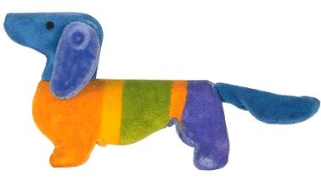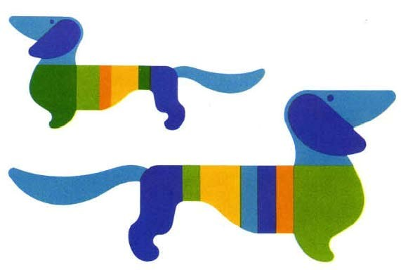

**Waldi**

|  |  |
| --- | --- |
| **Name:** | Waldi. |
| **Description:** | Waldi was the first official mascot in the history of the Olympic Games. He is a dachshund, a very popular animal in Bavaria, famed for its endurance, tenacity and agility.  The mascot features several different colours: its head and tail are light blue, with a striped body featuring at least three of the six Olympic colours. |

# Montreal 1976

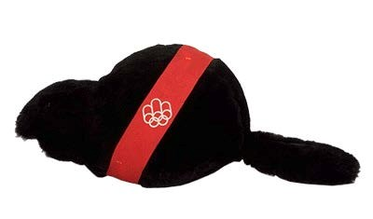

**Amik**

|  |  |
| --- | --- |
| **Name:** | Amik means beaver in Algonquin, a widespread language among the North American Indians in Canada. |
| **Description:** | Amik appears with a red strip featuring the Montreal Games logo, which symbolises the ribbon traditionally used for the winners’ medals. There is also a version with a multi-coloured ribbon, in the colours of the Organising Committee. |
| **Creator:** | Guy St-Arnaud, Yvon Laroche and Pierre-Yves Pelletier, under the leadership of Georges Huel. |
| **Did you know:** | * A national competition was held in Canada to find a name for the mascot.      * Choosing a beaver was far from random, as the animal is closely linked with the history of Canada, where it appears on the reverse of the fivecent coin and various stamps. It also features on the coats of arms of Montreal and Kingston, where the sailing competitions were held.      * This animal is known for its patience and hard work, and has occupied a significant role in Canada’s development since the 16th century, when the trade in beaver fur became the major commercial activity in North America.      * In Greek mythology, Castor, and his twin Pollux, the sons of Zeus, were the gods of hospitality and athletes. |

# Moscow 1980

**Misha**

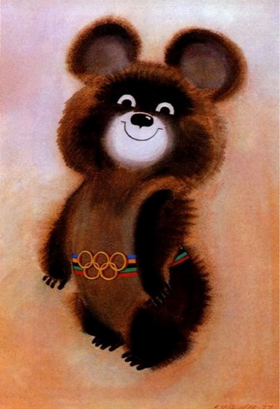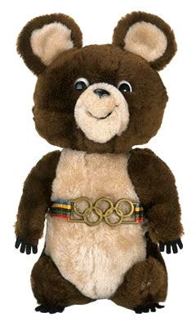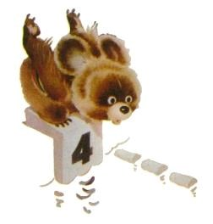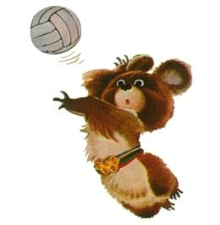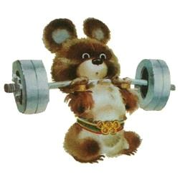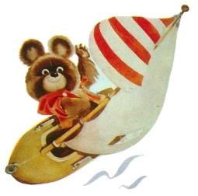

|  |  |
| --- | --- |
| **Name:** | The bear’s full name is Mikhail Potapych Toptygin. |
| **Description:** | The bear is a familiar animal in Russia, appearing in many popular stories, songs and poems.  Misha wears a striped belt around his waist made up of five bands in the colours of the Olympic rings. The belt consists of the five rings in a single colour. |
| **Creator:** | Victor Chizhikov. |
| **Did you know:** | * A survey was conducted among the viewers of a TV programme about animals and the readers of a sports newspaper to choose a bear for the mascot. Some 45,000 letters were received from all over the USSR. A group of artists then produced 60 graphic versions of the mascot. It was finally the version by Victor Chizhikov, a well-known children’s book illustrator, that was chosen.      * On 15 June 1978, Misha took off on a “Soyuz” rocket to spend some time on the “Salyut 6” space station.      * In an emotional moment, an enormous Misha bade farewell to the 100,000 spectators at the Great Arena at the end of the Closing Ceremony of the Games before being lifted off by balloons and disappearing into the sky.      * Although much less well-known than Misha, a seal named Vigri symbolised the sailing competitions at the 1980 Games, which were held in Tallinn. |

Find out more about the [Moscow 1980 Olympic Games on olympic.org.](http://www.olympic.org/moscow-1980-summer-olympics)

# Los Angeles 1984

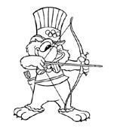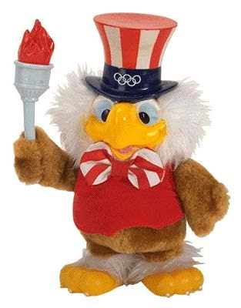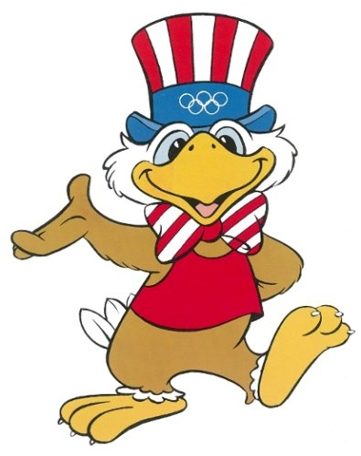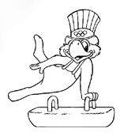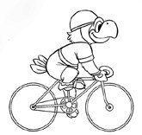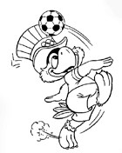

**Sam**

|  |  |
| --- | --- |
| **Name:** | Sam. |
| **Description:** | Sam looks friendly and cheerful in order not to frighten children and to embody the optimism of the Olympic spirit. With his hat featuring the design of the national flag, he shows that he is part of American culture. |
| **Creator:** | C. Robert Moore, Walt Disney Productions. |
| **Did you know:** | * Before becoming an eagle, the animal chosen as the mascot for the Games in Los Angeles was a bear, the emblem of California. This idea was dropped, as a bear had already been used for the Games in Moscow; so it was this famous bird of prey, the symbol of the American nation, which was the natural choice for the mascot’s creators.      * Sam also recalls the bronze eagle which welcomed the winner of the stadium race when he crossed the finish line at the ancient Olympic Games.      * A cartoon was created featuring the mascot Sam, in the form of a detective who used the magic of the five Olympic rings on his hat to get himself out of all kinds of situations. |

Find out more about the [Los Angeles 1984 Olympic Games on olympic.org.](http://www.olympic.org/los-angeles-1984-summer-olympics)

# Seoul 1988

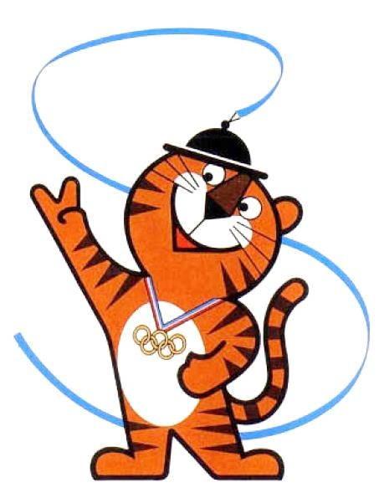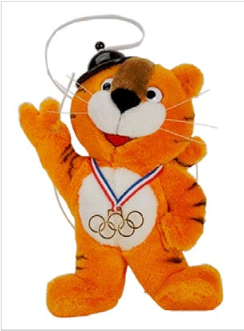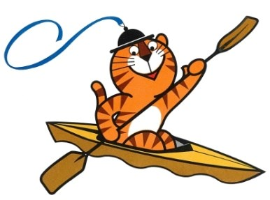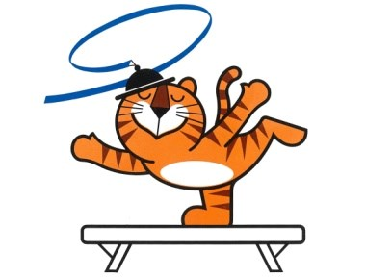

**Hodori**

|  |  |
| --- | --- |
| **Name:** | The “Ho” of Hodori comes from the Korean word meaning tiger, while “Dori” is a common masculine diminutive. The name was chosen from 2,295 competition entries submitted by the general public. |
| **Description:** | The tiger appears frequently in Korean popular art and legends. With a positive image, it is often associated with humour, bravery and nobility. Hodori wears the Olympic rings around his neck. On his head is a typical traditional Korean hat, the sangmo. The ribbon on the hat is in the shape of an S for Seoul, and appears in various forms. |
| **Creator:** | Kim Hyun |
| **Did you know:** | * The Organising Committee set up a contest to select the mascot which generated 4’344 entries. Four candidates were selected – a rabbit, a squirrel, a pair of mandarin ducks and a tiger. Finally the tiger was chosen.      * Kim Hyun, Hodori’s creator, was also behind the emblem for the Asian Games in 1986.      * Although less well known, there is a female version of the mascot named Hosuni. “Suni” is the Korean for “girl”.      * The cartoon book “Come along Hodori” about the mascot won the top prize in the children’s category of a Korean cartoon awards contest in 1988. |

Find out more about the [Seoul 1988 Olympic Games on olympic.org.](http://www.olympic.org/seoul-1988-summer-olympics)

# Barcelona 1992

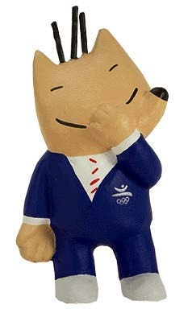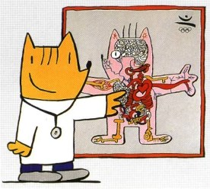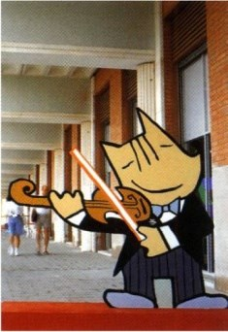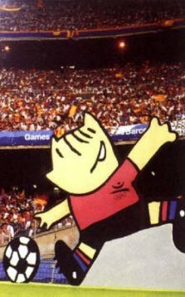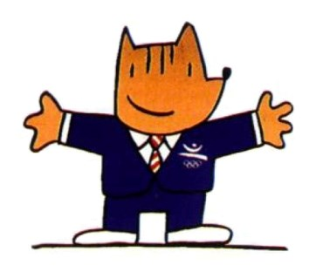

**Cobi**

|  |  |
| --- | --- |
| **Name:** | The name Cobi is an allusion to COOB’92, an abbreviation of the Barcelona’92 Olympic Organising Committee. The name was chosen because it is simple and easy to pronounce in most languages. |
| **Description:** | Cobi is a humanised Pyrenean mountain dog, in a “Cubist” style. While his expression and three spiky hairs are the same, he has an impressively large wardrobe.  Reactions to Cobi were mixed when he was first presented, but he grew in popularity during the months leading up to the Games, and ultimately proved a huge success. |
| **Creator:** | Javier Mariscal. |
| **Did you know:** | * A competition by the Organising Committee between six designers decided the choice of mascot. The jury of experts selected Mariscal’s submission.      * Mariscal’s contribution to the Games in Barcelona was not limited to Cobi. He also designed characters for the Opening Ceremony representing Spanish painting and culture, as well as the font used for the diplomas awarded to the first eight competitors in each event.      * A series of 26 episodes of the cartoon “The Cobi Troupe” related the adventures of Cobi and his friends. The aim of the series, whose target audience was 5-12-year-olds, was to make the mascot more widely known and promote the Games in Barcelona. The rights were bought by 24 television channels. |

Find out more about the [Barcelona 1992 Olympic Games on olympic.org.](http://www.olympic.org/barcelona-1992-summer-olympics)

# Atlanta 1996

**Izzy**

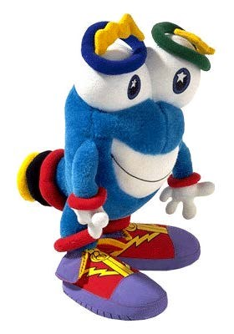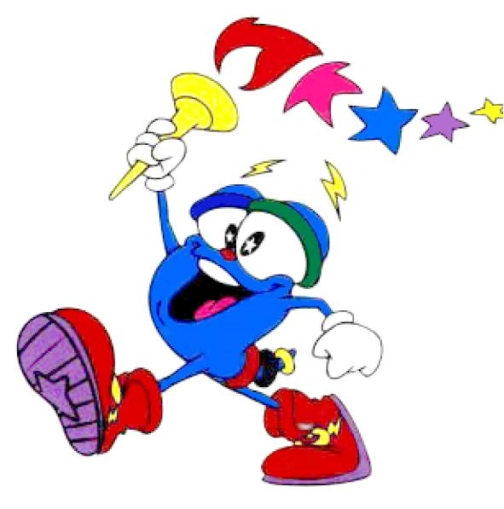

|  |  |
| --- | --- |
| **Name:** | Originally called “Whatizit”, the name Izzy was chosen by 32 American children aged from 7 to 12 from among the following five names: Kirby, Starz, Zack, Gleamer and Izzy. This shortlist was produced from the more than 3,300 suggestions from children in 16 different countries. |
| **Description:** | A product of information technology, Izzy is blue and wears training shoes. The five Olympic rings are in various places around his body. After the Closing Ceremony of the 1992 Games in Barcelona, where he received a mixed reception when first presented, Whatizit was redesigned and renamed by the children of Atlanta.  Over time, a mouth appeared where there had first been only lips; stars appeared in his eyes; and his initially skinny legs became more muscled.  Finally, a nose grew in the middle of his face. |
| **Creator:** | John Ryan, DESIGNefx |
| **Did you know:** | * Izzy is an unusual mascot in that he is not an animal, nor a human figure, nor an object.      * A 30-minute educational cartoon was created and shown throughout the autumn of 1995 on the Cartoon Network channel. To be able to get to the Olympic Games, Izzy had to win five magic rings.      * Izzy was also the hero of a video game entitled “Izzy's Quest for the Olympic Rings”. |

[Atlanta 1996 Olympic Games on olympic.org.](http://www.olympic.org/atlanta-1996-summer-olympics)

# Sydney 2000

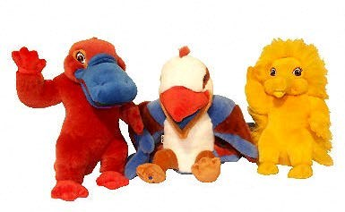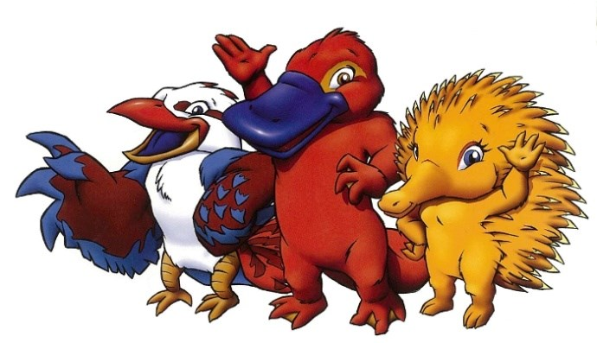

**Syd, Olly and Millie**

|  |  |
| --- | --- |
| **Name:** | Syd is a reference to Sydney, Olly to Olympic and Millie to the new millennium. |
| **Description:** | The three mascots are a duck-billed platypus (Syd), a kookaburra (Olly) and an echidna or spiny anteater (Millie). They symbolise the water, air and earth respectively. Their colours correspond to those of the Games emblem, and all three are typical examples of Australian fauna. |
| **Creator:** | Matthew Hatton |
| **Did you know:** | * The choice of mascots was based on a survey in Australia and other countries. Matthew Hatton’s duck-billed platypus sketch got him selected for the mascots project. The objective of the project was also to avoid kangaroos or koalas, which is why two other less well known animals were chosen.      * This was the first time there had been three official mascots. There had previously been couples, for example Hidy and Howdy for the 1988 Winter Games in Calgary, or even a quartet: the four Snowlets or the 1998 Winter Games in Nagano.      * The kookaburra and the duck-billed platypus are two emblems of the Australian state of New South Wales*,* of which Sydney is the capital. |

Find out more about the [Sydney 2000 Olympic Games on olympic.org.](http://www.olympic.org/sydney-2000-summer-olympics)

# Athens 2004

|  |  |
| --- | --- |
| **Name:** | Phevos and Athena. The names of the two mascots are a reference to two gods of Olympus: “Phoebos” is another name for Apollo, the god of light and music; “Athena” is the goddess of wisdom and protector of the city of Athens. The two mascots thus symbolise the link between Ancient Greece and the Olympic Games of the modern era. |
| **Description:** | Phevos and Athena are brother and sister. They owe their strange shape to a typical terracotta doll in the shape of a bell from the 7th century BC, the “daidala”. They symbolise the pleasure of playing and the values of Olympism.  The choice of a brother and sister was deliberate: they embody the unity of men and women, through equality and brotherhood.  Phevos wears a blue tunic to recall the sea and the colour of the Games emblem, while Athena is in orange to evoke the sun and the Paralympic emblem. |
| **Creator:** | Spiros Gogos, Paragraph Design |
| **Did you know:** | * In Ancient Greece, as well as being children’s toys, daidala had a symbolic function. Before they got married, girls would sacrifice their doll and their dress to the gods for purity and fertility. The example which inspired the mascots is displayed at the National Archaeological Museum in Athens.      * A competition was held to design the mascot. In all, 196 proposals were submitted by design agencies and professionals from all over the world. |

**Phevos and Athena**

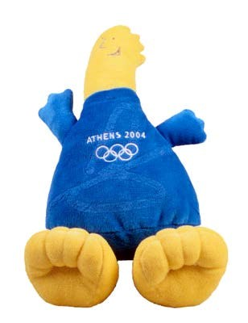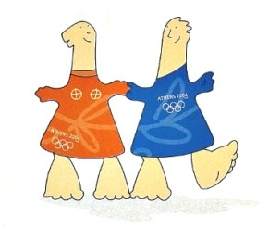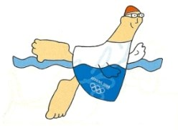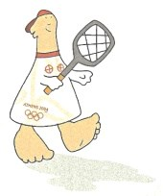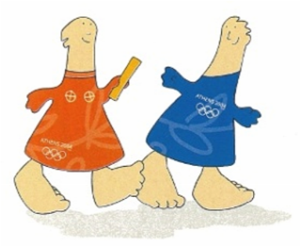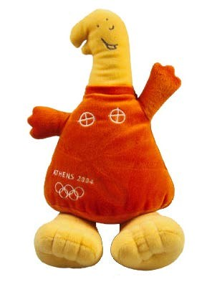

[Athens 2004 Olympic Games on olympic.org.](http://www.olympic.org/athens-2004-summer-olympics)

# Beijing 2008

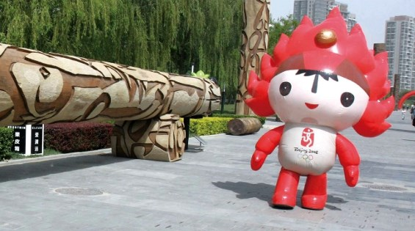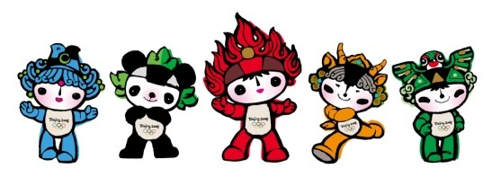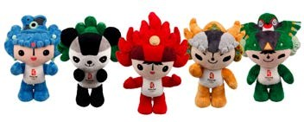

## Beibei, Jingjing, Huanhuan, Yingying, Nini

|  |  |
| --- | --- |
| **Name:** | Each name rhymes by repeating the same syllable: a traditional Chinese way of showing affection to children. Linking the five names forms the sentence “Welcome to Beijing” (Bei Jing Huan Ying Nin). The mascots form the “Fuwa”, which translates as “good-luck dolls”. |
| **Description:** | The mascots correspond to the five natural elements and, apart from Huanhuan, to four popular animals in China. Each mascot represents the colour of one of the five Olympic rings. Each also bears a wish, as it was traditional in ancient Chinese culture to transmit wishes through signs or symbols.  **Beibei** the fish is a reference to the element of water. She is blue and her wish is prosperity. The waves on her head are based on a design in traditional Chinese painting.  **Jingjing** the panda represents the forest. He is black and his wish is happiness. Porcelain paintings from the Song dynasty (960-1234 AD) were the inspiration for the lotus flowers on his head.  **Yingying**, the Tibetan antelope, represents earth. He is yellow and his wish is good health. Decorative elements from Western China appear on his head.  **Nini**, the swallow, represents the sky. She is green and her wish is good luck. Her design is inspired by those on Chinese kites. Swallow is pronounced “Yan” in Chinese, and an ancient name for Beijing was  “Yanjing”.  **Huanhuan** symbolises fire and the Olympic spirit. His red colour transmits the passion of sport. Dunhunag grotto art inspired the decoration on his head, together with certain traditional good-luck designs. |
| **Creator:** | Han Meilin. |
| **Did you know:** | * The Organising Committee invited graphic designers and communications agencies all over the world to send their suggestions for mascots for the Games and attracted more than 3,000 submissions.      * A series of 100 cartoon episodes entitled “The Olympic Adventures of Fuwa” was shown on more than 100 television channels throughout China, on the public transport system in Beijing and on China’s nationwide rail TV networks. |

Find out more about the [Beijing 2008 Olympic Games on olympic.org.](http://www.olympic.org/beijing-2008-summer-olympics)

# London 2012

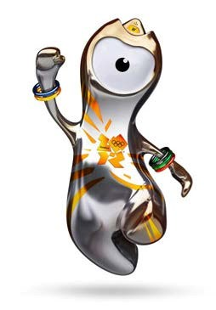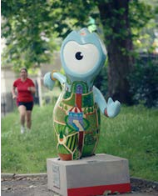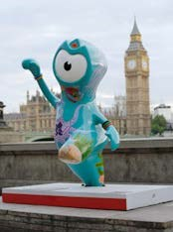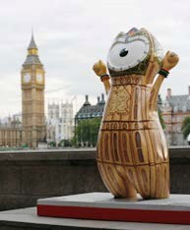

Photo: C

hristopher

Furlong

Photo:

Jason

Evans

Photo:

J

ason

Evans

**Wenlock**

|  |  |
| --- | --- |
| **Name:** | Wenlock takes his name from the town of Much Wenlock in Shropshire, which still hosts the traditional Much Wenlock Games. These were one of Pierre de Coubertin’s sources of inspiration for the modern Olympic Games. |
| **Description:** | According to the story by Michael Morpurgo, Wenlock’s metallic look is explained by the fact that he was made from one of the last drops of steel used to build the Olympic Stadium in London.  The light on his head is based on those found on London’s famous black cabs. The shape of his forehead is identical to that of the Olympic Stadium roof. His eye is the lens of a camera, filming everything he sees. On his wrists, he wears five bracelets in the colours of the Olympic rings. And the three points on his head represent the three places on the podium for the medal winners. |
| **Creator:** | Iris design agency. |
| **Did you know:** | * Streets, parks and underground station entrances in London were decorated with 84 sculptures of Wenlock and the Paralympic mascot Mandeville standing 2 metres 30 tall and each weighing a ton, to help guide tourists during the Games. These sculptures were decorated by 22 designers to reflect their surroundings.      * The mascots were chosen in a competition launched in 2008. More than 100 designers, artists and agencies submitted proposals. Wenlock and Mandeville were chosen from a series of designs which included a humanised pigeon, an animated teacup and representations of Big Ben featuring arms and legs. |

[London 2012 Olympic Games on olympic.org.](http://www.olympic.org/london-2012-summer-olympics)

# Rio 2016

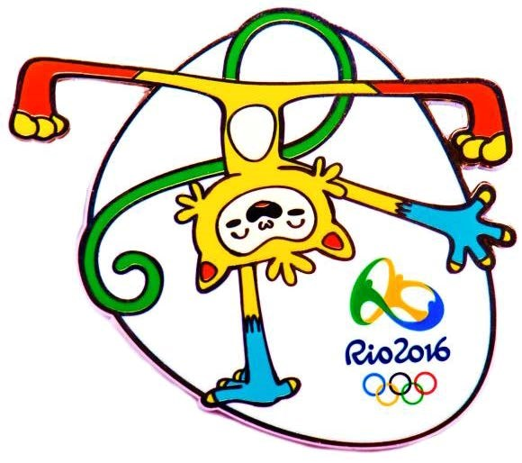  **Vinicius**

Photos: Alex Ferro / André Redlich

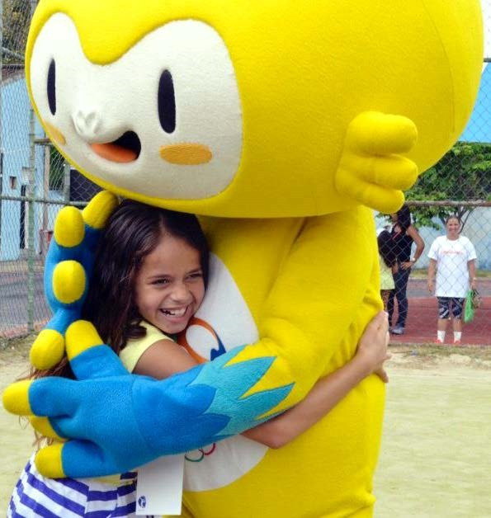

|  |  |
| --- | --- |
| **Name:** | The name of the Olympic mascot pays tribute to Brazilian musician Vinicius de Moraes. |
| **Description:** | Vinicius is a mix of different Brazilian animals. His design takes inspiration from pop culture, as well as video game and animation characters. Alongside his Paralympic Games colleague, Vinicius represents the diversity of the Brazilian people and culture, as well as its exuberant nature. |
| **Creator:** | Birdo Produções |
| **Did you know:** | * The call for tenders for the creation of the Rio 2016 mascots was launched in November 2012, and was aimed at Brazilian companies and professionals in the fields of design, animation and illustration. The country’s major firms took part. After various selection phases, a multidisciplinary jury unanimously selected the final project in August 2013. The Olympic and Paralympic mascots were unveiled simultaneously to the public on 23 November 2014.      * Over the three weeks following the presentation of the Olympic and Paralympic mascots, a public vote took place to select their respective names. Three choices were on offer: Oba and Eba; Tiba Tuque and Esquindim; and Vinicius and Tom. A total of 323,327 votes were registered. The third proposal won the competition, with 44 per cent of the valid votes.      * The mascots (life-sized costume versions) made their first public appearance at the *Ginásio Experimental Olímpico Juan Antonio Samaranch*, named after the former IOC President*.* This is a school in Rio, opened under the impetus of the Games and aimed at young sporting talents. |

Find out more about the [Rio 2016 Olympic Games on olympic.org.](http://www.olympic.org/london-2012-summer-olympics)

# Sources

#### Munich 1972: Waldi

* “Bow Wow ! Dachshund is Munich Olympic Mascot”, *Official report by the Organizing Committee on the preparations for the Games of the XXth Olympiad Munich 1972*, May 1971, n. 5, p. 7.
* *Die Spiele: the official report of the Organizing Committee for the Games of the XXth Olympiad Munich 1972*, München: Prosport, 1974, [vol. 1, p. 59.](http://www.olympic.org/Documents/Reports/Official%20Past%20Games%20Reports/Summer/ENG/1972_Munich_vol1.pdf)
* Martin, David E., Roger W.H. Gynn, *The Olympic Marathon*, Champaign III: Human Kinetics, 2000, p. 281.
* Paula Welch, “Cute Little Creatures”, *Olympic Review*, September-October 1988, [n. 250-251, pp. 436-441.](https://doc.rero.ch/record/235533?ln=en)
* The Olympic Museum: “Munich 1972 Olympic Games mascot”, official website of the International Olympic Committee (2012).

#### Montréal 1976: Amik

* “Beaver is COJO mascot”, in *Daily summary: Games of the XXI Olympiad Montréal 1976*, [Montreal]: OCOG, 18 July 1976.
* *Montreal 1976: Games of the XXI Olympiad Montreal 1976: official report*, Ottawa: COJO 1976, 1978, [vol. 1, pp. 320, 354.](http://www.olympic.org/Documents/Reports/Official%20Past%20Games%20Reports/Summer/ENG/1976_Montreal_Vol_1.pdf)
* “Montréal Games Mascot Unveiled“, *Olympress 1976: Games of the XXIst Olympiad Montréal,* October 1974, vol. 2, n. 8, p. 3.
* The Olympic Museum: “Montreal 1976 Olympic Games mascot”, official website of the International Olympic Committee (2012).

#### Moscou 1980: Misha

* *Games of the XXII Olympiad Moscow 1980: Official report of the Organising Committee of the Games of the XXII Olympiad*, Moscow: Fizkultura i Sport, 1981, [vol. 2, pp. 305, 418-419.](http://www.olympic.org/Documents/Reports/Official%20Past%20Games%20Reports/Summer/ENG/1980_Moscow_Vol_2.pdf)
* “Moscow 1980”, *Olympic Review*, December 1979, [n. 146, p. 687.](https://doc.rero.ch/record/235524?ln=en)
* Paula Welch, “Cute Little Creatures: Mascots lend a smile to the Games”, *Olympic Review*, September-October 1988, [n. 250-251, p. 438.](https://doc.rero.ch/record/235533?ln=en)
* Pyotr Skobelkin, “Misha dons a space helmet”, *Olympic Panorama*, 1978, n. 8, pp. 1 & 3.

#### Los Angeles 1984: Sam

* “Mascotte et mine d’or des prochains Jeux Olympiques”, *Lausanne Cités*, 24 May 1984.
* *Official report of the Games of the XXIIIrd Olympiad Los Angeles 1984*, Los Angeles: Los Angeles Olympic Organizing Committee, 1985, [vol. 1, p. 246.](http://www.olympic.org/Documents/Reports/Official%20Past%20Games%20Reports/Summer/ENG/1984_LosAngeles_Vol1.pdf)
* The Olympic Museum: “Mascot of the Los Angeles 1984 Olympic Games” official website of the International Olympic Committee (2012).

#### Seoul 1988: Hodori

* James F. Larson, Heung-Soo Park, *Global television and the politics of the Seoul Olympics*, United States of America and United Kingdom : Westview Press, 1993, p. 120.
* John A. Callcott, “Preparations well underway for XXIV Olympiad in Seoul”, *Olympic Review*, February 1985, [n. 208, p. 92.](https://doc.rero.ch/record/235530?ln=en)
* *Official report: Games of the XXIVth Olympiad Seoul 1988*, Seoul: Seoul Olympic Organizing Committee, 1989, [vol. 1, pp. 636-639 & 840.](http://www.olympic.org/Documents/Reports/Official%20Past%20Games%20Reports/Summer/ENG/1988_Seoul_Vol_1.pdf)
* The Olympic Museum: “Mascot of the 1988 Games in Seoul”, official website of the International Olympic Committee (2012).

#### Barcelone 1992: Cobi

* Andy Robinson, “Mariscal-Cobi – A jester in Barcelona”, *Olympic Review*, September-October 1990, [n. 275-276, pp. 442-445.](https://doc.rero.ch/record/235535?ln=en)
* “Cobi becomes the hero of the day”, *Olympic Panorama*, 1989, n. 1(48), National Olympic Committee of the USSR, Sovetsky Sport Publishers 1989, p. 22.
* *Official Report of the Games of the XXV Olympiad Barcelona 1992*, Barcelona: COOB'92, 1992, [vol.3, pp. 50, 321 & 346](http://www.olympic.org/Documents/Reports/Official%20Past%20Games%20Reports/Summer/ENG/1992_Barcelona_Vol_3.pdf) and [vol.4, p. 55.](http://www.olympic.org/Documents/Reports/Official%20Past%20Games%20Reports/Summer/ENG/1992_Barcelona_Vol_4.pdf)

#### Atlanta 1996: Izzy

* *1996 Olympic Games: press guide*, Atlanta: Atlanta Committee for the Olympic Games, 1996, p. 35.
* [“Izzy's Quest for the Olympic Rings”](http://fr.wikipedia.org/wiki/Izzy's_Quest_for_the_Olympic_Rings), Wikipedia article (French).
* *The Official Report of the Centennial Olympic Games: Atlanta 1996*, Atlanta: Peachtree publishers, 1997, [vol. 1, p. 274.](http://www.olympic.org/Documents/Reports/Official%20Past%20Games%20Reports/Summer/1996/ENG/1996-RO-S-Atlanta-Vol_1_I.pdf)
* The Olympic Museum: “Mascot of the 1996 Atlanta Olympic Games”, official website of the International Olympic Committee (2012).
* “Whatizit ? ‘Tis Izzy”, *Olympic Review*, December 1993, [n. 313, p. 493.](https://doc.rero.ch/record/235538?ln=en)

#### Sydney 2000: Syd, Millie, Olly

* *Media guide: Sydney 2000 Olympic Games: September 2000*, SOCOG, 2000, pp. 43-44.
* [“Symbols and Emblems of NSW”](http://www.nsw.gov.au/symbols-emblems-nsw), Official website of New South Wales Government.
* “The mascots of the Games of the XXVII Olympiad”, *Olympic Review*, February-March 1997, [XXVI-13, pp. 5-8.](https://doc.rero.ch/record/235542?ln=en)

#### Athènes 2004: Athina et Phivos

* “Athens 2004 Mascot”, Athens 2004 official website, 9 April 2002.
* “Athina et Phivos découvrent les 35 disciplines olympiques”, official website Athens 2004, press release, 11 July 2002.
* “Mascot”, Athens 2004 official website.
* *Official report of the XXVIII Olympiad: Athens 2004*, Athènes: ATHOC, 2005, [vol.1, pp. 320-323.](http://www.olympic.org/Documents/Reports/Official%20Past%20Games%20Reports/Summer/ENG/2004_Athens_Vol_1.pdf)
* “The Dream of Phèvos and Athenà”, *Athens.04, the official magazine of ATHOC*, June 2002, n. 02.
* The Olympic Museum: “Mascots of the 2004 Athens Olympic Games”, official website of the International Olympic Committee (2012).
* “Unique Mascots for a Unique Olympic Games”, *Athens.04, the official magazine of ATHOC*, June 2002, n. 02.

#### Beijing 2008: Fuwa

* [“Fuwa Cartoon Further Airs on Public Transport TVs”](http://english.cri.cn/2946/2007/11/21/176@296674.htm), Crienglish.com website, 21.11.2007.
* “Image and Look: The Official Mascots of the Beijing 2008 Olympic Games”, Beijing 2008 official website.
* *Official report of the Beijing 2008 Olympic Games*, Beijing: BOCOG, 2010, [vol.3, pp. 266-267.](http://www.olympic.org/Documents/Reports/Official%20Past%20Games%20Reports/Summer/ENG/2008-RO-S-Beijing-vol3.pdf)
* “The Official Mascots of the Beijing 2008 Olympic Games”, Beijing 2008 official website, press release,

11.11.2005.

* “The successful Olympic Adventures of Fuwa”, Beijing 2008 official website, press release, 28.08.2007.

#### Londres 2012: Wenlock

* [“London 2012 Launches Olympic Mascot”](http://www.olympic.org/news/media-resources?q=mascotte+londres&frommonth=mai&fromyear=2010&tomonth=mai&toyear=2010&chkcat=111&articlenewsgroup=-1&articleid=89822&searchpageipp=10&searchpage=1), official website of the International Olympic Committee, 19 May 2010.
* “London Mascots”, Olympic Review, April-May-June 2010, [n. 75, p. 13.](https://doc.rero.ch/record/235555?ln=en)
* “Mascots – We are the London 2012 Mascots”, official website London 2012.
* Matthew Beard and Michael Howie, “[Wenlock and Mandeville Go Large: 84 Giant Mascots to greet Games Tourists”](http://www.standard.co.uk/olympics/olympic-news/london-2012-olympics-84-giant-mascots-to-greet-games-tourists-7800528.html), *London Evening Standard*, 29 May, 2012.
* Owen Gibson, “[London Olympics 2012: Meet Wenlock and Mandeville, drips off the old block”](http://www.guardian.co.uk/uk/2010/may/19/london-olympics-2012-mascot), *The Guardian*, 19 May 2010.

#### Rio 2016: Vinicius

* [“Rio 2016 Olympic and Paralympic mascots delight children on first public appearance”](http://www.rio2016.com/en/news/news/rio-2016-olympic-and-paralympic-mascots-delight-children-on-first-public-appearance), Rio 2016 official website, news, 24.11.2014.
* [“Rio 2016 launches the Games Mascot selection process call for proposals”](http://www.rio2016.org/en/news/news/rio-2016-launches-the-games-mascot-selection-process-call-for-proposals), Rio 2016 official website, news,

06.11.2012.

* [“Rio 2016 Olympic and Paralympic mascots named Vinicius and Tom by public vote”](http://www.rio2016.com/en/news/news/rio-2016-olympic-and-paralympic-mascots-named-vinicius-and-tom-by-public-vote), Rio 2016 official website, news, 14.12.2014.
* Tânia Martins, “[Coming soon, the Rio 2016 mascots…”](http://www.rio2016.com/blog/en/coming-soon-rio-2016-mascots), Rio 2016 official website, Blog, 18.11.2014.

**Sources of images taken from Organising Committee publications:**

* *Jeux de la XXIIe Olympiade, Moscou 1980: programme* [natation, volleyball, haltérophilie, voile], Comité d'organisation "Olympiade-80", coord. V. Roditchenko, Moscou : Fizkoultoura i sport, 1980.
* Organising Committee Official Reports: Montréal 1976 (vol.1, pp.320, 354), Moscow 1980 (vol.1, p.419), Los Angeles 1984 (vol.1, pp.246-247), Seoul 1988 (vol.1, pp.636, 638-639), Barcelona 1992 (vol.1, p.373, vol.2, p.211, vol.3, pp.274, 321), Atlanta 1996 (vol.1, p.130), Beijing 2008 (vol.2, p.19).
* *Oi maskot ton olympiakon agonos Athina 2004 = The Mascots of the Athens 2004 Olympic Games = Les mascottes des Jeux Olympiques d'Athènes* 2004, Athènes : ATHOC, 2004, n.p.
* *Sydney 2000 Olympic Games mascot preliminary visual standards manual*, Sydney: SOCOG, 1996, n.p.

1. Marie-Hélène Roukhadzé, “The Olympic Mascot”, *Olympic Message*, August 1991, n. 30, pp. 8-9