Unit 1
Football – General Background
Present Simple and Continuous (Murphy – English Grammar in Use: Unit 1 – 4)
Soccer – is a ball game played by two teams. The ball is advanced with the feet, that’s why the sport is also called football. As not to confuse it with other variants of football, e. g. American football, rugby, or Gaelic football, the official name of this sport is association football (after the London Football Association). But English native speakers usually just call it soccer, football, footie, footy or footer.

A/ Work in pairs. Write as much information as you can.

- Team

- Officials

- Play

- Infractions

- Football skills

- Equipment
B/ Describe the pitch

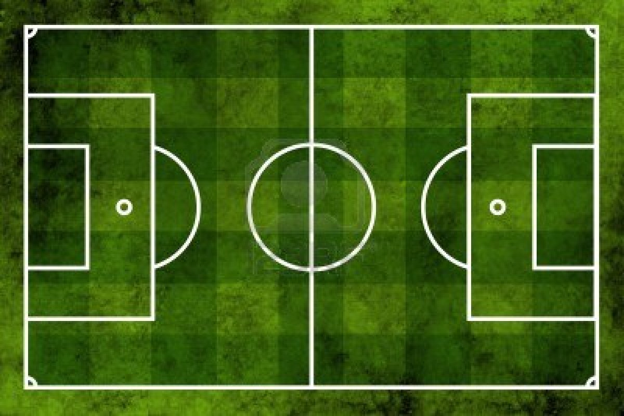

C/ Football Quiz – Choose one correct answer:

- What is Diego Maradona’s full name?
- Diego Armando Maradona
- Diego Enrique Maradona
- Diego Ignacio Maradona

- The anthem of Liverpool FC is
- Go West
- Three Lions
- You’ll Never Walk Alone

- Which club does Lionel Messi play for at present?
- Liverpool FC
- Barcelona FC
- Real Madrid FC

- What is Ricardo Izekson Dos Santos Leite commonly known as?
- Eto-o
- Kaka
- Pele

- Who holds the distinction for being the most expensive player in history?
- Cristian Ronaldo
- David Beckham
- Zlatan Ibrahimovich

- When is Zinedine Zidane’s birthday?
- November 28
- June 23
- April 11

- Which position did Pele play for?
- defender
- midfield
- forward

- How many times did Francesco Totti get the award for the best player of the year?
- 5
- 3
- 4

- In which year was Franz Beckenbauer born?
- 1956
- 1947
- 1945

