**Ice Hockey: History, Vocabulary, Fouls**

**1/ Read the short text about the history of ice hockey and answer the questions:**

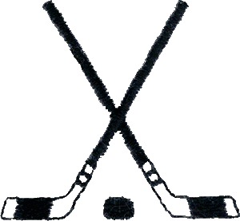

**The Origins of the Game**

Most historians place the roots of hockey in the chilly climates of northern Europe, specifically Great Britain and France, where field hockey was a popular summer sport more than 500 years ago. When the ponds and lakes froze in winter, it was not unusual for the athletes who fancied that sport to play a version of it on ice.

Articles in London newspapers around that time mention increasing interest in the sport, which many observers believe got its name from the French word “hoquet”, which means a “bent stick.” A number of writers thought this game should be forbidden because it was so disruptive to people out for a leisurely winter skate.

**Hockey Comes to North America**

Not surprisingly, the earliest North American games were played in Canada. British soldiers organized contests on frozen ponds in Halifax in the 1870s, and about that same time in Montreal students from McGill University began facing off against each other in a downtown ice rink. Hockey became so popular that games were soon being played on a regular basis between clubs from Toronto, Ottawa, and Montreal. The English Governor, Lord Stanley of Preston, was so impressed that in 1892 he bought a silver bowl with an interior gold finish and ordered that it would be given each year to the best amateur team in Canada. That trophy, of course, is known as the Stanley Cup and is awarded today to the winners of the National Hockey League playoffs.

**Discussion point:**

What do you know about ice hockey history?

Where did the game emerge?

What is the origin of the word “hockey”?

In which Canadian cities were the first ice hockey clubs founded?

**True or false:**

The word “hoquet” is of Spanish origin.

The first ice hockey games were organized in Canada by British soldiers.

The Stanley Cup is a golden bowl with an interior silver finish.

The Stanley Cup is awarded to the winners of the British Hockey League playoffs.

**3/ Ice Hockey Vocabulary**

**Match the following words and definitions:**

|  |  |
| --- | --- |
| 1 puck | A/ player who wears protective gear and defends the goalmouth |
| 2 hockey stick | B/ playing area directly in front of the goal |
| 3 goalkeeper | C/ make sb fall by putting your foot in front of them when they are moving |
| 4 defender | D/ line which divides the rink into two halves |
| 5 dangerous play | E/ when one player is replaced by another player |
| 6 pass | F/ play that could cause injury |
| 7 crease | G/ to hit the puck to a teammate |
| 8 center line | H/ player whose main role is to prevent the other team from scoring |
| 9 substitution | I/ a long piece of wood, curved at one end, that each player carries and uses to hit the ball |
| 10 trip | J/ a disc-shaped object made of hardened rubber |

|  |  |  |  |
| --- | --- | --- | --- |
|  | | | |
| **4. Ice Hockey Crossword**  **Across**  **2.** Move the puck from one player to another.  **5.** Something that protects a hockey player's head.  **6.** What hockey players carry in their hands.  **7.** A very hard shot.  **9.** Something that covers the ground in a hockey rink. | **10.** A position in hockey.  **11.** Place where hockey games are played.  **12.** A position in hockey.  **14.** A position in hockey.  **15.** Person who makes saves.  **Down**  **1.** The player who wears a C on his or her jersey. | **3.** What hockey players wear on their feet.  **4.** Area in front of the net.  **6.** Try to score.  **8.** Small black disc that is used instead of a ball.  **11.** The person who blows whistles and calls penalties.  **13.** What the goalie guards. | |
|  | | | hockeyskating |
| © 2006 Lanternfish ESL at [www.bogglesworldesl.com](http://www.bogglesworldesl.com) | | | |

U4 Ice-hockey penalties/fouls

Task 1: Look at the list of penalties below and classify them to the following headings:

Penalties Against a Player Technical penalties

* Boarding
* Clipping
* Cross-Checking
* Delaying the Game
* Elbowing
* Equipment Malfunctions
* Falling on the Puck
* Handling the Puck
* Holding an Opponent
* Holding the Stick
* Hooking
* Charging
* Checking from Behind
* Interference
* Kneeing
* Late Line-Up
* Slashing
* Spearing
* Too Many Players on the Ice
* Tripping

Task 2: Now make further classification of the fouls below into the following categories:

Stick fouls Physical fouls:

* Boarding
* Butt-ending
* Clipping
* Cross-Checking
* Elbowing
* Fighting
* Headbutting
* Hooking
* Charging
* Checking from Behind
* Kicking
* Kneeing
* Roughing
* Slashing
* Slew-footing
* Spearing
* Tripping

Task 3: Look at the pictures and decide which fouls you can see in them:

[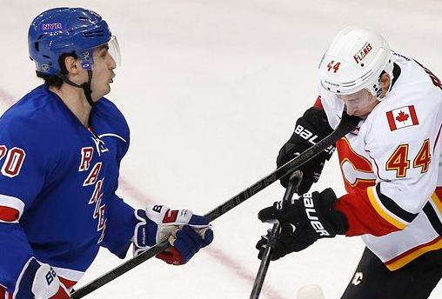](https://likelovehockey.wordpress.com/2014/10/21/a-briefs-look-at-penalties/)

[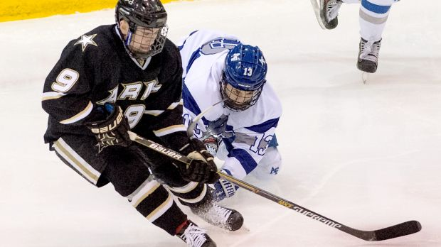](http://www.foxsports.com/nhl/story/army-hockey-tyler-pham-suspended-one-game-for-slew-footing-012115)

[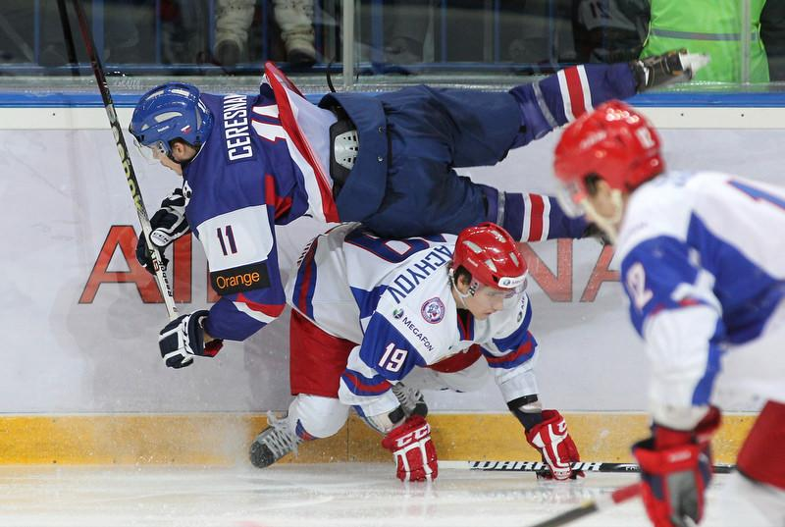](http://freestylephotography.com/2012/12/28/best-cure-for-jetlag/)

[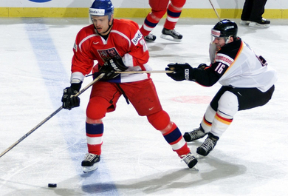](http://www.azhockey.com/IIHF100%2031%20to%2040.html)