Unit 3 Physical Therapy Exercises
From seminar 2: Homework task: Listening: Your body´s real age
https://www.youtube.com/watch?v=Nwfg157hejM

* Any questions about the language or the task? *Questions:
- What are the parts of the body that are renewed frequently?
- What are the parts of the body that last longer?
- What is the part of the body that remains the same your whole life?

Revision – seminar 2:
*Complete the gaps using the correct form of the verb in brackets:
(most are past simple, past continuous, present perfect continuous and present perfect)

Ouch! I just stepped in a hole and I think I _________________ my ankle (sprain).
Yesterday I ______________ too quickly and I hit my shin on the corner of the bed (walk).
The doctor ______________ the patients neck rotation, when suddenly the patient feinted (examine).
Last year I _____________ my lower back when I was lifting something very heavy (injure).
I ______________ here for 1 hour for the doctor….and my chest pain is getting worse! (wait).
Did you hear that Tim fell off his bike yesterday? He _______________ to the orthopaedic clinic today as he thinks he ______________ his arm (go, break).
Last year playing football I _____________ my ACL. Now my knee always hurts, so I wonder if I am ______________ arthritis in it (develop).
I _________ really fit and healthy last year as I _____regularly__________ a lot of sport (to be, play).
Mary has just ______________ with type 2 diabetes. The specialist said she has to eat a more balanced diet with less sugar and exercise more (diagnose).
The man was unlucky when he had a car accident, as he ___________ 3 ribs and also ___________ his scapula. He has a lot of pain around his chest and upper back (break, fracture).
During the hockey season last year I ____________ my thigh muscle when I _____________ for the ball. It ___________ several months to full recover (injure, run, take).
I ________________ a splitting headache all day, I need to take some pain killers (have).
Yesterday I _____________ severe back pain all day but today it feels much better (have).
Unfortunately Tom ____________ a cold right before his tennis match and couldn’t compete. He was unlucky as he _______________ extremely hard in the lead up to the tournament (catch, train).
I __________________ a lot recently so I’m feeling really fit and healthy! (work out).
James _____________ in hospital last year after suffering from a serious heart attack (treat).

Unit 3 Physical Therapy Exercises
1. How do physiotherapists use exercise in their work? What types of exercise do they use? * Discuss with the group:

A) Read and complete the gaps:

Physiotherapists use exercise as one of their main tools to assist their ____________ to recover from illness and injury, to maintain their level of health and function, and to improve their physical __________ or condition, so they can maximise their performance.

Physios use many different type of exercise in their daily work. They often prescribe general exercise as part of an overall fitness or conditioning program, including both ___________ exercise or cardiovascular training, and ___________ exercise, which is higher intensity exercise usually for shorter time periods.

Exercising regularly helps patients take an _________ role in the process of their recovery from injury, illness or disease. This is one of the main goals of physical therapy exercises. Stretching or _____________ exercises, and ______________ exercise, so that patients can condition their muscles to be stronger, are just two of the many types of physical therapy exercises.

2. Type of exercises used by physiotherapists

* Connect the different types of exercise listed, with their definitions below:

proprioceptive rehabilitation static stretching gait training
stabilizing exercises strengthening dynamic stretching
cardio-vascular exercise range of movement breathing exercises

Exercises that focus on moving the spinal or peripheral joints repetitively so that they can achieve a normal range of motion.

A focus on effective inspiration and expiration, using the diaphragm and the muscles of breathing as effectively as possible.

Rehab that is designed to promote improved strength of muscles, which may involve isolated muscle exercise or whole body exercises such as push ups or sit ups.

These are muscular flexibility exercises that focus on improving the length of a muscle, and are often used during the cool-down and recovery after sport.

Often used with geriatric or post-operative patients in order to allow them to regain their normal mobility and independence once again.
When joints or regions of the body are hypermobile or have poor muscular control, these types of rehabilitation exercises are important.

This form of exercise is recommended not just for athletes and sports people, but also the general population to encourage good fitness and health.

Important after injuries which create instability around a joint, this type of training encourages co-contraction of muscles around the joint to optimize control of movement.

This form of flexibility training is frequently used by players before sport, as way to warm-up their muscles and take their joints through a large range of motion in an active way.

3. Speaking: Try and name some problems / conditions often seen by physiotherapists that may need each type of exercise above:
eg. after a muscle strain / tear, patients need strengthening exercises.

- proprioceptive rehabilitation:
- static stretching:
- gait training:
- stabilizing exercises:
- strengthening:
- dynamic stretching:
- cardio-vascular exercise:
- range of movement:
- breathing exercises:

4. Grammar / vocabulary: Cause and effect with anatomical movement

* Are the following true or false? Discuss and correct any mistakes with the group.
* Notice the different ways cause and effect are worded (in Italics)

Flexion of the shoulder occurs as a result of the shoulder flexors contracting, which results in the arm moving forwards and upwards. T / F
Knee extension occurs due to the quadriceps muscle group contracting. T / F
Hip abduction results from contraction of the adductor muscle group. T / F
Because the elbow is a hinge joint, there is little rotation that occurs. T / F
When the fingers fully flex, the hand moves into a ‘gripping’ position. T / F
Since the thoracic spine is quite rigid, very little spinal extension occurs in this region. T / F
Neck side flexion occurs when the chin moves downwards towards the chest. T / F
Pronation of the forearm occurs as a result of the action of the forearm extensors T / F
When you stand up on your ‘tip toes’, your ankle is moving into plantar flexion. T / F
Circumduction can only occur at ball and socket joints, such as the shoulder. T / F
Ankle inversion and eversion occur due to contraction of the hamstrings. T / F
In the ‘drop foot’ condition, the ankle falls into plantarflexion because the ankle dorsiflexors aren’t strong enough to hold the foot up. T / F

5. Examples of various exercises for several conditions.

* Look at and discuss the pictures and conditions with the group.
* Then choose 1-2 exercises and practice describing how to do them in English.
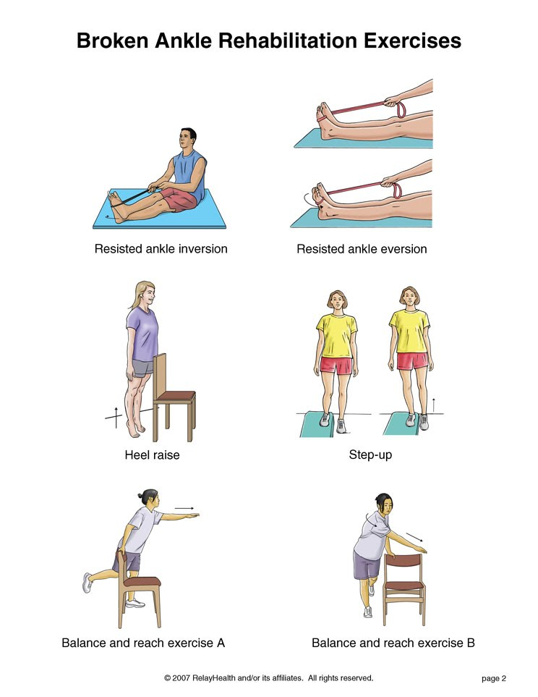
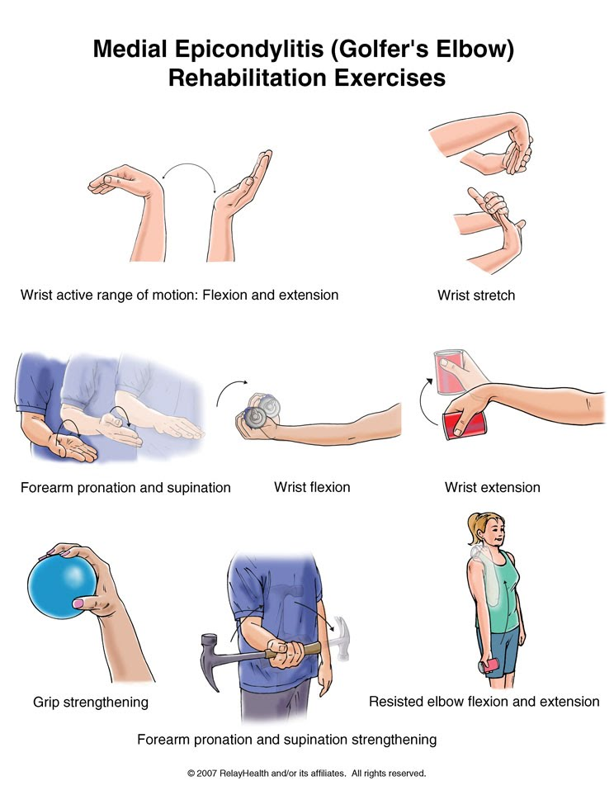

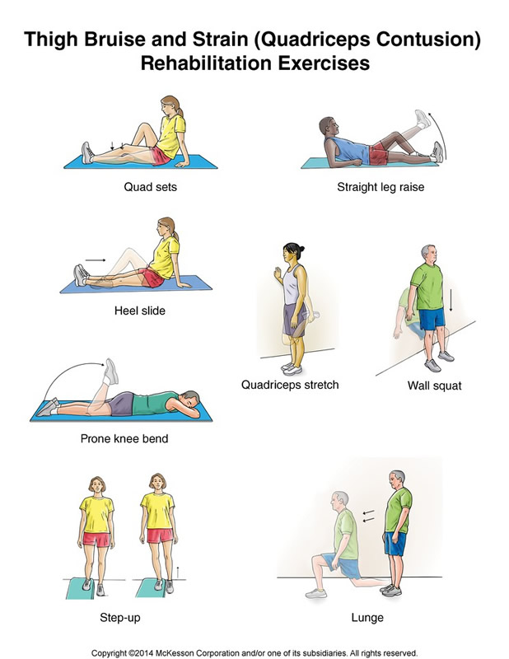

Homework Task: Describing a home exercise

* Prepare instructions for an exercise.

* Describe what type of exercise it is, what conditions it may be used for, how to do the exercise and any other instructions that could be important.

* We will review some of these examples next seminar.

