# CLOSE TO BRNO MUST SEE

## Moravský kras

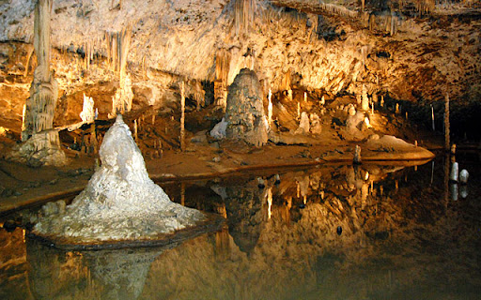

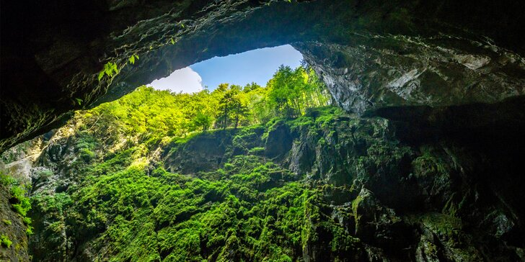

<http://www.moravskykras.net/en/moravian-karst.html>

How to get there

<https://goo.gl/maps/poomZcrd4ViSReCW8>

Macocha – deepest place in CZ

Caves, views, forests

## Křtiny

## 

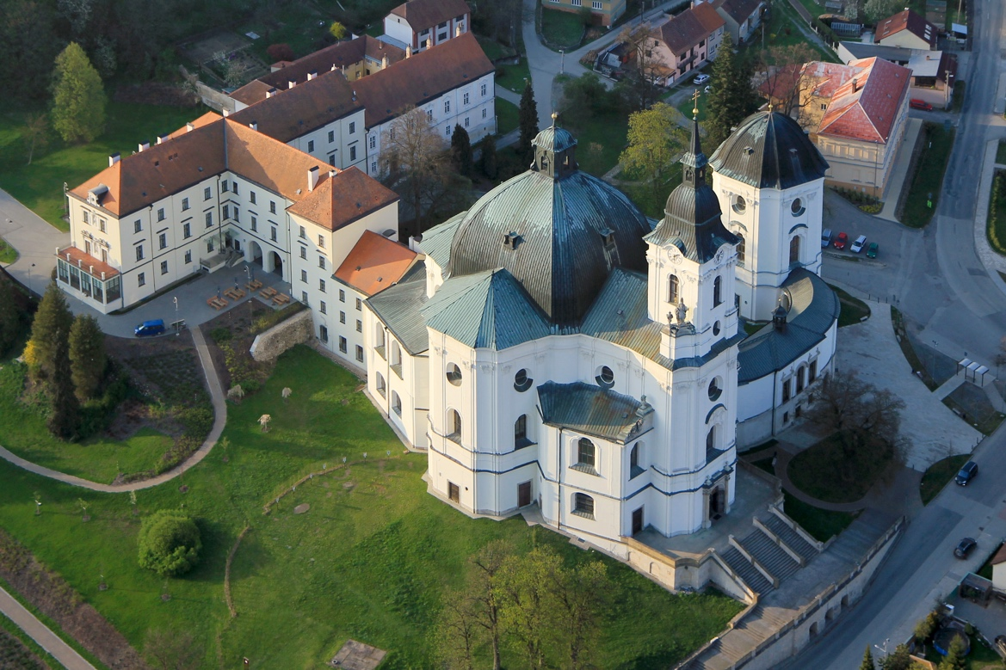

How to get there

<https://goo.gl/maps/nZvCbUj8DL5WPDCs8>

Huge Church from Santini

## Ivančice + Moravský Krumlov

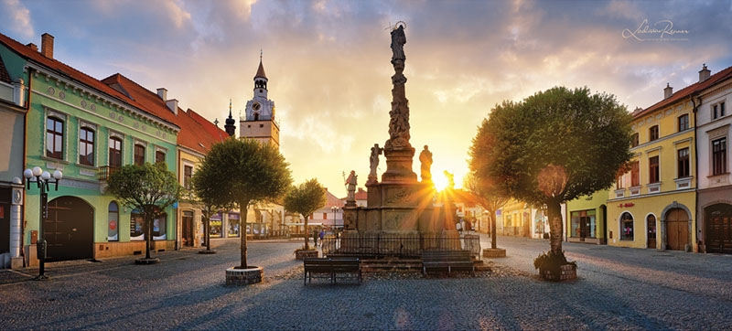

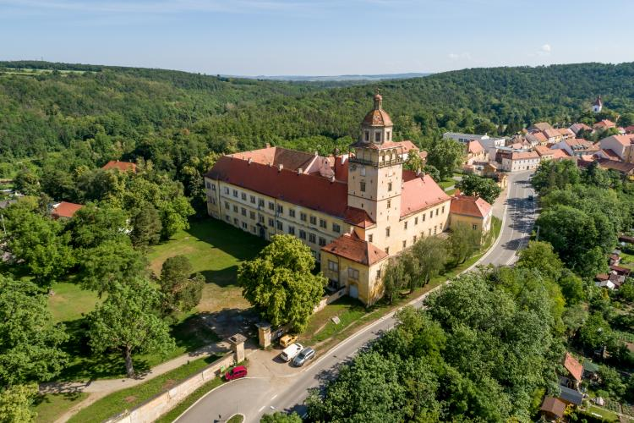

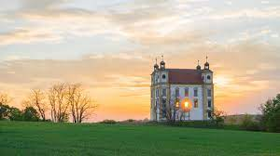

How to get there

<https://goo.gl/maps/DAUqrDpmcPJHnhxw8>

Huge park for tours, historical city centre with church, one of the biggest jewish cemeteries + in Moravský Krumlov there is a castle with the view (Floriánek) and a castle in the city where there is a super famous Slavic Epopey – huge pictures from the Slavic history.

## Znojmo

Straight bus from Brno, super beautiful historical city, national park next to it, super views.

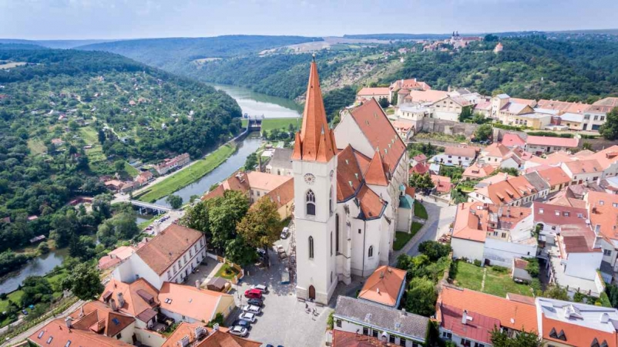

# CZ MUST SEE

Olomouc + Prague – you have mostly been to

## Český Krumlov

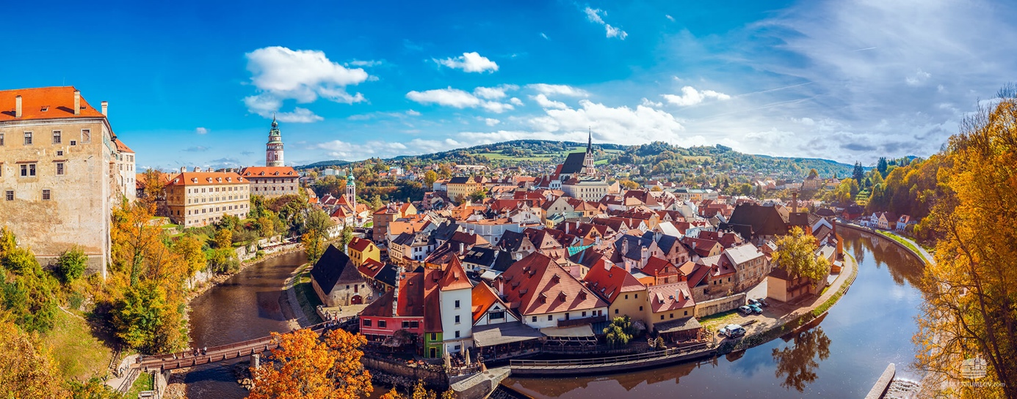

Super famous historical city – churches, castello, river Vltava, parks,…

Close to it 🡪

## Lipno lake

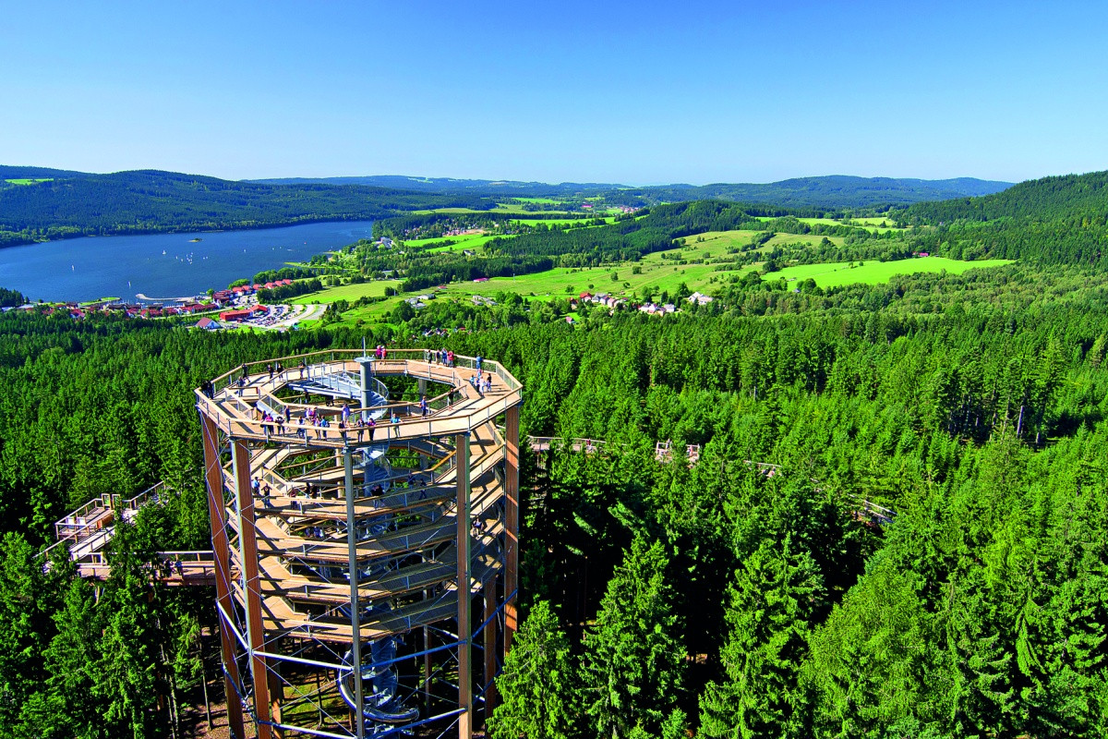

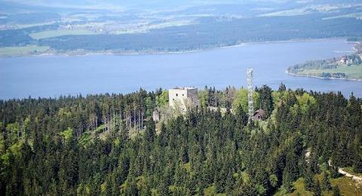

Artificial lake /damn about 30 minutes by bus from Český Krumlov – Lipno nad Vltavou City has a huge treewalk (picture), there are castle ruins around (Vítkův hrádek in the picture) and many many other things – famous resorts in the summer (swimming, cycling,…) and in the winter for skiing.

🡪 close to it

## National park Šumava mountains + lakes

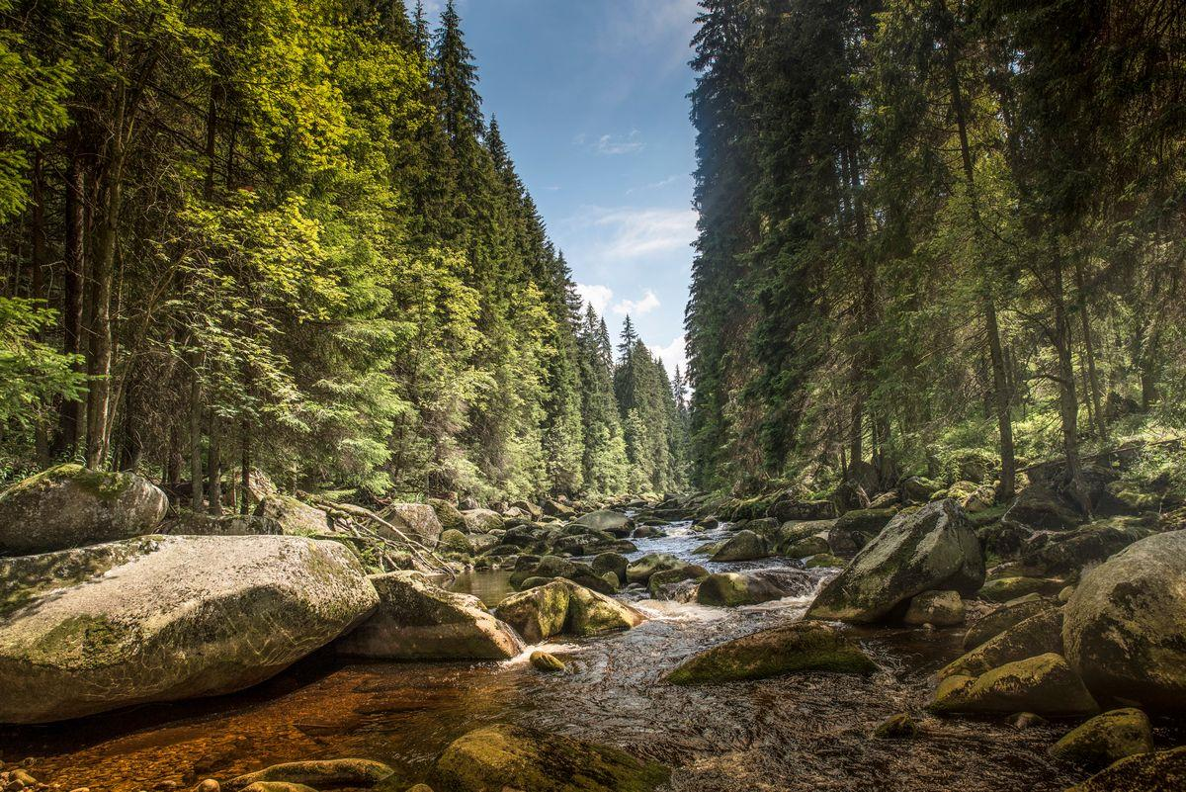

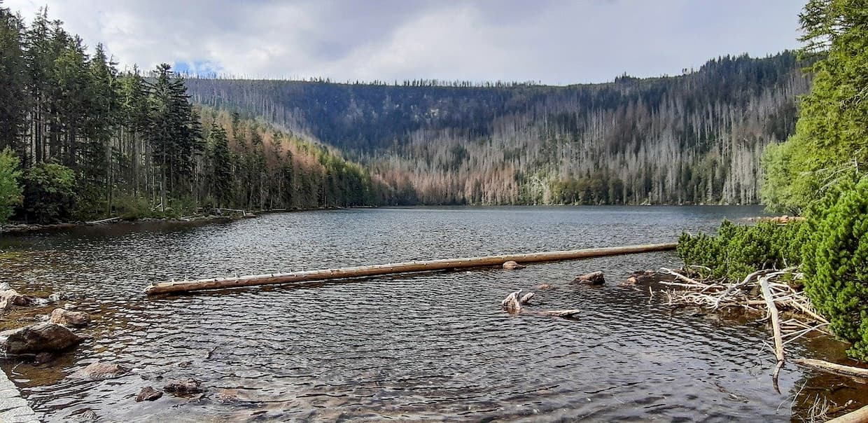

Devils lake (deepest in CZ)

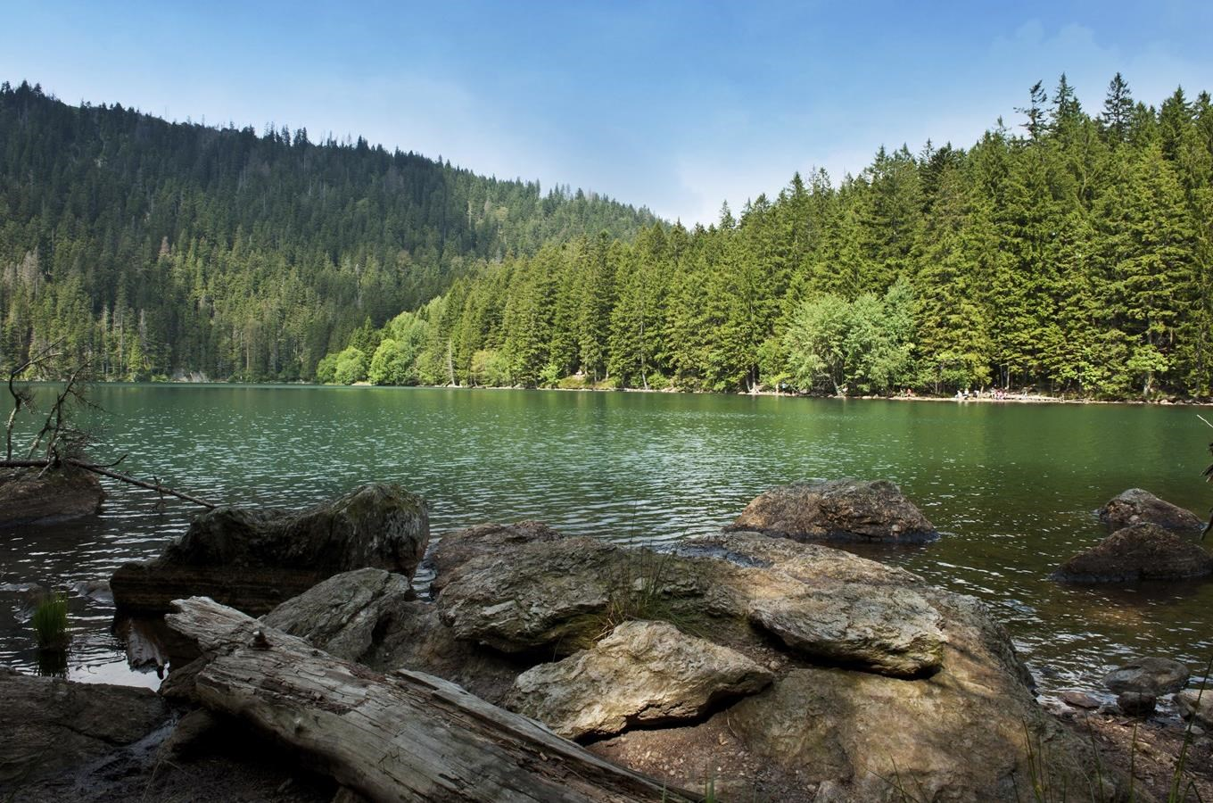

Black lake (guess the biggest one)

And a lot more places, especially super clear and beautiful nature…

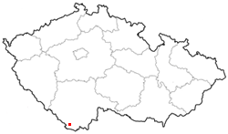

## České Švýcarsko (Czech Swiss)

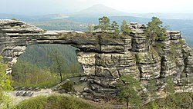

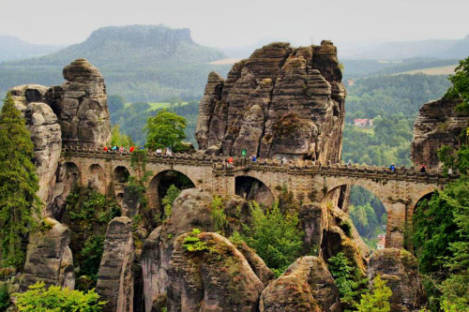

Another super famous Czech national park with mountains, nature, lakes etc.

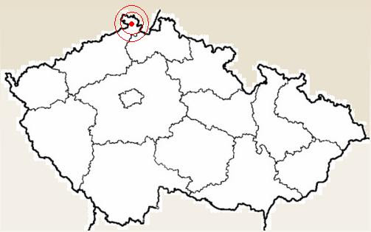

## Karlovy Vary

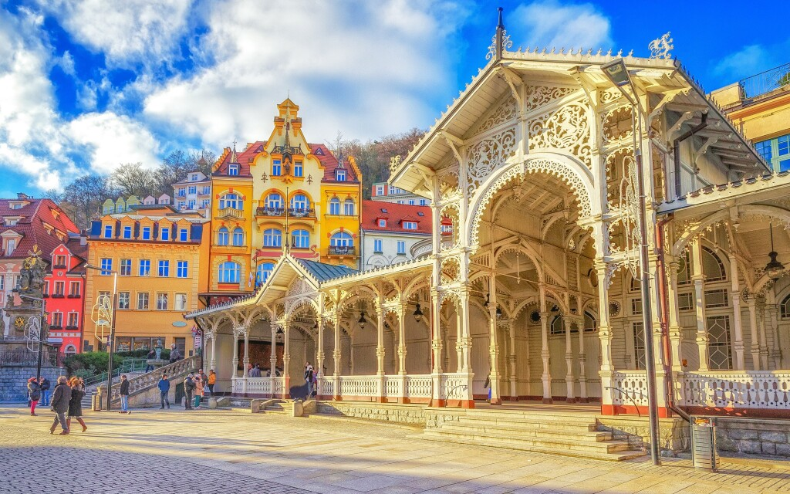

Famous Spa city, film festival takes place here, beautiful parks around the city.

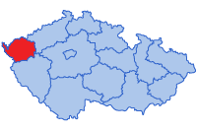

## Žďárské vrchy + Žďár nad Sázavou

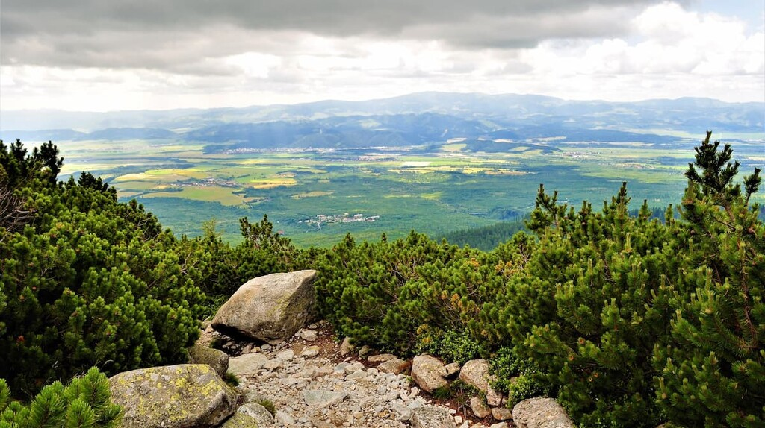

Quite close to Brno, Žďárské vrchy are favourite place for walks (lots of rocks, mountains, super views, beautiful nature,…) and close to it is city of Žďár nad Sázavou with UNESCO church Zelená Hora (Green Mountain). Castle is right under the Church.

