**Homework:**

1. **Study the rules for making questions, then create a quiz about Olympic games (at least 4 questions).**

*For example: When were the modern Olympic games held for the first time*

1. **Do the TASK Listening: Human body (in this document)**
2. **Complete all the exercises in this document and look at the topics in “interaktivní osnova”**

**4. Sports Around the World**

**5. History of Sport**

**6. Basic Human Anatomy**

## Revision:

**Read the following statements and complete the correct preposition. Then talk to your partner – do you agree with these statements? Why, why not?**

1. If I don’t understand a word, I look it _____ in a dictionary.
2. I don’t listen _____my teacher if I want to know what to do in the seminar.
3. When learning a language, I don’t focus _____learning new vocabulary.
4. Accept Imperfection: If I get rid _____the fear of making a mistake, I will learn the language a whole lot easier.
5. Putting an emphasis _____realistic situations will help me profoundly to learn a foreign language.
6. It is not necessary to be aware _____how the language actually works, you just need to understand it.
7. No one but you is responsible _____your own learning progress.
8. We can use the context to work _____the meaning of unknown words.
9. To effectively learn a new language, you have to come up _____ a consistent study routine that includes daily practice, varied resources, and interactive activities.

**Key: 1up, 2to, 3on, 4 of, 5on, 6 of, 7 for, 8 out, 9 with**

## Sports Around the World

Sport is no longer a matter of simply playing games. It is a way of life for people all over the world. It can also be an international language, a force for peace or a political weapon as well as business.

Sport is something that touches our lives to a lesser or greater degree. Some sports are global, others are more localised. Many sports have changed through the ages, others have stayed essentially the same for hundreds of years.

QUESTIONS

Can you give examples of global and local sports? Are there any sports played exclusively in the Czech Republic?

What are the sports with a long history? What are the most recent sports and games?

CLASSIFICATION OF SPORTS

Stadium Team Sports

American Football, Football, Rugby, Baseball, Softball, Cricket, Hockey

Court Games

Basketball, Volleyball, Badminton, Tennis, Squash

Athletics

Track Events, Field Events

Gymnastics

Men´s, Women´s Gymnastics (Artistic); Rhythmic Gymnastics

Combat Sports

Boxing, Wrestling, Sumo Wrestling, Martial Arts

Water Sports

Swimming, Rowing, Canoeing, Windsurfing, Diving, Scuba Diving

Winter Sports

Skiing, Ski Jumping, Bobsleigh, Snowboarding, Skating, Ice Hockey

Activity/ Adventure Sports

Cycling, Mountain Biking, Skateboarding, Inline Skating, Mountaineering, Paragliding

TASK

Add to the list more sports you know.

Give characteristics of sports you like best.

VOCABULARY

**Exercise 1:**

What sports are the people probably talking about?

1. It is all a matter of balance really.
2. You need a good eye and a lot of concentration.
3. The women´s downhill starts at ten.
4. After his performance on the rings, he´ll be hoping for something better on the horse.
5. You get sore at first and can hardly sit down, but you get used to it after a while.
6. The next big race is the 800 metres, in which Sarah Gates represents Great Britain.
7. It´s incredibly noisy, fast and dangerous, but exciting to watch.
8. And so Clare Downs wins the 100 metres freestyle to add to her victory in breaststroke.

**Exercise 2:**

Read this text and choose the best alternative from the four choices given to fill each gap.

To be good at whatever sport you (1) _________ , you need to (2) ____________ a lot of time and energy on it. Professional footballers, for example, need to develop particular

(3) ______________ , like passing the ball and tackling, but they also need to improve their endurance and general (4)_____________ . They (5) ___________ most days. This usually involves running around the (6)______________ and doing lots of exercises.

1. **A** do **B** make **C** play **D** take

2. **A** give **B**  spend **C** use **D** waste

3. **A** abilities **B** characteristics **C** strategies **D** skills

4. **A** state **B** fitness **C** form **D** image

5. **A** prepare **B** perform **C** rehearse **D** train

6. **A** pitch **B** court **C** grass **D** pool

**Exercise 3:**

Complete the sentences with the expressions given below.

*tournament record score beat win opponent*

1. Who do you think will……………….?
2. Sweden…………… Portugal 2-0.
3. She´s a very difficult …………………
4. What was the final…………………..?
5. It´s an incredible time – I think he has broken the world ……………..
6. It´s a five-day…………………..

**Exercise 4:**

Complete the following phrases with either *win* or *beat*.

1. …a medal
2. …a trophy
3. …your rival
4. …a race
5. …the champion
6. …a competition
7. …the hot favourite
8. …by two seconds
9. …the first round match
10. …the championship

Key: Exercise 2: 1do, 2spend, 3skills, 4fitness, 5train, 6 pitch

Exercise 3: 1win, 2beat, 3opponent, 4 score, 5record, 6 tournament

Exercise 4: beat: 3, 5, 7, otherwise win

## The History of Sports and Competition

**Before you read**

Match the words on the left with their definitions on the right:

1. To chase

2. Tool

3. To bring about

4. To domesticate

5. Patient

6. Keen on

7. Spectacle

A) to train an animal to live with humans

B) to follow sb. or sth. in order to catch them

C) an instrument held in hand

D) to make sth. happen, to cause a change

E) an unusual and impressive event or sight

F) able to wait for a long time

G) wanting to do sth., very interested

**The Origins of Sports**

It is possible to search for the origins of sports in primitive matters of survival. Some sports and disciplines such as running and throwing can be associated with chasing and killing animals. Tools that were once used for killing have been transformed into symbolic instruments like bats, rackets and clubs.

The coming of farming brought about a revolutionary change in the human way of living – hunting skills were no longer needed. Instead, farmers had to develop the skills of domesticating and feeding animals, they had to be patient and responsible. Nevertheless, people still went hunting for pleasure and excitement.

Greek civilisation is probably the first culture to integrate sports and competition into civic life. Athletic excellence was a heroic, mythical success. The Greek ambition was to win and little attention was paid to such things as “fairness”. Greeks were also very keen on physical perfection and part of the competition was to show the muscular bodies of men, but not women. One of the ideals of Greek games was *kalos kai agathos*.

The games were probably less important as a spectacle than they were as a point around which to organize training. Fitness and strength were important qualities of warriors as much as sports performers.

**After you read**

Decide whether these statements are true (T), false (F) or not mentioned (NM):

1. Many sports are similar to the methods people once used for getting food.
2. When people started farming and domesticating animals, they did not want to hunt any more.
3. The best Greek athletes were considered to be chosen by gods.
4. Women were allowed to take part in the Games.
5. The Games in ancient Greece were held primarily to entertain the crowds.

Key: 1T, 2F, 3 NM, 4F, 5 F

**THE OLYMPIC GAMES**

Watch this video and complete the text below <https://www.youtube.com/watch?v=Ot34DU6GQf4>

Complete the text:

The ancient Olympic Games were held in 1. _____________, Greece, every four year from at least 2. _____ BC, until they were banned by Emperor 3. ________________ in 389/393/394 AD. (date is unclear)

Originally, there was only one race, a 4. __________ event, and the prize for the winner was an olive wreath. As time went on, other races and sports were added. A unique feature of the Games was that at the time of the staging, countries which were at 5. _____________ laid down their weapons, competed and returned to the war after the event.

The Modern Olympics as we know it was the brain-child of a Frenchman 6._______________. He first proposed the idea of restaging the festivals of ancient Greece. In 1894 an Olympic Congress met in 7.___________ and decided to stage its first Modern Games in Athens in 8.________.

The Games were not held in the years 1916, 9._______ and 1944 due to the First and Second World Wars.

Key: 1 Olympia, 2 776, 3 Theodosius, 4 running, 5 war, 6 Piere de Coubertin, 7 Paris, 8 1986, 9 1940

## Questions - Grammar

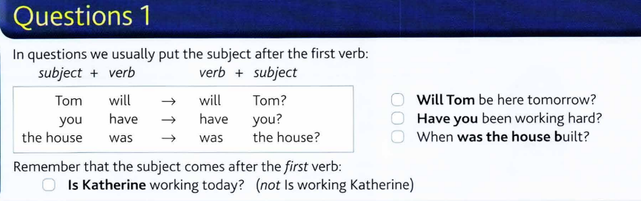

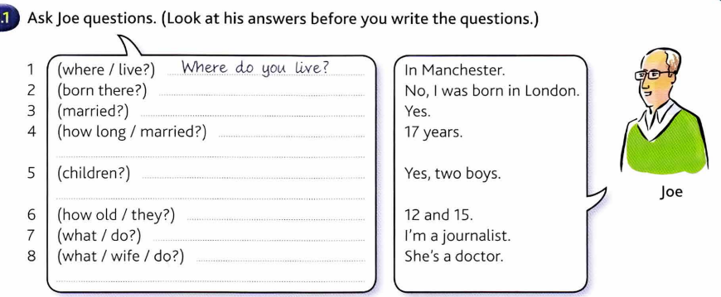

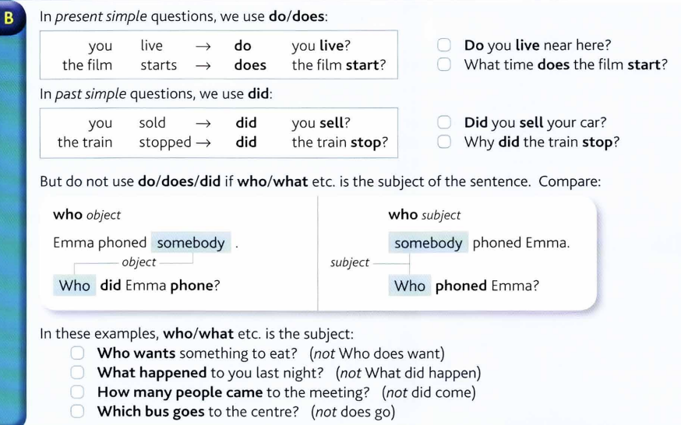

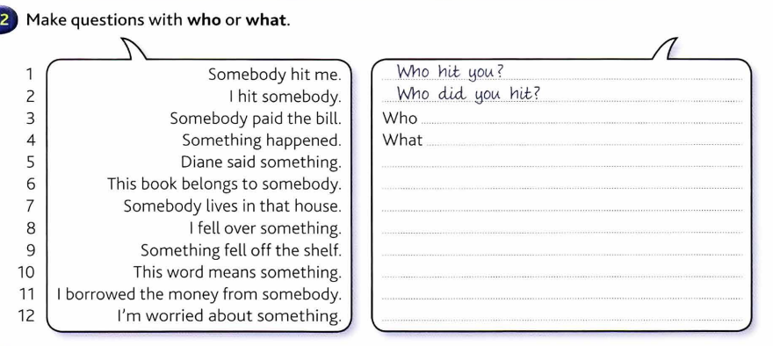

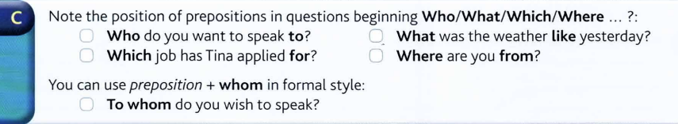

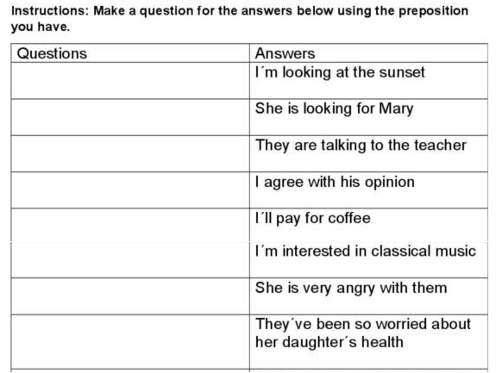

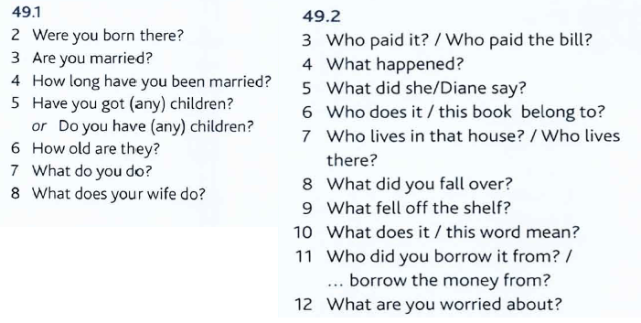

What are you looking at?; What is she looking for?; Who are they talking to?; What do you agree with?; What will you pay for? What are you interested in? Who is she angry with? What they have been so worried about?

**TASK**

Do you know any interesting facts from the history of the Games? Prepare a few quiz questions for your colleagues.

**Topics for discussion**

• Ecological impact of the Olympics.

• Impact of the Olympics on local people.

• Commercialisation of the Olympics (e.g. sponsorship).

• Security problems at the Olympics.

• National and local government spending on sport.

• The size of the Olympics.

• Hosting the Olympics in this country/city

## Task Listening: Human body

[***https://www.youtube.com/watch?v=Ae4MadKPJC0***](https://www.youtube.com/watch?v=Ae4MadKPJC0)

Listen and supply missing words :

The human body is a network of **____________**, **___________** and **_____________**.

The infrastructure for other systems is provided by **______________, _______________, ________________** and **________________** systems.

The skeletal system **_____________** the body together, gives it **_____________**, and **________________** organs and tissues.

The muscular system is composed of 3 types of muscles: **_____________, ______________, _______________**.

The cardiovascular system comprises the **______________, _______________** and the **_______________** itself.

This system distributes **______________**, white blood cells, **______________** and **______________** throughout the body.

The nervous system consists of the **_____________**, the spinal **______________**, **_____________** and spinal nerves.

The 3 regulation systems are: **______________, ____________, _______________**.

The endocrine system is a series of **______________** producing hormones.

The lymphatic system is a collection of lymph **______________** and vessels which participate in the regulation of the body´s **_________________.**

The urinary system is composed of **________________**, **______________**, **____________** and **______________**.

Waste material is expelled from the body as **_______________**.

The systems supplying energy for all bodily functions are **_____________** and **______________**.

Air goes through the **_____________** cavity and is transported to the **_______________**.

Food is first processed in the mouth, moves into the **_____________**, then into the **_______________** and the **________________**.

Primary female sex organs are: **_____________**, fallopian tubes, the **______________**, **_____________**.

Primary male sex organs consist of **______________**, **_____________** channel.

## Basic anatomy

*Match the description with one of the systems. What organs do you associate with each of them?*

**skeletal digestive lymphatic integumentary respiratory nervous reproductive urinary muscular circulatory endocrine**

1. The ___________ system supports and protects, regulates body temperature, makes chemicals and hormones, and acts as a sense organ.   
2. The ___________ system supports and protects, makes movement easier (with joints), stores minerals, and makes blood cells.   
3. The ___________ system brings about body movement, maintains posture, and produces heat.   
4. The ___________ system allows a person to communicate with the environment and integrates and controls the body.   
5. The ___________ system secretes hormones into the blood that serve to communicate with, integrate, and control mechanisms.   
6. The ___________ system transports substances through the body and establishes immunity.   
7. The ___________ system is a subdivision of the circulatory system. It does not contain blood, but rather lymph, which is formed from the fluid surrounding body cells and diffused into lymph vessels. The major functions of this system are the movement of fluid and its critical role in the defense mechanism of the body against disease.   
8. The ___________ system exchanges oxygen from the air for the waste product carbon dioxide, which is eliminated from the body.   
9. The ___________ system breaks down food, absorbs nutrients, and excretes solid waste.   
10. The _____________ _______ system cleans waste products from blood in the form of urine and maintains electrolyte balance, water balance, and acid-base balance.   
11. The ___________ system produces sex cells, allows transfer of sex cells and fertilization to occur, permits development and birth of offspring, nourishes offspring, and produces sex hormones.

Key: 1integumentary, 2skeletal, 3muscular, 4nervous, 5 endocrine, 6 circulatory, 7 lymphatic, 8 respiratory, 9 digestive, 10 urinary, 11 reproductive

***Complete the following verbs in the correct form:***

COMPOSE, CONSIST, COMPRISE, PROTECT, MAKE, CONTAIN, SERVE, DIVIDE

Skeletal system 1_________ of about 206 bones. The bones 2_________ as a shield and 3_________ the vital internal organs from injury. They are 4_________ of minerals, organic matter and water. In the bones, there is red and yellow bone marrow, the yellow marrow 5___________ fat cells. The spinal column is 6_________ up of vertebrae and spinal discs and it is 7_________ into several parts, e.g. cervical and thoracic. Humerus, ulna and radius 8____________ the upper limb.

1consists, 2 serve, 3 protect, 4 composed, 5 contains, 6 made, 7 divided, 8 comprise

**Task Reading: Read this text, underline any new vocabulary and learn them. Then answer the questions below.**

## HUMAN ANATOMY

The human body is a complex machine. It takes in and absorbs oxygen through the respiratory system. Then the blood is distributed through the cardiovascular system to all **tissues**. The digestive system converts food to energy and disposes of the rest. The skeletal-muscular system gives form to the body. And the skin covers the mass. It is the largest organ of the body. The science of the structure of this complicated "machine" is called ***anatomy****.*

1. One of the major systems is the **SKELETAL-MUSCULAR SYSTEM**. It consists of more than 200 bones and the **muscles** and **tendons** which are connected to them. They are strong but can bend at their joints. They also protect the vital internal organs from injury.

**Bones** are as strong as steel but much lighter and more flexible. They are composed of minerals, organic matter, and water, held together by a substance called ***collagen****,* and are filled with red and yellow **bone marrow**. The red marrow produces the red blood cells which transport oxygen, while the yellow marrow consists primarily of fat cells. The bones are covered by ***periosteum****.*

**[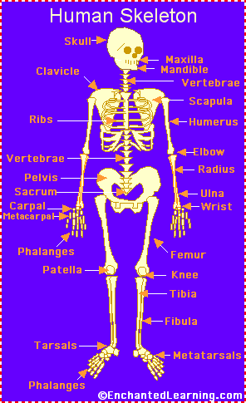](http://www.enchantedlearning.com/label/)Human skeleton**

The human skeleton consists of 206 bones. We are actually born with more bones (about 300), but many fuse together as a child grows up. These bones support your body and allow you to move. Bones contain a lot of **calcium** (an element found in milk, broccoli, and other foods). Bones manufacture blood cells and store important minerals.   
  
The longest bone in our bodies is the **femur** (thigh bone). The smallest bone is the **stirrup bone** inside the ear. Each hand has 26 bones in it. Your nose and ears are not made of bone; they are made of cartilage, a flexible substance that is not as hard as bone.   
  
**Joints**: Bones are connected to other bones at joints. There are many different types of joints, including: fixed joints (such as in the skull, which consists of many bones), hinged joints (such as in the fingers and toes), and ball-and-socket joints (such as the shoulders and hips).

**Muscles** control movement and many organic functions. Skeletal muscles are called **voluntary** because they can be consciously controlled. Other muscles, such as the stomach muscles and the heart, are **involuntary** and are operated automatically by the central nervous system.

2. The most important muscle in the body is the **heart.** Its rhythmic contractions are called the **pulse rate**. Without the heart and its **CARDIOVASCULAR** (circulatory) **SYSTEM**, human life would not be possible

The human heart consists of four chambers, two **atria** and two **ventricles.** It functions in two phases - the contraction phase, called the ***systole***, and relaxation phase calledthe ***diastole*** *.*

The rest of the system consists of **vessels** which are: **arteries**, **veins**, **arterioles** (small arteries), **venules** (small veins), and **capillaries.**

3. The cardiovascular system also carries **hormones** which are secreted by glands of the **ENDOCRINE SYSTEM**.

4. The **RESPIRATORY SYSTEM** starts at the nose, where air is breathed in during **inspiration**. It then passes through the **larynx** (voice box) and **trachea** (windpipe) into the **bronchi** and **bronchioles**, and ends in little air pockets called ***alveoli***within the **lungs**. The process is called ***respiration***.

5. The largest organ in the body is the outer covering called **skin** plus its structures (hair, nails, sebaceous and sweat glands, and specialized sensory receptors). They altogether make up the **INTEGUMENTARY SYSTEM**. Skin protects the body from microbes and other impurities, prevents the loss of body fluids, and regulates body temperature. It consists of the **epidermis**, the **dermis**, and the **subcutis** (subcutaneous layer).

6. Another major body complex is the **DIGESTIVE SYSTEM**, which processes the food so that it can be used for energy. The process begins in the **mouth**, where food is chopped and crushed by the teeth. The food then passes through the **esophagus** in the **stomach**. From there the food passes into **small intestine**, where it is absorbed.

7. What cannot be absorbed is passed out through the **large intestine** as **feces**. Liquid wastes are eliminated through the **URINARY SYSTEM**. They are picked up by the blood and removed by the **kidneys**. From there they pass through the **ureter**, **bladder**, a **urethra**, and are excreted from the body as **urine**.

8. Closely associated with the urinary system is the **REPRODUCTIVE SYSTEM**, by which human life is carried on to future generations. The basic **male reproductive system** consists of two **testicles**, producing **sperms**, the **penis** and the **prostate**. The **female reproductive system** contains three main parts: the **vagina**, the **uterus**, two **ovaries**, which produce the **ova**.

9. The **NERVOUS SYSTEM** controls all other systems and bodily movements.

The nervous system is divided into the **central nervous system** (the brain and spinal cord) and the **peripheral nervous system,** which consists of the nerves that connect muscles and sensory organs with the central nervous system.

The **brain** is not only the most important component of the nervous system; it is also the controller of all bodily activities, thoughts, and emotions.

**English terms** denoting parts of the human body:

|  |  |  |  |  |
| --- | --- | --- | --- | --- |
| ankle arm navel chest chin | ear elbow eye fingers foot | hand head heel hip knee | leg mouth nose neck shin | shoulder thigh toes waist wrist |

|  |  |
| --- | --- |
| **Label the human body diagram using the word list above.** |  |

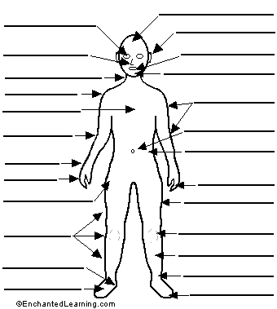

**Human anatomy – short quiz**

1. What is the largest organ of the body?

2. What is the main function of the skeletal-muscular system?

3. What is the most important muscle in the body and why?

4. How many pairs of ribs are there in the human body?

5. How are blood vessels divided?

6. Describe the passages of the respiratory system.

7. Name the structures of skin.

8. What are the main layers composing the skin?

9. What are the main parts of the digestive system?

10. Where do the liquid wastes pass from the kidneys?

11. How is the nervous system divided?

12. How are muscles divided?

**Skeletal system song**

[**https://www.youtube.com/watch?v=XAUaMLP9qMM**](https://www.youtube.com/watch?v=XAUaMLP9qMM)

Cranium the **_____**, eight bony plates will merge

Jawbone I have heard **_____**is the word

The scapula and **_____**, shoulder – collarbone

Backbone is **_____**

Then there is the **_____**, it is made up of three

Ilium and pubis, ischium helps legs swing

And together they help you run and play and

move **_____**in night and day

**Refrain:**

Like a **_____**maybe it protects it

and gives body **_____**

Here are the parts of **_____**

Short, long, **_____**, irregular

They are hard, protect your **_____**and they’re inside you

Here are the parts of **_____**

From feet to face it is a system

**_____**moving, la la la

They are inside you

Here are the parts, here are the parts

Hello my name is … Humerus, arm

**_____**and radius

Where? In the **_____**

Thigh bone is femur, **_____**, knee

Coccyx, it was once a **_____**

Tibia and fibula make up the **_____**

Tarsals are in the ankle, **_____**are the foot bones

The **_____**, they are your toes

Yeah, just like your finger bones, like

**Refrain**

Here are the parts – **_____**skeleton

Made up of backbone, skull, **_____**for the lungs

On imaginary line or around

Middle of us, here it is, the line’s down.

Here are the parts of **_____**

Made up of bones on both sides of the line

They help you dance like your legs and your arms

Namely your **_____**and pelvis, I’m done

**Refrain**

**m**

***Ex. 2. Complete synonyms***

|  |  |  |  |
| --- | --- | --- | --- |
| carpus |  | trachea |  |
| sternum |  | clavicle |  |
| thorax |  | tibia |  |
| maxilla |  | digit |  |
| cervix |  | talus |  |
| scapula |  | cranium |  |
| spine |  | mandible |  |
| patella |  | femur |  |
| ulna |  | oesophagus |  |

wrist, breast bone, chest/rib cage, upper jaw, neck, shoulder blade, backbone/vertebral column, knee, elbow (bone),

windpipe, collar bone, shin bone, finger, ankle bone, skull, lower jaw, thigh bone, gullet