Lectures in Brno, March-April 2006. Dr Ulrich Loening

1. Human ecology,
2. Sustainable use of resources
3. Ecological economics
4. Agricultural Revolutions,
5. Plant protection
6. Genetically Engineered Crops;
7. Gaia Theory.
8. Global Warming

- HUMAN ECOLOGY

INTRODUCTION.

WE START with 3 simple figures that show the rates of change on the planet:

What has gone up steeply in the last few decades?
the human population
the consumption of fossil fuels of other resources
agricultural activity
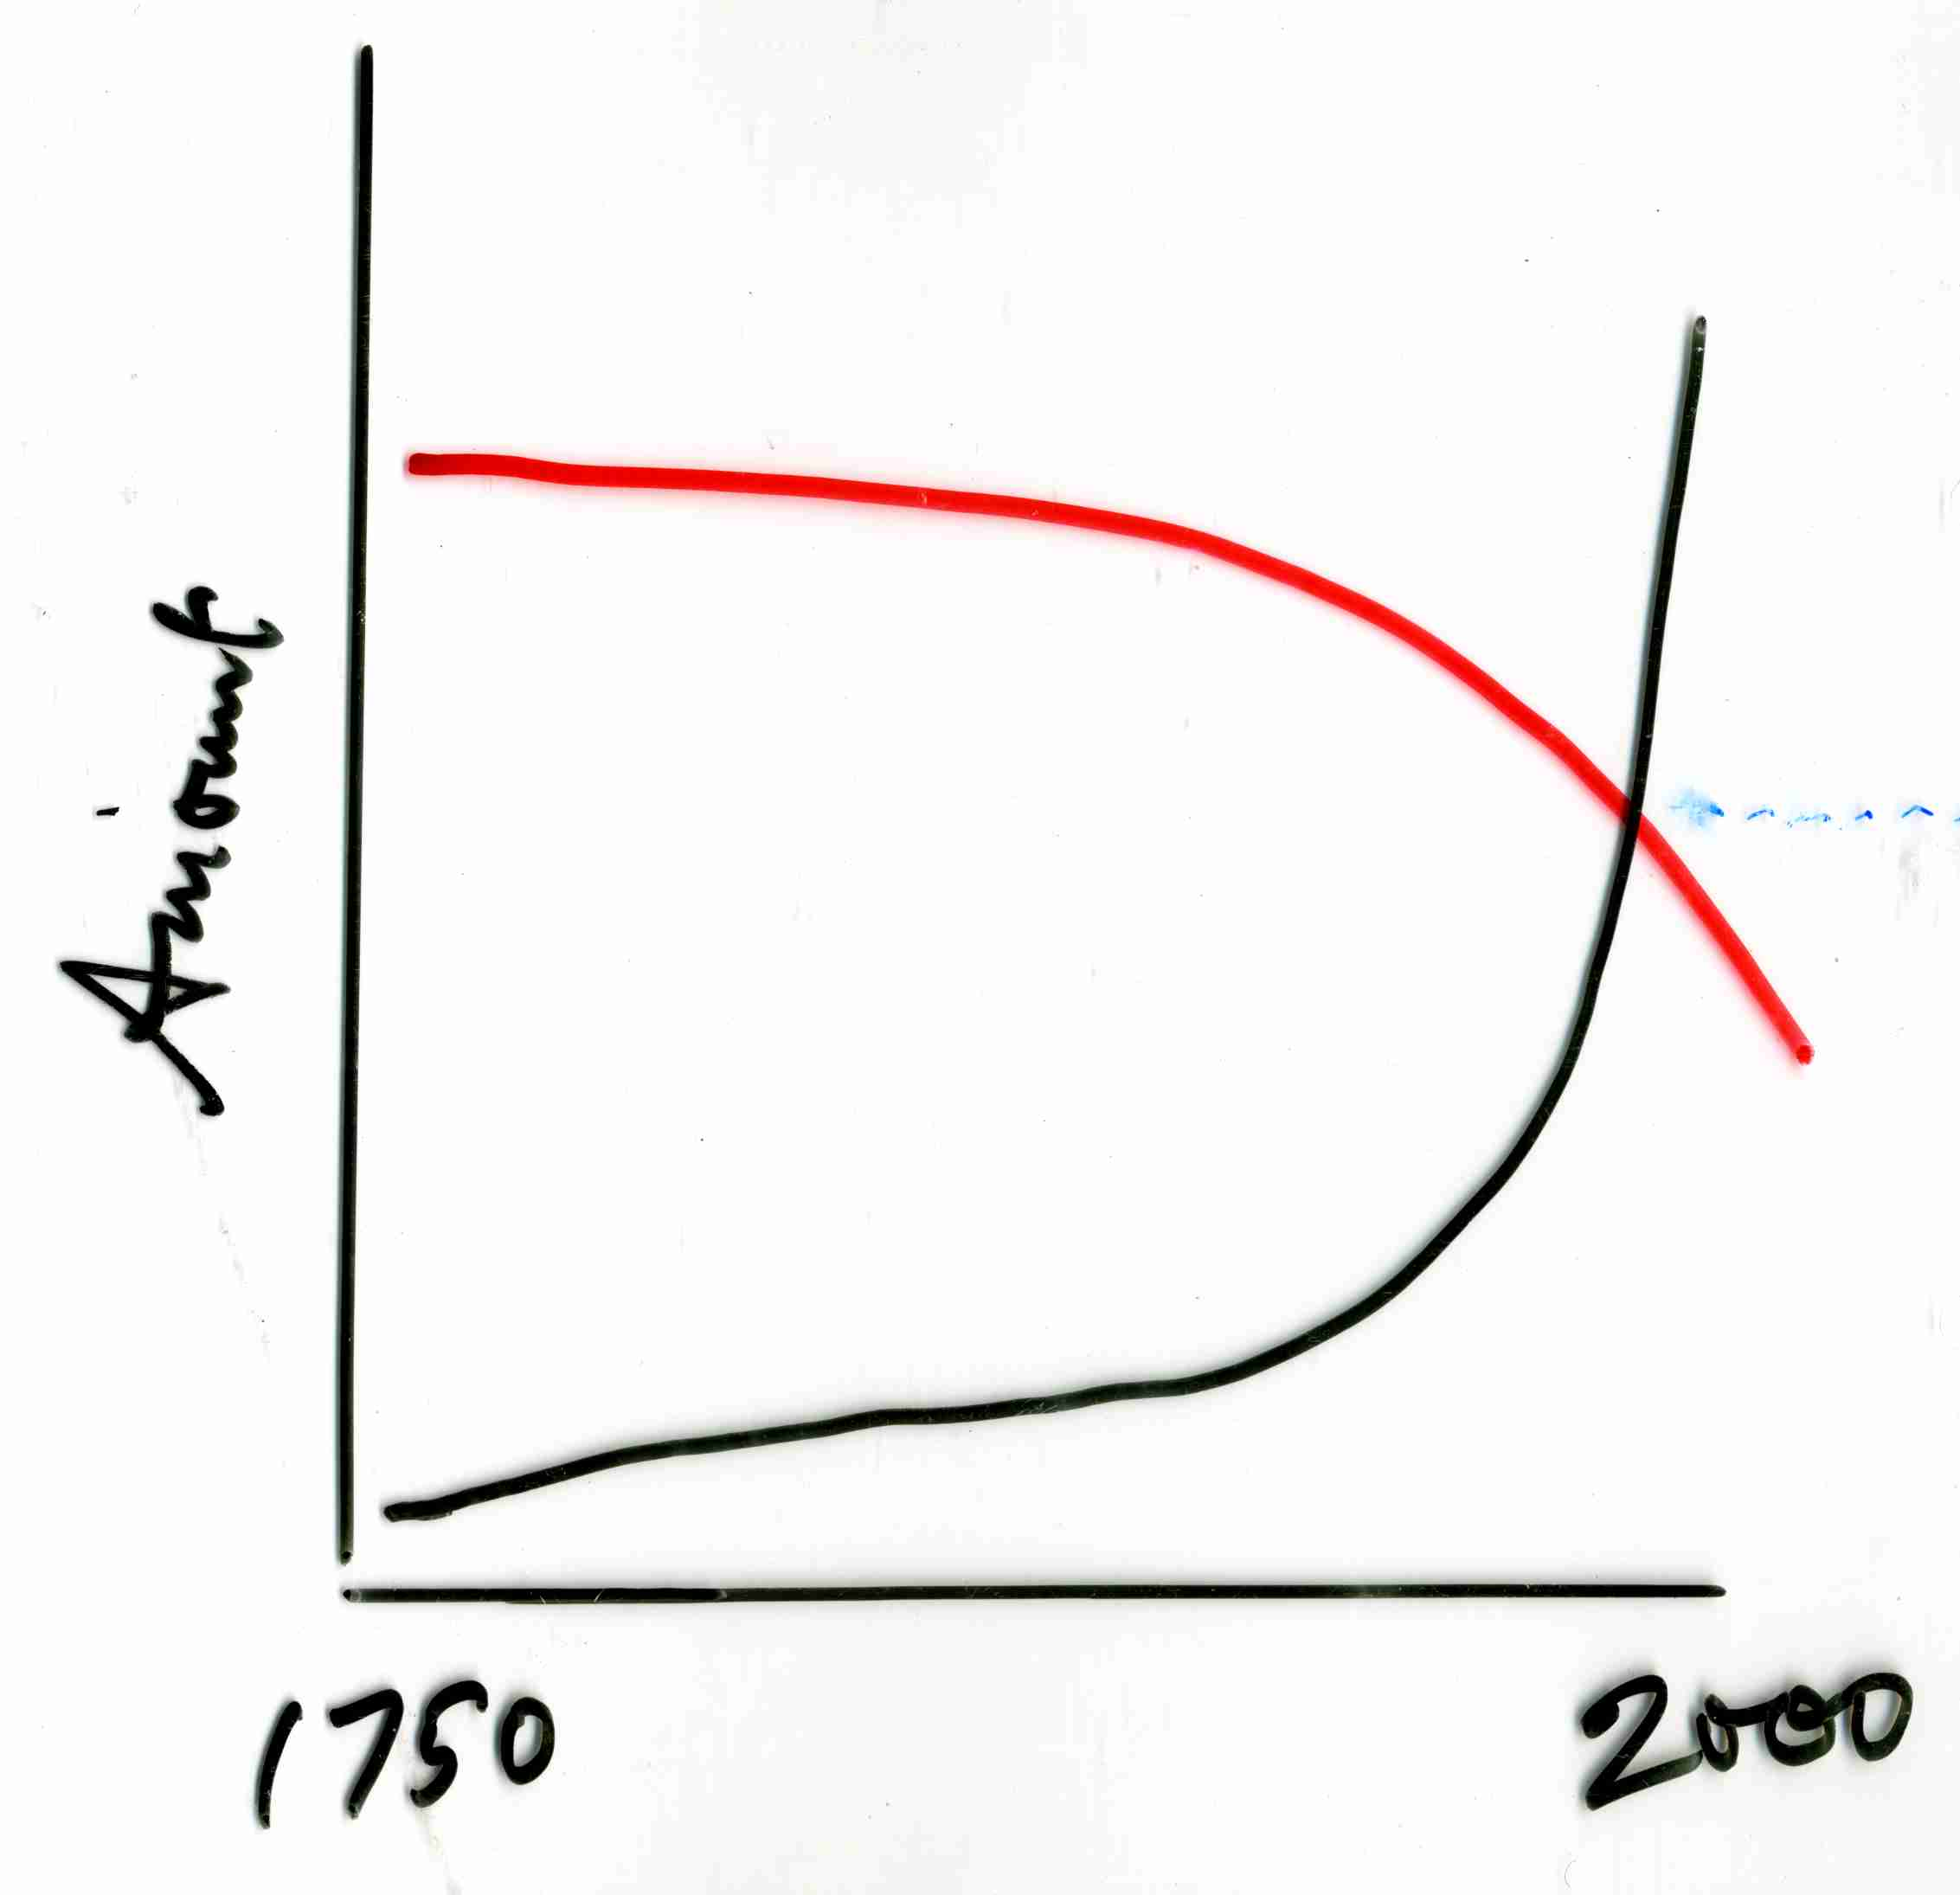
desertification
pollution
and much else

What has been coming down?
Forest cover
Soil quality
fresh water
fish stocks
whales
habitats, ecosystem health
environmental services
bio-diversity
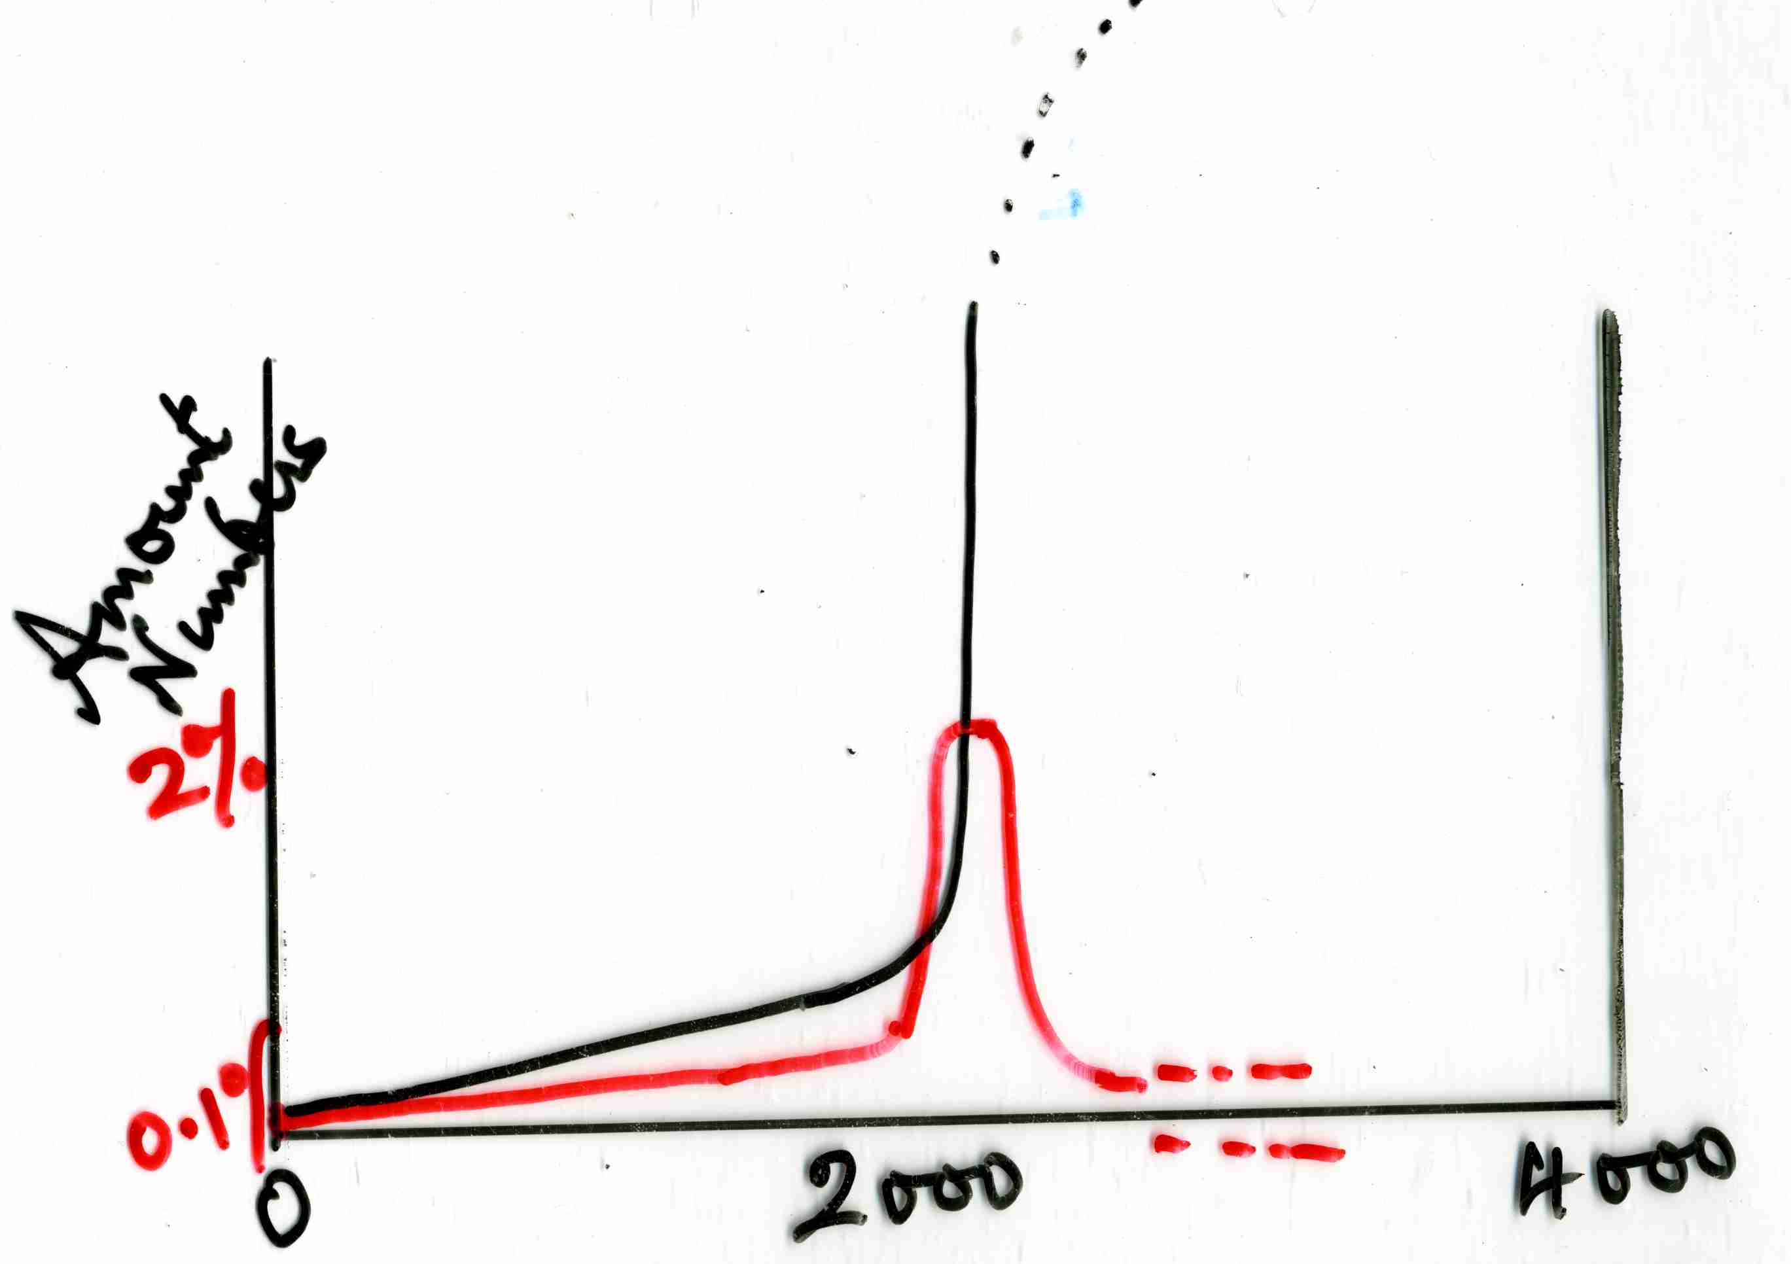
human diversity
What are the rates of change?
plot the rates on a time scale of 4000 years from the birth of Christ to the same period into the future; we see how population growth and use of fossil fuels is but a brief episode in human history; likewise most of the other changes.

Yet 2000 years is not long; it is only part of recorded history; only about 80 generations; you could write the names, dates and professions of your ancestral line back to then on one sheet of paper!

We see that we live in a most dramatic period in the Earth's history, let alone human history; there have never been so many large animals of a single species as the human species now. That is a matter for urgent understanding.

Quote:
"The most significant biological event of the present geological era has been the expansion of the human population from a modest and probably fairly stable size of a few million to several billions in only a few thousand years." (Ann Ehrlich. p395)

We can add that that species is also the first that is conscious of itself and its place in the biosphere; this leads to an obligation to understand and to act accordingly. These talks will be about some aspects of how to understand our place in the biosphere, and how to act “sensibly”

1. THE IDEA OF ECOLOGY

Ecology, from the Greek, "the science of the home", compare to economics, "the management of the home".

Ecology deals with the relations and interconnections between living things and their environments, of which they themselves are a part. The relation between human societies, the environment, resources, and the ways in which all these affect each other, is the subject we call human ecology. Human Ecology is not only a natural science, but equally a social science, which includes the arts and humanities, philosophy and economics. Mankind is a cultural animal and our behaviour is the main determinant of our ecological impacts. Actually, that also applies to animals, but of course humans have a much greater cultural life.

These lectures will highlight some of the biological principles underlying human interaction with the biosphere, as well as discussing some of the social issues resulting.

I come to this as the former director of the Centre for Human Ecology in the University of Edinburgh, which acts as a forum with inputs from many different sorts of people, from all faculties, some industry and international bodies.

There cannot be a text-book as such. Some key references given end.

--------------------------------------------------------------

Sir Frank Fraser-Darling wrote in 1950, (quoted in Morton Boyd, 1986) that:
"...The phenomenon of accelerating devastation and increasing population has, in effect, been inevitable from the moment man began to break ecological climaxes and upset equilibria without allowing them to rebuild... Most of us are not prepared to defer to this final logic, that the very achievement of humanness dooms us, and that civilisation is an ultimate contradiction."

Similarly, the Brundtland Report (1987) begins with the idea that:
"Humanity's inability to fit its doings into this (nature's) pattern is changing planetary systems, fundamentally."

And then:
"The next few decades are crucial. The time has come to break out of past patterns. Attempts to maintain social and ecological stability through old approaches to development and environmental protection will increase instability. Security must be sought through change."

Why 'Human' 'Ecology'?
We are here to explore any (and all!) aspects of human inter-relationships and inter-dependence with the planet. Through the ages, people’s understanding and philosophies have changed and ecological influences evolved as impacts have increased, so now we have reached a unique period in the planet’s history; not just in human history. Never before has any one species of large animal had so great an influence. Human Ecology is the approach that tries to take a fresh look at the state of humanity on the planet.
That means that all aspects of our ways of life are open to exploration, understanding and questioning.

Summary of Human Ecological Principles (Hardin 1985)

1.We can never do merely one thing.
2.Ne effects are truly side effects.
3.No system can long survive the effects of unopposed positive feedback.
4.Negative feedback can be a positive boon.
5.The "sanctity of life" must give way before the "sanctity of carrying capacity."
7.Not all elements of the human carrying capacity are expandable.
8.Population growth ultimately makes democracy impossible.
9.Selection dictates the direction of evolution.
10.Every biocide selects for its own failure.
11.Every human law selects for its own evasion.
12.No inning is the last inning.

-----------------------------------------------------------------------------------------
Some basic Principles: (this is taken from lectures at Centre for Human Ecology, and was not in my talks in Brno, March 2006)

Very different time scales;
origin of life, eons, 1000ms years
evolutionary and geological, ms years
long ecological, forests, soils, ks years
short ecological,cycling of materials, decades and less

The Biosphere: The complex web of activities of the biosphere, that part of the Earth where life exists, a few metres down into soil and deeper into oceans, and hundreds of metres into the atmosphere. All this maintains itself in some state of ecological stability, through the complex interactions between species and their environments. We will look at several aspects, of stability, of human impacts, of change and evolution, and especially of the unpredictability and fragility of ecosystems.

Energy and Resources:
Nature recycles materials and the processes are powered by the sun. We will list the differences between humans and nature.

Food webs: The plants (autotrophs) are the energy and material sources for other species (heterotrophs): herbivores and decomposers (primary consumers, secondary producers), carnivores (secondary consumers); thus a food chain is created, but at each step only about 10% of the energy is passed to the next stage - trophic level). Decomposers recycle materials from any level. Humans fit into this picture of food webs, and we will examine the possiblities for what we can and cannot do.

The idea of available or "free" or "potential" energy : obviously sunlight and high temperature energy can do much more than the same amount of energy as slightly warmed water (2nd Law of Thermodynamics.) In the process of high potential energy powering something, it becomes degraded to low temperature heat. This "free" energy is equally chemical reducing power, negative potential ; related inversely to entropy: the organised order of living things is created using the power of the sun. The idea behind Gaia theory is based on the 2nd Law of Th. Again, these principles underlie what is possible for humans.`

The cycles of the chief elements of living things in the environment:

Rates of growth:
All living things have the capacity to breed much faster than their net survival rate - the potential for population increase is far in excess of the actual. Every tree produced millions of seeds, of which only one on average ever grows to its parent's size. The allegorical lily pond, doubling the area covered by leaves each day, till the pond was full after 30 days. When was it half full?
100 beetles, growth rate 0.75 per individual per week. After 3 weeks, there would be 949 beetles
10 180804
20326,901737
1 year8.7 x 10¹⁸

Similarly with compound interest from invested money; Judas's 30 shekels, 2.5 g of gold, invested at 5% per year payable in gold, would be the weight of the Earth in gold in the year 1292! This has important consequences when we examine ecological economics.

Limits to growth: the effects of feed-back. Graph of growth of 'pioneer' species, as S curve, eventually reaching or replaced by 'climax'. Maximum Sustainable Yield, if the growth is to be harvested by us, is half-way up the S curve, the stage of maximum growth rates. But under this condition, the ecosystems has been changed, a new climax results with man taking a yield and producing another residue. Approximate plateau at climax. But humans have exceeded this and continue to be pioneers. Arrive at the concept of Carrying Capacity - the maximum sustainable population.

Stability and Sustainability. Continued life and evolution, and the survival of species within the eco-systems, depends on the complex interplay of all the components; sustainable processes are not necessarily stable; the resilience of environment against change is vital; much more to say about this later.

Some examples of types of environment:
Temperate forests: creation of soil by succession of plants etc. finally trees. Complex interactions in soil between fungi, bacteria, protozoa and others, binding and releasing nutrients gradually, creating humus. In northern Europe & America, following the ice age, forests moved northwards some 10-12000 years ago. Tens of tree and many plant species; oaks may have >200 species of insect associated.

Tropical rain forests are different; contain perhaps half of all species on Earth; hundreds of species of tree alone. Usually very poor soil, despite the lush growth; decay matter by decomposers is fast and materials taken up by plants immediately. Therefore much less humus. The wealth is in the biota, built up over long periods. Temperature fairly constant; seasons are wet and dry rather than summer and winter; Very many complex interactions: some are individually critical, e.g., bat and six species of flowering tree in SE Asia; other more open webs of interactions. Huge biomass and twice the productivity of temperate forests. Local and perhaps continental climate strongly affected; water cycles, through evapo-transpiration; hotter and drier if forest is felled.

Brief discussion of arctic, desert, ocean and lake environments, illustrating different diversities and controls.

Reductionist and holistic thinking

The power of science has been in isolating components: think of the hierarchy from atoms, to molecules, macro-molecules, cell organelles, cells, organisms, communities, ecosystems and social systems. Each can be partly analysed and explained in terms of the components below - reductionist science; but at each level, new properties emerge, explained only at that level or above and in terms of connections - more holistic science. Similarly we can consider the science of the parts, which is what most biology is about, and the science of interactions, which is what ecology is about - "the whole is more than the sum of the parts". The difference leads to much public and political mis-understanding of scientific conclusions; the science of the parts must be incomplete; holistic approaches are emerging to deal with complex systems; the Gaia idea starts with reductionist questions and ends in holistic understanding.

HUMAN IMPACTS ON THE PLANET.

All living things affect each other and the environment - they are the environment. Mankind also has impacts, but are they all one way, in using resources and degrading, or are they part of a self-controlling eco-system? In fact, since the dawn of civilisations, man's impacts have been striking and mostly destructive of the environment in the sense of reducing the life-support systems in the long-term. Humanity has now been so successful that the impacts are on the scale of the planet. One may indeed argue that the benefits of civilisation have been obtained at the cost of the environment. It is a major question, for how long this can continue. As each civilisation has degraded its environment, so it has collapsed with ecological losses a major part of the cause. This is not usually how we learn about the past in history lessons!

From the earliest times, development began with agriculture - the domestication of remarkably few species of plant and animal: in the near East, wheat, barley, pulses, cattle, goats and sheep; in the far East, roots and rice; in the "New World", maize, potato, manioc.

Farming: "The marked instability of agro-ecosystems ( and other artificial communities) in contrast to the stability of natural communities, results from the lack in crop systems of co-evolutionary links between inter-acting species. However, co-evolution may be either stabilising or destabilising: sometimes the loss of one species may lead to decay of an entire system." (E. p141).

Recall some image of the old civilisations; (JAM, p544 - ..); and point out how the lessons to be learnt are again relevant.

"No other part of the world [than the Mediterranean] so strikingly drives home the story of man's failure to maintain the environment." (Th. 1981)

Sumeria, city of Ur, maybe 1/3m people, in rich but dry land irrigated by the Euphrates, with the silted river above the plain. Requires also a mechanism for ridding of the salt, which they did not have. From 3500 BC on, this led to loss of wheat (salt sensitive) and the growing of more barley; a lowering of yields from 2.5 t/ha to 0.9 t/ha; only impoverished villages left by 1700 BC. Irrigation in many parts of the world remains difficult to achieve without causing salinisation; and deep "fossil" water supplies are being used up as well as polluted.

Ancient Egypt, in contrast: annual flooding of the Nile provided water and nutrients from the Ethiopian mountains, and flushed out the salt. Population increased from 0.3m to about 5m in year 0; reduced then by wars; rapid rise in modern times to 45m (graph, JAM p556).
First dam in 1905, increased irrigated land but failed to meet high hopes. Second larger dam in 1960s. Created some benefits but mostly troubles, loss of the delta by erosion, loss of fishing in Med. but gain in Lake Nasser, loss of fertility means replacement by fertiliser etc (list, p559). "Before human beings started to 'improve' it, the valley of the Nile was one of the richest natural regions on Earth."
Big dams all over the world cause severe ecological as well as social problems.

Greece: quote from Plato:
"Contemporary Attica may be described as a mere relic of the original country. There has been a constant movement of soil away from the high ground and what remains is like the skeleton of a body emaciated by disease. All the rich soil has melted away, leaving a country of skin and bone. Originally the mountains of Attica were heavilty forested. Fine trees produced timber suitable for roofing the largest buildings; the roofs hewn from this timber are still in existance. The country produced boudless feed for cattle, there are some mountains which had trees not so very long ago, that now have nothing but bee pastures. The annual rainfall was not lost as it is now through being allowed to run over the denuded surface to the sea, it was absorbed by the ground and stored...the drainage from the high ground was collected in this way and discharged into the hollows as springs and rivers with abundant flow and a wide territorial distribution. Shrines remain at the sources of dried up water sources as witness to this." (Th.)

Compare with modern quote:
"It is important to recognise, too, how tightly linked are the resources of soil, water and forest. Deforestation produces erosion and water pollution and makes run-off erratic, reducing the availability of water and causing more erosion. This process can become irreversible by altering the environment so drastically that reforestation is impossible." (Ehrlich, p278)

In the Greek hillsides, that is what happened, and even the lowlands became unsuitable for agriculture and provided excellent breeding grounds for Anopheles - and an increase in malaria resulted.

Roman: the Italian countryside gradually lost fertility, land planted with olive, fruit and grape; after 200 BC, grain grown in North Africa, Sicily, Spain and Egypt. The solution continued to be conquest, until about 100 AD when the Empire was at max manageable size. Thereafter there were increasingly severe food shortages; decline and fall, with destructiveness of war, diseases and famine - an imbalance of population and resources. Huge import of grain, grown in Egypt, & N Africa, to provide every citizen of Rome free; finally desertified most of N africa. Also, slow chronic lead poisoning, especially in the aristocracy, who dined from lead-lined bronze ware, while the poor ate from earthen-ware; slow onset of infertility and insanity among the ruling classes, well documented in history. Yet it took a long battle, only a very few years ago, to start to take the lead out of petrol and it is still only partly achieved.

Lebanon; the famous cedar of Lebanon, once formed extensive forests, now reduced to a few trees. They were up to 25m tall, 4m diameter; huge logs sent to Babylon and Egypt. Probably, after the erosion of soil by goats, the forests could not be re-established to-day. There are still now only very few examples of sustainable forest use; deforestation still proceeds faster on average than growth and recovery. No civilisation has yet, except in a few corners, managed sustainable forestry.

Harappan civilisation in the Indus: 2500 - 1600 BC, it is likely that forests along the river destroyed to such an extent that soil erosion and flooding led to decline of this civilisation. Now in the Himalaya, forest destruction leads similarly to erosion and flooding down-river, eg., in Bangladesh. The Chipko movement is trying to save the remaining forest.

Chinese, "Farmers of Forty Centuries", has a long tradition of re-cycling agricultural practices (King 1908), but at the long-term costs of loss of mountain forests. Now a major task to reforest.

After the Dark Ages, the Renaissance; Northern Italy, the Po valley which had escaped destructive farming, led the way to spread throughout Europe, into soils which are among the best in the world.
Yet sustainable agriculture may remain elusive; we do not know for how long, even in the rich deep temperate soils of northern Europe and a few other parts of the world, the current high intensity agriculture can continue.

Modern impacts of mankind.

The most dramatic and extraordinary change has been the growth of the human population, achieved by enhancing the natural carrying capacity of the land, leading to numbers which, were they animals in a confined area, would be called a plague.

7. THE GAIA IDEA: Global stability
(See separate presentation on Gaia)

What would one look for, as a space traveller from another planet, to see if there is life on Earth?

The composition of the atmosphere has been constant for millions of years: CO₂ and O₂; similarly the salt conc. of the sea; the average temperature, despite 30% increase in sun's heat over 3 aeons. Yet the whole is not in chemical equilibrium; it would all burn up, left to its own. What maintains the chemical and physical parameters constant and so far from stable equilibrium? This is the surest sign of life.

Old idea that the Earth acts like a whole organism, like a living thing itself in the sense that it is homeostatic. Life itself appears to maintain conditions on Earth that ensure its own survival. Just like liver, heart, leaves, etc., it must function to maintain homeostasis, so life processes maintain conditions for life on Earth. Easy to become teleological, which this is not. Species have evolved such that they are successful in their environments. The biosphere has evolved correspondingly.

Example of the GAIA idea is a very simple model, to show how stability can be realised without purpose, design or selection. Imagine a simple planet with black and white daisies growing on it. Their optimum temperature for growth is, say, 20º. If the planet warms above that, then the white daisies will be cooler than the black; they will be at an advantage and grow faster; therefore the albedo of the planet surface will increase and the planet cool down. Conversely the black daisies are advantaged on a cooler land surface, will grow faster and absorb more heat. One can construct computer models to show how the planet is maintained at nearly constant temperature despite the evolving greater output from the sun; see graph, (Lovelock).

One can make much more complex models, with multiple species, rabbits and foxes and so on.

Note especially that the conditions on Earth are suited to life. The salt concentration in body fluids is the best for the stability of membranes; it is not that of the primordial seas; that in the sea is higher, reductions have not quite managed the ideal, and marine organisms have to work to keep their internal concentrations down. The 21% oxygen is such that, were it higher too many things would burn uncontrollably; were it lower, active animals would be less so. The CO₂ conc. just maintains the temperature low enough, yet is sufficient to allow photosynthesis, especially with the C-4 plants. But the evolution of the latter indicates how near the edge of the possible the evolution of the Earth has taken.

Consider in contrast, conditions back at the origin of life: no oxygen, a reducing atmosphere, much CO₂. The first big evolutionary step after life began was photosynthesis, which after aeons increased the oxygen of the atmosphere so much that it became the first major pollutant. Living cells still have to battle to keep their internal environment in a reducing state; oxygen is a poison, the first major pollutant! The old stability had to give way to a new; the reduced organic materials produced by photosynthesis and the presence of oxygen, allowed the evolution of new life forms, the heterotrophs; the CO₂ concentration greatly reduced and oxygen increased, after which both remained very constant over geological periods. GAIA had taken a new turn and created a new stability.

Any major change now might create another 'flip' to some new condition in which different evolved life forms would maintain a different environment; life would continue, but perhaps without us or similar mammals. A vital question that we will return to, is whether the operations of mankind are getting dangerously near to such a change. (Lovelock, 1988). Clearly, with so much of the land surface changed, and now the concentrations of gases in the atmosphere being changed globally by man, there are unknown dangers to consider.

