Major dates concerning the strategic history of France
1624 – 1661 – (1763) – 1789 – 1792 – 1799 – 1804 – 1814/1815 – 1830 – 1848 – 1852 – 1870 – (1914-1918) – 1940 – 1944 – 1958

The Making of the Hexagon:

France 1552-1798
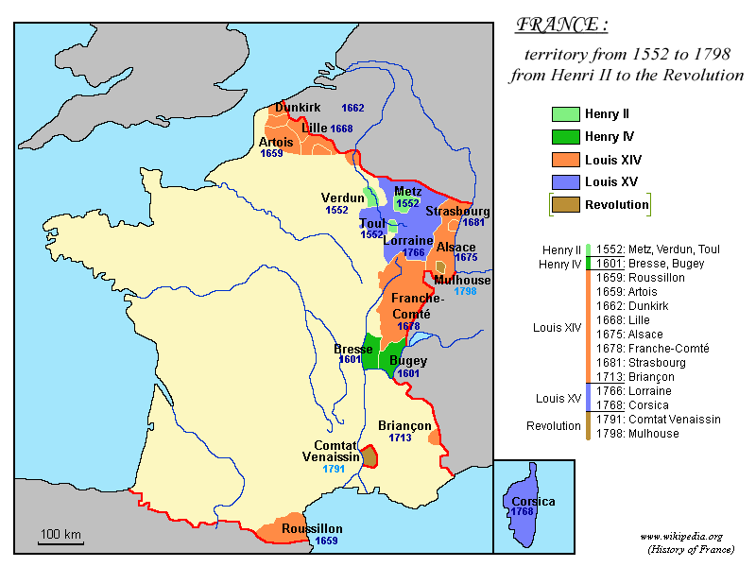
(Source: http://commons.wikimedia.org/wiki/File:France_1552_to_1798-en.png)

Napoleonic France
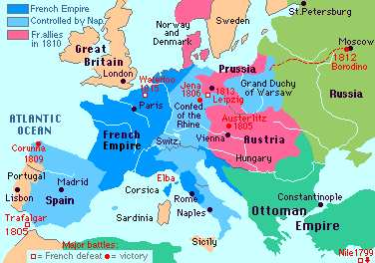
(Source: http://www.french-at-a-touch.com/ French_History/map_of_french_empire.htm)
Modern France
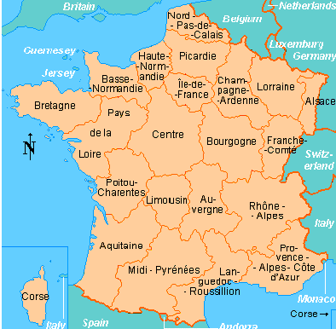
(Source: http://www.french-at-a-touch.com/
French_History/maps_of_france.htm)

More maps: http://www.ieg-maps.uni-mainz.de/map3-3.htm

