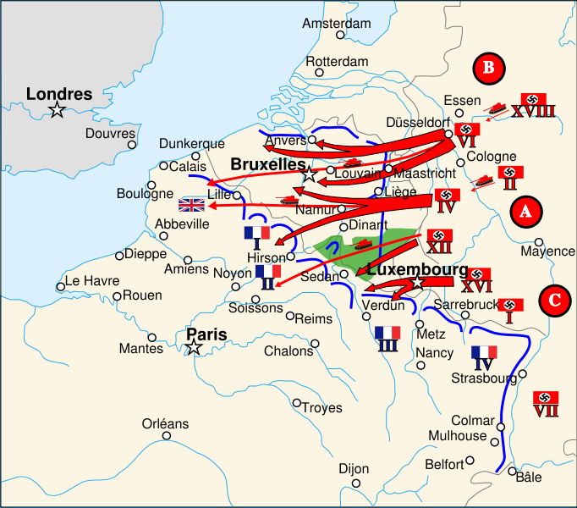
http://commons.wikimedia.org/wiki/File:France_1940-Plan_de_bataille.svg

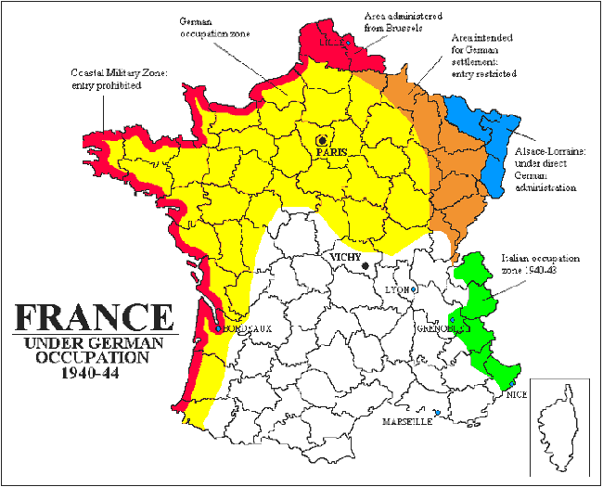
http://www.jewishvirtuallibrary.org/jsource/Holocaust/vichymap.html

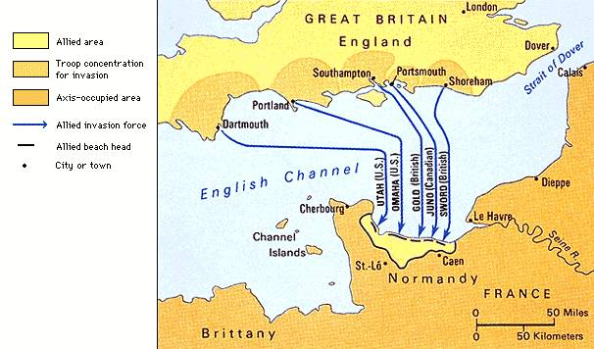
http://homepage.eircom.net/~finnegam/war/normandy_invasion.htm

