Maps of the 1st French (Colonial) Empire

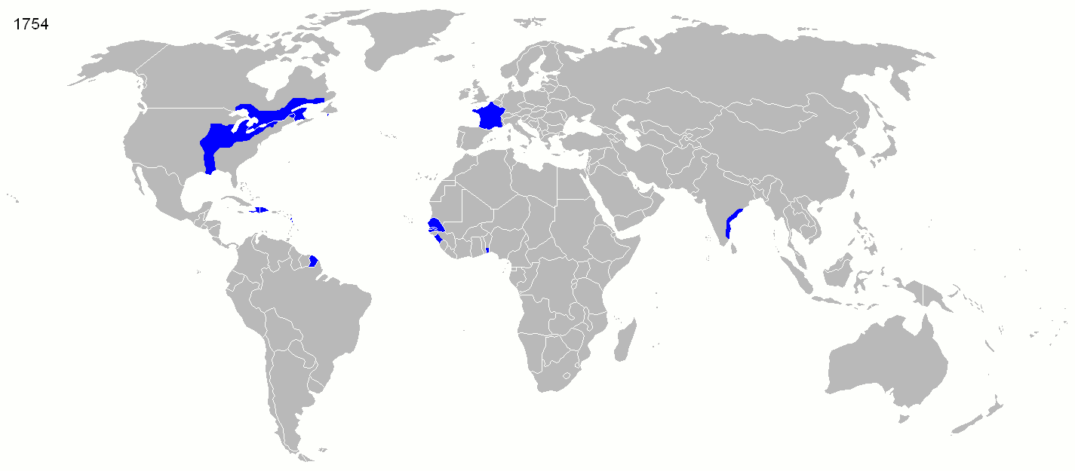
http://fr.wikipedia.org/wiki/Fichier:French_Empire_evolution.gif
(for 1550, 1660, 1754, 1822, 1885, 1914, 1938, 1959 and 1974)

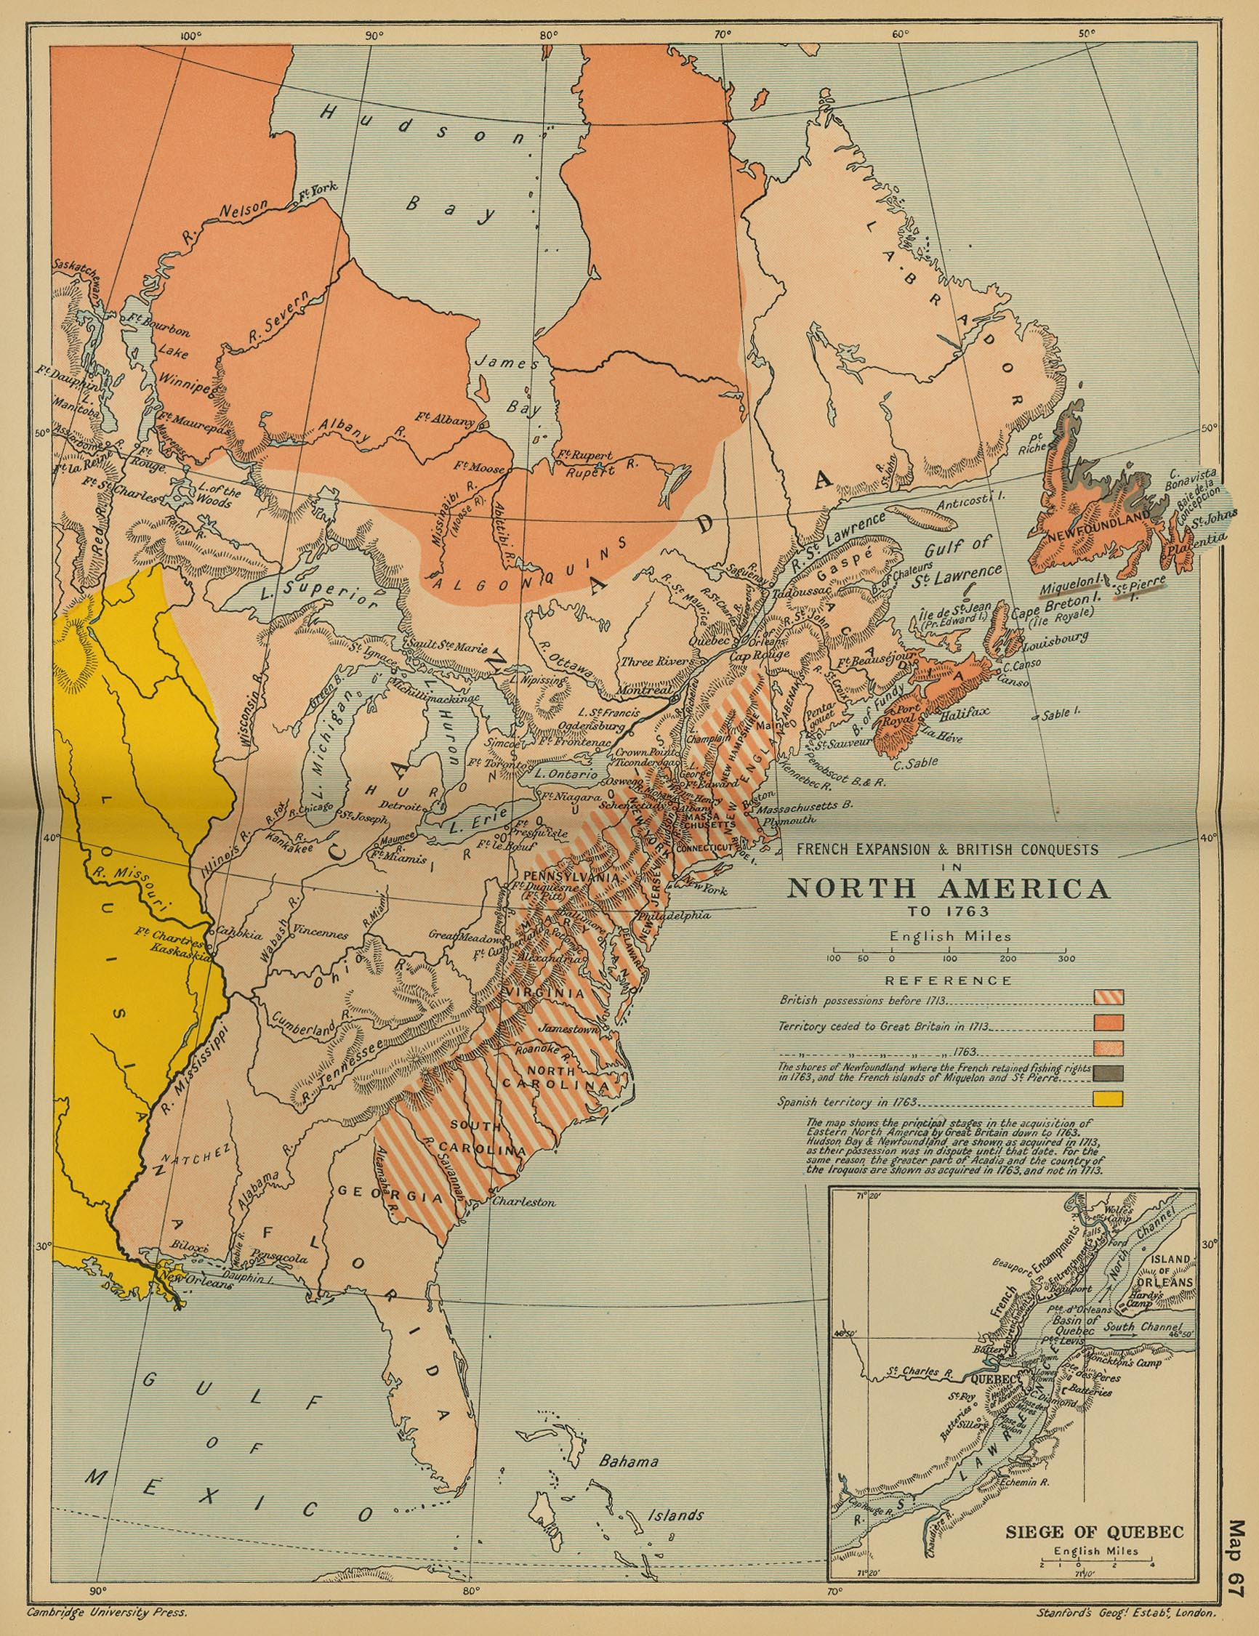

http://www.lib.utexas.edu/maps/historical/ward_1912/america_north_french_british_1763.jpg

