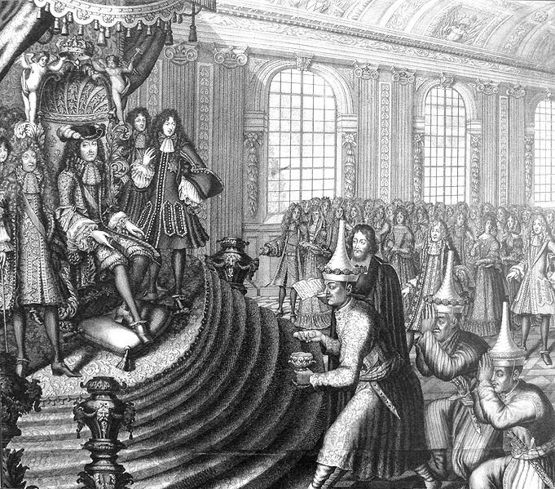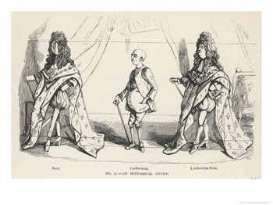
Siamese Embassy To Louis XIV (1686) by Nicolas Larmessin W. M. Thackeray

Louis de Rouvroy, Duke de Saint-Simon (1675-1755; godson of Louis XIV.): Memoirs
I shall pass over the stormy period of Louis XIV's minority. At twenty-three years of age he entered the great world as King, under the most favorable auspices. His ministers were the most skillful in all Europe; his generals the best; his Court was filled with illustrious and clever men, formed during the troubles which had followed the death of Louis XIII. […]The intrigues and adventures which early in life he had been engaged in--when the Comtesse de Soissons lodged at the Tuileries, as superintendent of the Queen's household, and was the center figure of the Court troup--had exercised an unfortunate influence upon him: he received those impressions with which he could never- after successfully struggle. From this time, intellect, education, nobility of sentiment, and high principle, in others, became objects of suspicion to him, and soon of hatred. The more he advanced in years the more this sentiment was confirmed in him. He wished to reign by himself. His jealousy on this point unceasingly became weakness. He reigned, indeed, in little things; the great he could never reach: even in the former, too, he was often governed. The superior ability of his early ministers and his early generals soon wearied him. He liked nobody to be in any way superior to him. Thus he chose his ministers, not for their knowledge, but for their ignorance; not for their capacity, but for their want of it. He liked to form them, as he said; liked to teach them even the most trifling things. It was the same with his generals. He took credit to himself for instructing them; wished it to be thought that from his cabinet he commanded and directed all his armies. Naturally fond of trifles, he unceasingly occupied himself with the most petty details of his troops, his household, his mansions; would even instruct his cooks, who received, like novices, lessons they had known by heart for years. This vanity, this unmeasured and unreasonable love of admiration, was his ruin. His ministers, his generals, his mistresses, his courtiers, soon perceived his weakness. They praised him with emulation and spoiled him. Praises, or to say truth, flattery, pleased him to such an extent, that the coarsest was well received, the vilest even better relished. It was the sole means by which you could approach him. Those whom he liked owed his affection for them, to their untiring flatteries. This is what gave his ministers so much authority, and the opportunities they had for adulating him, of attributing everything to him, and of pretending to learn everything from him. Suppleness, meanness, an admiring, dependent, cringing manner--above all, an air of nothingness--were the sole means of pleasing him.
This poison spread. It spread, too, to an incredible extent, in a prince who, although of intellect beneath mediocrity, was not utterly without sense, and who had had some experience. Without voice or musical knowledge, he use to sing, in private, the passages of the opera prologues that were fullest of his praises! He was drowned in vanity; and so deeply, that at his public suppers--all the Court present, musicians also--he would hum these self-same praises between his teeth, when the music they were set to was played! And yet, it must be admitted, he might have done better. Though his intellect, as I have said, was beneath mediocrity, it was capable of being formed. He loved glory, was fond of order and regularity; was by disposition prudent, moderate, discreet, master of his movements and his tongue. Will it be believed? He was also by disposition good and just! God had sufficiently gifted him to enable him to be a good King; perhaps even a tolerably great King! […]Thus, we see this monarch grand, rich, conquering, the arbiter of Europe; feared and admired as long as the ministers and captains existed who really deserved the name. When they were no more, the machine kept moving some time by impulsion, and from their influence. But soon afterwards we saw beneath the surface; faults and errors were multiplied, and decay came on with giant strides; without, however, opening the eyes of that despotic master, so anxious to do everything and direct everything himself, and who seemed to indemnify himself for disdain abroad by increasing fear and trembling at home. So much for the reign of this vain-glorious monarch.
Let me touch now upon some other incidents in his career, and upon some points in his character. He early showed a disinclination for Paris. The troubles that had taken place there during the minority made him regard the place as dangerous; he wished, too, to render himself venerable by hiding himself from the eyes of the multitude; all these considerations fixed him at St. Germains soon after the death of the Queen, his mother. It was to that place he began to attract the world by fetes and gallantries, and by making it felt that he wished to be often seen. His love for Madame de la Valliere, which was at first kept secret, occasioned frequent excursions to Versailles, then a little card castle, which had been built by Louis XIII--annoyed, and his suite still more so, at being frequently obliged to sleep in a wretched inn there, after he had been out hunting in the forest of Saint Leger. That monarch rarely slept at Versailles more than one night, and then from necessity; the King, his son, slept there, so that he might be more in private with his mistress, pleasures unknown to the hero and just man, worthy son of Saint Louis, who built the little chateau. These excursions of Louis XIV by degrees gave birth to those immense buildings he erected at Versailles; and their convenience for a numerous court, so different from the apartments at St. Germains, led him to take up his abode there entirely shortly after the death of the Queen. He built an infinite number of apartments, which were asked for by those who wished to pay their court to him; whereas at St. Germains nearly everybody was obliged to lodge in the town, and the few who found accommodation at the chateau were strangely inconvenienced. The frequent fetes, the private promenades at Versailles, the journeys, were means on which the King seized in order to distinguish or mortify the courtiers, and thus render them more assiduous in pleasing him. He felt that of real favors he had not enough to bestow; in order to keep up the spirit of devotion, he therefore unceasingly invented all sorts of ideal ones, little preferences and petty distinctions, which answered his purpose as well.
He was exceedingly jealous of the attention paid him. Not only did he notice the presence of the most distinguished courtiers, but those of inferior degree also. He looked to the right and to the left, not only upon rising but upon going to bed, at his meals, in passing through his apartments, or his gardens of Versailles, where alone the courtiers were allowed to follow him; he saw and noticed everybody; not one escaped him, not even those who hoped to remain unnoticed. He marked well all absentees from the court, found out the reason of their absence, and never lost an opportunity of acting towards them as the occasion might seem to justify. With some of the courtiers (the most distinguished), it was a demerit not to make the court their ordinary abode; with others it was a fault to come but rarely; for those who never or scarcely ever came it was certain disgrace. When their names were in anyway mentioned, "I do not know them," the King would reply haughtily. Those who presented themselves but seldom were thus characterized: "They are people I never see"; these decrees were irrevocable. He could not bear people who liked Paris.
Louis XIV took great pains to be well informed of all that passed everywhere; in the public places, in the private houses, in society and familiar intercourse. His spies and tell-tales were infinite. He had them of all species; many who were ignorant that their information reached him; others who knew it; others who wrote to him direct, sending their letters through channels he indicated; and all these letters were seen by him alone, and always before everything else; Others who sometimes spoke to him secretly in his cabinet, entering by the back stairs. These unknown means ruined an infinite number of people of all classes, who never could discover the cause; often ruined them very unjustly; for the King, once prejudiced, never altered his opinion, or so rarely, that nothing was more rare. He had, too, another fault, very dangerous for others and often for himself, since it deprived him of good subjects. He had an excellent memory; in this way, that if he saw a man who, twenty years before, perhaps, had in some manner offended him, he did not forget the man, though he might forget the offense. This was enough, however, to exclude the person from all favor. The representations of a minister, of a general, of his confessor even, could not move the King. He would not yield. The most cruel means by which the King was informed of what was passing--for many years before anybody knew it--was that of opening letters. The promptitude and dexterity with which they were opened passes understanding. He saw extracts from all the letters in which there were passages that the chiefs of the post-office, and then the minister who governed it, thought ought to go before him; entire letters, too, were sent to him, when their contents seemed to justify the sending. Thus the chiefs of the post, nay, the principal clerks were in a position to suppose what they pleased and against whom they pleased. A word of contempt against the King or the government, a joke, a detached phrase, was enough. It is incredible how many people, justly or unjustly, were more or less ruined, always without resource, without trial, and without knowing why. The secret was impenetrable; for nothing ever cost the King less than profound silence and dissimulation.
From: Duc de Saint-Simon, Memoirs, Bayle St. John, trans., (London; Swan Sonnonschein & Co., 1900), pp. 357-365. Reprinted in: Mark A. Kishlansky, ed., Sources of World History, Vol. II (New York; Harper Collins, 1995) pp. 18-23.

From Letter of the Duchess of Orleans To the DUCHESS OF HANOVER.
4th January, 1704, Versailles.
I must really tell you how just the King is. The Duchesse de Bourgogne's ladies, who are called Ladies of the Palace, tried to arrogate the rank and take the place of my ladies everywhere. Such a thing was never done either in the time of the Queen or of the Dauphiness. They got the King's Guards to keep their places and push back the chairs belonging to my ladies. I complained first of all to the Duc de Noailles, who replied that it was the King's order. Then I went immediately to the King and said to him, "May I ask your Majesty if it is by your orders that my ladies have now no place or rank as they used to have? If it is your desire, I have nothing more to say, because I only wish to obey you, but your Majesty knows that formerly when the Queen and the Dauphiness were alive the Ladies of the Palace had no rank, and my Maids of Honour, Gentlemen of Honour, and Ladies of the Robe had their places like those of the Queen and the Dauphiness. I do not know why the Ladies of the Palace should pretend to anything else." The King became quite red, and replied, "I have given no such order, who said that I had?" "The Maréchal de Noailles," I replied. The King asked him why he had said such a thing, and he denied it entirely. "I am willing to believe, since you say so," l replied, "that my lackey misunderstood you, but as the King has given no such orders, see that your Guards don't keep places for those ladies and hinder my servants from carrying chairs for my service," as we say here. Although these ladies are high in favour, the King, nevertheless, sent the majordomo to find out how things should be done. I told him, and it will not happen again. These women are becoming far too insolent now that they are in favour, and they imagined that I would not have the courage to report the matter to the King. But I shall not lose my rank nor prerogatives on account of the favour they enjoy. The King is too just for that.
From G. S. Stevenson, ed., The Letters of Madame, (New York: D. Appleton and Co., 1924), pp. 232-233.
http://www.fordham.edu/halsall/mod/1704duchess.html



Reading assignment for next week:
French constitution of 1791
http://sourcebook.fsc.edu/history/constitutionof1791.html
PLEASE BRING THIS CONSTITUTION WITH YOU NEXT WEEK (printed on paper or stored in your laptop/notebook). WE WILL WORK WITH THE TEXT IN CLASS, SO YOU NEED A COPY IN CLASS!

