Department of Political Science
Faculty of Social Studies
Masaryk University
NATO & European Security Crisis Simulation
BSS 186/486 – NATO & European Security
Spring 2017
This course had a compressed schedule, with double class sessions each week, ending on April 13th. To complete the course, the class (27 students) role-played diplomatic and defense ministerial roles for 13 different NATO countries, and 2 students played the roles of NATO Secretary General and Chairman of the NATO Military Committee.
The following package is a complete set of the materials used in the simulation:
Advance Background Package (distributed one week in advance) pp. 2-7
Evening Situation Report (distributed the evening before the simulation) pp. 8-9
Morning Press Briefing (provided at the beginning of the simulation) p. 10
Mid-simulation Press Injects (“breaking news” provided during the simulation) p. 11
The simulation was a success, with the students effectively getting “in their roles” and viewing the various crises situations with the kinds of perspectives and interests that one would expect real-world states to have. Through the simulation, they learned to appreciate the art of finding a “balance” between competing interests, especially important in a NATO setting where decisions require consensus. They also learned that general propositions of policy had to be reduced to words to be communicated to others, after having clearly thought through the consequences of their actions and the audiences for their words. Students uniformly said they especially enjoyed the simulation, and that it gave them a different perspective beyond academic discussion in the classroom or reading reports.
Please feel free to use or adapt these materials as you see fit.
Schuyler Foerster, DPhil
Fulbright Distinguished Chair in Social Studies, Spring 2017
Masaryk University

BSS 186/486 – NATO & European Security
Faculty of Social Studies, Masaryk University
NATO Crisis Simulation
ADVANCE BACKGROUND PACKAGE
Situation
It is May 2018. NATO’s strategic situation remains threatened along various fronts.
Ukraine
Despite evidence that sanctions have adversely affected the Russian economy, President Putin continues to support separatist activities and military operations in Eastern Ukraine. Reports indicate that additional troops, with tanks and other armored vehicles, have crossed into the contested area again.
Within Crimea, deteriorating economic conditions and persistent attacks on utility and supply lines into Crimea from Ukraine have led to protests against Moscow for having “failed” to achieve the gilded expectations of annexation. Western analysts suspect that the Kremlin's aim is to seize more territory to create a land corridor into Crimea to facilitate support for that enclave.
There are sporadic violations of the Minsk cease-fire agreement, but there has been virtually no progress in the Minsk process negotiations. There have been some—meager—efforts by the Ukrainian government to reach a political accommodation with Ukrainian separatists, but with continuing—and increasing—Russian support, the separatists have no reason to reach a compromise settlement with Kiev.
Russia
With growing anger in the U.S. regarding Russia’s interference in the 2016 elections, Russia has taken an increasingly hard line, citing a growing threat from the U.S. to start a war. Claiming its determination to deter NATO aggression, Russia held a major exercise last month on Russian soil east of the Baltic States, and has left most of its forces in place, within 100 kilometers of the border.
Russia has also stepped up naval patrols in the Baltic Sea and in the Black Sea, and increased the number of patrols by its strategic bombers and reconnaissance aircraft. Increased air and naval activity close to the sovereign air and sea-space of many NATO Allies has been accompanied by harassment of NATO air and sea patrols. Russian military aircraft have also stepped up flight of military aircraft near NATO borders without using “identification-friend-or-foe” (IFF) codes or filing flight plans. (In 2016, NATO scrambled interceptor fighter jets 780 times, almost twice the number of intercept sorties in 2015.)
Russia has also formally submitted documentation declaring that it is abrogating the 1987 Intermediate Nuclear Forces agreement, as it continues operational deployment of its new SS-C-8 ground-launched cruise missile.
In Kaliningrad, May 8th was celebrated as the anniversary of the Soviet defeat of Fascism in Germany with an unusual display of Russian nationalism. One local group announced that it had sent a letter to President Putin to create a “land bridge” to Russia so that Kaliningrad would not feel threatened by what it argued was an unusually aggressive and militaristic NATO posture.
Baltic & Central European States
Public opinion in all three Baltic States is increasingly nervous about Russian intentions. Anti-Russian sentiment has been building in Estonia and Latvia, which has spilled over into occasional harassment of Russian speakers in those countries, many of whom have yet to qualify for citizenship. In response, there have been increasing public protests throughout both countries, mostly by Russian speakers in those countries but including additional individuals unknown to local residents.
All three Baltic States have increased draft conscription and established mandatory “resistance training” for all men between the ages of 18 and 55. Police and homeland security forces have been reinforced and more heavily armed.
NATO’s European Reassurance Initiative has continued unabated, despite initial statements by President Trump that NATO was “obsolete.” Initial U.S. forces deploying in 2017 on nine-month rotation have been replaced with another combat brigade and battalion of forces, also on a rotational basis.
In Poland, the government has continued to lobby Washington to establish a permanent military base in the country, including the possibility of storing nuclear weapons there. Russia, for its part, has warned that such moves would constitute a gross violation of the NATO-Russia Founding Act and would such actions as “directly counter to Russia’s vital national security interests.”
Following parliamentary action in Hungary in April 2017, Prime Minister Viktor Orbán has succeeded in closing Central European University, which had been established by George Soros. Student protests in Budapest have resulted in numerous arrests and growing violence. Analysts point to an increase in Russian funding for numerous front organizations, calling student protests the work of “fascist agitators.” In NATO and the European Union, there have been increasing calls to censure Hungary for its slide into “illiberal democracy,” but no formal actions have been taken.
Norway & the Arctic
Russia continues to assert claims to much of the Arctic Circle, citing its claims that the Lomonosov Ridge is an extension of the Eurasian continental shelf. Despite agreements with the Arctic Council (whose members are Canada, Denmark, Finland, Norway, Russia, Sweden, and the U.S.) to adjudicate claims through negotiation, Russia has sent exploratory ships—with destroyer escorts—into the Arctic with the declared intention to set up drilling operations.
Norway has also cited increasing Russian air and maritime activity in the area north of their shared Arctic border.
Other European political developments
- Emmanuel Macron narrowly defeated Marine Le Pen to become President of France
- Angela Merkel was reelected Chancellor in Germany; the “Alt Right”
- In the Czech Republic, Miloš Zeman was reelected President and Andrej Babis was elected Prime Minister, both with substantial margins of victory.
- UK Brexit negotiations with the EU are moving forward painfully, with less than a year to go. In addition to the economic and trade issues, Spain has insisted that any EU-UK Agreement must include UK recognition of Spanish sovereignty over Gibraltar, warning that if Gibraltar were to become a “non-EU enclave” on the Iberian Peninsula, Spain would not be able to control immigration and terrorist activity coming in from North Africa.
Middle East
ISIS has effectively been removed from Iraq, but a fierce battle to remove ISIS from its home “capital” of Raqqa, in northern Syria, looms. Kurdish fighters remain the most effective members of the anti-ISIS coalition, but Turkey has warned that Kurds should not be allowed to participate in the “liberation” of Raqqa because it would reinforce Kurdish aspirations for their own territory.
The U.S. has reinforced its base at Inçirlik, both for military action against ISIS but also as protection of the base itself. There have been reports have numerous Kurdish raids into Turkish territory, and the Turkish army has responded with reprisals against Kurdish communities in southeastern Turkey.
No action has been taken against Syria for its use of chemical weapons against civilians in northern Iraq in early April 2017 (which Russia continues to claim was set off by Russian airstrikes against “terrorist” chemical weapons storage facilities). Since the U.S. announced in April 2017 that the removal of Assad was no longer a priority for the U.S., Assad has acted as if he had a free hand. Russian military presence in Syria has increased as well.
In anticipation of an assault on Raqqa, most of the leadership of ISIS has fled to the Sinai and to Libya to regroup against Western targets. While the capture of Raqqa would be a blow to the “caliphate,” it would by no means destroy ISIS and its many affiliates.
There is no plan for what to do with Raqqa if and when ISIS is removed from the city, which has been almost totally destroyed.
Iran continues to comply with the strict provisions of the Iran nuclear agreement. The U.S. has said that further ballistic missile tests “might” lead the U.S. to withdraw from that agreement.
U.S. political developments
President Trump’s erratic behavior has continued through the first 16 months of his Presidency. Jared Kushner is seen as the most powerful advisor to the President. There have been several “shake-ups” in the White House staff, but Tillerson and Mattis remain—at least in name—Secretary of State and Defense, respectively.
Six months before the 2018 Congressional elections, Republicans in the House of Representatives remain divided about their loyalty to the President and are still trying to gauge whether their constituents will reward or punish them for their loyalty. Senate Republicans likewise remain split in their support for the President. It is not certain that the Republic Party will maintain a majority in either the House of Representatives or the Senate after 2018.
President Trump has become increasing bellicose in his “tweets” on Russia, warning that Russian aggression would be met with the same kind of military determination that has been witnessed in the war against ISIS and in blocking Chinese access to the South China Sea.
Some analysts suggest that a Democratic majority in both Houses will substantially increase the likelihood that Congress would seek to impeach, and convict, the President of abuse of power and “treasonous” actions endangering American interests, among other charges.
Other observers have expressed concern that President Trump would welcome an international crisis to divert attention from domestic troubles and to unite his party in advance of the elections.

Next Steps
NATO Foreign and Defense Ministers and Defense Chiefs will meet in Brno CZ on Thursday, 13 April, to review the strategic situation. The Secretary General has asked for a set of recommendations for political and/or military action to which Allies would agree, so that contingency preparations can be made.
On 13 April, the North Atlantic Council (NAC) will meet in Ministerial session; Defense Chiefs will meet in the NATO Military Committee to provide specific military recommendations to the NAC.
- The North Atlantic Council (NAC) is the supreme political decision-making body of NATO, and is presided over by the Secretary General. All delegations will attend, with the Foreign Minister in the lead, supported by Defense Ministers/Defense Chiefs. The Secretary General would be supported by the Chair of the Military Committee.
- The NATO Military Committee may meet to consider military recommendations. The Defense Chiefs of the Allied countries will attend.
To that end, NATO Ambassadors agreed today on the following objectives to guide any actions on which NATO may decide at its Ministerial meeting on 13 April:
- NATO should be prepared to fulfill all commitments to its Members, including Article 5.
- NATO should be prepared to fulfill all commitments made to Partners, especially Ukraine.
- NATO should take steps to continually reassure all allies of NATO’s commitment;
- NATO should take steps to deter Russia from escalating further the crisis in Ukraine and from taking aggressive military actions that could lead to miscalculation and war.
- NATO should consider steps to establish a substantive dialogue with Russia to enable a reduction of tensions.
- NATO should NOT provoke escalation of any crisis through the Alliance’s actions.
- NATO should establish a clear statement of objectives regarding ISIS and Syria and the growing threat of terrorism spreading across the Middle East and North Africa.
The Secretary General has asked EACH DELEGATION come to the 13 April meeting with a clear statement of its goals with respect to growing crises in the EAST and to the SOUTH.

NATO CRISIS SIMULATION ROLE ASSIGNMENTS
NATO | SECRETARY GENERAL | CHAIR, MILITARY COMMITTEE
NATO | Katharina Kling | Jan Běláč
COUNTRY | FOREIGN MINISTER | DEFENSE MINISTER
Croatia | Patricie Sušovská | Pavel Vinkler
Czech Republic | Michael Doskočil | Marek Dvořáček
Estonia | Lenka Martináková | Janina Saarnio
France | Noemie Bichon | Petr Jakubec
Germany | Lene Wiehe | Tomáš Hošek
Greece | Petra Kozová | Lucie Škripová
Norway | Pavla Pitrunová | Martin Zita
Poland | Michael Bátria | Barbara Brezden
Slovakia | Katarína Havierniková | Terézia Rekšáková
Spain | Lara Rodriguez | [vacant]
Turkey | Alexandra Pavelová | Alžběta Bajerová
United Kingdom | Samuel Žilinčik | Sylvie Janičatová
United States | Natálie Chlustinová | Alana Vorda
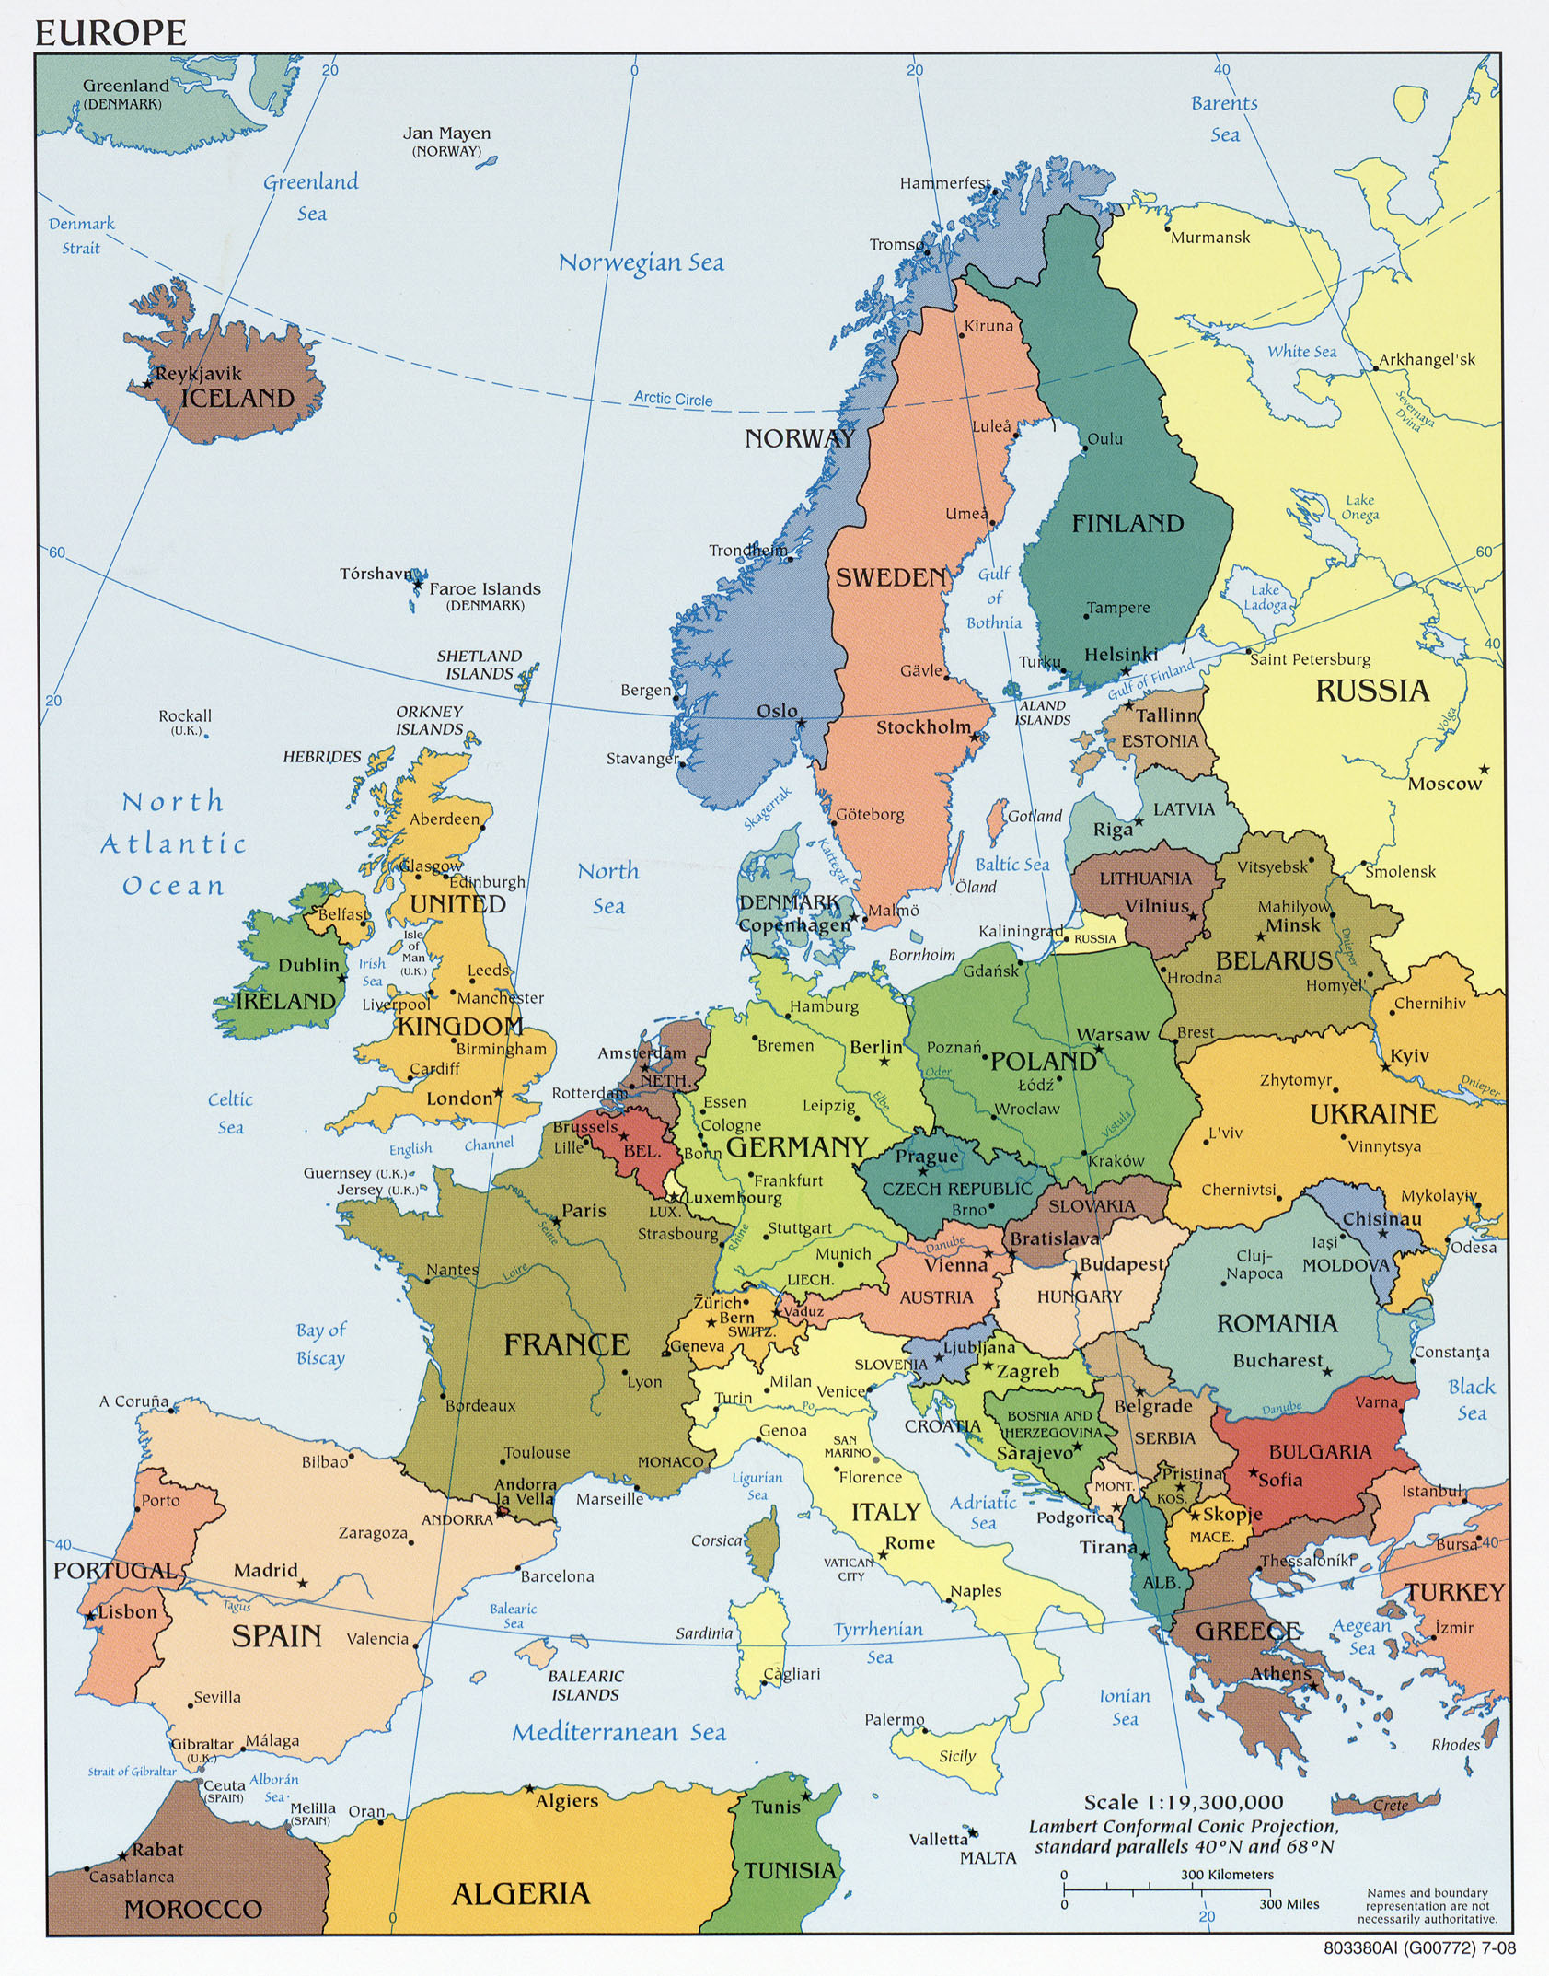
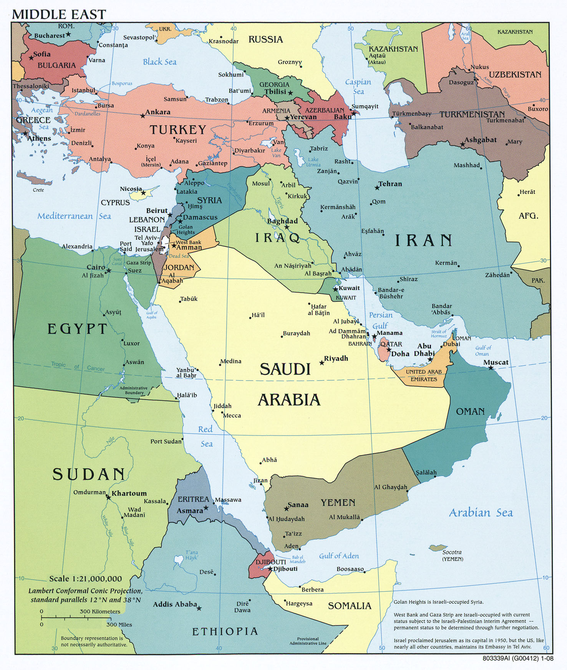

BSS 186/486 – NATO & European Security
Faculty of Social Studies, Masaryk University
NATO Crisis Simulation
Evening Situation Report
Updated Situation
On the eve of NATO’s Meeting to discuss the current strategic situation:
Ukraine
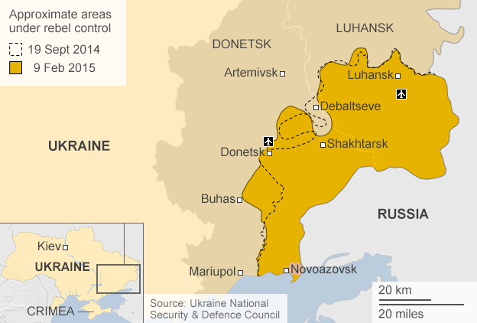
Blaming “outside agitators” for the riots in Crimea, the Kremlin has airlifted additional security forces into Crimea to put down protests, and has threatened to declare martial law in the region. In addition, a battalion of Russian infantry—with armored personnel carriers—have begun to move through Mariupol in eastern Ukraine. NATO sources indicate that the forces appear to be poised to move down the coast in an effort to secure a land bridge to Crimea.
Kiev has protested the Russian movements as a violation of the OSCE Minsk Accords and has warned that further Russian incursion into Ukrainian territory would be met with “all appropriate force.” The Ukrainian Ambassador to NATO has formally notified the Secretary General that Ukraine, as a NATO Partner, is seeking consultation within NATO under relevant provisions of the NATO-Ukraine Charter.
Baltic & Central European States
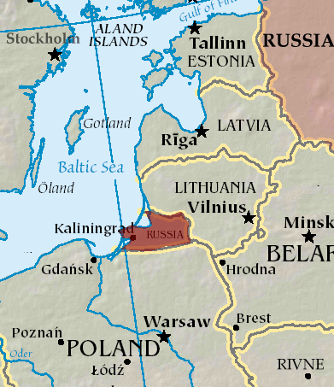
The Lithuanian government has issued a stern protest to Moscow, warning that continued “nationalist” rhetoric out of Kaliningrad calling for a “land-bridge” between that enclave and Russia “does not contribute in any way to the stability of an already-fragile security situation and threatens to enflame public opinion against Russia” within his own country.
In both Tallinn and Riga over the weekend, more protests erupted by Russian communities who continue to be denied citizenship because of their inability to pass language tests. The protests were peaceful, but organizers warned that they would come back if the government did not respond to their demands. Russian language media warned residents that “fascist activists” might hijack the protests and turn them violent. Local security forces said they would continue to respect non-violent protest but would take “necessary measures” to protect the population from violent outbreaks.
Norway & the Arctic
The Oslo Dagbladet reports that Finland and Sweden have approached Moscow regarding Russian actions in the Arctic. Noting that—as non-NATO members, but members of the Arctic Council—they cannot remain silent, as Russia appears to stake out unilateral claims to contested waters in the Arctic. Citing rising tensions in Europe from the Arctic to the Black Sea, as well as growing public support in their own countries for NATO membership, the two countries’ ambassadors to Moscow cautioned the Kremlin not to “drive other countries” into NATO.
U.S. and the Middle East
The rapid seesaw of U.S. policy toward Syria has continued to have unsettling repercussions throughout the region. The U.S. cruise missile attack in April 2017 on a Syrian airfield appears to have been, as the White House indicated at the time, a “one-off” attack, and President Trump has insisted that U.S. policy in the region has not changed: the priority is to defeat ISIS, and the U.S. has no intention of getting involved in the Syrian civil war.
Although Syrian President Assad has not used chemical weapons again, he has continued to attack rebels and civilians in Idlib Province in northern Syria, where his forces have effectively “corralled” those who continue to fight his regime and fled other cities, such as Aleppo, which Assad’s forces recaptured. To date, the U.S. has not taken further military action against Assad or his forces, (although they continue support anti-ISIS efforts), and Assad remains firmly in control, with determined support from Russian President Putin.
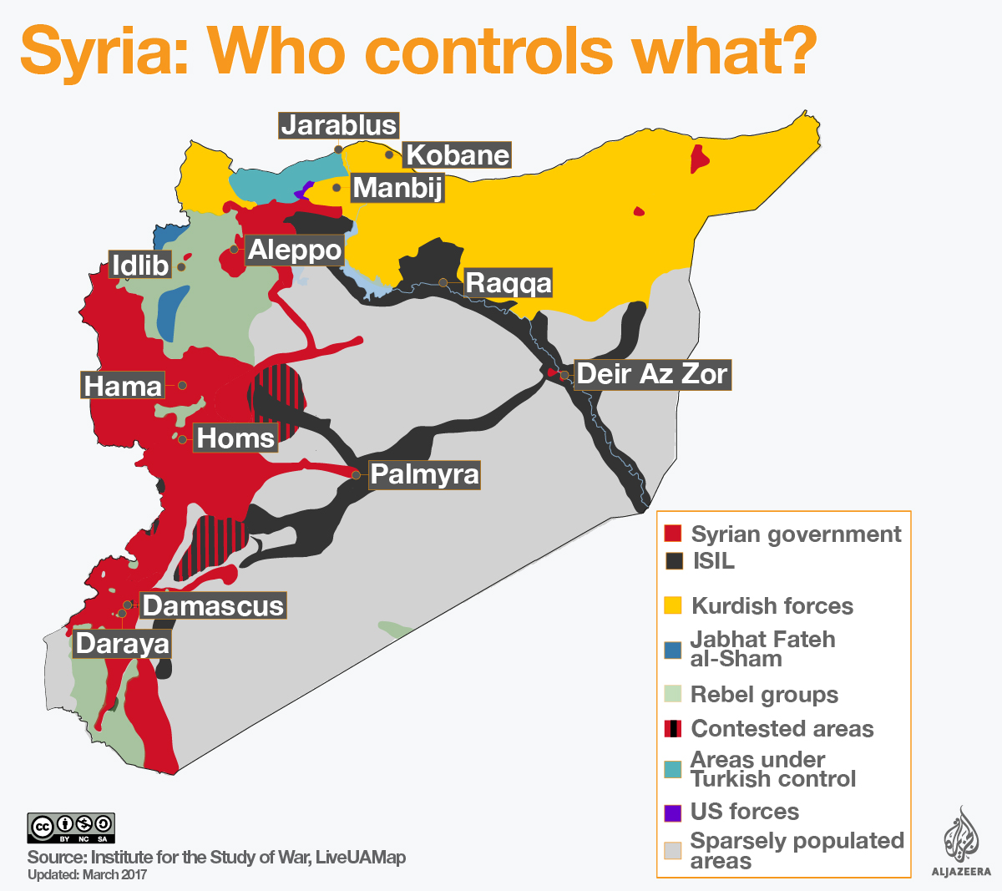
Meanwhile, a coalition of Iraqi forces, Kurdish fighters, and Syrian rebels—with help from U.S. Special Forces units and U.S. airstrikes—are advancing on the ISIS stronghold of Raqqa. Many ISIS fighters remain in the city, vowing to fight to the death, and many of their family members have been relocated to that city as well, raising concerns about civilian casualties.
Turkey has warned that it would not accept an expansion of Kurdish-held territory. Assad has reiterated that this so-called “U.S.-led coalition” continues to “violate Syrian sovereignty,” and that he and “Syria’s true allies” (meaning Russia, Iran, and Hezbollah) will not rest until all rebel and terrorist held territory is again under Syrian government control.

BSS 186/486 – NATO & European Security
Faculty of Social Studies, Masaryk University
NATO Crisis Simulation [xx May 2018]
Morning Press Reports
Estonia Post Times
This morning, in Tartu, Estonia, a group called the "Estonian Russian Alliance" claims that they have occupied Tartu City Hall and called upon Russia to support their cause in restoring the Baltic borders of the Soviet Union. There are no known records of the existence of this group. Crowds of ethnic Russians surrounded the building and kept Estonian Homeland security forces at bay.
This follows anti-Russian protests last night in Tartu, after which some of Tartu’s 15% ethnic Russian population launched a counter-demonstration, claiming persecution.
A Kremlin press spokesman repeated Russia’s determination to protect the rights of Russian minorities living in neighboring countries.
Moscow Times
An explosion in the Moscow subway early this morning—before rush hour—created extensive damage but few casualties and no fatalities.
A Russian Interior Ministry spokesman said that the explosives were detonated by a suicide bomber, tentatively identified by forensic evidence as a Chechen radical. No groups have claimed credit.
A Kremlin spokesman spoke of the need for Russia and the West to focus together on a clear common enemy in radicalism and terrorism, instead of the ‘artificial issues’ currently dividing them.
Kiev Times
The Ukrainian Interior Ministry announced today that they had captured four Russian Spetsnaz soldiers 100 km southwest of Mariupol.
Unless Russia admitted to its aggression eastern Ukraine, the Ministry said they would be tried as criminals instead of being treated as prisoners of war.
The Kremlin responded that this would be viewed as a “severe provocation” in what was already a volatile relationship.
Al Jazeera
Abu Bakr al-Baghdadi, the leader of ISIS, announced through a video that he is still in Raqqa, in charge of the Caliphate, and that the families of “all our martyrs” are prepared to die in defense of the city.
Based on reports from Kurdish and Syrian rebel fighters, the Pentagon said it expected the battle for Raqqa to be bloody and protracted.
Washington Post
As the battle for Raqqa nears, Americans are getting increasingly concerned that the U.S. will lose many lives in trying to take Raqqa, but to what end? As Congressman Rand Paul (R-KY) said, “This is not America’s war. This is Europe’s war – they’re getting all the refugees. Where is NATO in this fight?
BSS 186/486 – NATO & European Security
Faculty of Social Studies, Masaryk University
NATO Crisis Simulation [xx May 2018]
Mid-Simulation Press Injects
Breaking News I
CNN
NATO sources report indications of movement of units of a Russian motorized rifle brigade toward the Estonian border. Russian Defense Ministry spokesmen indicated that these were only routine maneuvers.
The Warsaw Voice
Poland’s Defense Ministry announced that Polish Air Force F-16’s intercepted a Russian fighter in Polish airspace and escorted it back to Russian airspace in Kaliningrad without incident. The Russian Ministry of Defense had no comment.
Oslo News
Norway’s Ministry of the Interior reports that the wreckage of a small Russian intelligence surveillance submarine has washed up on the Norwegian coastline just outside the Arctic Circle.

Breaking News II
El Pais
This morning there was an explosion in a marketplace in Gibraltar. There were 15 fatalities—including the suicide bomber who committed the attack—and over 100 seriously wounded. “Al Qaeda in the Maghreb” has claimed responsibility for the attack. The Spanish government has expressed concern that the independent status of Gibraltar makes it difficult for them to control their border.

