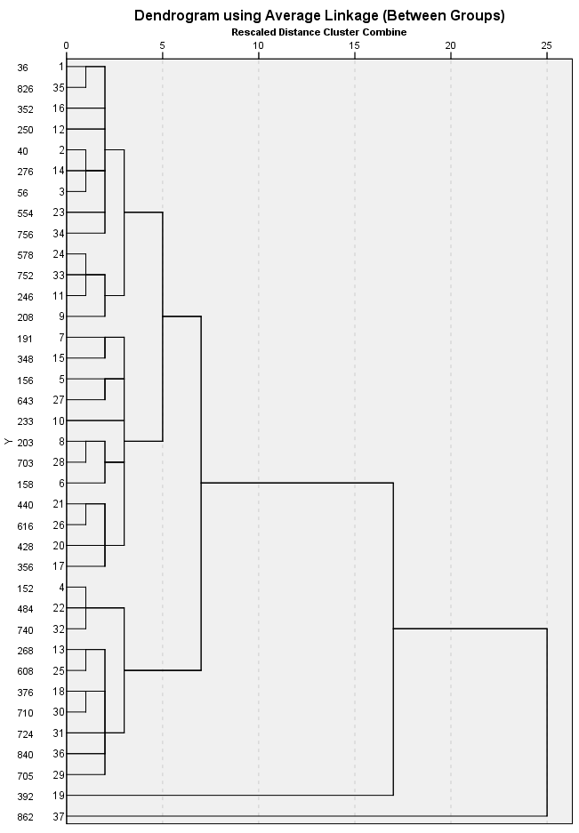

Report
Average Linkage (Between Groups) |  | v3_mean | v4_mean | v5_mean | v6_mean | v7_mean | v8_mean | v9_mean | v10_mean | v11_mean
1 | Mean | 1,5154 | 2,2575 | 2,2636 | 1,5116 | 1,9867 | 2,1096 | 2,1093 | 2,4472 | 1,9983
 | N |  |  |  |  |  |  |  |  | 13
 | Std. Deviation |  |  |  |  |  |  |  |  | ,13112
2 | Mean | 1,4345 | 1,7162 | 1,6901 | 1,6351 | 1,8710 | 1,7422 | 1,7147 | 2,1222 | 1,9754
 | N |  |  |  |  |  |  |  |  | 10
 | Std. Deviation |  |  |  |  |  |  |  |  | ,18839
3 | Mean | 1,5115 | 1,7778 | 2,1658 | 1,8030 | 2,2027 | 2,1488 | 2,0863 | 2,3789 | 2,2746
 | N |  |  |  |  |  |  |  |  | 12
 | Std. Deviation |  |  |  |  |  |  |  |  | ,14538
4 | Mean | 1,8261 | 2,0793 | 3,0340 | 2,1205 | 3,0844 | 2,3965 | 2,2422 | 2,5363 | 2,4035
 | N |  |  |  |  |  |  |  |  | 1
 | Std. Deviation |  |  |  |  |  |  |  |  | .
5 | Mean | 1,1248 | 1,2233 | 1,1820 | 1,1792 | 1,4639 | 1,1672 | 1,1785 | 1,9677 | 1,3129
 | N |  |  |  |  |  |  |  |  | 1
 | Std. Deviation |  |  |  |  |  |  |  |  | .
Total | Mean |  |  |  |  |  |  |  |  | 2,0742
 | N |  |  |  |  |  |  |  |  | 37
 | Std. Deviation |  |  |  |  |  |  |  |  | ,24157

