New-paradigm globalisation and networked FDI: Evidence from Japan
Richard Baldwin, Toshihiro Okubo 24 May 2012
New-paradigm globalisation – driven by lower coordination costs rather than trade costs – is changing the nature of international commerce, the political economy of trade liberalisation, the nature of trade agreements and much more. This column, using data on Japanese multinationls, presents evidence that the nature of FDI is also changing away from the traditional classification of ‘horizontal’ or ‘vertical’.
0
a
A

Related
- A proposal for rethinking the euro-area entry criteria [1]
Zsolt Darvas
- A Financial Perspective on Exchange Rates [2]
Philip Lane, Jay Shambaugh
International trade theory is going through another revolution – the third in three decades. The first came in the 1980s ( ‘new trade theory’) when Paul Krugman [3], Elhanan Helpman [4], Victor Norman, Tony Venables [5] and Jim Brander opened the black box of the production possibility frontier. They allow for firms and increasing returns to scale; this massively extended the real-world relevance of trade theory.
The second revolution (‘new new trade theory’) came when Marc Melitz (2003) opened the black box further by allowing for firm-level productivity differences. Antràs [6] (2003) contributed to this by opening up the black box of firm organisation. Again, these developments tremendously boosted the ability of theory to address important aspects of reality.
More recently, a new theoretical innovation (dare one call it new-trade cubed?) did it once again. The new perspective – sometimes called new-paradigm globalisation – opens up the black box of production function, allowing for potentially internationalised supply chains. While this perspective goes way back, a recent rash of theory and empirical work shows that this ‘new-paradigm globalisation’ has incredibly important implications for policy and empirics.¹
A few years ago, one of us argued that the big difference between old and new paradigm globalisation was the driving force (Baldwin 2006). Old-paradigm globalisation focuses on lower trade costs; the new paradigm focuses on coordination costs – the information and communication technology (ICT) revolution in particular. Lower coordination costs made it feasible to geographically unbundle production stages and wage differences made it profitable. This ‘second unbundling’ transformed international commerce as the sorts of flows that used to be contained inside factories now became international. Many US-based scholars have focused on wage implications most notably Grossman and Rossi-Hansberg (2008). But the second unbundling – variously known as offshoring, vertical specialisation, fragmentation, etc. – has many other implications for empirical work and policy making.

New trade theory cubed: Implications for FDI theory
In a recent paper, we turn the new-paradigm focus to FDI theory (Baldwin and Okubo 2012). Canonical thinking about FDI distinguishes two main types: horizontal and vertical (Markusen 1984 and Helpman 1984).
- Horizontal FDI in the former is said to be ‘market seeking’;
- Vertical FDI is ‘efficiency seeking’.
Empirical tests typically search for FDI motives by considering whether FDI activity is greatest between large nations (market seeking), or nations with big endowment and/or factor prices differences (efficiency seeking) (Carr et al. 2001, Blonigen et al. 2003). The two have been synthesised and enriched to include export platform FDI (Markusen and Venables 2000, Yeaple 2003, Ekholm et al. 2007). Grossman, Helpman and Szeidle (2006) generalise these results by allowing a richer range of multinational activities that can be called complex FDI.
Our paper contributes to this by using firm-level data on the sales and sourcing patterns of Japanese affiliates in all industries in all nations to suggests that very little FDI falls neatly into any of the standard bins, i.e. horizontal, vertical or export platform. We find that most affiliates are buying some, but not all, of their intermediates from abroad and selling some, but not all of their output abroad. We refer to this FDI as ‘networked FDI’ since the evidence is that these affiliates are operating as nodes in regional production networks. Moreover, we show that this aspect of the data became much stronger from 1996 to 2005.
We suggest that a very natural way to test FDI theories is to use the sales and sourcing patterns of affiliates. We also argue that the location and nature of FDI activity depends upon third-country effects of two types – basically the international equivalent of backward and forward linkages. The first, forward linkages, suggests that FDI production is favoured by locations near many large markets – perhaps measured by some sort of market potential index for the host nation (Baltagi et al. 2005). The second, backward linkages, suggest that FDI production is favoured by proximity to masses of similar activity in both the host nation and nearby nations. This might be measured by some sort of host-nation-specific price index for intermediates and they have not, to our knowledge, been explored empirically or theoretically.

FDI and regional comparative advantage
Taken together, the two third-nation effects suggest that the location and nature of FDI activity is influenced by something that might be called ‘regional comparative advantage’. For example, even if Cambodia and Uganda had identical national policies, endowments, and market size, Cambodia’s proximity to massive manufacturing activity creates backward and forward linkages that make FDI more attractive in Cambodia than in Uganda. The policy implications of these observations are clear. Policies that worked in East Asia must be rethought before applying them to very different regions such as Latin America, Central Asia, and Africa.

The sales-sourcing box
New-paradigm globalisation suggests that we view FDI as part of the second unbundling. This, in turn, suggests a perspective that focuses on each affiliate’s sales and sourcing pattern (Figure 1). The existing classifications are corner solutions: Pure horizontal FDI is the northeast corner; pure vertical FDI is the eastern border; pure export platform FDI is the southwest corner.
Figure 1. The sales-sourcing box diagram
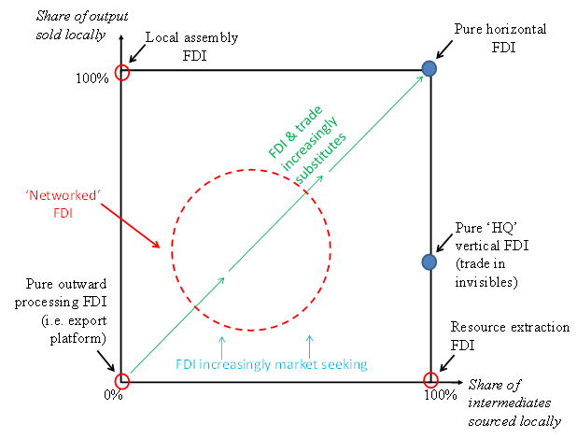

Japanese evidence
Using an aggregated version of Japan’s firm-level data, we plot the Japanese affiliates in the sales-sourcing box diagram (sub-sector averages). We do this for 1996 (Figure 2) and 2005 (Figure 3). Plainly, three categories can’t cover the full range of reality.
Figure 2. Sales and sourcing by sector, 1996
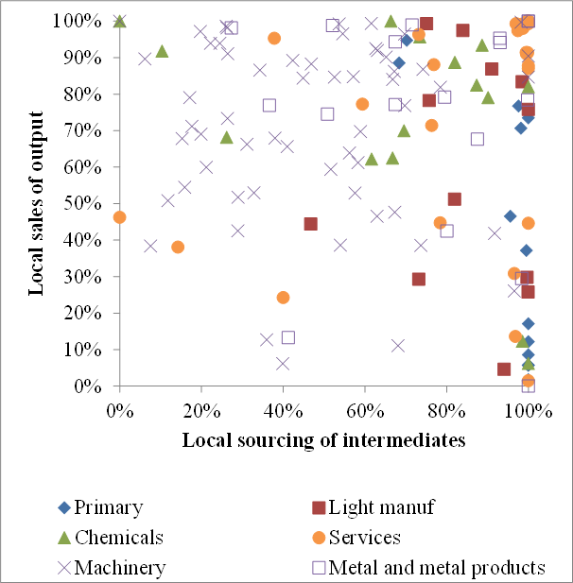
As production unbundling advanced, the sales-sourcing pattern of Japanese FDI changes dramatically, as the comparison between 1996 and 2005 shows. Although the sector classifications changed between the two years, the broad picture is clear – most sectors saw a decrease in the local sourcing of intermediates.
Figure 3. Sales and sourcing Japanese affiliates, all host nations, 2005
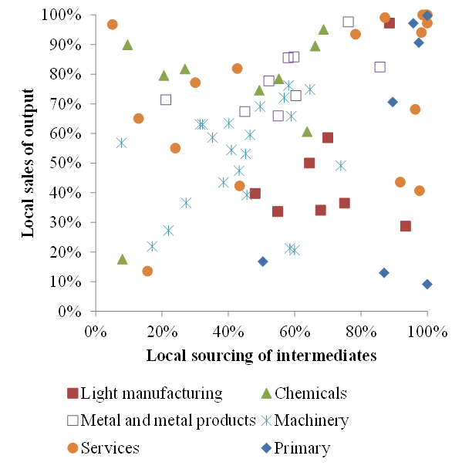
In particular, Figure 3 shows the emergence of what we called ‘networked FDI’ – i.e. FDI where the affiliates import substantial shares of their intermediates and export substantial shares of their output. In this sense, trade and investment became far more entwined between 1996 and 2005. Figure 4 – taken from the recent METI White Paper (2012) – shows the evolution over time for three important sectors.
Figure 4. Evolution of sales and sourcing in Asian affiliates
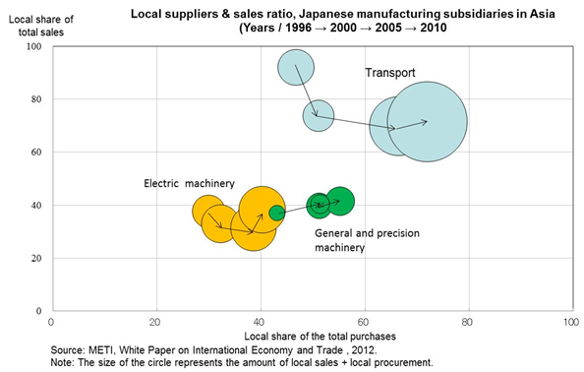
Of course, this is a very rough classification and many nuances are hidden by this presentation, but it does serve to illustrate the point – first made by Hanson et al. (2001) – that the standard horizontal or vertical thinking is inadequate for understanding the behaviour of FDI.
In our paper, we find large regional variations among the three major host regions – Asia, North America and the EU. The North American sales-sourcing patterns are strikingly different in terms of the dominance of local sales.

Concluding remarks
The dominance on the theory side of North-American inspired modelling and on the empirical side by US multinationals data has resulted in a belief that FDI is mostly motivated by ‘horizontal’ or market-seeking goals. Our research suggests that this is almost exactly wrong in the Japanese data.
Our divergent conclusions stem from two key differences. First, we note that the standard view is based on a rather indirect empirical strategy when it comes to testing FDI theories. Most papers seek to determine whether FDI activity (typically affiliate sales) are stimulated by market-seeking motives (horizontal) or efficiency-seeking motives (vertical), or a combination of the two (complex FDI) using macro data (GDP, endowments, etc) not micro data. We suggest that a very literal reading of the theory points to a very different empirical levers for distinguishing horizontal and vertical FDI, namely the sales and sourcing patterns of affiliates. We argue that affiliates’ purchases of non-local intermediate goods (despite positive trade costs) indicates that it is cheaper to undertake some but not all production stages in the host nation. Likewise, exports back to the home country despite trade costs suggest that separating manufacturing stages lowers the cost of production. Likewise, the share of affiliate sales to the local market are perhaps the most natural indicator of horizontal FDI, with pure horizontal FDI requiring 100% local sales.
Using these levers, we find three key findings.
- FDI in almost all sectors and almost all nations involves some ‘vertical-ness’, and some ‘horizontal-ness’.
- In many nations and many sectors, the Japanese affiliates have sales and sourcing patterns that suggest that individual affiliates are part of a production network.
This ‘networked FDI’ may be a very interesting phenomenon to study from a theory, empirical and policy point of view since it suggests that ‘regional comparative advantage’ (basically third-nation effects on the supply and demand sides) may be an important consideration in crafting and evaluating national FDI policies.
- Our data systematically show affiliates in North American have quite different sales-sourcing patterns compared to those in Asia and Europe.
Specifically affiliates in North American have sales-sourcing patterns that are far more in line with horizontal FDI than those in Asia and Europe. This suggests that strong conclusions from US data may have to be tempered before they are applied to the rest of the world – especially developing nations.

References
Antras, Pol (2003). "Firms, Contracts, and Trade Structure", Quarterly Journal of Economics, Vol. 118, No. 4, November 2003, pp. 1375-1418.
Baldwin, Richard & Robert-Nicoud, Frédéric, 2010. "Trade-in-goods and trade-in-tasks: An Integrating Framework", CEPR Discussion Paper 7775.
Baldwin, Richard (2006). “Globalisation: the great unbundling(s) [7]”, in Globalisation challenges for Europe, Secretariat of the Economic Council, Finnish Prime Minister’s Office, Helsinki, 2006, pp 5-47.
Baltagi, Badi, Peter Egger, and Michael Pfaffermayr (2005). “Estimating models of complex FDI: Are there third-country effects?”, Center for Policy Research working paper 1525-3066, Syracuse University.
Carr, David L., James R. Markusen, and Keith E. Maskus (2001). “Estimating the Knowledge-capital Model of the Multinational Enterprise”, American Economic Review 91, pp 693–708.
Deardorff, Alan V. (1998a). “Fragmentation in Simple Trade Models [8]”, RSIE Discussion Paper 422, University of Michigan, January 8, 1998.
Deardorff, Alan V. (1998b). “Fragmentation across cones [8]”, RSIE Discussion Paper 427, Discussion Paper 427, August 7, 1998.
Dixit, Avinash and Gene M. Grossman, (1982), “Trade and Protection with Multi-Stage Production”, Review of Economic Studies, 49:4, 583-594.
Gene M. Grossman & Esteban Rossi-Hansberg, 2008. "Trading Tasks: A Simple Theory of Offshoring [9]", American Economic Review, American Economic Association, vol. 98(5), pages 1978-97, December.
Hanson, Gordon, Raymond Mataloni and Matthew Slaughter (2001). "Expansion Strategies of U.S. Multinational Firms," in Dani Rodrik and Susan Collins (eds.) Brookings Trade Forum 2001, Brookings Institution Press.
Grossman, Gene, Elhanan Helpman and Adam Szeidle (2006). “Optimal Integration Strategies for the Multinational Firm”, Journal of International Economics 70: 216-238, 2006.
Jones, Ronald W. and Henryk Kierzkowski (1990): “The Role of Services in Production and International Trade: A Theoretical Framework”, in Ronald Jones and Anne Krueger, eds., The Political Economy of International Trade, Basil Blackwell, Oxford.
Markusen, J., Venables, A., 2000. "The theory of endowment, intra-industry and multinational trade", Journal of International Economics 52, 209–234.
Melitz, M. J. (2003). “The Impact of Trade on Intra-Industry Reallocations and Aggregate Industry Productivity”, Econometrica 71:1695-1725.
Venables, Anthony (1999). “Fragmentation and multinational production”, European Economic Review 43, 935-945.
Yeaple, S.R., 2003. "The complex integration strategies of multinationals and cross country dependencies in the structure of foreign direct investment", Journal of International Economics 60 (2), 293–314.

1Heckscher-Ohlin theory did incorporated trade in intermediate goods (Batra and Casas 1973, Woodland 1977, and Dixit and Grossman 1982), but the most commonly cited reference in the offshoring/fragmentation literature was, until recently, Jones and Kierzkowski (1990). Subsequent theory includes Deardorff (1989a, b), Venables (1999), Kohler (2004a), Markusen (2006), Grossman and Rossi-Hansberg (2006a,b) Rodríguez-Clare (2007), and Antràs et al. (2006). See Baldwin and Robert-Nicoud (2010) for an integration of the various contributions.
0

