The Christmas Story of Brunswikians
Lubomír Kostroň

In our country, Czechia (Bohemia) and Moravia, people bake an exclusive longish kind of Christmas cake, which is called “vánočka”. Vánočka is composed of three layers of dough braids: six of them are entangled together as the bottom flat layer, four are put on them, as the middle layer and then the last two on the very top. The raisins, almonds and nuts are included, of course. Since I began to collect the information, which the following story is composed of, purposefully at the Christmas time of 2017, this metaphor for the story seems to be appropriate: the individual destinies are entangled together for some time, then the next generation of folks comes in, adds to the story and in some sense continues … and so on. This way even the ideas are shared, connecting the individuals, for some time… This is the substance of this story. People, exciting ideas, work …. In Brunswik´s terminology, the focus is on wide “distal to distal relationships”.
Therefore, the story will be composed of individual memories and impressions of those who participated – or at least of those – as far as I know – who played some significant role in the story. Now, we have to begin with the oldest layer of our story, which is on the top of the cake . As it is usual: once upon the time ….

The history of Egon Brunwik´s stretches long way back. The origins of the Austrian Hungarian family of von Brunswick or de Brunswik are uncertain, though they point to the city of Braunschweig in Germany. …. There seems to be a link with the Brunswic family, which is documented in the city of Kolberg (Kolobrzeg, Kolobřeh) in Pommeria (Pomořansko) toward the end of 13th century. In newly founded city, a certain Johannes de Brunswic is mentioned as a citizen in 1292 and as a member of the city council from 1294 to 1324. …. On June 7, 1631 the court of Nyitra county, published a revised coat of arms of the Brunczvik family. Michale von Brunczvik, the only son of Tobias who had an offspring, purchased the estate of Korompa (Dolná Krupá in Trnava district of Slovakia) following which he and his descendants used the title Brunswik von Korompa.

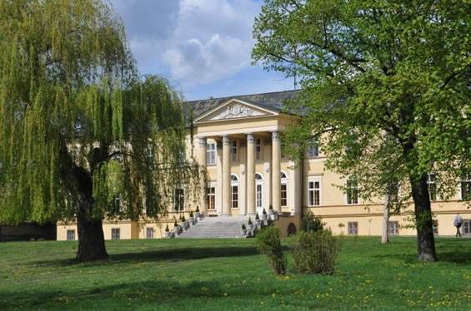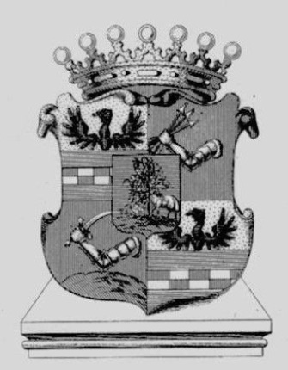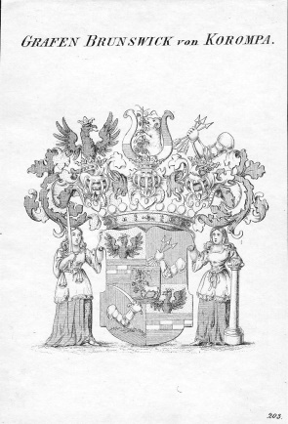
Fig.1 Dolná Krupá mansion with the Count of Brunswick von Korompa coat of arms

Dolná Krupá was the place, where Ludwig van Beethoven may have spent several summers invited by the family of Brunswik. Dolná Krupá mansion was one of the residences of the Chotek family. …. It was the place, of the Dolná Krupá rosarium, created by countess Marie Henrietta Brunswik (1789-1857), a wife of Heřman Chotek-Vojnín. Josephine Brunswick (1779 – 1821) is most likely the woman to whom the Letter to Immortal Lover was addressed. It is said, that in Dolná Krupá Ludwig van Beethoven composed the so called “Moonlight” sonata. After World War I, the members of the family have dropped the "von Korompa" particle from their name and are using only the Brunswik surname. The male Brunswiks served the Austrian and Hungarian Crown. They were civil servants, civil engineers or higher officers. Some of them were “Feldmarschallleutnant.” That is the equivalent of a four star general. In Austria and in the other European countries the title of an engineer is protected by law. Graduate study and a degree similar to a doctor’s degree is required. That is the reason there are so many engineers in the Brunswik family. Two of Mr. Harald Brunswik's sons and Mr. Brunswik himself continued the tradition. Egon's father was also an engineer. Egon’s father was Julius Stefan Josef Brunswik, born on 10th December 1863 in Fogaras. He was “königlicher” engineer in the Hungarian Ministry of Commerce (Handelsministerium). His wife and Egon’s mother was Helene Gabriele Stefanie Klara von Wieser, daughter of the k.u.k. (kaiserlich und königlicher) Generalmajor Kommandant of the 30. Infanteriebrigade zu Miskolcz. They maried on 4th June 1902 in Vienna. (www.brunsik.org, Egon Brunswik´s family)

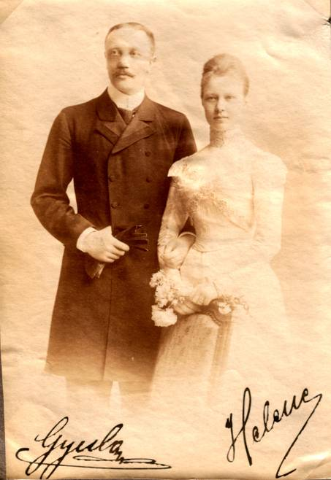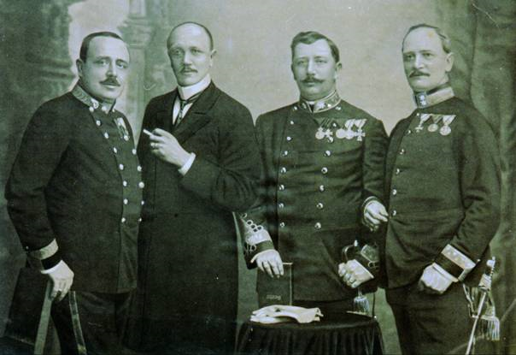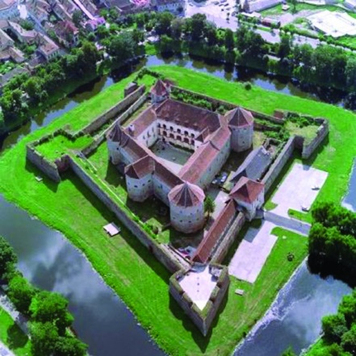
Fig.2: Julius (Gyula) and Helene Brunswik
Fig.3: The Brunswik brothers: Julius, Romeo, Julius Stefan and Adolf
Fig.4: The romantic view of fortress in Foragas, nowadays deep inside Romania
KRH: Egon Brunswik (1903 – 1955) was born in Budapest. In 1921 he graduated from the Theresianische Akademie after receiving training in mathematics, science, classics, and history. He then studied engineering and passed the state examinations but afterward enrolled as a student of psychology at the University of Vienna. Here he became an assistant in Karl Buhler's Psychological Institute (among his student colleagues were Paul F. Lazarsfeld and Konrad Lorenz) and received a PH.D. in 1927. While a graduate student in psychology, he also passed the state examination for Gymnasium teachers in mathematics and physics. He was under the influence of Moritz Schlick and the Vienna Circle of logical positivists.
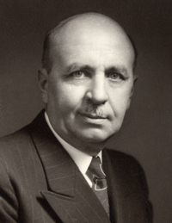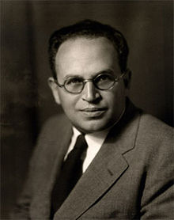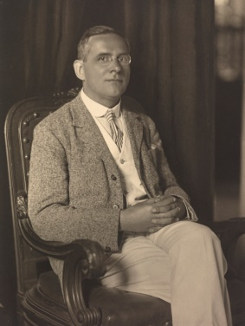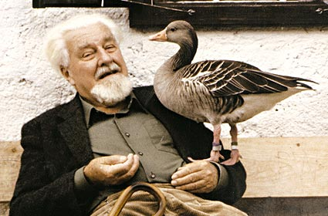
Fig.5: Karl Buhler (1879 Meckesheim – 1936 Los Angeles)
Fig.6: Felix Lazarsfeld (1901 Vienna – 1876 Newark, N.J.)
Fig.7: Moritz Schlick (1882 Berlin – 1936 Vienna)
Fig.8: Konrad Lorentz (1903 Vienna – 1989 Vienna)
Brunswik established the first psychological laboratory in Turkey while he was visiting lecturer in the School of Education in Ankara during 1931-1932.
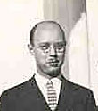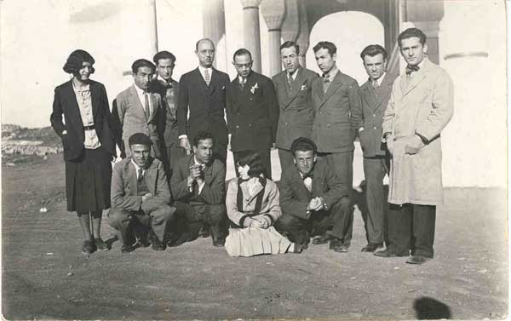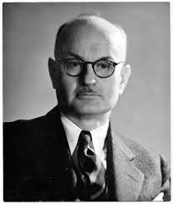
Fig.9: Egon Brunswik as a young man.
Fig.10: Egon Brunswik and his colleagues at Ankara, Turkey
Fig.11: Edward Chase Tolman, University of California at Berkeley (1886 West Newton Mass. – 1959 Berkeley, Ca.),
He became Privatdozent at the University of Vienna in 1934. In 1933, however, Edward C. Tolman, chairman of the department of psychology at the University of California (Berkeley), spent a year in Vienna. He and Brunswik found that although they had been working in different areas of psychological research, their theories of behavior were complementary, and in 1935/1936 Brunswik received a Rockefeller fellowship that enabled him to visit the University of California. He remained at Berkeley: he became an assistant professor of psychology in 1937 and a full professor in 1947.
In 1937 Brunswik married Else Frenkel, his coleague, former assistant in Buhler's institute, who became well known as a psychoanalytically oriented psychologist. She participated in then intensive reseach of authoritatian personality together with T.W. Adorno. Brunswiks became an American citizens in 1943.

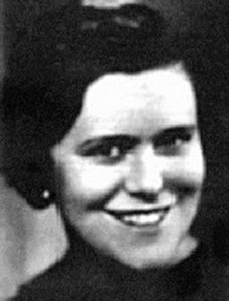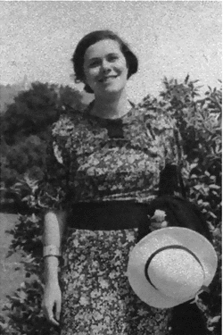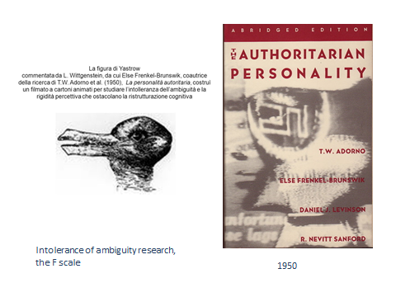
Fig.12: Else Frenkel – Brunswik (18.8.1908 Lemberg (Lvov) – 31.3.1958 Berkeley)
Brunswik´s work in Vienna focused on experiments with perception
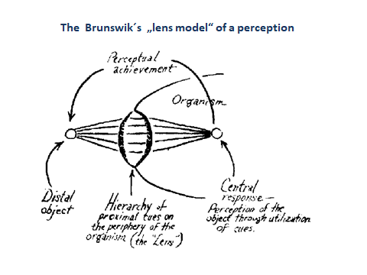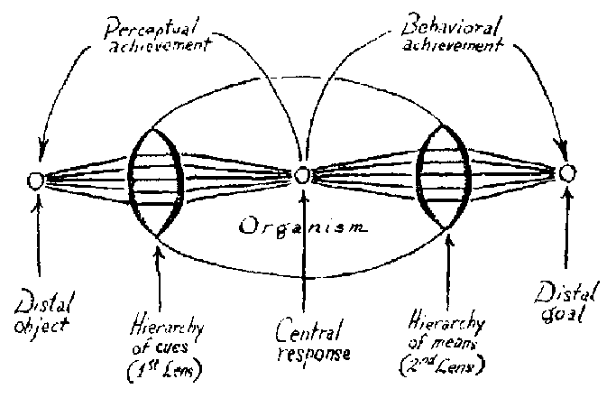
Fig.13: Brunwik´s „lens model“ od perception
Fig.14: „lens model“ of perception extended to include the behavior

and had culminated in the publication of „Wahrnehmung und Gegenstandswelt“ in 1934. Together with E.C.Tolman, they published “The organism and the causal texture of the environment” in 1935. All of his subsequent work was devoted to the extension and elaboration of the fundamental position set forth in this book, namely, that psychology should give as much attention to the properties of the organism's environment as it does to the organism itself. He asserted that the environment with which the organism comes into contact is an uncertain, probabilistic one, however lawful it may be in terms of physical principles. Adaptation to a probabilistic world requires that the organism learn to employ probabilistic means to achieve goals and learn to utilize probabilistic, uncertain evidence about the world. His "probabilistic functionalism" was the first behavioral system founded on probabilism, an approach that is attracting increasing attention in the fields of learning (Estes 1959), thinking (Bruner et al. 1956), decision processes (Edwards 1961), perception (Postman 1963), communication (Miller 1953), and the study of curiosity (Berlyne 1960). Brunswik's emphasis on the importance of the environment is reflected in the increasing development of "psychological ecology," best illustrated by the work of Roger Barker (1960).
Brunswik wrote a great deal about the history of psychology. His historical analysis is remarkable for its development in structural terms rather than in the customary longitudinal recapitulation of names, dates, and places. It consists of a general identification of the kinds of variables that have traditionally been employed in psychological theory and research and a description of the changes in the emphasis of these variables over time. Brunswik's theory stems as much from his analysis of the history of psychology as it does from his research. His historical as well as his theoretical analysis also led him to criticize orthodox methods of experimental design (particularly the "rule of one variable") and to suggest methods for avoiding what he believed to be an unfortunate artificiality inherent in classical experimental procedures. His main field of empirical research was perception, but he also brought his probabilistic approach to bear on problems of interpersonal perception, thinking, learning, and clinical psychology. His research findings were published in Perception and the Representative Design of Experiments (1947), which also includes Brunswik's methodological innovations and related research by others.
Perhaps the most significant feature of Brunswik's work is its coherence. Each theoretical, historical, and research paper is explicitly and tightly integrated with every other one. Brunswik's cast of mind compelled him to fit together with precision his conceptual framework, his methodology, and his views of the history of psychology. In 1952 he presented an overview of the field of psychology in The Conceptual Framework of Psychology-acknowledged to be remarkable both for its deep analysis and for its broad scope. Such an integration of ideas has seldom, if ever, been attempted by a modern psychologist, and in Brunswik's case it demonstrates a remarkable capacity for independent and creative thought.
Brunswik's ideas received wide attention during his lifetime and continue to do so. The extent of his direct influence on psychology, however, remains doubtful. Although his ideas are powerful and his research complicated and ingenious, the scope, depth, and integration of his work make it formidable. His unorthodoxy tends to discourage the timid and to offend those who think it mistaken. However, his history, theory, and methodology struck at key problems in psychology which remain unsolved, and it is too soon to appraise with finality Brunswik's contribution to their eventual solution. Some of Brunswik´s key publications are listed at the end of this story. K.R.H. (1968).

Even though my own grandmother and father were born in Tyrol (Austria), I do not know the German language. Therefore, unfortunatelly, all further information about Brunswik and his work had to be based upon English language sources…. Now we move to the next generation, to the middle layer of our story, to people, who are associated with the Egon Brunswik students…

Pam Hammond: My parents (and my Dad) grew up in the area that is called “the avenues” - in the Richmond District of San Francisco. It is out near ocean beach. Dad’s father LLewllyn B. Hammond was a descendant of pre Revolutionary British Americans, who probably came from England. He never made it past the fourth grade in schools, worked as an electrician and became a successful contractor, who built several houses in that area after the earthquake. Dad’s father died when he was in his 50’s. Shortly thereafter Dad’s mom, Jeannete A. Hammond, moved into a rooming house. She was a daughter of German Jewish immigrants (her maiden name was Horowitz), who came from Alsace Lorainne.

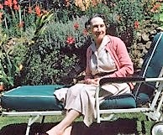
Fig.15: Jeannete A. Hammond

Dad, Kenneth Robert Hammond, was born on Jan.13, 1917. He had one brother, Harold Hammond, who was several years older than Dad. He also became an electrician and had his own company. He lived in a town nearby. Like his father, he passed away in his 50’s.

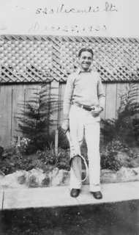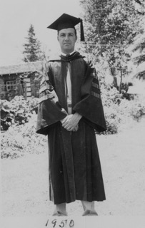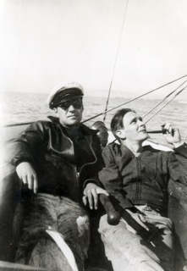

Fig.16: Kenneth R. Hammond as a young man

The family had a cottage over in Glen Ellen (across the Golden Gate Bridge and a little to the north). It was said that Jack London would frequent that area and all the townspeople would love to come out and greet him.

Shirley Berg: “Ken remembers his father teaching himself to survey, to create blueprints he needed to build. He would appreciate his need, consider his skills and say “I can do that”. And he did. It was the same spirit, that led Ken, after graduating from a mechanical arts high school, to consider a photograph of graduating class of the University of California in Berkeley and say “Why not me?”. And indeed. Ken would go to study at the University of California at Berkeley.

Why psychology? In 1939 two things happened: in Europe Hitler invaded Poland and Ken, as a junior, had to decide about his major. Everywhere there was a talk about war and Ken was drawn, intensely and intellectually to consider the problem of war. Psychology, the study of mental processes and behavior seemed a good option for a major - and that later lead to a distinguished career in the study of judgment and decision-making.”
After graduating with his B.A. in 1940, he worked as an electrician for some time.

Pam (e-mail): My mom, Virginia Redd came from a large and well-known Utah family of Redd’s, living in Monticello, Utah. There were 10 children in her family. Monticello is still very small - only a couple thousand I would say. My mom left high school in Monticello before she graduated. She completed high school in Salt Lake at a rooming house for young women. She went to college only briefly at Utah state in Logan. She then left on her own for San Francisco - 2 of her aunts were living and working there. Virginia came to San Francisco and found employment as a secretary. Her acquaintance with my grandmother Jeanette (we called her Nana) occurred at the above mentioned rooming house and it is there, where she met Dad and they became a couple. Ken and Virginia were married in 1941.
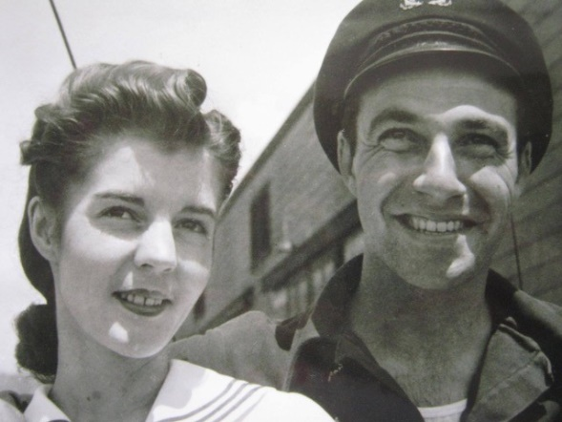
Fig.17: Virginia a Ken Hammonds

In the meantime, Ken also attended the classes at the university. K.R.H.: „That is the place, where he first met Egon Brunswik - at a distance in 1938, shortly after he arrived in Berkeley from Vienna. Although only an undergraduate at the time, he had heard of the remarkable new professor and so he sat in on a few of his classes to see what a European professor was like. He made an impression on him, despite his less-than-perfect English“. KRH Essay 1

Also, Ken obtained a pilot´s licence and enlisted in the Merchant Marine service in 1940. Before the WW II ended and Ken returned back home from the sea permanently, Pam and Kathy were born and completed the family of Virginia and Jeanette. Ken returned to Graduate School of the University of California at Berkeley to see what the interesting professor from Austria has to say.

This is the way, K.R.H. remembers this time:
„when I returned to Berkeley as a graduate student in 1945 I sought him out. Indeed, I sat at his feet at every opportunity. He was both forbidding and friendly at the same time; forbidding because of his obvious store of knowledge (you thought twice about striking up a conversation with him, or going to his office), friendly because once you did he was unfailingly courteous and then you were glad you did, and thought just a bit better of yourself for having done it. Within moments of talking with him you were aware of the fact that you were in the presence of a true scholar (I was not alone in thinking that he knew everything); yet his demeanor was so pleasant (even to graduate students) that one was disarmed, and fright (but not awe) quickly disappeared. I felt that he took me seriously and listened carefully to what I had to say, despite the naiveté of my remarks. And he had a great deal to say about whatever topic you brought to him. He was not appreciated by undergraduates, however—he was always over their heads—and the chairman of the department, Edward Tolman, had to write a strong letter to the Dean pleading for his reappointment after his first year. „ KRH Brunswik´s Challenge essay 1
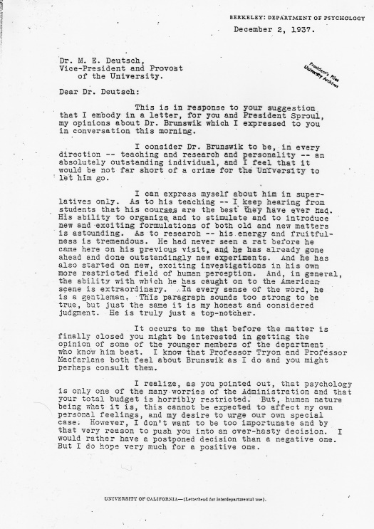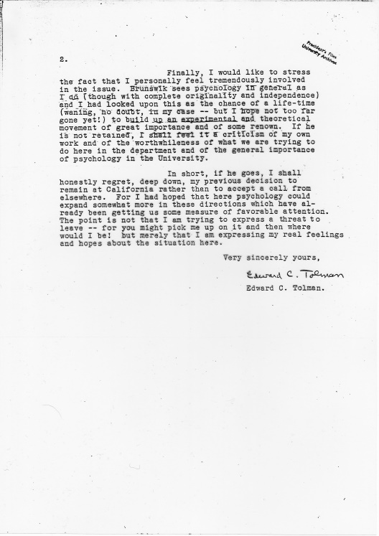
Fig.18: Edward C. Tolman´s letter on behalf of Egon Brunswik ( I believe this letter was discovered by Mitchell G. Asch ?)

Pam : “right after Mom and Dad married, they traveled to Utah and briefly considered moving out there and making a life ranching. That idea was short lived however. Dad and Mom drove further to Colorado, for a second honeymoon, discovered Boulder and the University of Colorado, the perfect place for living (and a career). Within three years, after returning to San Francisco, Kenneth earned his M.A. in 1947 and PhD in 1948, both in psychology. Besides studying, Dad and Mom they did a lot of sailing together with friends in San Francisco Bay. Also, as a young man Dad played tennis and the saxophone. The family lived in San Francisco until Pam was four years old. Then the family left for Boulder in 1947 or 1948 so Kathy and Pam essentially grew up there.

In Boulder, Dad became infatuated with horses. He leased pasture land close to our house (1740 Columbine Ave. and 18th Street , “On the Hill”) and bought a few horses.
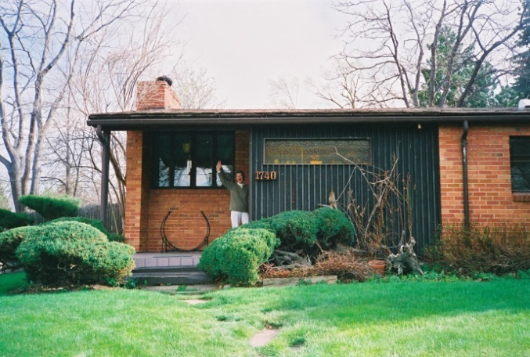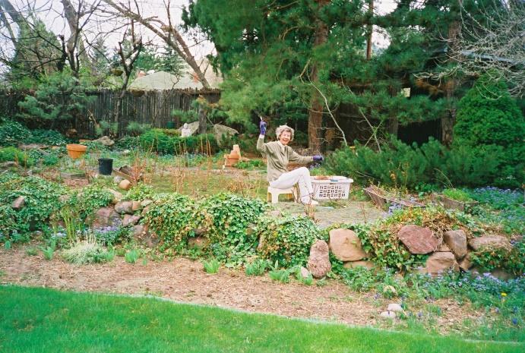
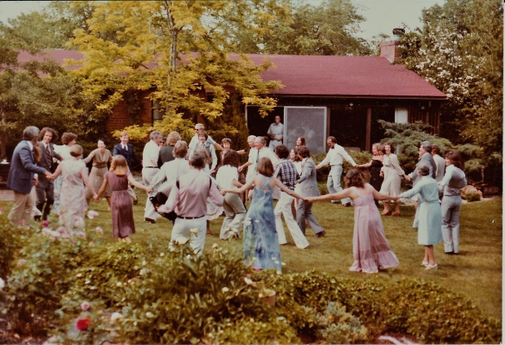
Fig.19: 1740 Columbine Ave. in Boulder, the home of Hammonds family
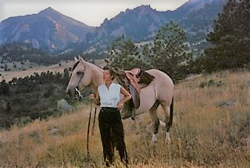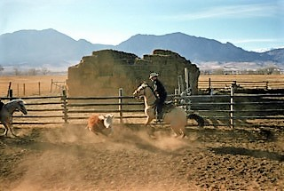
Fig.20: Virginia and (?) enjoying country and horses
He rode a lot, bred a mare that he loved and he and mom (sometimes with other friends) took many pack trips on their horses up into the Rocky Mountains in Colorado and Canada. At that time there were the summer festivities in town like Pow wow, Rodeo and County Fair - and Pam - Kathy(?) used to take an active part in them. He rode until he could no longer attach the horse trailer to our car because of arthritis in his hands.” (e-mail)
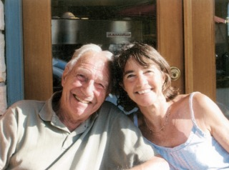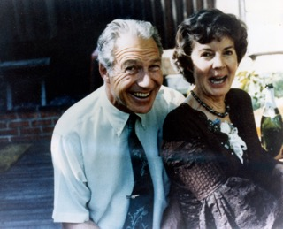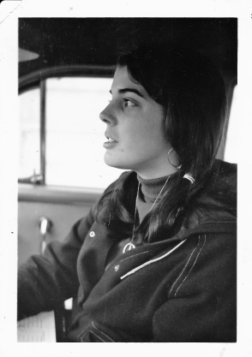
Fig.21: happy family; Ken and Kathy(?), Ken and Virginia, Pamela
Ken gives a number of interesting details, concerning their life in Boulder and on building the Psychology department of the University of Colorado during last 50 years in an extensive video interview (see references).
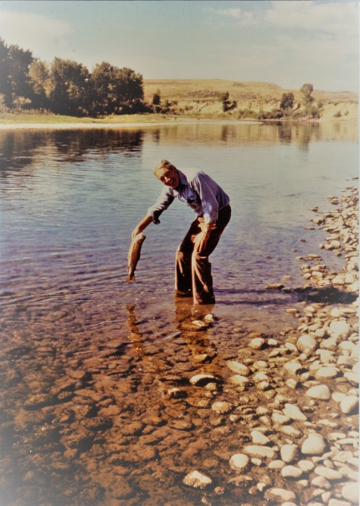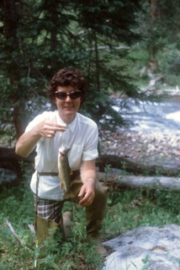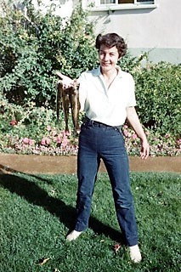
Firg.22: Ken fishing at North Platte River; fishing and not alone!
As photos disclose, Mom Virginia was a beautiful, very gentle, kind and in her later years almost fragile noble woman loving their thoughtfully created garden. Together, with her husband, they created a pair of kind hosts in their very pleasant and stylish house. They traveled within the U.S. on vacations as well as visiting the universities through Europe. They had some lively social life with the in town people as well as the visitors from abroad. A long, dynamic and colorful life, staying together for 62 years. Virginia, in her late years, fought with diabetes and preceded Dad in death in 2003. Her (and Dad´s) gravestone returned them symbolically back, to Monticello, UT. Later Ken moved to the residence of Academy for senior academicians , located in Boulder, a bit above the hill, not far from the place they spent most of their life. In Academy he lived with a friend, Hedy Page.
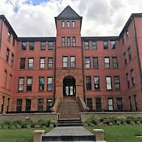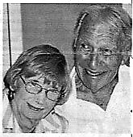
Fig. 23: The Academy at Boulder , Hegy Page and Kenneth

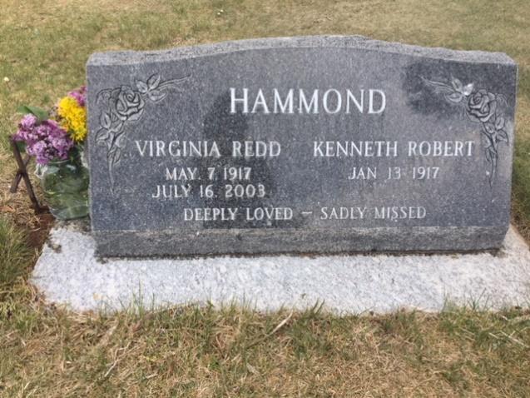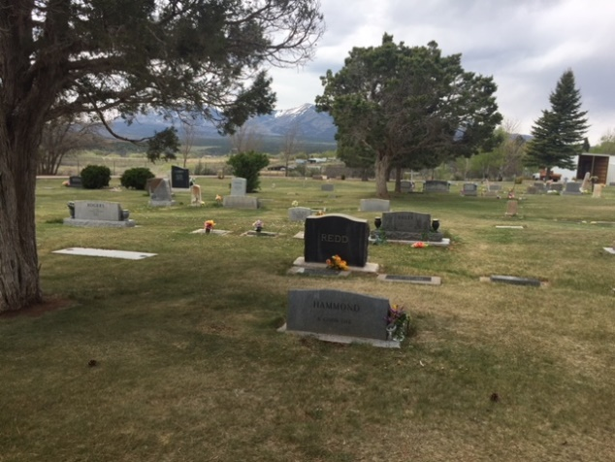

Fig.24: The Virginia and Ken´s grave at the cemetery in Monticello, Utah

How did the academic career of Ken begun?

KRH: “… after receiving my PhD, by a stroke of luck there was a professor from the University of Colorado visiting Berkeley. I was introduced to her, we hit it off, she made arrangements, that is to say, she told the chairman at Boulder, Karl Muenzinger, after whom the Muenzinger Psychology Department is named, that she had met me and thought I was promising. He happened to be a good friend of the chairman at the University of California at Berkeley and well, that was that. I soon found myself in Boulder, Colorado. I stayed there for my entire professional life.”

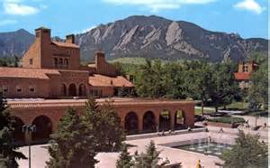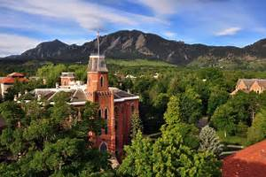
Fig.25: University of Colorado at Boulder. Student Memorial Center and “The Old Main” building. The campus is built in the Tuscany renaissance style, to which the chipped red stone suits very well.

But for reasons that are partly a product of luck and for substantial reasons, I soon became interested in the field of judgment and decision making. I began to think about how many actions are guided by the judgments we make, and I also, unsurprisingly, since this terrible war had just concluded, that wars began with judgments people made, that that kind of activity was necessary. So I found myself immersed in that topic.” Interview

Yet as a student, KRH published his first paper, using Brunswikian approach to study the clinical inference. Then, how did it develop further – namely in respect to the application of the Egon Brunswik´s heritage?
Egon Brunswik had only one of four PhD students , and just one, who completed his dissertation under his supervision – Max M. Levin.

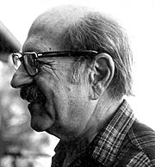
Fig.26: Egon Brunswik´s PhD student Max M. Levin (March 29,1916 – Febr.16, 2008). Used to serve as a Senior Lecturer and Senior Preceptor at UC Santa Cruz's Crown College from 1967-1982, died in Portland, Oregon,
KRH: „ As a post World War II graduate student in psychology, 1945-1948, I stumbled on these new principles of experimental design in textbooks in agricultural research, and soon found myself in the odd position of explaining experimental designs to my professors in terms of "fertilizer, alternating crop rows, and plant growth" because I wanted to make use of the new methods in my dissertation. The first textbook for psychology students that included the new methods did not appear until 1949 (McNemar, 1949). Several textbooks appeared soon after, however, and psychologists—students and faculty alike—took hold of these ideas with enthusiasm. It was not long before every graduate student in psychology was required to pass examinations on "experimental design" and to become sufficiently competent in the application of these methods to construct their experiments according to the (unquestioned) principles of "the systematic design of experiments." If the reader is a graduate student in psychology anywhere in the world, she or he is undoubtedly familiar with, and has been examined for, competence in these methods (often known as "analysis of variance") and modern variations thereof. „It was precisely in these circumstances that Brunswik put forward his criticisms of the methodological "ideology" of the day. His main charge was that it was bringing more harm than good to psychology. To say this was poor timing would be a gross understatement. But, of course, Brunswik did what he had to do, namely, give voice to methodological blasphemy and thus strike a blow at what many saw as the very foundation of psychological science. Therefore, his views received exactly the kind of response one might expect in such circumstances; they were ignored (no textbook in statistical methods or experimental design ever mentioned them), and when not ignored, they were harshly denigrated. All of this had an unfortunate consequence and perhaps together with his high blood preassure problems resulted in Brunswik´s committed suicide. It was in 1955 at his age of 52.“ (KRH Brunswik´s challenge web essay 1)

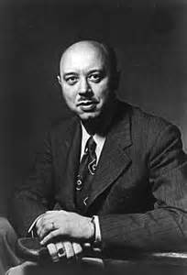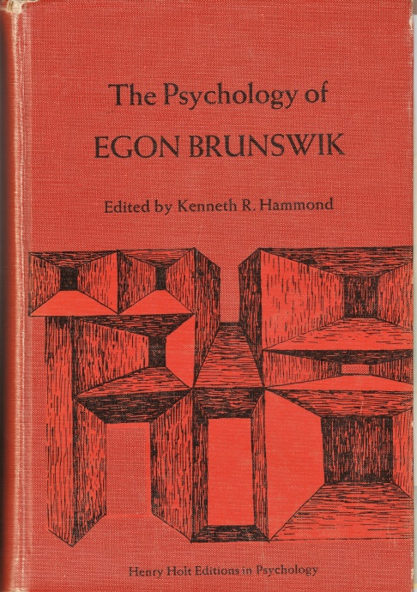
Fig.:27 Egon Brunswik Fig.:28 The first E.B. monograph

KRM: “….The situation at that time prompted (me) with the assistance of Edward C.Tolman, Donald T.Campbell, and Jane Loewinger to prepare this volume” – “The Psychology of Egon Brunswik” in 1965. It was the first comprehensive summary of Brunswik´s thoughts as well as reactions and comments of few prominent psychologists of that time.

Kenneth was a co-founder (with Morris Garnsey) of the Institute of Behavioral Science and co-founder (with Gary McCLelland) of the Center for Research on Judgment and Policy. Also was the founder of the Brunswik Society as a part of a larger Judgment and Decision making Society.

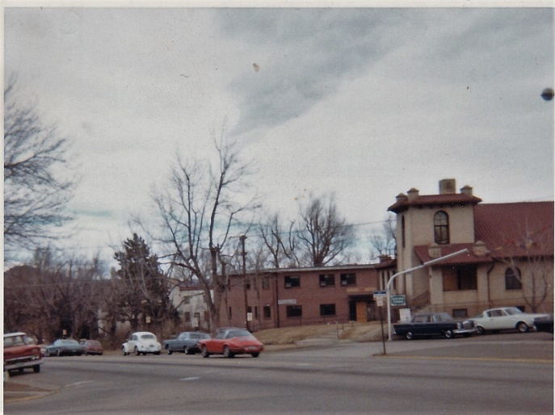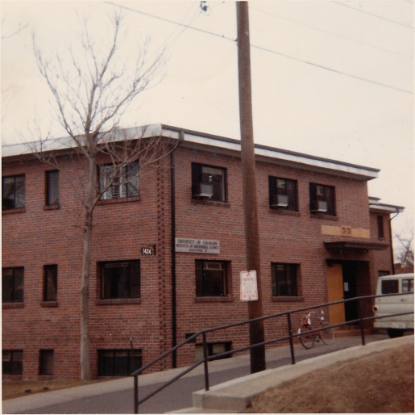

Fig.29: Institute of Behavioral Science, building No.3, Boulder at Broadway and University Eve. during the 60s.

The Institute of Behavioral Sciences (or “IBS”) as I knew it (1968 – 70), was a place of vigorous research activities. The number of Research Reports, publishing empirical studies, exceeded at that time number 100. It was a place, where a number of visitors as well as interested graduate students met. Of course, I do remember just a few – perhaps all those, who created the Brunswik Society, left their trace at the regular Society meetings and their research are reported in the Newsletter (see www.brunswik.org).

The Ken´s obituary says: He held a year-long travel award from the Ford Foundation for travel and lectures in Europe and the Soviet Union in1964-65. He was a NATO visiting lecturer in England, France, Italy, and Greece in 1970. He was a scholar in residence at the Rockefeller Center in Italy in 1974, and a research scholar at the International Institute for Applied Systems Analysis in Austria in 1977. He was awarded an honorary degree by the University of Uppsala in Sweden in 1982. He published 13 books and over 100 articles. His most recent books include “Beyond Rationality: The Search for Wisdom in a Troubled Time”, the award-winning “Human Judgment and Social Policy: Irreducible Uncertainty, Inevitable Error, Unavoidable Injustice”, and “Judgments Under Stress”. His most recent lecture was at the Max Planck Institute for Human Development in Berlin in 2006. He was a member of the faculty of the University of Colorado from 1948 until his retirement in 1987.
He will be missed tremendously by his two daughters, Pamela Hammond of Mukilteo, Washington, and Kathleen Armbruster of Mill Valley, California, four grandchildren, Peter Armbruster, Aaron Armbruster and five great grandchildren, Alex, Luke, Liam, Ellie and Grace.

Of course, he is missed. Otherwise there would be no such Christmas “vánočka” served. As you see, now I got to the lowest, broadest, most contemporary layer of the cake. It is about dozens of students, close and distant co-workers and friends. How to embrace such an expanding world?
The following people are inherent part of my story in Boulder and cann´t be missed here:

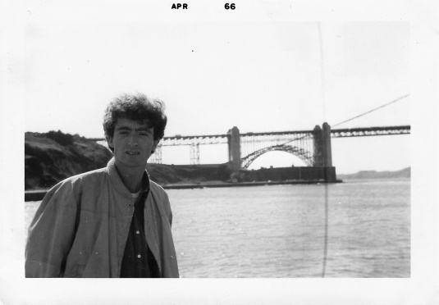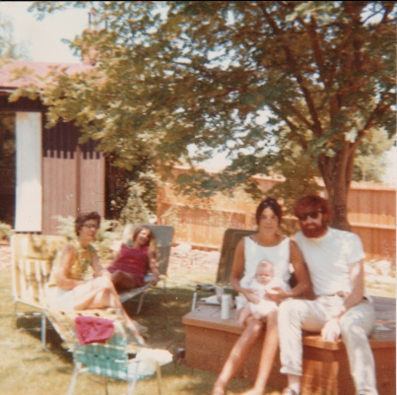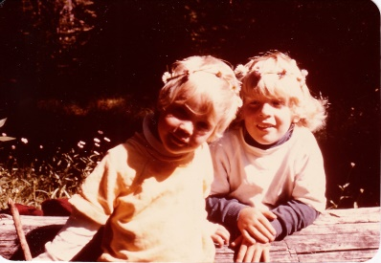
Fig. 30: Timothy Earle and sweet afternoon at Hammond´s garden in the late 60´s

Timothy Earle, now at the Western Washington University. His interests were focused on risk perception and management. At that time Pam and Tim were couples and Bo Earle and Erin Earle are their children – now adults! I still see Tim, browsing patiently through the piles of computer prints in IBS (apparently they had some, for me hidden meaning), leaving them only while getting another cup of coffee. I was amazed by his patience and focus – since I felt this is the kind of behavior, Ken expects from the true scholars – we ought to become in our careers! And of course, I was anything, but
that…..

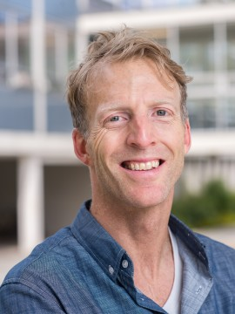
Fig.31: Bo Earle

This handsome young man is Bo Earle, assistant professor of English language at the University of British Columbia in Vancouver, who seems to be a son of Pam and Tim (has a wealth of reddish hair, as his father used to have). He is Brunswikian in a sense, that he translated a Brunswikian book – the name of which I cann´t remember! He obtained his BA and MA at the University of Washington, his PhD at the University of Chicago.

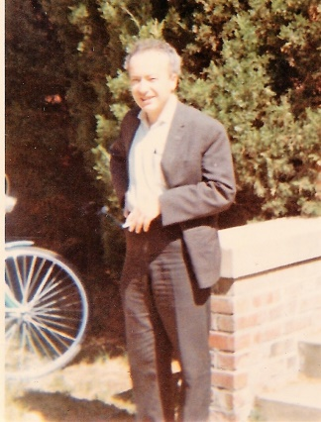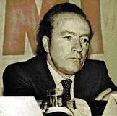

Fig.32: Erol Gungor in Boulder during the 60s and later back, home (Nov.25,1938 – April 24, 1983 Istambul).

Erol Gungor arrived in Boulder earlier than me in 1968 and my only memory of him is, that he enjoyed Bob Dylan enormously – at the times, when I did not understand a word of Dylan´s lyrics. Of course, I was not curious about his professional interests, because I would not understand that either. It would be interesting to know, if there are any traces of Brunswik in Ankara….
He graduated in the year 1961. In the same year, he started to work as experimental psychology assistant with Prof. Turhan. He attended to PhD program in the year 1965. He studied specialization and research in the US at Colorado University and then became associate professsor in 1971 Istanbul Faculty of Arts and Experimental Psychology chair (Gungor, 1994: 417). He was awarded Professor Title in the year 1978. Erol Gungor, who instructed Social Psychology in I.U. Faculty of Arts until the year 1982, was appointed as rector to Selçuk University in July, 1982.

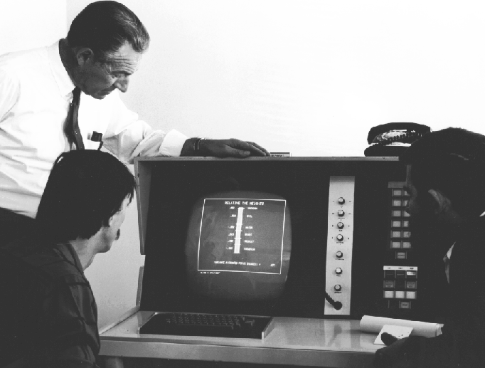
Fig. 33: Ken Hammond, Zeke Little, Peter Boyle, and the Cognigraph, circa 1969. Peter must be seated on the right (totally invisible face).
Peter Boyle, whom I have associated (for some reason?) with South African Republic. I take him as an expert on early computers. He participated on running the POLICY experiments on “computers” (punched paper card blocks or paper tape rolls were the memory media). Big progress - to SEE how people make judgments on bar-graphs and curves ON LINE!!
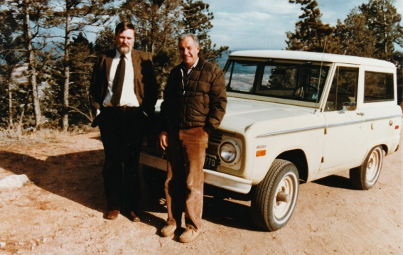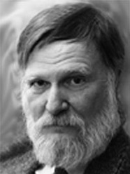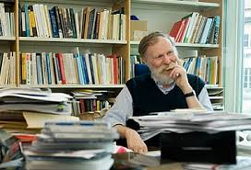
Fig.34: Berndt Brehmer (1940 - 2014), University of Umea, Swedish National Defense College. On the left with Ken and his fabulous Ford Bronco sometime during the 70s (during “my time” Ken used to drive an exquisite red MG Triumph yet). Berndt was very dedicated Brunswikian thinker and author, considered to be the “crown prince” among some Brunswikians. Then suddenly he disappeared from the world of publications…. only to be learned later, that he works as a scientist for the Swedish army; what worse, he transformed his Brunswikian experience into an emerging exciting field – the system dynamics modelling. This, with the advent of computers, allowed much deeper understandings of processes, including judgment and decision making in groups – in a military command settings. As I learned in Google with sorrow – he is not among us anymore. 1

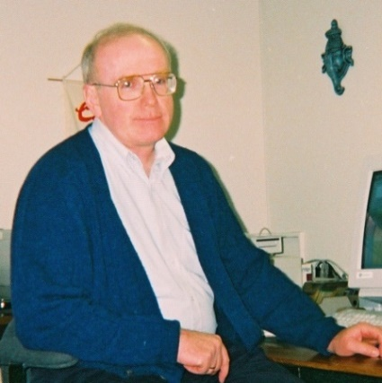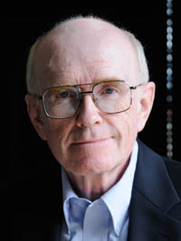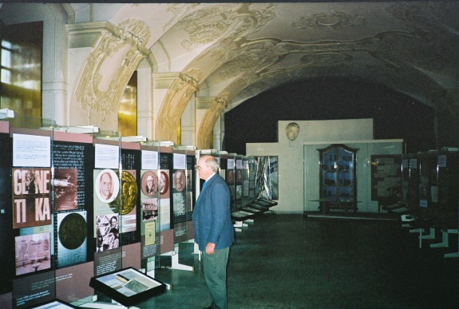

Fig.35: Thomas R. Stewart, profesor retired, S.U.N.Y at Albany, former director of the Research Centre at the Rockefeller College of Public Affairs and Policy. On the picture he inspects the Johann Gregor Mendel´s museum exhibition in the Augustinian monastery in Brno.

Tom is a very kind, quiet, consistent and reliable man, manager and scientist. I wish I could spend more time with him. He offered to me an introduction to the area of his own Brunswikian patterned research (clinical diagnostics, weather forecasting) – which I did not really use, to my pity, at the time we were nearby. Instead, I collected many publications to bring back home… Tom was kind enough to visit us in Brno and to give three lectures – at Masaryk University as well as the Technical University; his slides are still at hand when needed. Now he with his wife live closer again to his love – the Rocky Mountains.

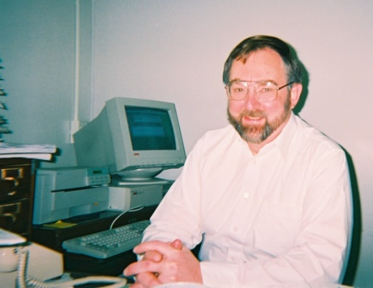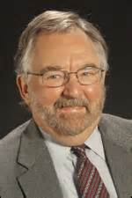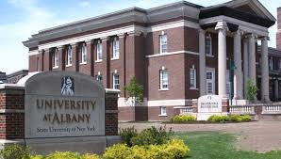

Fig.36: John Rohrbaugh, professor retired, S.U.N.Y. at Albany, Rockefeller College of Public Affairs and Policy. K.R.H´s doctoral student. His research has focused on the problem-solving processes of management groups, executive teams, and expert task forces to identify methods that would improve organizational decision making. With John we have a long lasting acquaintance. While he used to tour Easter Europe and to work at the IIASA in Luxemburg, by Vienna, he visited us in Brno few times and introduced us the POLICY analysis; later he provided us with some used PCs from that institution, which we gladly accepted in our under equiped Psychology department. Later he proved to be patient and kind host and mentor, while I was in Albany with them. Even nowadays, when we try to reintroduce the POLICY analysis to mediate some cognitive conflicts solutions, he is willing to assist us with advice. Our students still make use of his intellectual tasks typology as an example of how to approach cognitively very diverse problems.

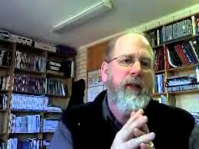

Fig.37: Ray W.Cooksey, professor emeritus, University of Western Australia, University
of New England, Business School
At the later institution there is his fascinating professional profile on their web, worth of reading. He has held positions in three different departments/schools at UNE over the past 32+ years: Centre for Behavioral Studies in Education, Department of Psychology and the UNE Business School - a diverse set of experiences that informs both his teaching and research. His research is focused mainly in the areas of decision making and cognition, chaos and complexity theory organizational and behavioral systems theory, cause mapping and multivariate statistics. Ray was kind enough to provide us with some of his papers, which I enjoyed to translate into Czech to students at times, when not many of them were fluent in English.

In an attempt to make the list of Brunswikians as much complete as possible, here is a group picture taken over from The Brunswikian Newsletter (www.brunswik.org). It includes not only this picture, but reports on a number of meetings like this one was – without pictures. Tom Stewart was “spiritus agens” and editor of this web site for many years. Moreover, together with Ken, they edited the “Essential Brunswik” comprehensive monograph, which includes papers of not only Brunswik himself, but of most society members. This all they made available at www.brunsik.org free of charge to all interested.

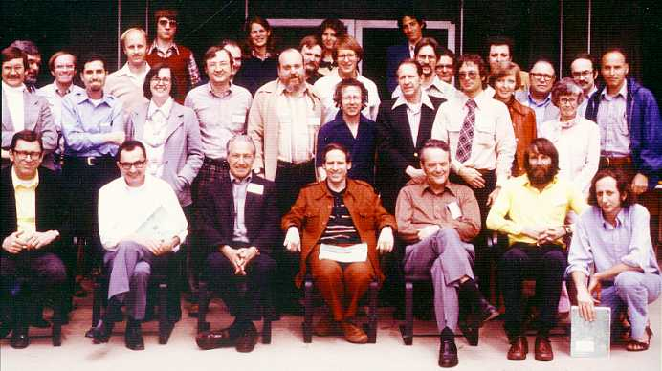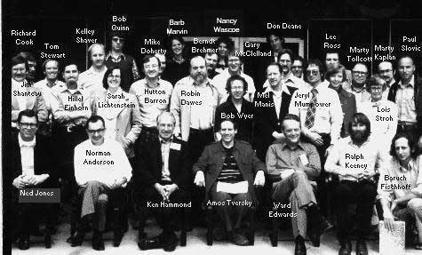

Fig.38: The picture was taken in Boulder, Colorado, at The Harvest Broker Hotel during the 12th of Ken Hammond's Judgment Research Meetings (April 28-30, 1978).

The following few authors I do not know all personally, but they are important to us since they represent the German speaking community and centers of interest in Egon Brunswik close by – they live and work in Europe.

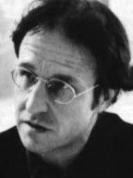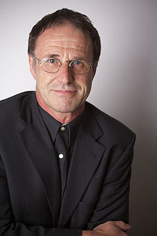
Fig. 39: Friedrich Stadler (17.7.1951, Zeltweg)

Friedrich Stadler is a professor for history and philosophy of science at the University of Vienna. As a founder and the director of modern Wiener Kreis Gesellschaft established in 1991 as a research center of the Vienna circle of logical positivism heritage. During the 90s he organized an international symposium dedicated to Egon Brunswik and the intellectual context of that time in Vienna. Stadler’s main research interests are modern history and philosophy of science, intellectual history and exile studies, the history, theories and methods of the cultural studies, contemporary history of the Vienna University, and Austrian history of philosophy and science with a special focus on the Vienna Circle and Logical Empiricism.

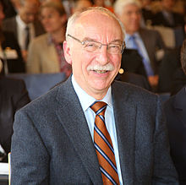

Fig. 40: Gerd Gigerenzer (3.9.1947, Wallersdorf)
Gerd Gigerenzer received his PhD from the University of Munich in 1977 and became a professor of psychology there the same year. In 1984 he moved to the University of Konstanz and in 1990 to the University of Salzburg. From 1992 to 1995 he was Professor of Psychology at the University of Chicago and has been the John M. Olin Distinguished Visiting Professor, School of Law at the University of Virginia. In 1995 he became director of the Max Planck Institute for Psychological Research in Munich. He has organized a meeting of the Brunswikian Society in Berlin, 2000 .
With Daniel Goldstein he first theorized the recognition heuristic and the take-the-best heuristic. He and his collaborators have theoretically and experimentally shown that many so-called cognitive fallacies are better understood as adaptive responses to a world of uncertainty.

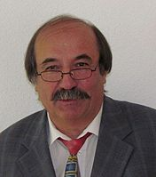

Fig. 41: Werner W.Witmann, (11.1.1944 Eger)
Werner W.Witmann, professor emeritus, Department of Psychology, Chair II), Universität Manheim. His work is focused on assessment in education and psychology, methodology of psychological research which resulted in his interest in some respected personalities in these areas, including Egon Brunswik and KRH.

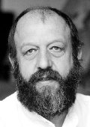

Fig. 42: Bernard Wolf
Bernhard Wolf professor, Universität Koblenz-Landau, Institute for educational sciences. Also he presented several important essays on the Brunswikian website.
As I said, I do not know much about the work of these gentlemen, but they are important as points of departure for those of you inventors, who prefer to acquire knowledge independently, on your own. Now back to the University of Colorado in Boulder, to the nest, where the gravity center of this story is.

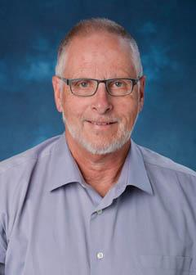

Fig. 43: Gary McClelland
Gary McClelland, Professor Emeritus, University of Colorado at Boulder, Psychology and neuroscience, at C.U. since 1974. “We renamed the program on human judgment at the IBS, which was much larger organization unit of the university, to the Center of Human Judgment. (see page 14). Later it was transformed into the Institute of Cognitive Science (ICS). Gary's two primary research interests are (1) judgment and decision making and (2) statistical methods. He is a founding member of the Society for Judgment and Decision Making and a founding fellow of the Association for Psychological Science.” GMC

Garry has drawn my attention by a critical paper, presented at the Brunswik Society Meeting at L.A. in 1995 (“Surveing Asteroid Configus with Statistical Methods – A Parable Showing Why the World Will Always look Flat to Brunswikians”). I did not find any reaction by Brunswikians to it. He was kind enough to explain his position to me by an e-mail in a following way: “…representative designs or random samples require enormous (> 1000) to have much chance of detecting interactions and non-linearity. So my conclusion that Brunswikians using representative designs will always find simple models of the judges they study. Why hasn’t it had more impact among Brunswikians? (1). Many Brunswikians don’t seem open to new ideas to me. (2). Those who do understand the argument still believe that more accurate judgments are obtained in representative designs than the artificial sets of stimuli required to achieve adequate statistical power for more sophisticated models”. (GMC, personal communication, Jan 19, 2018) I believe, that Garry McClelland, Berndt Brehmer and perhaps some other Brunswikians would be very qualified to write a rewrite up-to-date chapters to the “Essential Brunswik” volume. The students of today would deserve it.

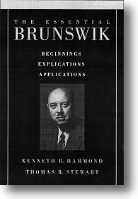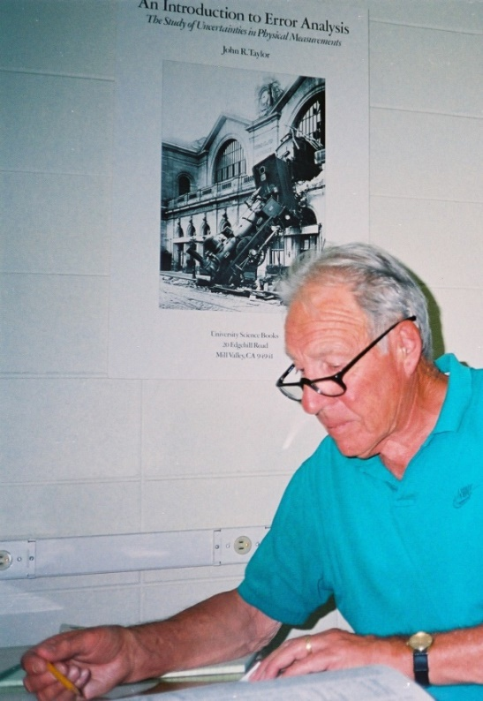

Fig. 44: Ken Hammond´s and Tom Stewart´s summary of thee generations of Brunswikians´ work. (The real good stuff in the two layers of “vánočka” Christmas cake is here.)

Now I will paraphrase Ken: “Because this (paper) is memorial volume for (EB and KRH), our readers will be no doubt surprised to find a … (paragraph, L.K.)… critical of his work. In most memorial volumes, we agree, this would be in a poor taste. …. Certainly, Brunswik worked hard enough to invoke criticism – there should be no reason to walk softly now…” (KRH, Psychology of Egon Brunswik, pp.vi – vii).

Looking at these two faces on the Fig. 44, I have to add one last personal note. Ken Hammond described Brunswik as a man whom it was hard to approach, intellectually “over students´ heads”, demanding. If one did try, then Brunswik was friendly, interested and supportive. My experience is, that Ken was about the same – yet in his own way (as E.C.Tolman wrote about Brunswik - a “top notcher”). He attracted young people by his personal appeal, raised curiosity by exceptional Brunswik´s story, by his original, extraordinary message. Ken by his strong persuasion, that the work being done is important (I recall his anxiety about the global cognitive conflict between the East and the West, the possible WW III – “just few more years to survive…”). I can see, that he might understand to Brunswik´s resignation in his final years well; the mainstream Kahneman and Twersky approach to judgment and decision making won the public recognition and even the fame. But why?

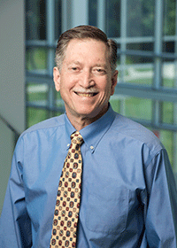
Fig. 45: Leonard Adelman, professor, Systems Engineering and Operations Research, George Mason University, Virginia. His research is oriented toward (1) understanding judgment and decision processes, and (2) designing and evaluating systems to support them. Regarding the former, Adelman has performed research to understand how people define (or “frame”) judgment and decision problems.

Len Adelman guess is, “that it was in part because (a) their research fit nicely with the methodology of mainstream psychology, with which Ken (and Brunswikians) found problems, and that (b) their 1979 Prospect Theory paper attacking the axiomatic-based theory of the rational decision maker was published in Econometrica, acquiring a very broad audience in the business community where Ken never published his research (e-mail communication).

Besides the fact, that he influenced my life in a fundamental way, which I am thankful to him for, I also experienced Ken´s disapproval of my different opinion (regarding his idea of “analytical creativity” which is introduced in his book “Judgment under Stress”). I express this all not as a neutral, “objective” observer – it took me well over forty years to free myself of the feeling, that I disappointed my mentor and failed to develop Brunswikian mission… What is worse, I trace such traits in my own academic career and expectations from my students and even our kids.

Anyway, Brunswik would have grave problems to extend his “development of psychology as an experimental science” scheme closer to our times – the era of logical positivism seems to be behind and not only probability, but postmodern relativism is creeping in in many instances. To assess the influence and proportion of the Brunswikian thinking and research in the overall, exploding academic publications mainstream is a difficult task, worth of a PhD research. For it returns us back to the basic questions of logical positivist – what is the truth, the meaning, role and practical effect of (social) science in the real life… Which is, of course, another story…..

Fig.46: Lubomír Kostroň at 1740 Columbine Ave during the late 60s. At that time I did not know, that gardening will bring much more joy to my life, than research in academic settings….

Now, to close the story, there is a place to humbly confess how I got into it.

For me, it all begins in 1965, when I was admitted as a student to the psychology department of the Masaryk university in Brno, Czech republic - at my slight wonder – I wanted to study the history of fine arts. My dad (also an university professor), an old boy-scout, had a large (second generation) library of fine books. One of them, was a booklet by a Czech, Bohuslav Glos, entitled “What I had seen in America” and included a hand written dedication to my father dated 1933. I browsed through it one day and (just by a chance!) the author visited our family in the early 60s. I could talk to him and it was all clear to me suddenly – if psychology, I want to study it in the U.S, they know it best there! Sufficiently wild idea! During the late 60 (1966?), Kenneth Hammond toured the Eastern Europe and had a lecture also at our Psychology department. It was fascinating! Also just by chance, my class-mate Tanya and myself had a first date on that day – and we went to visit this exotic professor to a local hotel – he was kind to us and soon we discussed a possibility to study in the U.S. What a great day! Fantastic hope into the future – and a beautiful girl by my side. What else to wish? So we both participated in a Ken´s cross cultural research of cognitive conflict (no computers, just sets of experimental paper cards with tasks to assess the level of democracy in a fictive state, do you remember?) and I was kept hoping, that after completing the bachelor´s level, I would be offered a year scholarship (as a research assistant) at the University of Colorado. Kenneth kept his word, even though there was a certain risk involved in the person of unknown student. On this side of the Atlantic ocean the obstacles were also mounting – to get the exit visas from Czech republic to the U.S. for a year (!) – required not only tourist passport, but a ministerial, “service” one. It took two years to get all required documents and stamps here. To make long story short, on May 31,1968 I landed down at the Stapleton International Airport in Denver and was brought to 1740 Columbine Ave. by pen-pal Patricia, directed to Denver by Ken. Of course, I would learn how to bake whatever cake Hammonds might think of even now, after the years - just to celebrate the overwhelming sunny morning, when I woke up at their guest (former daughter ś !) bedroom. Then the Russian invasion of Czechoslovakia took place, one year went by quickly and the time came to decide what to do – I was given a second year scholarship as a teaching assistant – to complete the M.A. in psychology requirements. I collected some more research data, which were used by Berndt, I believe, in some study. Then I returned home in July 1970 and my M.A. diploma arrived later by mail (the second cultural shock was as hard as the first one).
You can imagine, that there is a whole world of impressions, some traveling (about 40 thousand miles?), many great people and close friends to talk about. Bags and bags of books sent by snail-mail. In the meantime Tanya completed her studies (her dissertation was an interpersonal learning lens model application). Soon we got married and submerged into a family life.

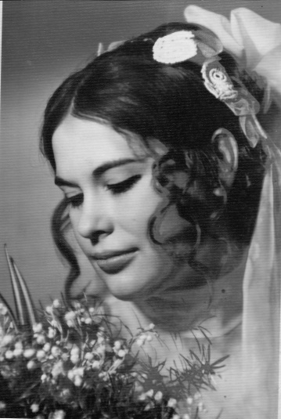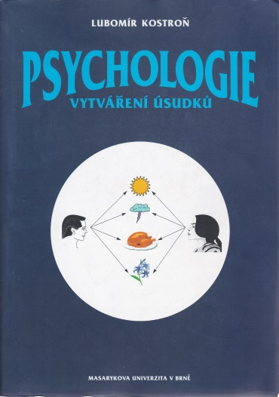

Fig.47: Taťjana Kostroňová as a bride and as a partner in family problem solutions. The book on Brunswikians in Czech.

Well, returning to Brunswikian business, I have to confess, that my practical jobs were remote from the academic world. My PhDr. thesis was on business store managers typology. It used the three dimensional research project (types of working environment, types of personalities, cognitive and behavioral interaction between both). I kept this “paradigm” in mind in all jobs, I had ever since. Academic psychology perspective was closed to me – but, surprisingly, I could work for a degree in economics! Which I did pursue (the thesis on the efficiency of medical technology design, production and the use, was also a good school of life). At the 1990 I was invited to our Psychology department at the Masaryk university to teach. Of course I smuggled Brunswikian agenda everywhere it made a sense, there were even two M.A. dissertations written
(by Martin Vaculík and Helena Klimusová), based upon triple system lens model, modeling the cognitive conflict, using the POLICY software. Both of them teach psychology students in Brno. Finally, Osman Salih, wrote a dissertation “Egon Brunswik and Contemporary Psychology – from probabilistic functionalism to judgment under uncertainity ” at the Charles University in Prague in 2009.

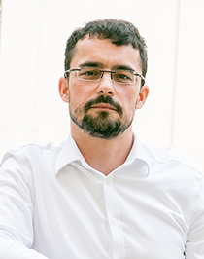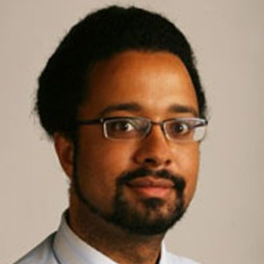
Fig. 48: Martin Vaculík , School of Social Studies, Masaryk University, Brno, Czechia
Helena Klimusová , School of Philosophy, Masaryk University, Brno, Czechia
Osman Salih, Department of Psychology, Charles University, Prague, Czechia
However, I was never really a good researcher – I had an increasingly hard time to believe, that research in theoretical psychology (social sciences) makes much sense (as you know well, the organism, ecology and tasks are changing at all times…). The interest in ecology was a route to a broader study the psychology in architecture - which I loved for some years and wrote a textbook about (what else, KRH and Brunswik are in it). Besides introducing reader into the basic E.B. and K.R.H. concepts, I tried to sort out the parameters, which are used in “a system dynamic model of sustainable development of regions, dwellings and communities” (see Beran V., Dlask P. 2005) according to their nature (analytical cognition vs. intuitive extremes on the “cognitive continuum” scale). Independently of Berndt Brehmer I got also interested in the fashionable complex systems and chaos theory, later in dynamic systems modelling (the Fulbright foundation, Tom and John were kind enough as to provide me with all I could ever dream of at Albany). It turned out, that even in these disciplines I am not as bright and diligent scholar, as mastering and using them requires. I found myself to be just a happy translator of smart papers and a few books from English into Czech - items of my own choice and taste. A variety of them is locked on my website – the copyright law is now respected fully even here. Thus I left the M.U. in about 2006 and continued to teach human relations development and management to the more mature audience at a private school until the last year. Two years ago the privately owned New York University in Prague hired me as a lecturer of a graduate course in general psychology in English – and that is where Brunswik, Hammond and you are taking place again. This semester the students of psychology in Brno might be also interested ! And this is the reason, I bake this cake and share this story with you.

January 20,2018

Notes
This story is not intended for general publication, since it contains pieces of some rather private information. It is meant
a) to introduce psychology students in graduate courses to two pioneering personalities (in a way heretics), proposing unorthodox approach to cognition, judgment and decision making – as well as to the research design. The “science as a story telling” method, demonstrated here, grows from an opinion, that science may be logically coherent, but without understanding the social and human context, it does not have much sense. What more, individual experiences and emotions shared here are what makes it fun and adventure to enjoy – and perhaps to seek for more information. The above story is just an introduction to a course, which is provided with an extensive set of slides, giving proper definitions of important Brunswikian concepts as well as publication references.
b) to please few Brunswikians and KRH family members, for reflections of the past times are usually pleasant – and to show my affection to them all.
I want to express my deep gratitude to Kathy Armbruster and Pamela Hammond for sharing some information as well as family photographs. Also, to Tom Stewart, who remained at all time supportive, sharing his knowledge and wisdom as a good friend. Dear John Rohrbaugh was willing to help in any way advice repeatedly. And of course to Garry McClelland, who was kind enough as to explain some things I did not understand at the moment, this cake was almost done. Thank you!
Cognigraph: (from Hammond, K.R. and Brehmer, B. (1973). Quasi-rationality and distrust: Implications for international conflict. In Rappoport, L. and Summers, D. A. Human Judgment and Social Interaction. New York: Holt, Rinehart, and Winston.)
Note related to the Fig.2 and 3: The authors are very grateful to Mr. Harald Brunswik of Hörbranz, Austria, whose father--Eugen Brunswik--was Egon Brunswik's cousin, for the information and photographs
Some paragraphs include reference to their quoted authors (Pam, KRH, obituary, Sherley Berg). My own writing used a different font.

Literature used and some selected resources:
Beran V., Dlask. P (2005) Management udržitelného rozvoje regionu, sídel a obcí”, Praha, Academia
Berg Shirley (July 2008) Ken Hammond, The Academy News and Views, Vol.2. Issue 2,
Bower Bruce (2002) A Maverick Reclaimed – some Psychologists Say it´s Time That Egon Brunswik Got His Due”, Science News, March 9, vol. 161, pp.155-156
Brunswik E. (1937) Psychology as a science of objective relations
Brunswik E. (1952) The Conceptual Framework of Psychology
Brunswik E. (1955) Representative design and probabilistic theory in a functional psychology
Brunswik Egon (1955) In defense of probabilistic functionalism: A reply
Brunwik E. (1955) "Ratiomorphic" models of perception and thinking
Brunswik E. (1956) Historical and thematic relations of psychology to other sciences
Brunswik E. (1956) Perception and the representative design of psychological experiments
Hammon K.R.(ed.) (1966) Psychology of Egon Brunswik, Holt, Rinehart and Winston
Hammond K. R.(1968). Brunswik, Egon. In International encyclopedia of the social sciences (pp. 156-158). New York: Macmillan.
Hammond K.R. (1996) Humanm Judgment and Social Policy – Irreducible Uncertainiy, Inevitable Error, Unavoidable Injustice, Oxford Universit Press
Hammond K.R., Stewart R.T. (2001) The Essential Brunswik – begginnings, Explications, Applications, Oxford University Press
Tolman Edward C., Brunswik Egon (1935) The organism and the causal texture of the environment

Internet resources

There are web sites to all the Bruswikians, mentioned here, associated with their respective institutions.
http://familypedia.wikia.com/wiki/Brunswik_von_Korompa_family
ttp://oralhistory.boulderlibrary.org/interview/oh1545/. There exist two more video recordings, available upon request: a) K.R.Hammond lecturing at SUNY (provided kindly by Tom Stewart) and b) Berndt Brehmer on meeting of the Brunswikian Society at Dallas, presenting a research report.
www.brunswik.org
www.kostron.cz

