ENSb 1307

The exam consists of 6 essays and is worth a total of 75 points. Each answer should be 300–400 words using 11-pt Times New Roman Font 1.5 line spacing. Number your answers so it is obvious which question you are addressing. You must answer independently and not work with anyone else.

**Email me your answers by midnight (CEST) Thursday, June 3**

You must answer the first three questions worth 15 points each.

1. Explain the bioenergetics model for ecological succession given below. Why does it matter that NPP approaches zero in the climax community? How is this model relevant for Socio-economic systems?

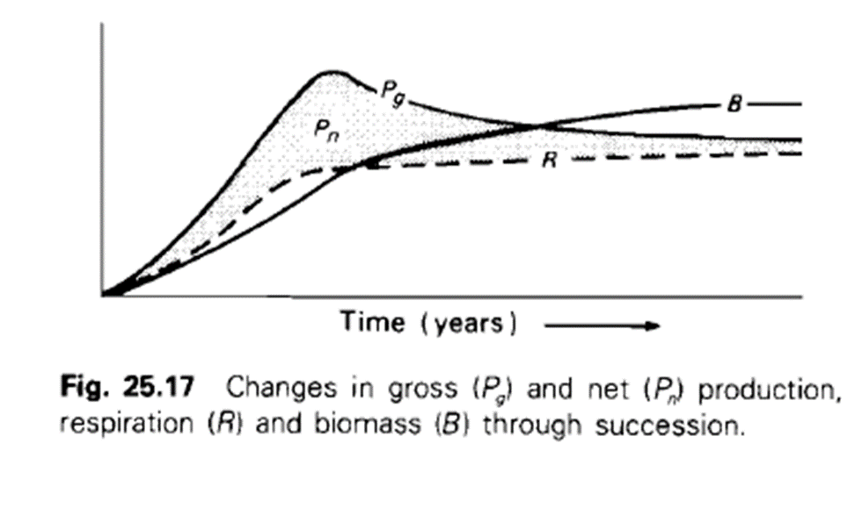

1. The final conclusions of our book, *Flourishing within Limits* state, we need to do the following:
2. increased investment in education and knowledge creation,
3. accounting the contributions of ecosystem services,
4. a transition from non-renewable to renewable energy sources,
5. focus on development and quality over growth and quantity, and
6. building community networks within sustainable places

Which of these do you think is most important? Which do you think is most difficult to achieve?

1. Why are some reasons that we should celebrate limits?

Answer any three of the following (10 points each):

1. What is the complex system cycle and how does it extend the standard succession concept from r-selected to K-selected species? How does collapse potentially benefit the system in the long run?
2. “What is life” from a thermodynamic perspective? How does it differ at the scale of the individual, population, or ecosystem?
3. What are the advantages and disadvantages of putting a price on ecosystem services?
4. What are some of the factors that go into measuring ecological footprint? How is this related to biocapacity?
5. What are some of the parallels between ecological systems and economic systems?
6. Describe the economic system as an open, “metabolic” system. How is this different than the standard view of economics?
7. What is the significance of the Blue Marble photo (the picture of Earth taken by Apollo 17 astronauts) in the modern environmental movement?
8. One of the “Habits of a systems thinker” stated “consider how mental models affect current reality and the future”. Give an example we discussed in class of a mental model that would improve human-environment conditions if we changed it.