**PSYb 2910 Science as a story telling**

The prerequisites for registering are the successful completion of the General psychology courses PSYb1050 and PSYb1060.

**Course Objectives**

a**) to discover**: behind the theories (of a general psychology) there are hidden names, faces and life-stories of an authentic people; these make their context, which we usually miss.

b**) to play: become a designer** –

**choose** two, three of the questions presented in this syllabus,

**find** enough of relevant information and compose a fresh, coherent view of them.

Put old concepts into a new light.

**Tell your own story** – how will psychology look like in about ten years? What psychological tools should you master to make a living as a professional?

Even better **– became a new tool maker yourself**!

c) to improve the English proficiency.

**Learning outcomes:**

To complete the requirements of this course, the student have to acquire more **personal understanding of general academic concepts. Their courage to be critical and creative thinker will be reinforced**. Thus the ability to cope with unexpected professional problems and to recognize better possibilities of their solution is to developed.

**The structure – the course menu to choose one topic from:**

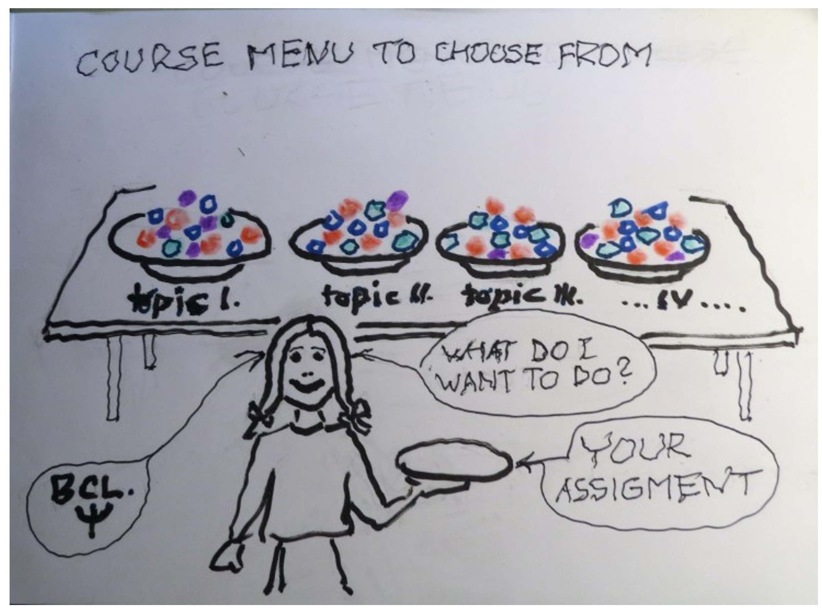

* a**) Perception, judgment** (read how Viennese logical positivist Egon Brunswik met Californian behaviourist, Edward C. Tolman and what resulted from their co-operation);
* b) **Social judgment theory** (read how Kenneth R. Hammond at the University of Colorado competed with Kahneman in Princeton and Twersky of Oregon Research Institute – and lost the race);
* c) **The nature of information and knowledge** (read how simply Polish sci-fi writer Stanislaw Lem sees the transformation of percept impulses into an information);
* d**) Model of general psychology** (build a mysterious Golem of Rabi Jehuda Leva ben Becalel on our own) beyond cognition - what to add to make a model of living system ?;
* e) **General psychology and the concept of** personality (what fits with what?);
* f) **Ill - defined problems´ solution** (history of naval catastrophes - stories of reasoning, emotions and social context. **The theory of tasks** (John Rohrbaugh), **situations** and the environment/ecology);
* g**) The decision-making under uncertainty**, social context and group support (Thomas Stewart, Ray W.Cooksey, others…) ;
* h**) System dynamics** (tell your story of how a structure was transformed into a process)
* i) **Interpersonal cognitive conflict solution** (workshop with POLICY DOS software, which Martin Vaculík used then, and how the judgment analysis is done nowadays);
* j) **The eternal puzzle of Consciousness** (will the quantum physics approach meet with the molecular neurology?);
* k) **The ultimate aim of knowledge** – the art of asking the right questions;
* l) Metapsychology **(how do you see the future of psychology?).**

**Literature**

* KAHNEMAN, Daniel. *Thinking, fast and slow*. 1st ed. New York: Farrar, Straus and Giroux, 2011. 499 s. ISBN 9780374275631. [info](https://is.muni.cz/publication/985273)
* Slides, reading materials and references provided for the course ([www.kostron.cz](http://www.kostron.cz))

**Methods**

**Four blocks of lectures and discussions ( always on Wednesday March 10, 17, 24, 31, April 7, 2.00 p.m. – 18.30 p.m.) are to be reached on the following address**

https://cesnet.zoom.us/j/91730529637?pwd=TmN3RXdzSUtFVXk3cExHN1lrR0hrZz09

**Continuous e-mail consultations, feedback and support on** [l.Kostron@seznam.cz](mailto:l.Kostron@seznam.cz) **,** the assignment presentation.

On the last meeting **about 10 works may be presented to the class and discussed (and group graded?).** The extent: 15 minutes presentation (plus 15 minutes discussion) or about 10 pages essay. It is strongly recommended to check the timing of presentation while preparing it. The grading of the presentations by students will be recorded on prepared marking sheets. Those, who prefer it, may submit their paper for lecturer´s grading only.

**Assessment metods**

The high grade papers will be those with a reasonably complex topic, proving high ingenuity, originality and independent approach in thinking as well as searching for information sources. A good example, used in the presentation, will be also appreciated.

**Language used**

English