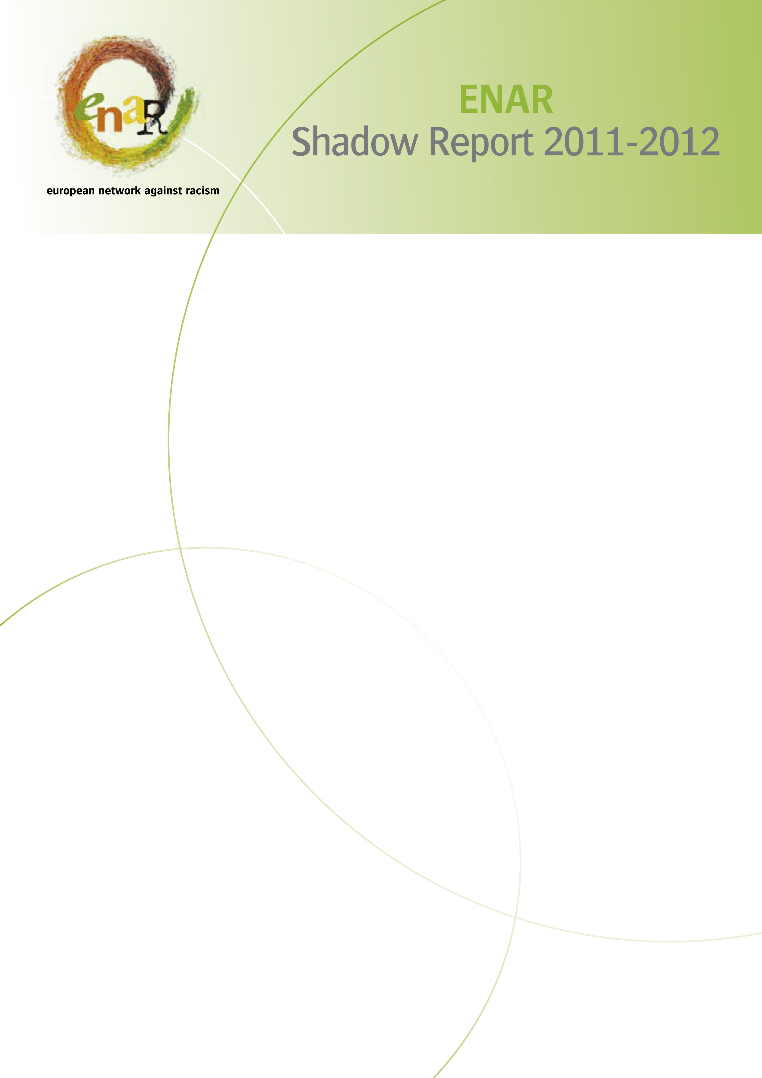

ENAR Shadow Report

Racism and related discriminatory practices in (insert your country)

(Insert author’s name and organisation)

Please DO NOT CHANGE
- Font format, style and size, keep as per given in the template: Arial 12, with 1 line spacing
- Lay out of the template: keep each heading, subheading and paragraph as given in the template (highlights are used for your information only, please erase highlights in your final draft)

1. Executive summary

Please provide a brief summary of the report (no more than a page or two).

This section should include a few sentences on the aim of the report, but the main emphasis is to summarise the key findings of the report, preferably listed in the order of political relevance and in line with the order in which they are written in the report. Be sure to make specific reference to the time period covered by this report, i.e. from March 2011 to March 2012. This is to be followed by recommendations in bullet form. (These recommendations will likely be same ones in section 9).

As you know, the aim is to provide an overview of the contextualisation of the situation on racism and related discrimination in your country during the period 2011/2012. This should be used to lobby for positive changes at the national level, in line with ENAR’s progressive narrative on equality and diversity for all. The results of this report will be collated and compared with other EU Member State reports in the form of a European Shadow Report, which in turn will be used to lobby for positive changes at the EU level. The special focus of this year’s report is on Muslim communities and the prevalence of Islamophobia in the country.

Accuracy is essential. Particularly because based on your summary of recommendations, political action may be taken by people who have not read the entire report. This is relevant in cases in which this section is the only one translated in the national language.

Consider planning and writing the executive summary according to the following steps:

- List the main findings, first, in the order of political relevance in the country and, secondly, according to the order in which they appear in the report.
- Add supporting or explanatory sentences as needed, but avoid too much detail or examples (max 2-3 sentences per area) in the executive summary.

2. Table of contents

The author should please complete this.

3. Introduction
The introduction should begin with a general paragraph describing the aim of the report and the various topics to be covered. Be sure to make specific reference to the time period covered by this report, i.e. from March 2011 to March 2012.

The introduction should include an overview of the topics which are to be addressed in the report in regard to the situation on racism and related discrimination in the particular country.
- Here, you should write one or two sentences on the particular communities most vulnerable to racism and discrimination in the country and why
- Also mention whether any particular legal changes in regard to discrimination and equality have taken place in the period under review.
- If there were legal changes or new targeted communities, a more detailed description of this should come in the next section (IV. Significant Developments in the Country).
- If there were no legal changes or changes in regard to the targeted communities, then a sentence or two stating that there have been no major changes since the last shadow report should come here in the introduction.
- The reader should be referred to earlier shadow reports for more information.
- This particular edition’s specific focus is on the situation of the Muslim communities in your country, which should be mentioned here. In this introduction section, you should highlight the forthcoming aspects in regard to this special focus in just a few sentences. The more detailed description is to come in a later section.
- And finally, the introduction section should include a description as well as a 1-2 paragraph explanation of your report’s design/ structure.

The introduction should be maximum 1 to 2 pages.

4. Significant developments in the country during the period under review

This first main section should be dedicated to highlighting significant developments in the country during the year under review. Here, the aim is to provide an objective update on the legal, social, and political trends/changes in the country and time period under review.

- Please provide an update on significant political and legal developments that occurred in 2011/2012 and structure this chapter according to these subheadings:

1.1 changes in regard to the communities most vulnerable to racism or related discrimination in your national context
1.2 changes in legal developments regarding discrimination and equality legislation from the previous year
1.3 changes in migration, asylum and integration policies
1.4 changes in public perceptions, political discourse or attitudes from the previous year in regard to most vulnerable groups
1.5 developments addressing social aspects, i.e. integration/inclusion of migrants and ethnic and religious minorities, including changes in National Reform Programmes, National Roma Integration Strategies, local action plans, and the involvement of NGOs in this process
1.6 provide data/statistics/quotes from civil society actors to support this assessment

We have changed the template from previous years in order to avoid the repetition from one year to the next. It is still important, however, to provide a general overview of the situation in the country to ensure that the report can be read in isolation from previous years’ reports. The reader, however, can be referred to earlier reports to obtain more detailed information, i.e. if the legal changes were last made in 2008, refer the reader to that shadow report description, but still what legal policies are currently in place.

This section should be between 1 to 3 pages depending on the changes in the country from the previous year.

5. Special focus

Because the particular focus of this edition is on Islamophobia, there should be a section dedicated to the specific situation regarding discrimination of Muslim communities/individuals in your country. Again, provide an objective overview as far as possible.

This should include:
- a specific focus on the situation of the Muslim communities
- differences between the Muslim communities themselves (if there are more than one)
- provide information regarding Islamophobia in the country, how it manifests itself, whether there is a consciousness of this phenomenon among the general public, etc. Please consider whether the public discourse (politicians, media, opinion leaders) might display Islamophobic elements while there are few to no Muslims in your country. This type of narrative needs to be accounted for.
- are there particular regions in the country where the situation for Muslim communities is more tense, more problematic?
- contrast the situation for Muslim communities with those of other groups vulnerable racism or related discrimination in your national context and provide data/statistics, quotes from the civil society actors to support this.
- consider forms of multiple discrimination, for example, the intersection between race, religion, and gender: Are Muslim women particularly vulnerable?

Essentially, you should consider in this edition the areas in which discrimination against Muslims are most prevalent. This length of this section will vary from country to country depending on the actual situation of Muslim communities in your country.

If you think Islamophobia is not a concern in your country, get quotes from key stakeholders to support this theory.

6. Access and full participation in all collective areas of society

This should be the introductory section for the overview on discriminatory and racist trends, i.e. challenges for some in enjoying full participation and equal access to essential resources, such as employment, education, housing, health, access to goods and services, political participation (including citizenship/nationalisation options, double citizenship, voting rights in country of destination), media (including protection from cyberhate and representation in the media), and criminal justice (including racist violence and crime, and counter-terrorism).

6.1 Racism and related discrimination in employment

6.1.1 Manifestations of racism and related discrimination in employment

What are the key challenges in your national context when it comes to enabling full access to employment? Please consider the employment situation particular to Muslim communities as well. The following list is not extensive, but should help you address this section.

- restricted access to labour market due to legal status
- discrimination in recruitment policies, including job postings, job applications (i.e. still using picture photos, requiring mention of age, legal status, country of origin, etc. on the application)
- discrimination within employment, on the job tensions, evidence of this occurring more often in certain job sectors, lower wages, glass ceiling effect, failure to comply with religious needs, dietary needs, etc.
- underemployment, i.e. being placed in jobs below the qualification of the individual, failure to recognise previous qualifications, failure to recognise multiple language skills, including that from the country of origin, links of particular communities working in specific sectors
- unemployment, i.e. tendency of certain communities of being trapped in unemployment
- Please also include data/statistics.

6.1.2 Facilitating factors or protective measures to combat employment challenges

- Are positive actions measures encouraged? (.e.g. through recruitment policies)
- Consider the role of businesses, trade unions, EU and national funding schemes, and other related areas that are deemed positive in employment.

6.2 Racism and related discrimination in education

6.2.1 Manifestations of racism and related discrimination in education

- What are the main challenges regarding equal access to and participation in education in your national context (e.g. segregation, lower quality education, bullying, early school leavers, drop-outs, lack of recognition of multiple language needs, failure to benefit from country of origin language skills (resulting in disempowering youth), teacher discrimination, lack of mediation skills, intercultural dialogue, etc.)?
- What specific problems do the Muslim community face in this area? Do Muslim women face particular problems?
- For each problem area, highlight relevant developments and statistics demonstrating discrimination against Muslims during 2011/2012. Consider gendered differences in each of the areas if such statistics are available.

6.2.2 Facilitating factors or protective measures to combat education challenges

- Have there been any debates around promoting intercultural dialogue in schools?
- Have boys and girls from ethnic and religious minorities been equally involved?

6.3 Racism and related discrimination in housing

6.3.1 Manifestations of racism and related discrimination in housing

- What are the key problems related to housing in your national context? (low quality housing, homelessness, discrimination in private rental market, options to buy homes, access to credit to buy homes, etc.).
- Consider the particular situation for Muslim communities as well.
- For each problem area, please highlight relevant developments and statistics demonstrating discrimination against Muslims during 2011/2012, if applicable.

6.3.2 Facilitating factors or protective measures to combat housing challenges

- Are diversity instruments being implemented in housing organisations?
- Are landlords being targeted for anti-racism work and intercultural competence?
- Are ethnic homeowners contributing in countering discrimination in housing? If so, how?
- Are there community housing initiatives with enough power and influence to alter housing discrimination tendencies in certain neighbourhoods?
- Are realtors being trained anti-discrimination and intercultural competence?

6.4 Racism and related discrimination in health

6.4.1 Manifestations of racism and related discrimination in health

- What are the key problem areas in your national context? (e.g. access to healthcare, linguistic and cultural barriers, discriminatory attitudes from healthcare professionals, higher health disparity and problems among low-income individuals, greater psychological effects and mental illness among targeted and vulnerable groups)
- What specific problems do the Muslim community face in this area? Do Muslim women face particular problems?
- For each problem area highlight relevant developments and statistics demonstrating discrimination against Muslims during 2011/2012, if applicable.

6.4.2 Facilitating factors or protective measures to combat health inequalities

- Have there been any progressive developments in healthcare, such as hospitals with equality ombudsmen present and actively engaging vulnerable groups in preventative health?
- Is there equal support and treatment for men and women?

6.5 Racism and related discrimination in access to goods and services

6.5.1 Manifestations of racism and related discrimination with access to goods and services in the public and private sector

- What are the key problem areas in regard to access to goods and services in your national context? (e.g. entry into shops, access to transport, clubs, bars, financial services, including micro-credits, taxes, pensions, etc.).
- What differences are evident between the public and private sectors
- For each problem area highlight relevant developments and statistics demonstrating discrimination against Muslims during 2011/2012

6.5.2 Facilitating factor or protective measures to promote equality in accessing goods and services

- Is diversity being leveraged in these areas?
- Are anti-racism trainings and intercultural competence being transferred to new employees in bars, clubs, public transport system, etc.?
- Is there equal support and treatment between men and women?
- Is greater effort being taken to employ more people representing the vulnerable groups?

6.6 Racism and related discrimination in political participation

6.6.1 Manifestations of racism and related discrimination in the realm of political participation

- What are the key problem areas in regard to political participation in your national context? (e.g. voting rotes, citizenship and naturalisation options, duration of residence until eligible, penalties for dual citizenship, representation in government and public institutions such as the police force, political activism, etc.).
- What differences are evident between the public and private sectors
- For each problem area highlight relevant developments and statistics demonstrating discrimination against Muslims during 2011/2012, if applicable.

6.6.2 Facilitating factor or protective measures to promote equality in accessing goods and services

- Is diversity being leveraged within the political parties? Is there evidence that the toolkit from MPG to leverage diversity in parliament and political bodies is actually being done? Is it successful?
- Are there other examples?
- What is being done to empower vulnerable groups to be more politically active? Is activism encouraged?
- Is there equal support and treatment between men and women?
- Is greater effort being taken to employ more people representing the vulnerable groups within the political parties?

6.7 Racism and related discrimination in media

6.7.1 Manifestations of racism and related discrimination in the media, including the internet

- How are Muslims portrayed in the media?
- What are the key problem areas in your national context? (e.g. of areas that should be addressed: diversity within the media, media discourse/focus, social media etc.)
- Include a text box of 1-2 examples of good practice by NGOs in each area where they exist (see example below). The inclusion of good practice by NGOs is crucial in order to reflect the important role played by NGOs. Please ensure that you include as many examples as possible, providing a brief description of each example and pointing to sources of additional information on a particular project/initiative.

    - Facilitating factor or protective measures in the media

- Is diversity being leveraged in the political realm? What is being done to empower vulnerable groups to be more active in the media?
- Is there equal support and treatment between men and women?
- Is greater effort being taken to employ more people representing the vulnerable groups within the media?

6.8 Racism and related discrimination in criminal justice

6.8.1 Policing and ethnic profiling
- What are the key problem areas in your national context? (e.g. stop and search practices, immigration control, attitudes by police and law enforcement authorities, etc.)
- For each problem area highlight relevant developments and statistics demonstrating discrimination against Muslims during 2011/2012
- To what extent is the Muslim community vulnerable to ethnic profiling in your country?

6.8.2 Racist violence and crime
- What are the key problem areas in your national context? (e.g. racist violence targeted at an individual or group of persons, damage to property, physical attacks, etc) Who are the perpetrators?
- Provide an analysis of the responsiveness of the police and criminal justice system to racist violence in your country, particularly with regard to supporting victims of hate crime.
- What kind of support is available? Offered by whom - formerly by government agencies or informally by NGOs and charitable organisation?
- What is the process for investigating offences?
- Is hate crime/racist crime outlawed in your country? Are perpetrators prosecuted? Is there a difference if the offender is a public figure?
- To what extent is the Muslim community vulnerable to racist violence in your country?
- For each problem area highlight relevant developments and statistics demonstrating discrimination during 2011/2012
- To what extent is the Muslim community vulnerable to ethnic profiling in your country?

6.8.3 Hate speech
- What are the key problem areas in your national context? (e.g. hate speech targeted at an individual or group of persons) Who are the perpetrators?
- Is hate speech punishable by law in your country? Is there follow-through particularly on punishing public figures in your country?
- Has the EU Framework decision on racism and xenophobia been transposed in your country? If so, how? Which aspects of the Framework Decision have not been transposed?
- To what extent is the Muslim community vulnerable to ethnic profiling in your country?

6.8.4 Counter terrorism

- Have counter terrorism measures impacted ethnic and religious minority communities?
- To what extent is the Muslim community vulnerable to ethnic profiling in your country?

6.8.5 Facilitating factor or protective measures in criminal justice

- What developments / political discussions on hate crime/ hate speech have led to positive measures to monitor, sanction or curb hate crime / speech?
- Has there been any political discussion on the acceptability of the use of ethnic profiling or specific methods for ethnic profiling?
- Are there good examples in way of supporting victims of hate crime? What kind, offered by whom? Formerly by the government or informally by NGO and charitable organisation?
- Has there been improvement in data collection procedures and the availability of statistics on hate crime and/or hate speech?
- How has strategic litigation and court cases contributed to bringing about changes in this realm?
- To what extent is positive action being undertaken in your country to protect against Islamophobia and targeting Muslim communities in particular for ethnic profiling in your country?

7. Civil society assessment and critique in ensuring protection of fundamental rights

Please provide a critical assessment of the situation in your country in regard to the issues you have raised in this report. This is the opportunity to really provide the civil society assessment and be heard. Be sure to bring in many quotes from ENAR members and partner organisations in your country.

- present the NGO response to and assessment of the political, social, and legal developments in the country, including the views of the civil society and anti-racism NGOs, as well as, for instance, ethnic minority women’s organisations
- identify gaps in existing protections in order to inform future and on-going advocacy, and ensure that the needs of men and women are equally met
- consider the impact of policies/developments on the integration of migrants, asylum seekers and the protection or lack thereof of fundamental rights? (e.g. the impact of language and integration tests for migrants where such tests have recently been put in place, limits under family reunification legislation, entry rights, etc.)
- consider whether the national reform strategies are effective, how do you assess the National Roma integration strategies, etc.
- provide data/statistics/quotes from civil society actors to support this assessment

8. Good practices

Include examples of good practice by NGOs in each area where they exist (see example below). The inclusion of good practice by NGOs is crucial in order to reflect the important role played by NGOs. Be sure to describe why they are a good practice and the approach you took an assessing them as good practices. Please try to ensure at least one, if not more, good practice per area of focus. Refer to sources of additional information on a particular project/initiative and include weblinks.

Example of NGO Good Practice in Employment

Example of NGO Good Practice in Education

Example of NGO Good Practice in Housing

Example of NGO Good Practice in Health

Example of NGO Good Practice in Access to Goods and Services

Example of NGO Good Practice in Promoting Political Participation

Example of NGO Good Practice in Media

Example of NGO Good Practice in Criminal Justice

9. National recommendations

Please provide recommendations, in bullet-point form, for policy and action at the national level on the policy areas covered in previous sections as any general recommendations you may have.

Recommendations should be targeted and concrete, calling for specific actions. You may not have recommendations for every section, in which case you should skip a particular section.

This section should not be any longer than 1-1.5 pages.

Special Focus: Muslim Communities

Employment

Education

Housing

Health

Access to goods and services

Criminal justice

Media

10. Conclusion
Please provide a brief conclusion (no more than a few paragraphs) on the future outlook and focus of anti-racism and anti-discrimination. Try and be constructive here after bringing in the earlier critique in chapter 7.

Bibliography
Please reference your sources of information in bibliographic format as outlined in the Shadow Report Style Instructions.

Annex 1: List of abbreviations and terminology
Please include any abbreviations which are frequently used in the text as well as any terminology used in the text which you feel may need elaboration or clarification.



The Open Society Institute defines “ethnic profiling” as the “use of generalisations grounded in ethnicity, race, national origin, or religion - rather than objective evidence or individual behaviour - as the basis for making law enforcement and/or investigative decisions about who has been or may be involved in criminal activity” .

