29th November 2012

How the publicity can influence our mind?
Theory of mind - Dr Penny Tok

Estelle Favette
Erasmus 2012-2013
PSYCHOLOGY
First of all, it is interesting to know that publicity contains different form of message. The first is the linguistic message, even if it is brief like most of the time. Even when the message is not read aloud, we are always sensitive to some of its properties purely phonetic. The material realization of this text as well as the layout, may highlight or in contrary destroy the linguistic message. Then, in parallel to the linguistic message, we have an iconic message, which is simply an image. This image represents almost always something in the publicity world. But there is an important difference between both: linguistic message is coded, we cannot understand it if we do not know the code, that is to say the language in which it is written. Instead, the iconic message is not coded, it doesn’t reflect what it contains, it is. Finally, all of this needs colors, space, lights,… to catch the attention of the subjects, it represents the plastic message.

The choice of advertising axis is the item or the psychological effect sought by the communication. What attitude do we want to change? What characteristic of the product do you want to highlight? What kind of message will be perceived?
Three major axes can be used to help influence the mind of the consumer about the product: - the relational axis attempts to demonstrate that the product meets consumer expectations. Therefore, a relational message will evoke quality, performance and economy.
- the emotional axis is intended to elicit a positive or negative emotion likely to cause the purchase. Positive emotions are for example humor, love, joy, pride and welfare. Negative emotions could be fear, guilt, shame.
- the ethics axis is based on the moral sense of the receiver.

It is also interesting to note that the credibility of the publicity influence the consumer’s thoughts. It is based on three elements identified:
- Expertise is the responsibility of the person (doctor, scientist, etc)
- Trust will be greater if the person is perceived as disinterested and accessible.
- The popularity of the person will have a hearing on the appeal.
The advertising communication is persuasive, it uses a psychological process to exercise an influence on the target - the emotion, suggestion, humor, guilt, rational.
Persuasive publicity: changes the negative attitude of consumers towards the product, changes the perception of product attributes by the market, suggests new uses and resolves the concerns of the buyer.
Without analysis, the consumer could not doubt that all these details have an impact on our unconscious mind.

Showing you the influence of the publicity on our mind is more simpler with some examples than with theoretical explanations.
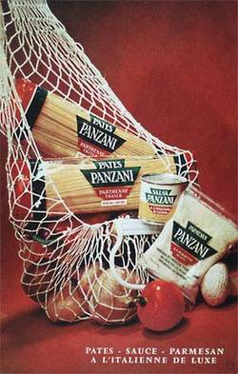
1. This pub represents the horn of plenty. Pastas seem to be fresh but they aren’t, it is just because of the fruits and vegetables that we can see around. Colors refer to Italy but it is not an Italian brand of pasta. We will develop an image of the product.

Panzani Pasta
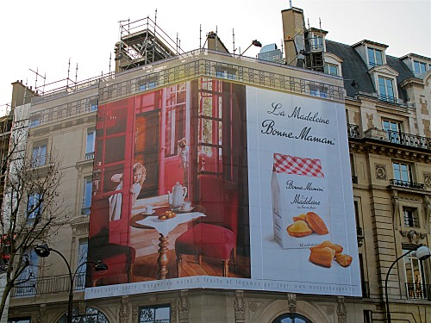
2. This one makes us believe in homemade madeleines, reminding us our childhood, and memories with our grand-parents why not. The decoration is not really up-to-date! So we think that it exists since a long time ago, but it is not.

Madeleines Bonne Maman

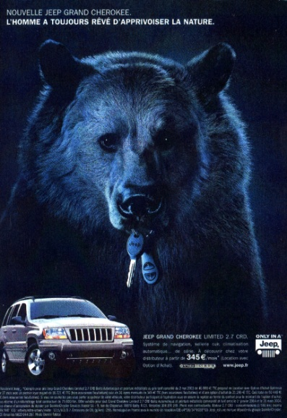
3. The last one suggests that we are powerful with this car because we control the bear. He hears us and brings the keys. Blue makes thinking about the king, so the powerful again.

New JEEP Grand Cherokee

So we can see with these examples of publicity that images, colors, presentation, decors, and so on are used to influence the consumer. And the most important, we have no idea about all of this. There are unconscious mechanisms, so they can manipulate our mind to push us to buy the product.

Another interesting thing is to know that significations, meanings change from a reader to another in terms of nationality, social class, culture, psychological characteristics, personality, environment, etc. We can admit, it is the hypothesis on which rest all communication and especially publicity, that in a given environment, at a given time, a message will be read and therefore received in a certain way by the majority of readers.
This is an example of Coca-Cola’s firm:

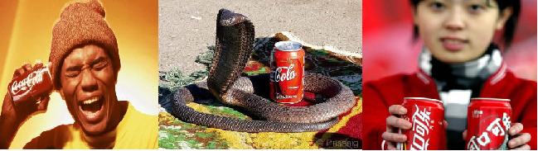
The first one comes from USA. It represents young black man in a yellow set. Black man represents disadvantaged population in America which is a stereotype of course. Then, the colors used are yellow, orange, red and brown which are synonyms of party, sun, summer, warmth and in consequence, thirst. In Europe this pub wouldn’t affect people like this because we don’t have the same story about black and white people.
The second one comes from Africa. The cobra is one of the main factors in this photography. Cobra rounds and protects the can of Coca Cola, it is an aggressive snake, so nobody can achieve him. Coca is perceived as something symbolic, as one of the best drinks. One more time, this pub wouldn’t work in Europe because snake is not a symbolic animal for them, it doesn’t mean anything.
And the last one comes from China. China flag is red. Red color translates religion, but also the joy in China... so there is a symbolic reminder of the country, and it is also the color of coca cola. We can say that China imposes mass consumption in the population, because the girl exposes us two cans of cola. Then, cans are put in the foreground while the young girl appears blurry in the background.

These examples can help to show the differences existing between cultures, between countries. All is calculated to influence unconsciously our mind. We will be more sensitive about this kind of details, it depends about the person. But publicity wants to touch the majority of the population so, as we saw, they adapt according to all that.

Where advertising influences most consumers, it is for food. One publicity of two concerns edible in the world. They are more "appetizing" to push and persuasive purchase. We can make a small remark on the fact that advertising on TV just pass between the films, when the consumer looks at the most and is in front of his screen. The latter will entice, give him hungry, want to buy the product, and thus arrives at the pub "buy" the man in the field of nutrition. The second category of the pub more diffuse on TV, radio, newspapers, ... are for products like hardware, like the vacuum cleaner, refrigerator, television, and computer. Because of the competition, each brand trying to push his product the best possible performance. He sells very expensive, or at unbeatable prices, and the consumer will always try to take the most efficient within its means. The buyer is totally mesmerized by commercials more persuasive the push to buy the most expensive products. Bien évidemment, il existe d'autres domaines que les publicitaires touchent: les services, comme les banques, les assurances, le courrier ou encore les produits ménagers, produits de beautés and so on.

Advertising based on a sensitive nature of man: the need to please. Showing comparing and boasting various produce, persuading the consumer that a particular product is the best, the buyer, to show that he deserves to be watching, take the most expensive product, the most powerful, the most vogue, whom everyone or that everyone wants. To conclude, I would like to clarify that this kind of manipulation can be dangerous because influence unconsciously our mind can be negative. Publicity for alcohol are also views of adolescents, and highlight the fad of "drink" home. The influence of these advertising can be dangerous for healthy because it may lead to buy the wrong product.

References

http://pubdumonde.e-monsite.com/pages/analyse-de-pub-coca-cola/publicite-chinoise-de-coca-cola.html

http://christophe.outteryck.fr/IMG/pdf/presentation_SI22.pdf
http://www.persee.fr/web/revues/home/prescript/article/colan_1268-7251_1965_num_15_1_4985

Publicity course second year of bachelor - Sainte Marie Institue

http://tpepub.centerblog.net/15-influence-de-la-pub-sur-les-consommateurs

http://brunorigolt.blog.lemonde.fr/files/2010/10/pub-panzani.1288161201.jpg

http://a398.idata.over-blog.com/500x375/0/41/70/57/AFFICHES/AFFICHES-BACHES-GEANTES/bache-affiche-geante-Bonne-Maman-Madeleine-6751.jpg

http://saison1.lalliance.fr/xmedia/atelier_BVP/images/scans/jeep_ours.jpg

