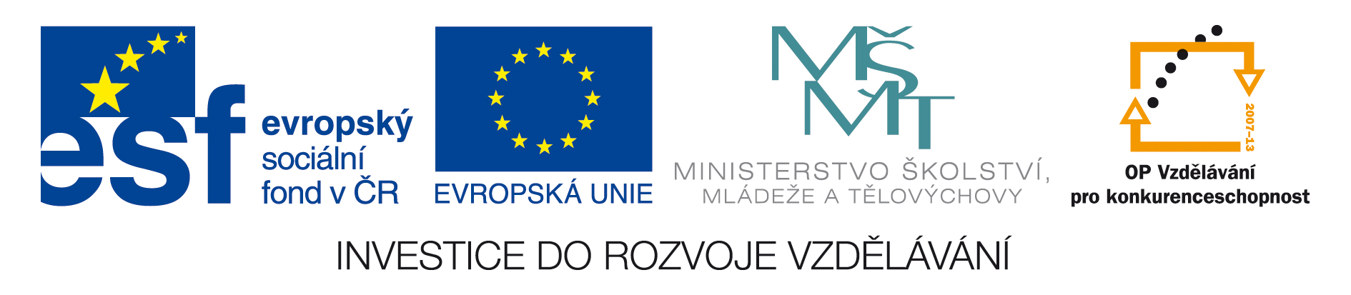

TENTO KURZ JE PODPOŘEN OPVK SOVA

CZ.1.07/2.2.00/28.0225
Internacionalizace, inovace, praxe: sociálně-vědní vzdělávání pro 21. století

PSY494P123
Podzimní semestr 2012
Nový kurz vyučovaný v anglickém jazyce.

Masaryk University
Course: Introduction to Assessment of Developmental Disorders

Course content: The role of psychometrics is integral in the field of psychology. Psychometrics deals with the theory and technique of psychological assessment which clinical psychologists either apply directly to the assessment and treatment of clients, by other practitioners who apply the information from psychological tests to inform decision making to researchers who rely on the data to advance knowledge through experimentation. This course will begin by briefly introducing the background of psychometrics and some of the statistical analyses that went into the design and development of selected tests. Students will then proceed to learn about common psychological screening, instructional, diagnostic and assessment tests used with both typically developing children as well as those with disabilities. As part of the course, students will be able to get hands-on experience with a number of psychological tests.

Learning Objectives: By the end of the course, students will:
- Be familiar with the psychometric properties of psychological tests as well key concepts and measures
- Understand the implications of psychological testing as well as other important considerations when administering and interpreting such tests.
- Be familiar with a range of psychological tests used across childhood and the circumstances in which they might be administered.
- Know the types of assessment formats and how to select the relevant psychological tests.
- Be aware of the controversies surrounding the use of psychological tests with children and the arguments for and against it
Course Assignments Two (2) in-class tests (Multi-choice and short answer questions)
One (1) 1500 words essay
One (1) 1000 words report
Participation in One (1) autism experience
Participation in One (1) 1 hour research experiment OR TWO (2) 30 minute experiments plus a 500 word summary
Course Delivery Schedule: There will be 10 lectures and 10 seminar series for this course.
Session No. | Lecture Topic
1 | Introduction to the application of psychometrics  - What is psychometrics and how it is applied to child development  - Issues to consider: cultural, age, family environment, SES  - Reasons for assessment (see A guide to early assessment)  - Types and properties of assessment  - Areas to consider when selecting tools: reliability, validity, technical adequacy
Readings
2 | Overview of developmental psychology  - Areas of developmental psychology studied  - Bio-psychosocial approach  - The role of assessment  - Standard procedure to adopt when the need for testing is suspected  - The situation in Singapore and in New Zealand
Readings
3 | Infancy to toddler years: Physical development/thrive & Cognitive development  - Reasons for assessment  - Identifying at-risk children  - Areas of assessment  - Assessment tool: Bayley Scales of Infant Development http://www.pearsonassessments.com/HAIWEB/Cultures/en-us/Productdetail.htm?Pid=015-8027-23X 1 -42 months
Readings
4 | Early childhood years: Part 1  - Prevention of communication disorders, preschool, Europe.  - Developmental assessments: Brigance Preschool Assessment  - Speech and language delay
Readings
5 | Early childhood years: Part 2  - Developmental disorders- ADHD  - Developmental disorders- Autism
Readings
6 | Early childhood years: Part 3  - Intelligence test: WPPSI, K-ABC
Readings
7 | School years: Part 1  - Curriculum based assessments  - Specific learning disabilities: intelligence testing, WISC, Ravens
Readings
8 | School years: Part 2  - Norm referenced versus criterion referenced tests  - Specific learning disabilities Specific learning disabilities: dyslexia, reading disability, dyscalculia
Readings
9 | School years: Part 3:  Other assessments: Neurological functioning, (i.e. Trail making test), Social Skills assessment,
Readings
10 | Controversies of testing and other considerations  - From the parental point of view

