THE SOUND AND SMELL OF THE LANDSCAPE
Landscapes are often associated with sounds and sometimes smell
- Towns have a lot of human made sound and smells
- The rural country side might have other sounds and smells
- Interviewing people about their emotions they often tell that smell and sounds can trigger off reactions
- Often smell, sound and visual experiences are combined – sometimes to the extent that it is hard to separate
In horticulture therapy the combination of smell, sounds and visual experiences are often combined. Results are hard to measure , but seem to be promising

Eero Järnefelt (1863 – 1937)
Pond Water Crowfoot
Atenum Art Museum, Helsinki

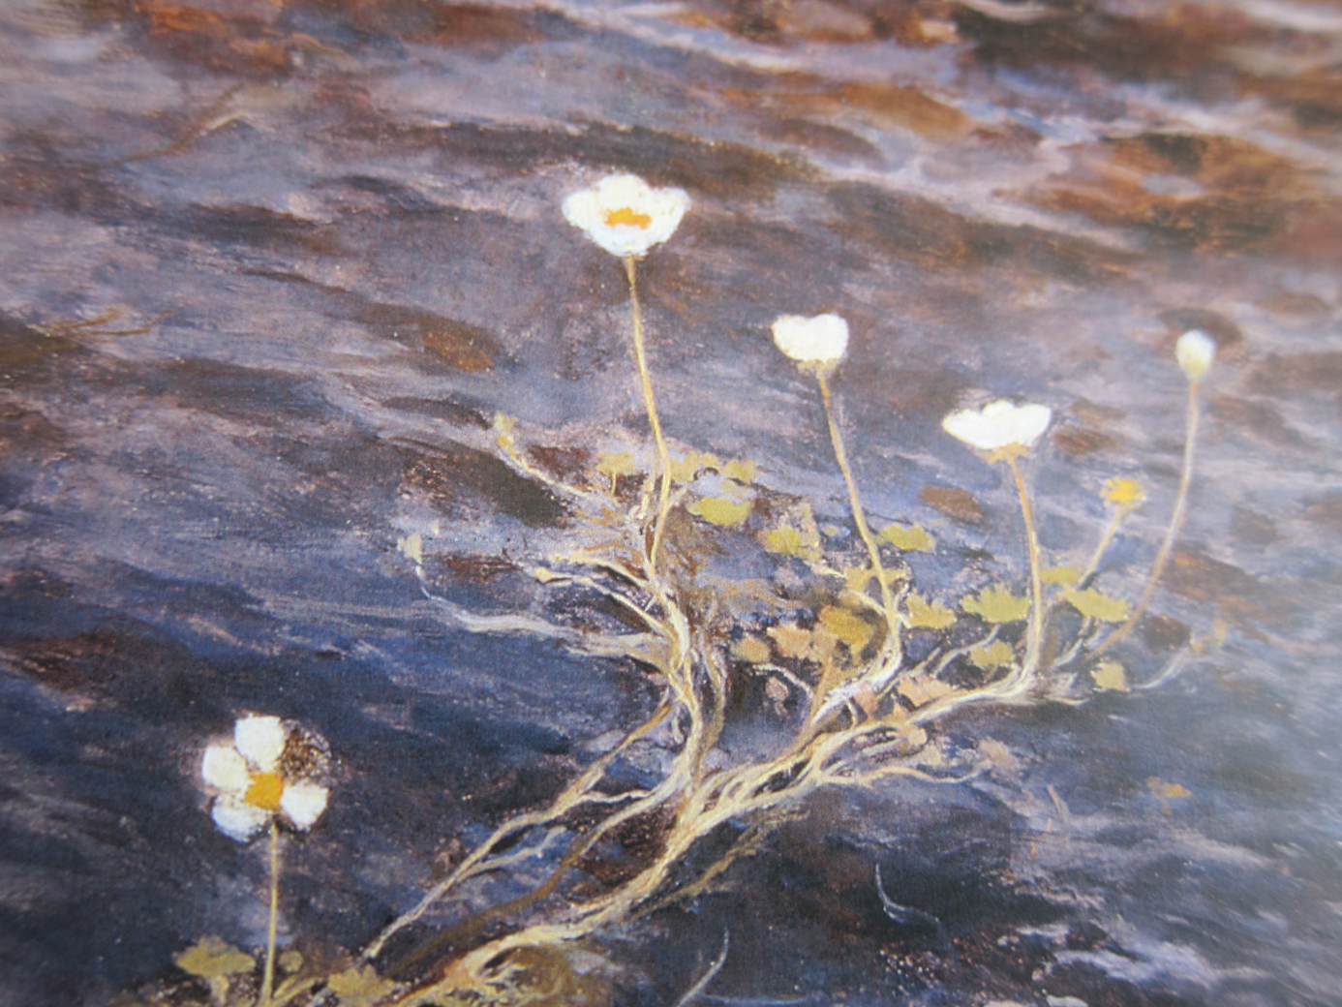

Arthur Dove
Morning Sun (1935)
The Philips Collection, Washington

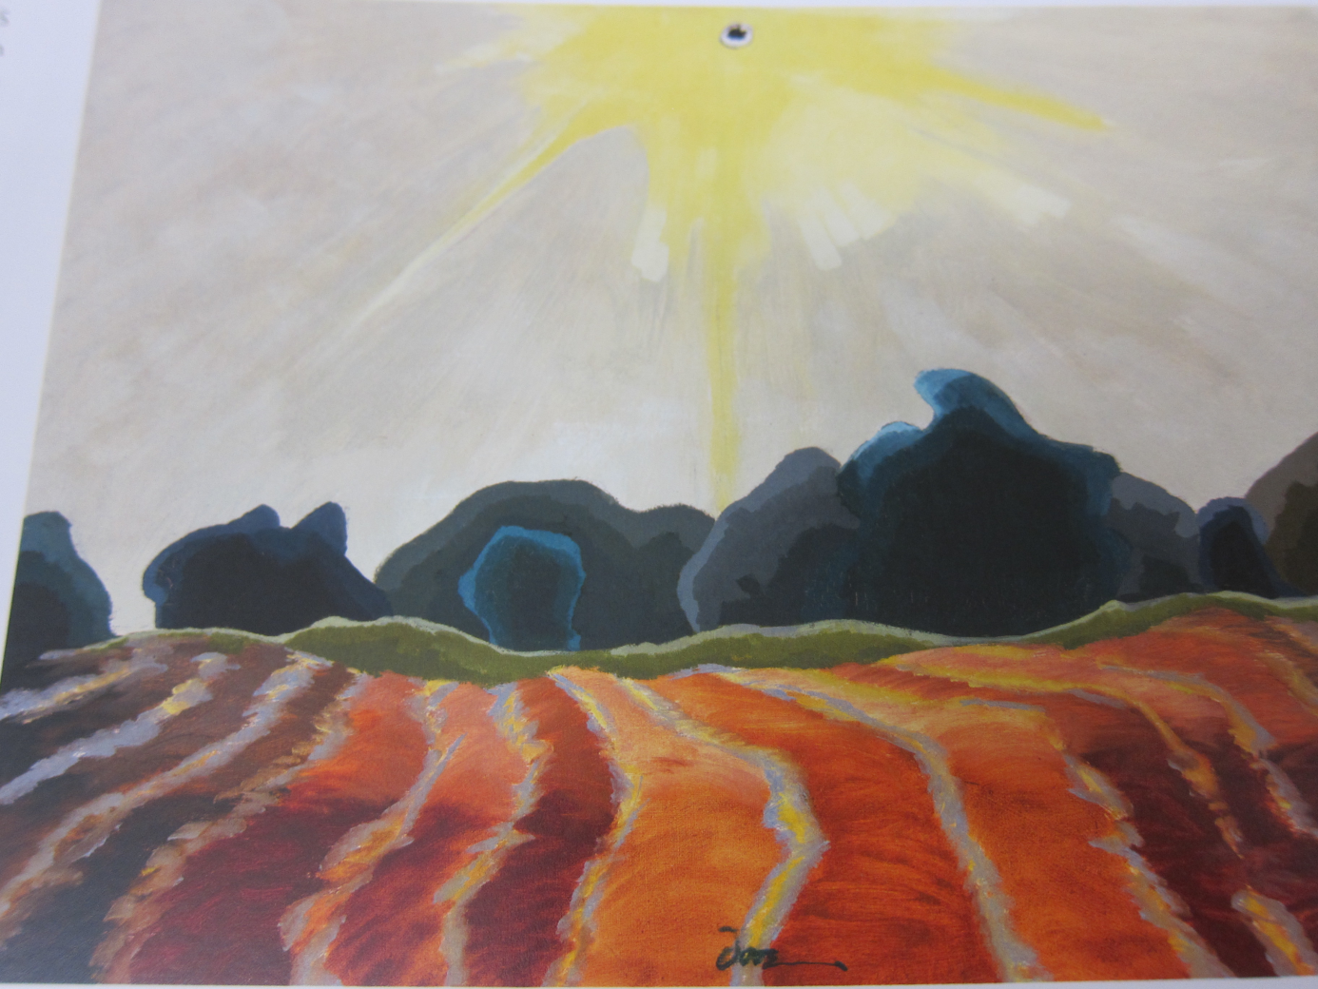

Akseli Gallen-Kallela (1865 – 1931)
The Great Black Woodpecker (1892 – 1894)
Private Collection

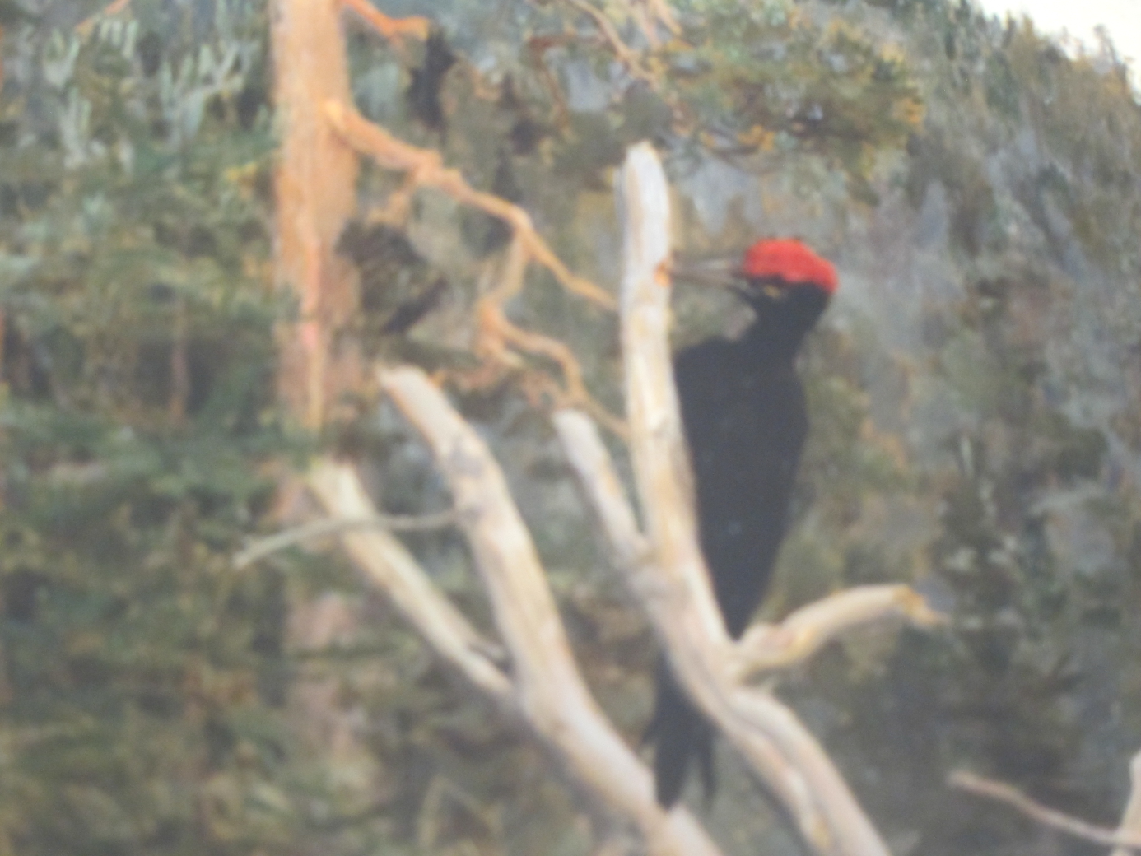

Harald Sohlberg (1869 -1935)
Flower Meadow in the North (1905)
The National Museum of Art, Architecture and Design, Oslo
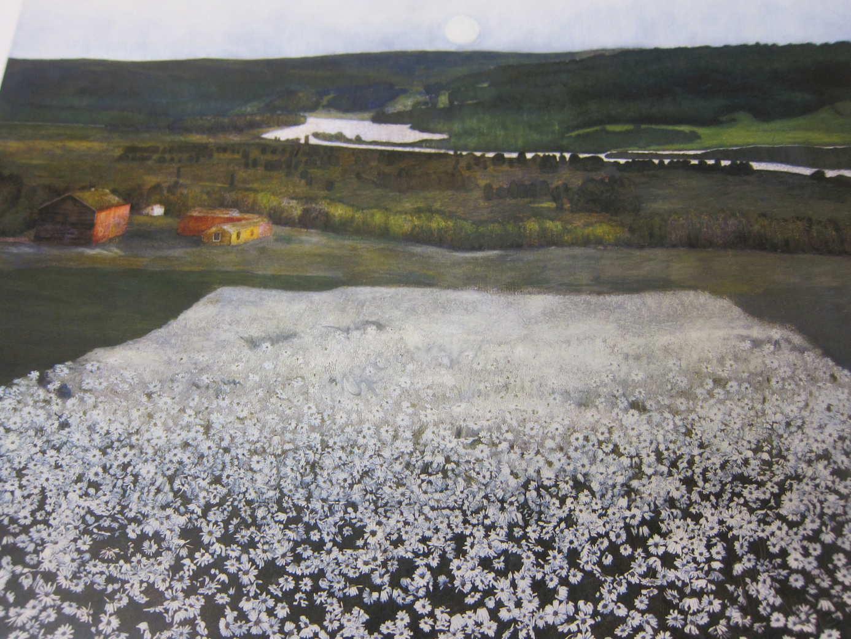

Pekka Halonen (1865 – 1933)
Winter Landscape (1907)
Hämeenlinna Art Museum, Finland

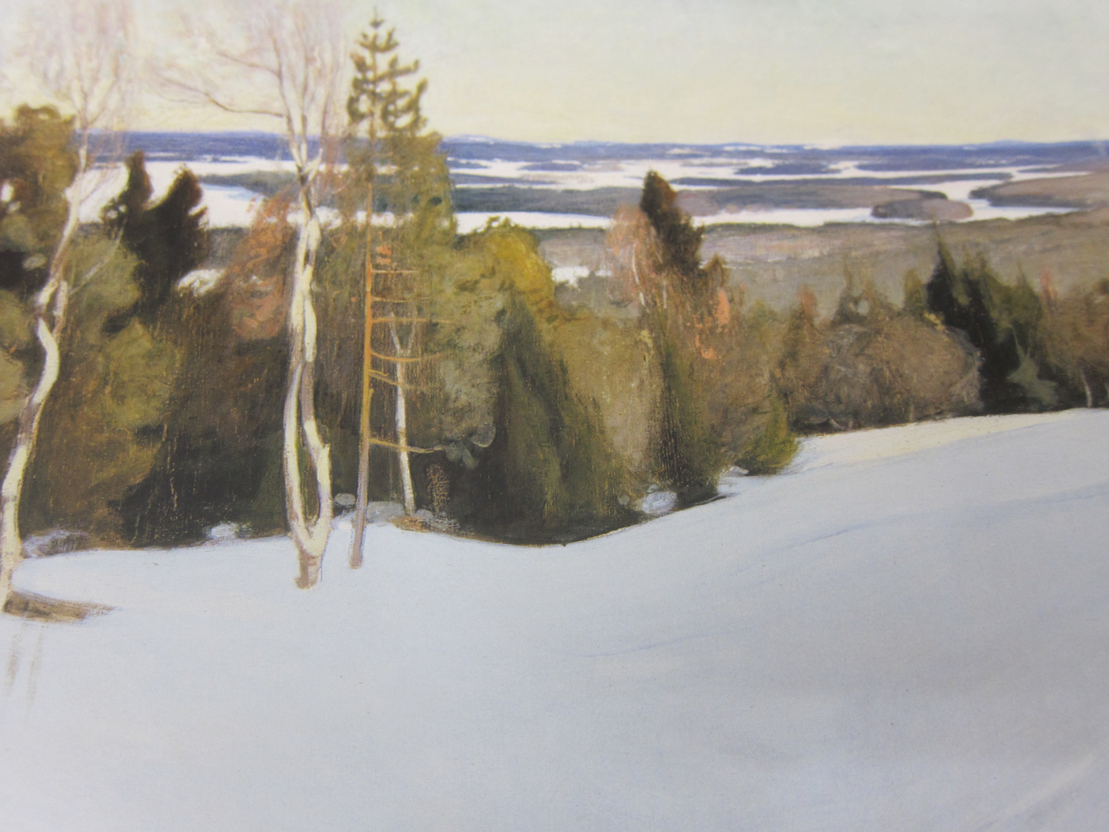

Pekka Halonen (1865 – 1933)
Washing on the ice (1900)
Atenum Art Gallery, Helsinki

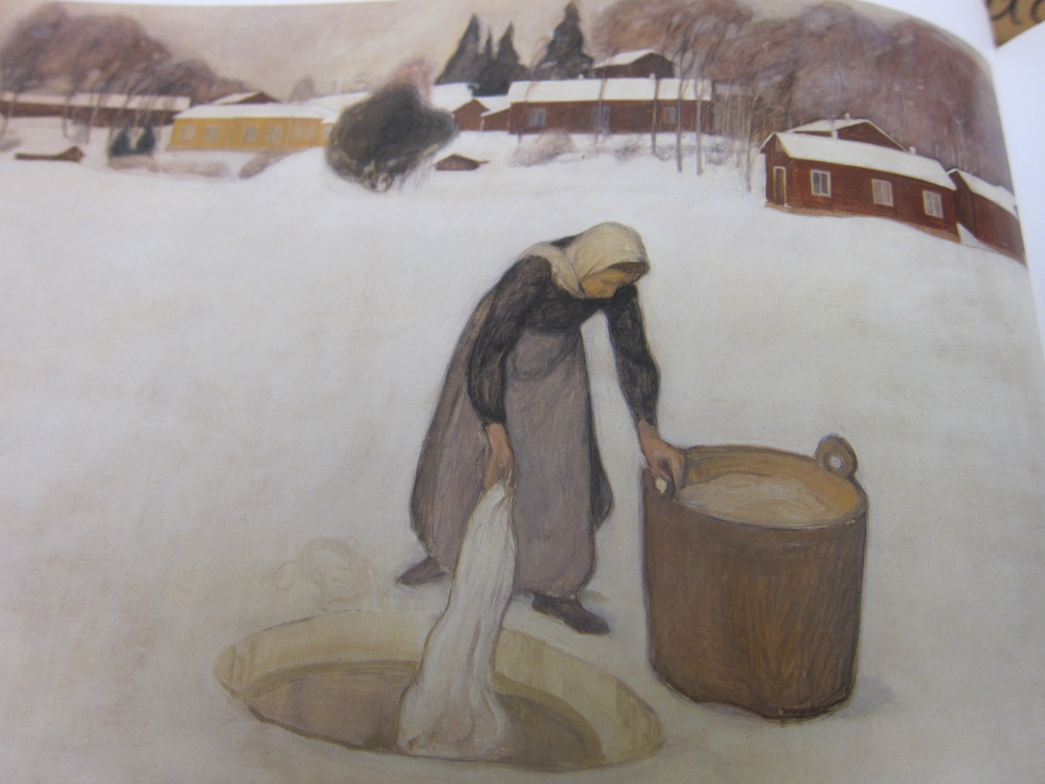

Anders Zorn (1860 – 1920)
Girls bathing in the open air (1890)
Atenum Art Museum Helsinki

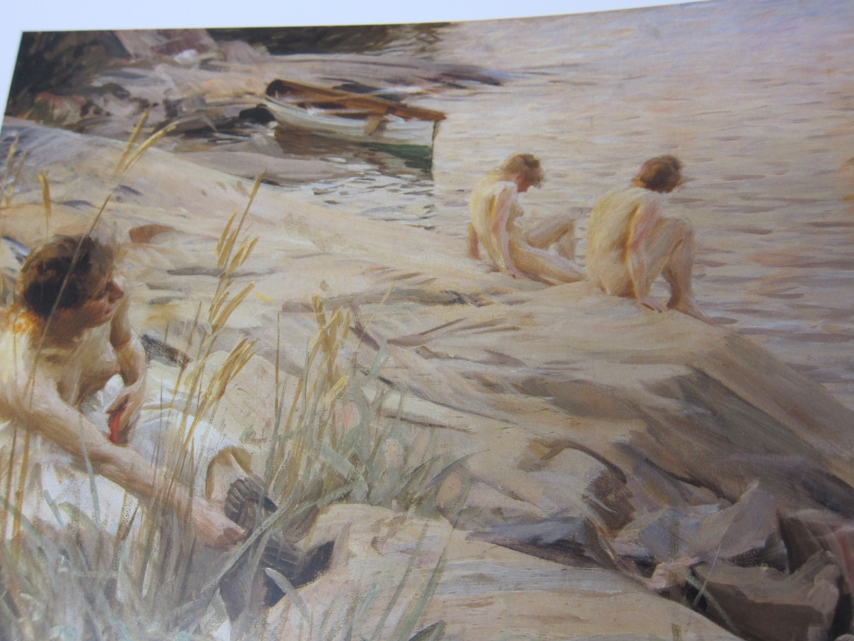

Harald Slott-Møller (1864 – 1937)
Danish landscape (1891)
Private collection deposited with Statens Museum for Kunst, Copenhagen

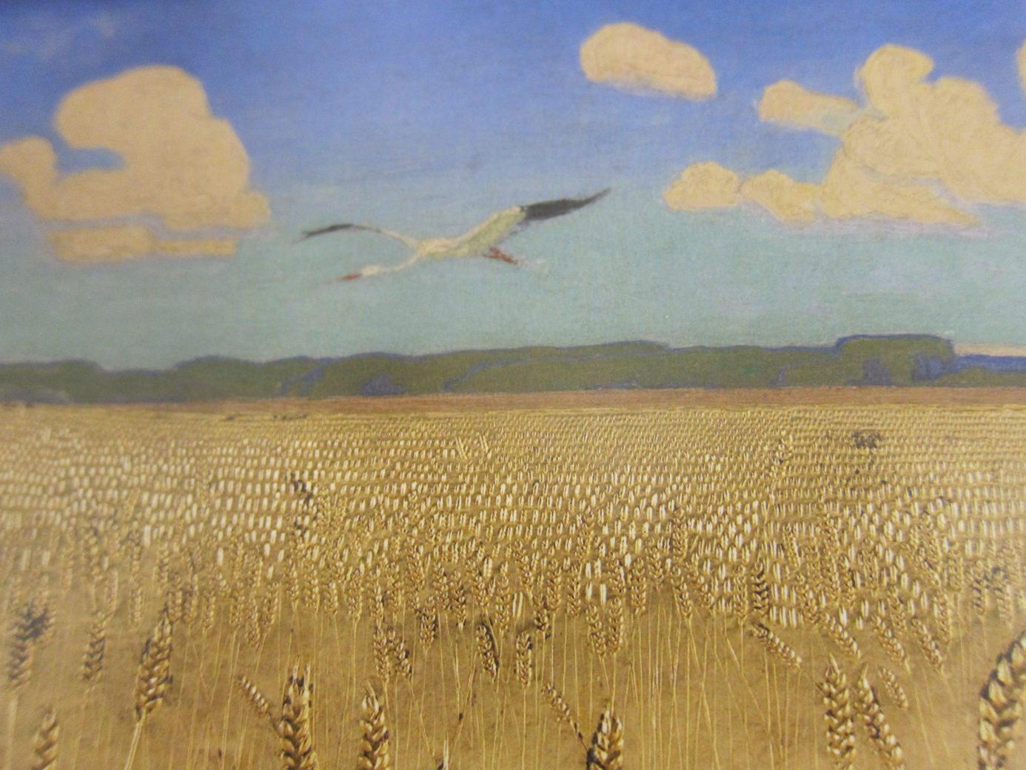

Hugo Simberg (1873 -1917)
Spring evening, when the ice is melting (1897)
Ateneum Art Museum, Helsinki

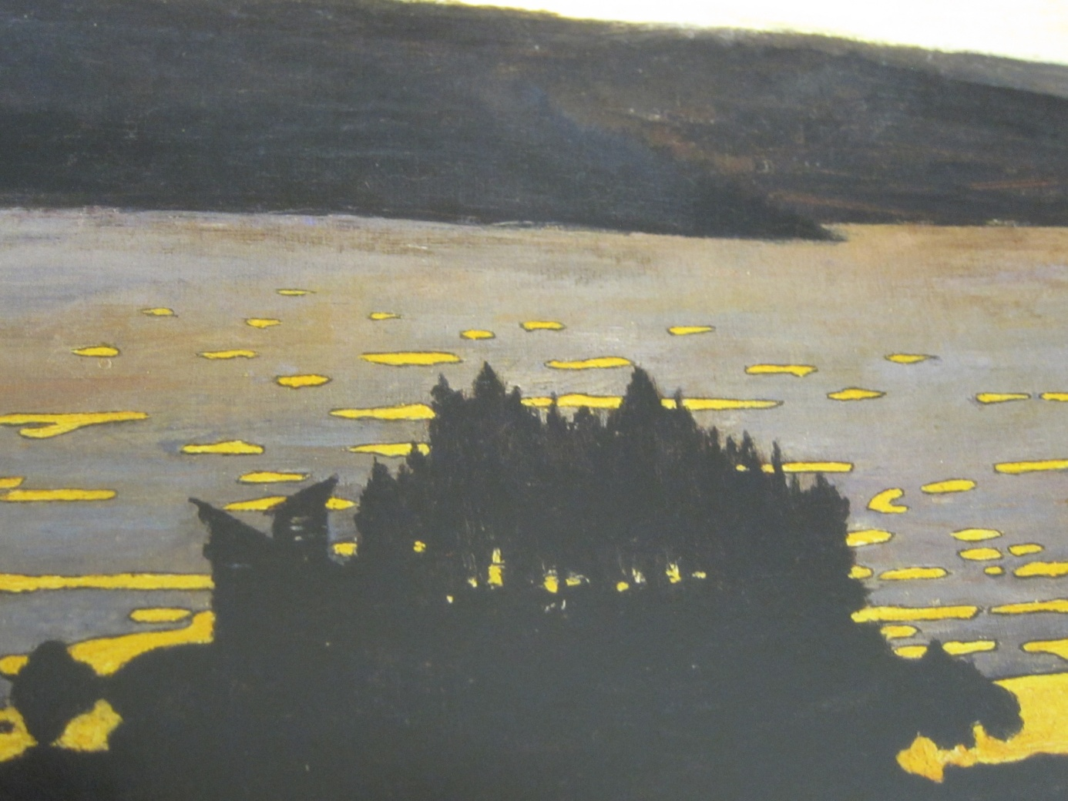

Harald Sohlberg (1869 -1935)
Night Glow
The National Museum of Art, Architecture and Design, Oslo
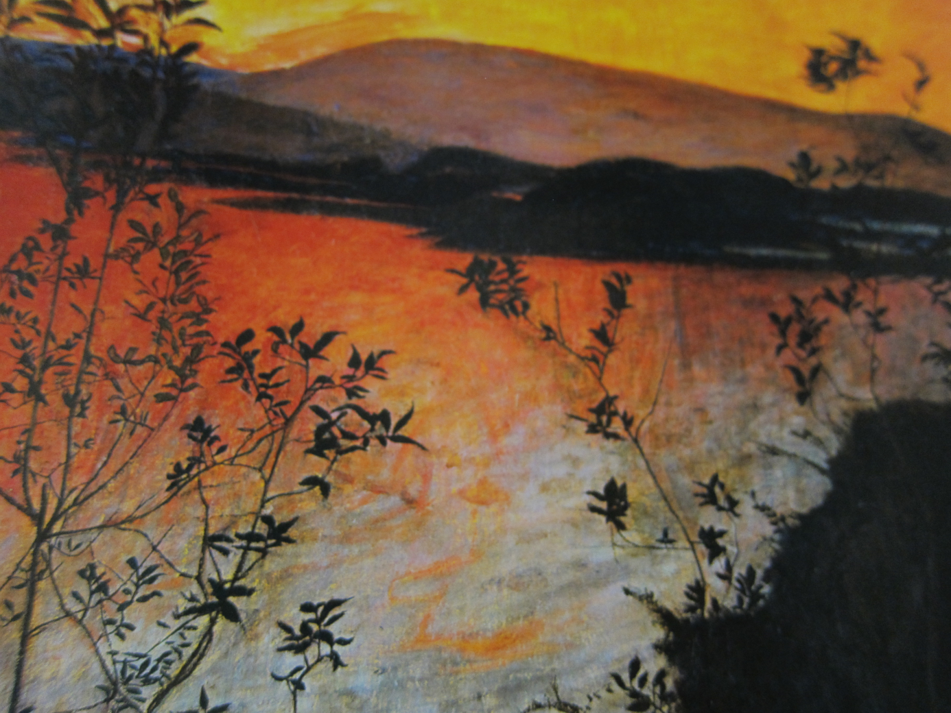

Harald Sohlberg (1869 - 1935)
Winter Night in the Mountains (1911)
Private Collection

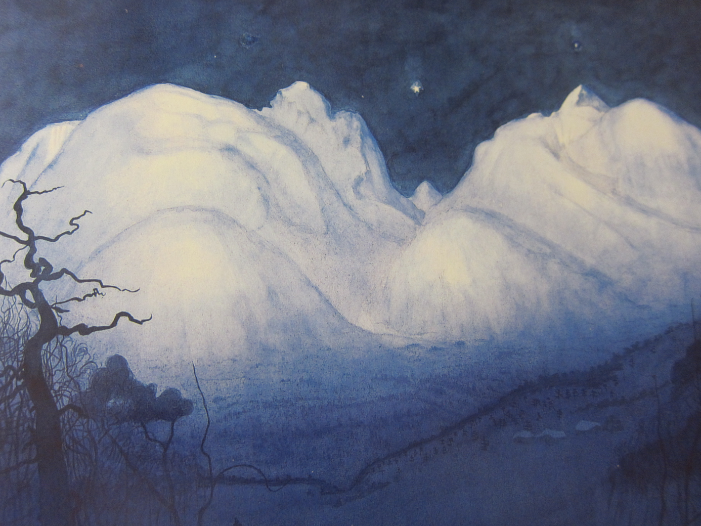

Prince Eugen (1865 – 1947)
Calm Water (1901)
The National Museum, Stockholm

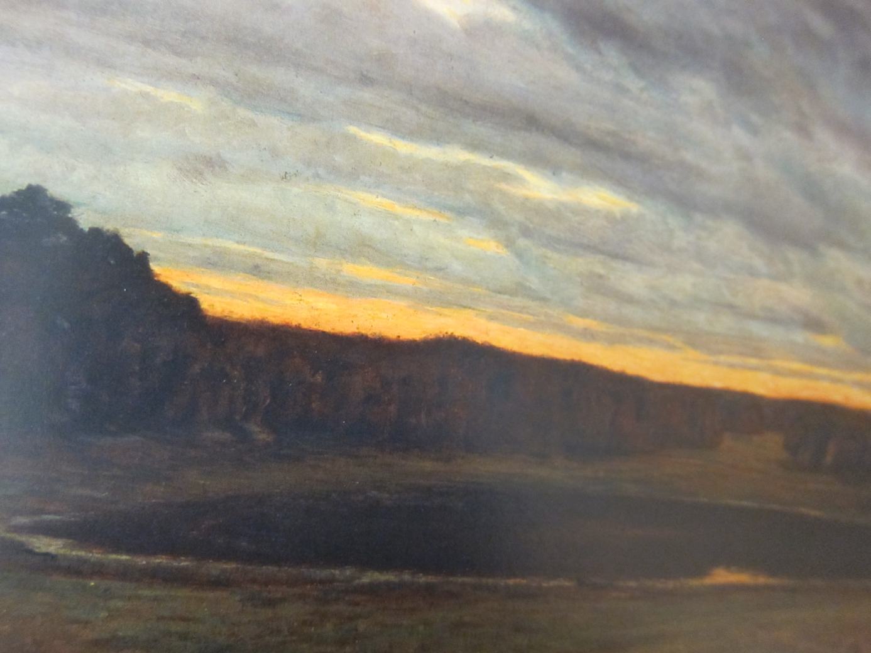

Thórarinn B. Thorláksson (1867 – 1924)
Mountain Stóri Dimon (1902)
National Gallery of Iceland, Reykjavik
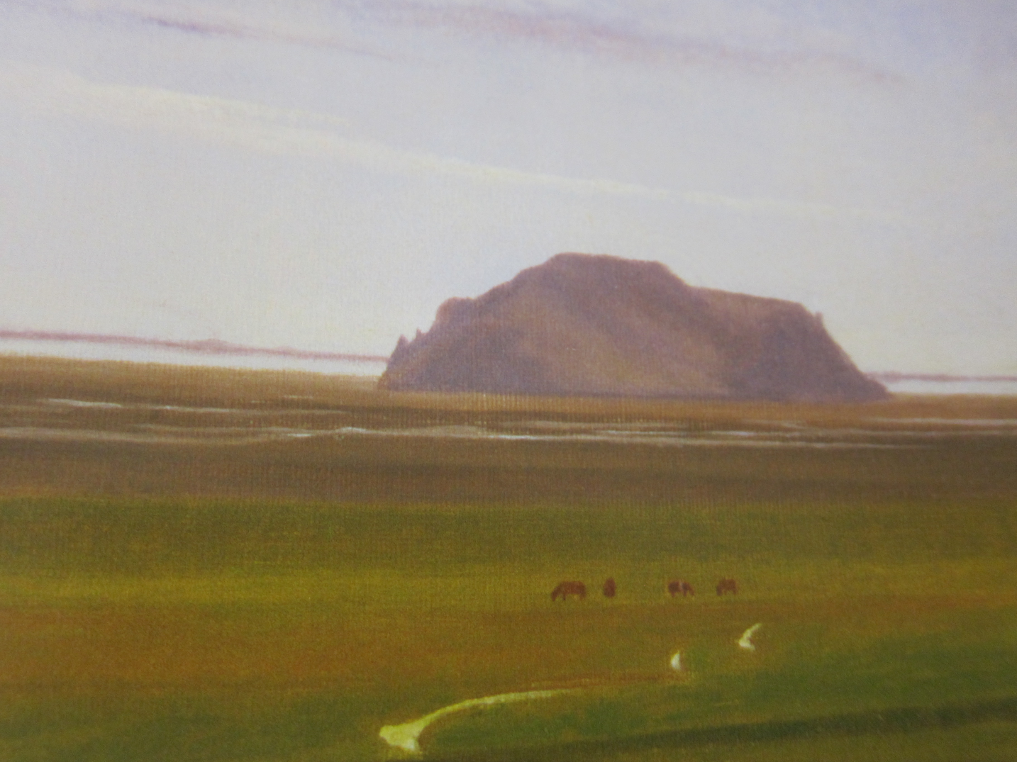

Victor Westerholm (1860 -1919) Finnish Vallinkoski Rapids 1913
Atenum Art Museum Helsinki

Finnish Vallinkoski Rapids (1914)
Victor Westerholm (1860 – 1919)
Atenum Art Museum, Helsinki
