THE SPIRITUAL DIMENSION OF LANDSCAPE AND NATURE

RUSSIAN ORTHODOX CHURCH SPIELBERG 25TH OF NOVEMBER 2012
PHILOSOPHICAL IDENTITY IS CALLED SAMENESS OR WHATEVER MAKES AN ENTITY DEFINABLE AND RECOGNIZABLE – MANY CHALLENGES WITH THE CONCEPT SUCH AS CHANGING PERSONAL IDENTITY OVER TIME, HOW TO SEPARATE BETWEEN INDIVIDUALS ( IF TWO PERSONS SHARE IDENTITY ARE THEY THE SAME)
SOCIOLOGICAL IDENTITY HAS TO DO WITH SELF-CONCEPTION, SOCIAL PRESENTATION AND THE ASPECTS THAT MAKES AN INDIVIDUAL UNIQUE AND DIFFERS FROM OTHERS (CULTURAL IDENTITY, GENDER IDENTITY, NATIONAL IDENTITY, RELIGIOUS IDENTITY AND SON ON)
PSYCOLOGICAL IDENTITY INCLUDES THE SOCIOLOGICAL DIMENSIONS AS WELL AS INDIVIDUAL DIMESIONS. DEPENDING UPON THE PSYCOLOGICAL TRADITION THE CONSCIOUS, SUB CONSCIOUS AND SOCIAL DIMENSIONS WILL BE EMPHASIZED -
RELIGIOUS IDENTITY WILL FROM THE POINT OF THE RELIGION OR RELIGIOUS TRADITION BE UNDERSTOOD AS THE ACKNOWLEDGMENT OF THE SPIRITUAL AND THE IDENTIFICATION WITH THE RELIGIOUS TRADTION AND THE SPIRITUAL REALM
NATIONAL IDENTITY
CULTURAL IDENTITY IS THE IDENTITY OF A GROUP OR OF AN INDIVIDUAL AS FAR AS ONE IS INFLENCED BY ONE’S BELONING TO A GROUP OR A CULTURE
(CULTURAL IDENTIFIERS: LOCATION, GENDER, HISTORY, NATIONALITY, LANGUAGE/DIALECT, SEXUALITY, RELIGIOUS BELIEFS, ETHNICITY ANA AESTHETICS, COMMON SOCIAL VALUES AND BELIFES, OTHER TRADITIONS AND IMPORTANT POINTS OF IDENTIFICATION LIKE MYTHS/ HISTORY, LITERATURE AND SO ON)
INDIVIDUAL IDENTITY
GENDER IDENTITY
PSYCHOLOGICAL IDENTITY

THE SOGNEFJORD NORWAY 1 OF SEPTEMBER 2012 KINSARVIK CHURCH

THE SOGNEFJORD 1ST OF SEPTEMBER 2012
THE SOGNEFJORD 1ST OF SEPTEMBER 2012

THE SOGNEFJORD 1ST OF SEPTEMBER 2012
THE SOGNEFJORD 1ST OF SEPTEMBER 2012

PSYCOLOGICAL THEORIES FROM INDIA

THE INDIAN RESEACHER AND PHILOSOPHER Jadunath Sing (1892 – 1978) PUBLISHED IN 1933 A SERIES OF BOOK ON IDIAN PHILOSOPHY EMPHASIZING THAT IT INCLUDED AN INTEGRATED THINKING ON;
- PHILOSOPHY/ THE SPIRITUAL
- ETHICS
- LOGICS
- PSYCHOLOGY

Caroline Augusta Foley Rhys David (1857 – 1942) Buddhist psychology (1914)

SANSKRIT TRADITIONS IMPORTANT BOTH IN BUDDHIST AND HINDU TRADITIONS

CONFLICTING EMOTIONS ABOUT AN OBJECT/SITUATION – CONSIDERED TO BE INTELLECTUAL DISTURBANCES (Sing, 1996: Bind II: 94).
SANSKRIT GRIEF (sóka)
HYPOTETICAL THINKING (tarka)
FEAR (bhaya)
DOUBT

DELUSIVE FEELINGS ( THE JAINA TRADITION) (Sing, 1996: Bind II: 99).
ATTACHMENT ( WHAT CONNECTS US) (RAGA)
AVERSION (DVESA)
BASIC FEELINGS BEHIND ALL HUMAN ACTION AND ALSO THE SAME FEELINGS THAT MAKES SLAVES
WE HAVE TO DISTANCE OR BECOME INDEPENT OF STRONG FEELINGS, SUCH AS GRIEF, IN ORDER TO BE FREE ( PHILOSOPHICAL EXISTENTIAL ACKNOWLEDGMENT)

Buddhagosa GRIEF A CONSUMING FEELING - BEING A MENTAL SUPPRESSION OF ALL OTHER FEELINGS (Sing, 1996: Bind II: 114 - 115).
Bhagavad Gita the body might die, but the self cannot die. The consciousness is from before the body and will remain after the body. A person in control of his sensory can control his body in that way influence sickness and mental reactions

Sanskrit traditions were very important for early European and American psychology.
HUMANS PART OF NATURE IN THE SAME WAY AS ALL OTHER LIVING BEINGS
WE ARE PART OF NATURE AND THE VERY CONCEPT OF NATURE IS IN A WAY MEANINGLESS
WHAT HAPPENS TO OTHER LIVING BEINGS WILL THEN HAVE THE SAME POSSIBLE EMOTIONAL IMPACT

COGNITIVE PSYCHOLOGY
BUDDHIST AND INDIAN PSYCHOLOGY AS INSPIRATION AND MODEL FOR TRAINING OF EMPATHIC PRESENCE AND MEDIATIVE TECHNIQUES
MINDFULLNESS TRAINING (Segal, William og Teasdale, 2002 og Kabat-Zinn med flere, 1993)
SELF – EMPATHY / SELF SENSITIVITY (Kabat-Zinn, 2003).

PSYCHOANALYSIS
BUDDHISM UNDERSTOOD AS A MENTAL WAY OF UNDERSTANDING OR RELATING TO
ERICH FROMM (1900 – 1980) CONNESTS PSYCHOANALYSIS TO ZEN BUDDHISM

THE SOGNEFJORD 1ST OF SEPTEMBER 2012

THE SOGNEFJORD 1ST OF SEPTEMBER 2012

AUGUST 2012 THE TIME OF CLOUDBERRY PICKING SAKSUMDAL NORWAY
27th OF JUNE 2012 SAMSØ DENMARK

27th OF JUNE 2012 SAMSØ DENMARK
STAUNS CHURCH 27th OF JUNE 2012 SAMSØ DENMARK

ETHICS, VALUES, ACTION AND IN-ACTION
THE VALUES AND MORALS BEHIND DESCISIONS AND ACTION IVOLVING THE ENVIRONMENT

IN PSYCHOLOGY EMPATHY IS OF CRUCIAL IMPORTANCE IN ORDER TO DEVELOPE GOOD COMMUNICATON
LACK OF EMPATHY IS THOUGHT OF AS A PROBLEM
FOR A THERAPIST EMPATHY IS OF CRUCIAL IMPORTANCE

- In daily life empathy is necessary to understand and interact with others. Empathy can be;
- cognitive and/or affective
- automatic and/or controlled by the cognitive
- Empathy can be understand as part of the personality
- Empathy can be used as part of the professional work of a therapist and can be regarded as a sophisticated skill

Empathy altruistic or egocentric self interest?

- Obviously speaking doing something towards other gives some kind of emotional reward
- The presence of altruistic motives are heatedly discussed
- There are many examples of people doing deeds towards others and the environment that seem to be against their material self interest.

EMPATHY FROM A RELIGIOUS PERSPECTIVE
- DO TOWARDS OTHERS LIKETHE SAME AS YOU WANT THEM TO DO TOWARDS YOU
- CARE OF THE OTHER IS A MORAL OBLIGATION
- THE THOUGHT OF HUMANS AS CUSTODIAN OF NATURE
- THE THOUGHT OF RESPONSIBILITY

EMPATHY AS PART OF THE HUMAN BIOLOGY – AS A PART OF BEING HUMAN

EMPATHY AS PART OF DEVELOPMENT / PART OF GROWING UP (DEVELOPMENTAL PSYCHOLOGY)
Hoffman (1990) :
- Global empathy
- Egocentric empathy (from about one year)

- Empathy for the emotions of others ( 2 – 3 years of age) Part of role taking
- Empathy for the living conditions of others .

INTERSUBJECTIVE CONSCIOUSNESS Daniel N. Stern (1934 -(Stern i Sameroff og Emde 1989
- AFFECTIVE
- SYNCRONIZING AND DEPENDENT OF THE INTERSUBJECTIVE INTERACTION
Questions
  - Can we and do we interact with the environment in the way that we develop empathy for the environment, other living species and even physical landscape?
  - In case will that empathy enable us to altruistic deeds ?

THE COMPLEXITY OF EMPATHY
THE SWEDISH PSYCHOLOGIST ULLA HOLM (1995) DIVIDES THE USE OF THE CONCEPT EMPATHY IN;

THE PROCESS OF EMPATHY (COGNITIVE AND EMOTIONAL)

B. PREDICTIVE EMPATHY

C. SITUATIONAL EMPATHY

D. ” TRAIT EMPATHY”

THE DIFFERENCE BETWEEN EMPATHY AND SYMPATHY
Empathy is sometimes used as equivalent to sympathy
However those who separate define empathy as the ability to understand from the others point of view and sympathy with how to feel like the other.
In Clara Hill (2004) understanding sympathy means feeling pity for the other and thus will always be from a superior powerful point of view.

A SIMPLIFIED PRACTICAL UNDERSTANDING OF EMPATHY
- ACKNOWLEDGEMENT OF THE FEELINGS AND REACTIONS OF THE OTHER
- AFFECTIVE UNDERSTANDING
- COGNITIVE UNDERSTANDING

COGNITIVE AND EMOTIONAL EMPATHY Hoffman (1978 og 1990)
  - COGNITIVE EMPATHY
  - EMOTIONAL EMPATHY

Piaget (1995)
AFFECTIVE THINKING
COGNITIVE THINKING
AFFECTIVE CONSCIOUSNESS
COGNITIVE CONSCIOUSNESS
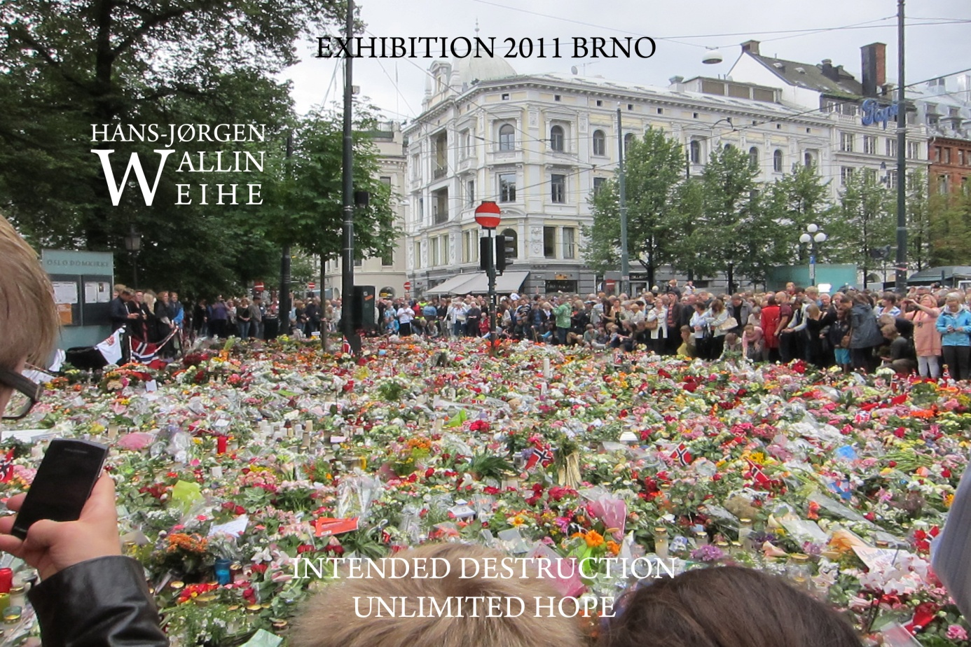
RIG – REPEATED INTERACTIONS THAT ARE REPEATED OVER TIME (Daniel N. Stern)
INTERACTIONS WITH HUMANS AND THE TERRAIN, NATURE OR OTHER LIVING THINGS WILL HAVE IMPORTANCE IN DEVELOPING OVER PERSONALITY AND OUR SENSITIVITY

STRATEGIC AND ALTURISTIC EMPATHY

INTUITIVE CARING Nel Noddings (1929 -) SYMPATHY RATHER THAN EMPATHY
ETHICAL CARING Nel Noddings (1929 -)
INTUITIVE EMPATHY
ETHICAL EMPATHY

ACCURATE EMPATHY Truax og Carkuff (1967) - IN RELATION TO HUMANS IT MEANS THAT WE ARE ACCURATE IN OUR UNDERSTANDING OF THE OTHER OR TO OUT IT LIKE THAT WE UNDERSTAND THE OTHER AS THE OTHER ONE UNDERSTAND HIM/HER SELF

CONGRUENCE THE STATE ACHIEVED BY COMING TOGETHER, THE STATE OF AGREEMENT. IF COMMUNICATION IS CONGRUENT PARA VERBAL SIGNALS THE SAME.

THE UNEASINESS WE SIGNAL – THE LACK OF CONGRUNCE SIGNALS CONFLICTING VALUES OR EVEN IDENTIFICATION

RECORDED EMPATHY – SIGNS OF EMPATHY
Hall og Bernieri (2001) ”Interpersonal Sensitivity - Theory and Measurement”
- VERBAL SIGNALS
- NON VERBAL SIGNALS
- PRACTICAL ACTION

der en rekke bidragsytere fremlegger forskning om betydningen av at den andre kan lese tegn på empati fra den andre i form av kontekstualisering eller verbale og nonverbale signaler.

THE FEELINGS OF GOOD WILL AS DISTURBANCE AND AS NOISE
- EMPATHY CAN DISTORT COMMUNICATION IN THE SENSE THAT WE ARE NOT ABLE TO BE ANALYTICAL (Preben Berthelsen Aarhus University Denmark)
THE PSYCHOTERAPIST Heinz Kohut (1913 – 1981) CLAIM THAT ALL COMMUNICATION WILL HAVE TO INCLUDE EMPATHY OTHERWISE COMMUNICATION WILL BE DISTSTORTED (Kohut 1959).

SELECTIVE EMPATHY Peschel og Peschel (Spiro 1993)
EMPATHIC ANGER John Stuart Mill (1806 – 1873)
- WE HAVE TO ACT OR FEEL THE URGE TO REACT
- IN MILLS UNDERSTANDING POLITICAL ACTION IS OFTEN MOTIVATED BY A SENSE OM EMPATHIC ANGER
THE AMERICAN PSYCOLOGIST Martin L. Hoffman (1990 USE EMPATHIC DISCOMFORT TO DESCRIBE THE SAME. HIS RESEARCH TOUCHES AREAS AS
- EMPATHIC AVERSION
- ANGER
- SYMPATHY
- FEELING OF INJUSTICE
- GUILT
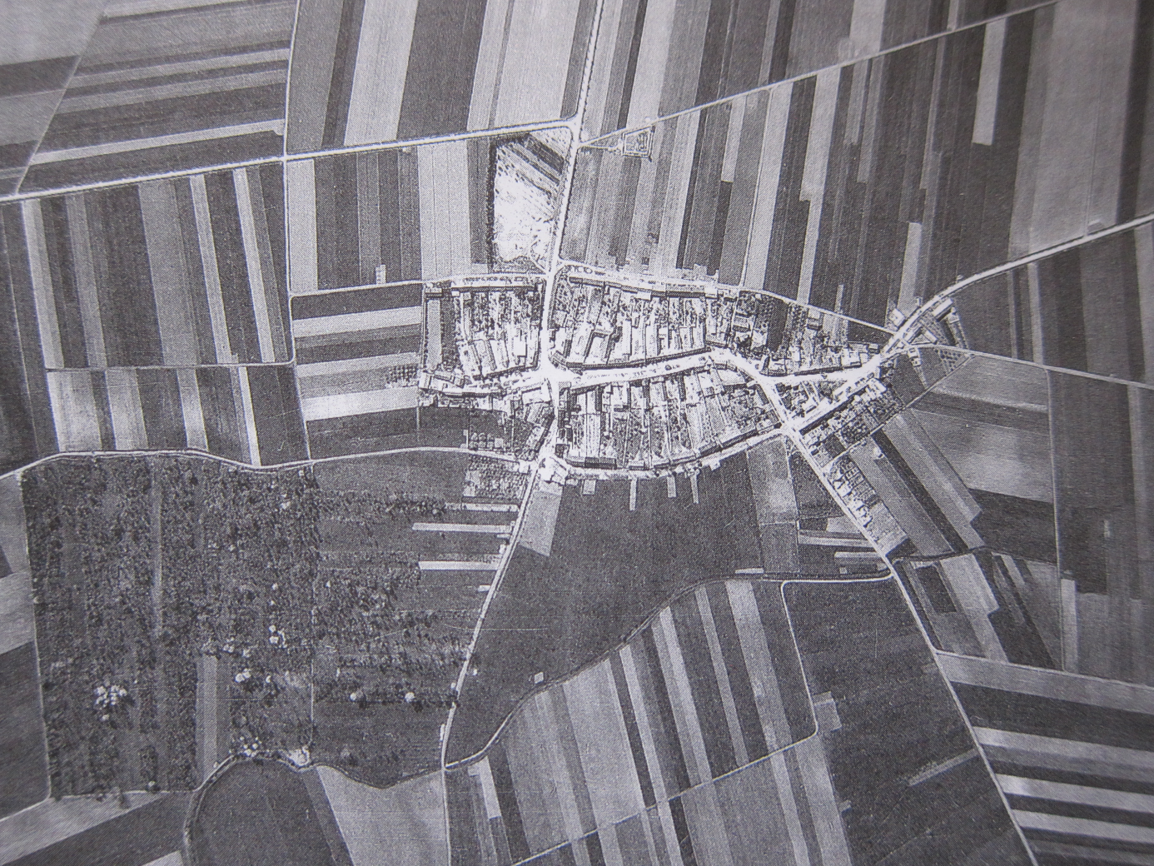
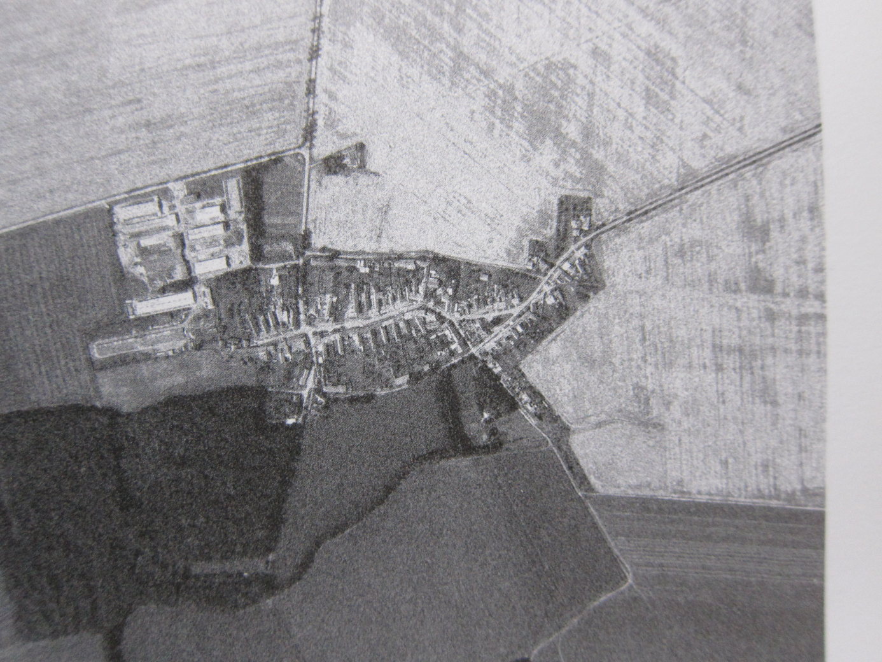
CHANGED LANDSCAPE MODERN MONOCULTURE REPLACES PREWAR MULTI -CULTURE AGRICULTURE
Hájek, Pavel (2008). Jde Prevně kupřredu naše zem. Praha: Malá Skalá
Page 20 and 21

TO DESCRIBE THE SITUATION OF THE OTHER FROM THE IMAGINED PERSPECTIVE OF THE OTHER IS OBVIOUSLY DIFFERENT FROM BEING IN THEIR POSITION Adam Smith (1723 – 1790)

THE POLITICAL DIMENSIONS OF IDENTITY OR IDENTIFYING WITH

George Herbert Mead (1863 – 1931) SYMBOLIC INTERACTION – TO TAKE THE PERSPECTIVE OF THE OTHER

WHAT WE CHOOSE TOO SEEE AND WHAT WE CHOOSE NOT TO SEEE – OR RATHER NOT TO RELATE
Lipsky (1980) emphasize the power among people working on street – level in making priorities, choosing to see or ignore
.
THE TECHNOLOGICAL BONDS AND DISTANCE BETWEEN HUMANS
Zygmunt Bauman (2003 og 2004) Liquid Love – on the fraility of human bonds – TECHNOLOGY MAKES DISTANCES BETWEEN HUMANS AND BETWEEN HUMANS AND THE ENVIRONMENT

SYSTEMS WITH GOOD INTENTIONS
SYSTEMS WITH NO MORAL AND GOOD ROUTINES
THE TECHNICAL SOLUTIONS

Litterature

Addams Jane 2002. Democracy and social ethics. Illinois: University of Illinois Press

Bandura Albert 1997. Self-efficacy. The exercise of control. New York: W. H. Freeman and Company

Basset Richard 2005. Hitler’s spy chief – The William Canaris mystery, London: Cassel Paperbacks

Bauman Zygmunt 2002. Arbejde, forbrugerisme og de nye fattige. København: Hans Reitzels forlag

Bauman Zygmunt 2003 Liquid Love – on the fraility of human bonds. Cambridge: Polity Press
Bauman Zygmunt 2005. Work, consumerism and the new poor, London: Open University Press
Blackmore Susan 1999. The Meme Machine. Oxford: Oxford University Press

Blagstrup Chr. MCMXXIV Salomonsens Konversations Leksikon. København: J. H. Schultz Forlagsboghandel A/S

Bohart A. C. , Greenberg L.S. (red) 1997 Empathy Reconsidered Washington: American Psychological Association

Bohart, A. C., Elliot R., Greenberg L. S. Og Watson, J. C. 2002, Empathy, i Norcross (Editor), Psycotherapy relationships that work: Therapist contributions and responsiveness to patients ( side 89 – 108), New York: Oxford University Press

Bourdieu Pierre 1999. The weight of the world – Social Suffering in Contemporary Society. Cambridge:Polity Press

Bourdieu, Peter 2004. Acts of Resistance London: Polity Press

Bronson Martha B. 2000. Selfregulation in early childhood. New York: The Guilford Press

Brothers, L. 1989. A biological perspective on empathy. American Journal of Psychiatry, 146, 10 - 19

Buckley Cara 2007. What drives a Person To Act Like a Hero, i The New York Times, Saturday, January 13, 2007, side 4.

Churchill Winston 1898 og 1901 The River War. London: Thomas Nelson & Sons

Ciladini R. B. 1994 Influence: The Psychology of Persuation. New York: William Morrow

Ciladini R. B. 1995. The Principles and techniques of social influence, i Advanced Social Psychology (red. A. Tesser) side 257 – 281, New York: McGraw- Hill

Daniles, Harry 2005. An introduction to Vygotsky. London:Routledge

Dawkin Richard. 1976. The Selfish Gene Oxford: Oxford University Press

Donzelot Jacques 1979. The policing of families. London: Hutchinson

Duan, C. Og Hill, C.E. 1996. Theoretical confusions in the construct of empathy: A review of the literature. Journal of Counceling Psychology, 43, 261-274

Dunn J. 1988. The beginning of social understanding. Cambridge, MA.: Harvard University Press

Durkheim Emile 2002 Moral education, Newton Abbot, Devon (UK): David & Charles

Ekman, P. Og Friesen, W. 1971. Constants across cultures in the face of emotion. Journal of Personality and Social Psychology, 17, 124 – 129.

Fliess, R. 1942. The metapschology of the analyst. Psychoanalytical Quarterly, 11, 211- 217

Freud Sigmund 1955 Group Psychology and the analysis of the ego -The Standard Edition of the Complete Works of Sigmund Freud Volume 18. London: Hogarth Press

Freud Sigmund 1962 The ego and id. London: Hogarth Press (Original 1923)

Freud Sigmund 1974. The standard edition of the complete works of Sigmund Freud. London: Hogarth

Gadamer H. G. 1960. Truth and Method London: Sheed & Ward

Galen 1994 Great books Galen On the Natural Faculities. Chicago: Encylopædia Brittannica, Inc.

Geremek Bronislaw 1997. Poverty a history. Oxford: Blackwell Press
Gladstein G. A. 1983. Understanding empathy: Integrating counceling, developemental and social psychological perspectives. Journal of Counceling Psychology, 30, 467 - 482

Goldber A. (ed) 1986. Progress in Self Psychology. New York: Guilford Press

Habermas Jürgen 1988. The Structural Transformation of the Public Sphere. Oxford: Polity Press

Hall Judith A. Og Bernieri Frank J. 2001. Interpersonal Sensitivity Theory and Measurement. Mahwah, NJ: Lawrence Erlbaum Associates Publishers

Haydon Graham 2006. Education Philosophy and the Ethical Environment. London: Routledge

Hockey Jenny og Allison James 2003. Social identities across the Life Course. London: Palgrave Macmillan

Hoffman M. 1978. Psychological and biological perspectives on altruism, International Journal of Behavioural development, 1, side 322 -334

Hoffman M. 1990 Empathy and Justice motivation, Motivation and Emotion , 14, side 151 – 172

Hogan R. 1975. Empathy: A conceptual and psychometric analysis. The Counceling Psychologist, 5, 14 - 18

Holm Ulla 2005. Empati å forstå menneskers følelser. Oslo: Gyldendal Akademisk

Ickes W. 1997. Empahic accuracy. New York: Guilford

Ignatieff, Michael 2001. Human Rights as Politics and Idoltary. Princeton: Princeton University Press

Izard Carroll E. 1977. Human emotions. New York og London: Plenum Press

Javo Cecilie, Rønning John A. og Heyerdahl Sonja 2004. Child-rearing in an indigenous Sami population in Norway: A cross-cultural comparison of parental attitudes and expectations. Scandinavian Journal of Psychology 45: 67-68

Johnson J. A., Cheek, J. M. og Smither, R. 1983. Empathy: Review of available measures, Journal of Personality and Social Psychology, 48, 635-653.

Karpov, Yuriy 2005. The neo-Vygotskian approach to child developement. Cambridge: Cambridge University Press

Koch Sigmund 1993. Psychology or the “psychological studies” ? American Psychologist volume 48, side 902 - 904

Kohut Heinz 1959. Introspection, Empathy and Psychoanalysis. Journal of the American Psychoanalytic Association, 7, side 459 -483

Kohut Heinz 1971. The Analysis of the Self. New York: International Universities Press

Kohut Heinz 1984. How does Analysis Cure ? Chicago: The University of Chicago Press

Lipps, T. 1905. Das wissen von Fremden Ichen. Psychologische Untersuchungen, 4, 694 -722

Lipsky Michael 1980. Street-level bureaucracy, dilemmas of the individual in Public Services. New York: Russel Sage Foundation.
Magai Carol og Haviland-Jones Jeanenette 2002. The Hidden Genius of Emotion – Lifespan Transformations of Personality. Cambridge: Cambridge University Press

Magnus og Higgins (Redaktører) 1996. The Cambridge Companion to Nietzche. Cambridge: Cambrdge University Press

Maher B. A. 1978 Progress in Experimental Personality Research , vol8 New York : Academic Press
Mill John Stuart 1956. A system of logic. London: Longmans, Green

Mill John Stuart 1908 Utilitarism. Stockholm:Bonnier

Mill John Stuart 1979 Utilitarism. Cambridge:Hackett Publishers
Mussen Paul Henry med flere 1990 Child developement and personality. New York:Harper Collins
Noddings Nel 1984. Caring – A Feminine Approach to Ethics & Moral Education. Berkley: University of California Press,
Oehlschlager Max 1991. The idea of wilderness. From prehistory to the age of ecology. Ldon: Yale University Press

Ornstein P.H. (red) 1959. The Search for self. New York: International Universities Press

OSS (Office of Strategic Services) 1948. Assessment of men. New York: Rhinehart Publishers

Pamuk Orhan 2007. Istanbul. Oslo: Gyldendal

Parsons Talcott 1967. Sociological Theory and Modern Society. New York: The Free Press

Pervin Lawrence A. 2003. The Science of Personality. New York: John Wiley & Sons Inc.

Piaget Jean 1995. Sociological Studies. London:Routledge

Piaget Jean 2001. The psychology of intelligence. London:Routledge (Original 1947)

Piaget Jean 2002 The language and Thought of the Child. London:Routledge (Original 1923)

Popper Karl 2002 (I) The poverty of historicism.London: Routledge

Popper Karl 2002 (II) The logic of scientific discovery London: Routledge
Said Edward 1979. Orientalism. New York: Vintage Books

Sameroff A. & Emde, R. N. (redaktører) Relationship Disorders. New York: Basic Books
Schafer R. 1959. Generative empathy in treatment situation. Psychoanalytical Quarterly 1959; 28:342 - 373
Skinner B. F. , Harnad Stevan og Catania A. Charles 1988. The Selection of Behavior: the operant behavirism of B. F., Skinner: comments and consequences edited by A. Charles Catania and Stevan Harnad. Cambridge: Cambridge University Press

Staub E. med flere 1984. Development and maintenance of prosocial behaviour, international perspectives on positive development New York: Plenum

Stave Gunnar 1990. Mannsmot og tenarsinn – Det norske Diakonhjem i hundre år. Oslo: Det Norske Samlaget

Stein Edith 1917. Zum problem der Einfühlung. Halle:Grossherzoglich Badische Albert-Ludwigs-Universität zu Freiburg i.Br. (Doktorgrads avhandling)

Stern Daniel N. 1985. The Interpersonal World of the Infant. New York: Basic Books

Strupp, H. H. 1980. Sucess and failure in time-limited psychotherapy: Comparison 4. Archives of General Psychiatry, 7, 947-954.

Vetlesen A. J. Perception 1994, Empathy and Judgement. Pennsylvania: The Pennsylvania State University

Weber Max 1979. The Protestant Ethic and the Spirit of Capitalism. London: Unwin University Books

Weihe Hans-Jørgen Wallin (2007) Empati og etikk, Oslo:Abstrakt forlag

West Henry R. 2004. An introduction to Mill’s utiltarian ethics. Cambridge: Cambridge University Press

Westen Drew 1996. Psychology, Brain & Culture, New York John Wiley & Sons

Wilson Edgar 2000. Sociobiology. Cambridge, Mass.: Bleknap Press

Wolpert Lewis 1992. The Unnatural Nature of Science London: Faber and Faber

Zalta Edward N. (Redaktør) 2004. The Stanford Encylopedia of Philosophy. Stanford: Stanford University Press

