Green rivers the heritage and dedication of Marjory Stoneman Douglas (1890 – 1898)
Hans Jorgen Wallin Weihe

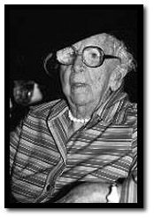
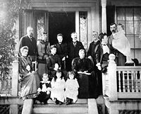
Marjory Stonman Douglas family picture. In the picture she is to the left on her fathers arm.

In 1912 a young lady called Marjory Stoneman Douglas graduated from Wellesley College and was elected to be the Class Orator and member of Florida’s first Suffragist group. At the time she was already a published writer and had made her first publication at the age of 16 in a well acknowledged magazine called St. Nicholas.
She continued to be outspoken more than 90 years to come and became one of the most famous US environmentalists and feminsts. She fell in love with the wetlands called Everglades in Florida in the early 1900s and where instrumental to the later protection of the Everglades. In fact the world she was crucial for the very survival of the wetlands. She was the leader of successful campaigns for the establishment of both the Everglades National Park and the Biscayne National Park.
After she graduated Marjory Stoneman Douglas became the assistant editor of the newspaper The Miami Herald. She used her position to write editorials urging the protection of the wetlands in a time of rapid commercial development and draining of Florida. At the time the political leadership of the state wanted to drain the wetlands in order to develop farmland.
In 1923 she left the paper and pursued a career as a writer concentrating on conservation issues. In 1947 she published the book “The Everglades: River of Grass”. The book was part a series of books called “The Rivers of America Series” and was both a guide to the Everglades as well as describing the political and natural history of the park. Even more it was a book arguing for conservation of the wetlands. Ever since the book was published it has remained on the market and still sells more than 10.000 copies a year.

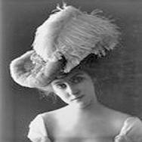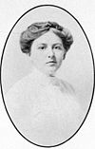

In 1969 she participated in the foundation of the organization Friends of the Everglades and was involved in developing legislation to protect the wildlife and land in the parks. Well after she had passes 100 years she was active in defense of the fragile ecosystem in the parks and continued to give lectures, speeches and be involved in organizational and political work.
However, her involvement ranged from environmental work, involvement in the protection of specific species like the Florida panther and ibises to issues of female emancipation, civil rights, housing and bathroom facilities for the poor to programs of nutrition for small children. Marjory Stoneman Douglas was always practical in her approach and most of all she wanted practical results. She used words as tools and lived to see the results of a continuous dedication to a better world. In 1997 about 1.3 million acre of Everglades wilderness was dedicated in her name for the Parks fiftieth anniversary. The house where she lived and died the 14th of May 1998 is being developed into an environmental education and research centre. She showed all of us that one dedicated individual can make a difference.

In an obituary published in the British newspaper “ The Independent” she was acknowledged by the following words; “ In the history of the American Environmental Movement, there have been few more remarkable figure”es than Marjoy Stoneman Douglas” (Cornwall, 1998). In Florida she was acknowledged as “the Grande Dame of the Everglades” (Basse, 1998).
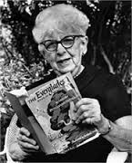

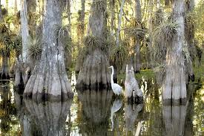

References
Basse, Craig (May 14th, 1998). Grande Dame of the Everglades. St.Petersburg Times (Florida), page 1 a.
Cornwall, Rupert (May 25th. 1998). Obituary: Marjory Stoneman Douglas. The Independent(London), page 16.
Davies, Jack (2009). An Everglade Providence: Marjory Stoneman Douglas and the American Environmental Century. Georgia: University of Georgia Press.
Douglas, Marjory Stoneman (1998). A River in Flood and Other Florida Stories. Miami: University Press of Florida.
Douglas, Marjory Stoneman (1990). Nine Florida Stories. University of North Florida
Douglas, Marjory Stoneman (1987). Marjory Stoneman Douglas: Voice of the River. Pineapple Press
Douglas, Marjory Stoneman (1973). Adeventures in a Green World – the Story of David Fairchild and Barbour Lathorp. Field Research Projects
Douglas, Marjory Stoneman (1969). The Joys of Bird Watching in Florida. Hurricane House.
Douglas, Marjory Stoneman (1967). Florida the Long Frontier. New York: Harper & Row.
Douglas, Marjory Stoneman (1959). Alligator crossing. New York: John Day
Douglas, Marjory Stoneman (1958).Hurricane. New York: Rinehart
Douglas, Marjory Stoneman (1953). Freedom River Florida 1845. New York: Charles Schreibner’s Sons
Douglas, Marjory Stoneman (1952).Road to the Sun. New York: Rinehart
Douglas, Marjory Stoneman (1947). The Everglades: River of Grass. New York: Rinehart
Grunwald, Michael (2006). The Swamp: The Everglades Florida and the Politics of Paradise. New York: Simon & Schuster.
McCally, David (1999). The Everglades: An Environmental History. Miami: The University Press of Florida.

