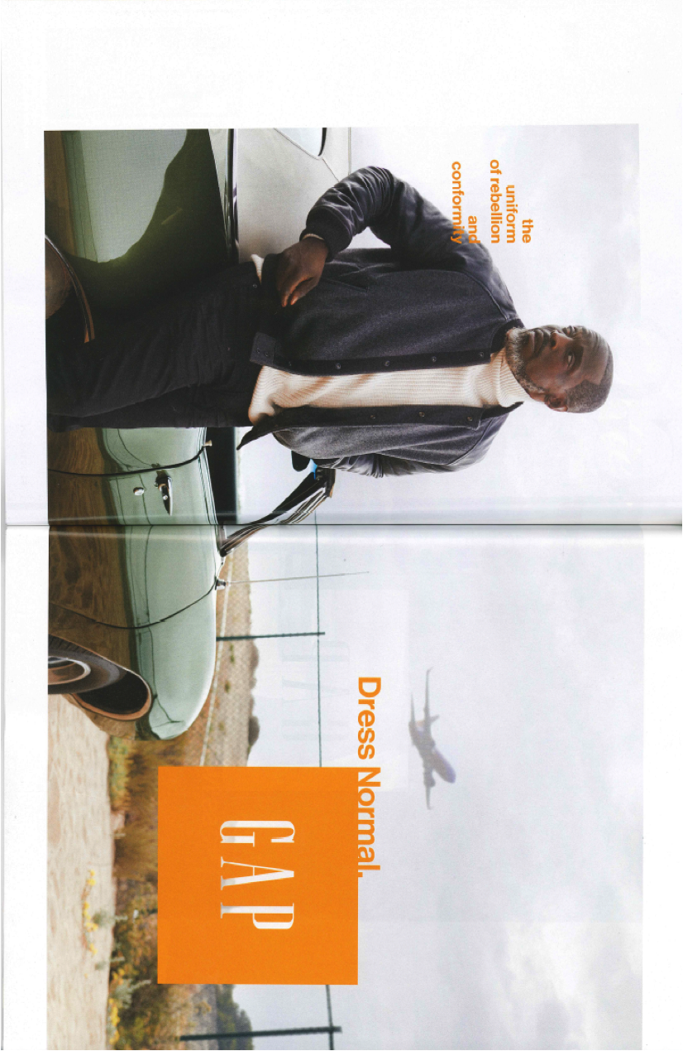
Gentlemen’s Quarterly (GQ), September 2014
Copy reads: “The uniform of rebellion and conformity. Dress Normal.”

