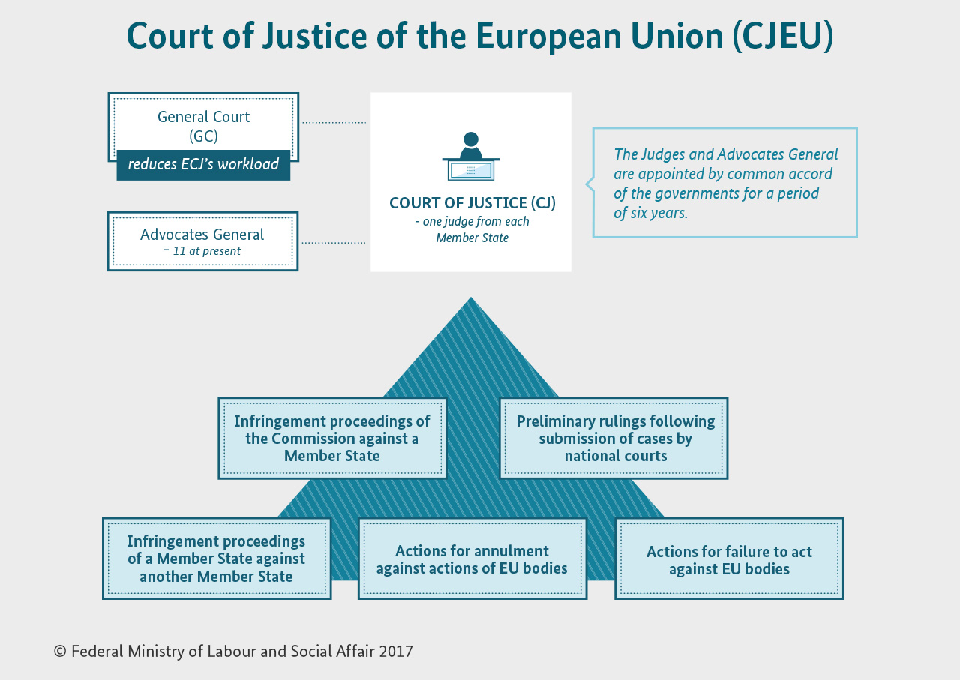

**1 With a partner describe the infographic, then answer the following questions:**

*1 Who are Advocates General?*

*2 How many judges are there?*

*3 What are infringement proceedings?*

*4 What are preliminary rulings?*

*5 What are actions for annulment?*

*6 Find recent examples of actions for failure to act against EU bodies.*

**2 Skim the text in the link and answer the following questions:**

https://goo.gl/cWr2nF

*1 What member states are involved and why was the infringement procedure started?*

*2 What is the main counterargument of the member states?*

*3 Why is the position of the EU not an easy one?*

**3 Think about arguments/counterarguments on this issue. Then discuss it with your partner.**

**4 Read the text and fill in the gaps with the words below. Then fill in the gaps in brackets with the terms referring to the respective rulings.**

|  |  |  |  |  |
| --- | --- | --- | --- | --- |
| *applied* | *against* | *infringed* | *interprets* | *settles* |

The Court of Justice of the European Union (CJEU) **___________ (1)** EU law to make sure it is **___________ (2) in the same way** in all EU countries, and **___________ (3) legal disputes** between national governments and EU institutions.

It can also, in certain circumstances, be used by **individuals, companies or organisations** to take action **___________ (4)** an EU institution, if they feel it has somehow **___________ (5)** their rights.

|  |  |  |  |
| --- | --- | --- | --- |
| *annul* | *violate* | *determine* | *gives* |
| *harmed* | *make* | *take* | *concerns* |
| *complain* | *doubt* | *put* | *comply* |

**What does the CJEU do?**

The CJEU **___________ (1)** rulings on cases brought before it. The most common types of case are:

* **annulling EU legal acts** (__________________________) – if an EU act is believed to **___________ (2)** EU treaties or fundamental rights, the Court can be asked to **___________ (3)** it – by an EU government, the Council of the EU, the European Commission or (in some cases) the European Parliament.  
  Private individuals can also ask the Court to annul an EU act that directly **___________ (4)** them.
* **interpreting the law** (__________________________) – national courts of EU countries are required to ensure EU law is properly applied, but courts in different countries might interpret it differently. If a national court is in **___________ (5)** about the interpretation or validity of an EU law, it can ask the Court for clarification. The same mechanism can be used to **___________ (6)** whether a national law or practice is compatible with EU law.
* **ensuring the EU takes action** (__________________________) – the Parliament, Council and Commission must **___________ (7)** certain decisions under certain circumstances. If they don't, EU governments, other EU institutions or (under certain conditions) individuals or companies can **___________ (8)** to the Court.
* **sanctioning EU institutions** (actions for damages) – any person or company who has had their interests **___________ (9)** as a result of the action or inaction of the EU or its staff can **___________ (10)** action against them through the Court.
* **enforcing the law** (__________________________) – this type of case is taken against a national government for failing to **___________ (11)** with EU law. Can be started by the European Commission or another EU country. If the country is found to be at fault, it must **___________ (12)** things right at once, or risk a second case being brought, which may result in a fine.

<http://www.bmas.de/SharedDocs/Bilder/EN/Topics/Social-Europe-and-international-Affairs/european-court-of-justice.jpg;jsessionid=0C314CDE30AD794D64183821B760F069?__blob=poster&v=3>

http://europa.eu/rapid/press-release_MEMO-17-1935_en.htm