November 22, 2017
Dear Sen. Tammy Duckworth,
As a constituent and fellow citizen of Illinois, I thank you for your efforts in shaping a better world for us, and more importantly, our younger generations. I appreciate the work you do and I believe wholeheartedly Illinois would be worse off without you.
I would like to bring to your attention the new bill, H.R. 3053, currently discussed at the Senate. My client, Exelon Corp., is heartened to see the government’s renewed interest in a geological disposal site discontinued under President Obama. This bill would kickstart the construction of the Yucca Mountain disposal site, and my client stands to profit from the undertaking.
Following its self-appointed obligation to dispose of civilian nuclear waste, the federal government has not provided for the disposal, due to political and scientific opposition. It even shut down the Yucca Mountain Site on grounds that the site was an environmental hazard. Should the government remain incapacitated for long, my client will be forced to shut down its nuclear plants. If they do shut down, Illinois’ economy will suffer severe repercussions that it will be difficult to recover from. I beseech you to reconsider your stance and embrace the bill.
With this letter I am presenting you a policy paper drafted in cooperation with my client. We will briefly examine the impact of nuclear energy in Illinois, the Yucca Mountain Controversy, then evaluate alternatives and finally present our own recommendations. I hope you will value our input and act accordingly.
I thank you for your time and patience.
Best Regards,
Lukas Grossi
Lobbyist, Darren Own Association

= Great.

Table of Contents
Introduction p.3
Illinois p.4
Yucca Mountain p.5
The Debate p.6
Alternatives p.8
Recommendation p.10
Conclusion p.11
References p.11

Introduction

Exelon owns in Illinois the largest fleet of nuclear reactors ever deployed in the US. These reactors produce half of Illinois’ electricity while operating at full capacity. The price of this production is its spent fuel, a highly radioactive waste. The product of nuclear fission involving plutonium or uranium, it is extremely toxic. It is possible that the person may develop the Bone Marrow Syndrome as a result of radioactive exposure, which degrades the degradation of the bone marrow, and results in infection and internal hemorrhaging. That is the best-case scenario.
The best solution is to isolate the spent nuclear fuel deep underground. To that end, the US government upheld its obligation to dispose of civilian-made nuclear waste, in lieu of environmental as well as public health and safety concerns by enacting the Nuclear Waste Disposal Act of 1982. In 1987, Congress nominated the Yucca Mountain Range in Nevada as the location for an underground disposal site, and amended the 1982 Act to reflect its choice.
Nevada fiercely opposed its designation, fighting the federal government in court and in Congress. They finally succeeded in 2009 when President Obama cut the funding to build the site. While Nevadans and their environmentalist allies were jubilant over their victory, their actions left the country without a means for safe disposal: as interim storages in civilian nuclear plants approach capacity, and with no way of allocating the waste elsewhere, Exelon will have to close down its plants, which would damage the Illinois economy severely. Furthermore, every storage site is a radioactive hazard waiting to happen and they require active 24-hour management. If the plants close down, then the storages will likely remain unattended, with little to no warning if and how the radioactive waste will occur.
The bill recently introduced by President Trump in Congress, H.R. 3053, is a step in the right direction. By finishing the construction of the site, Exelon will be able to continue supplying electricity to the domestic market while more eco-friendly methods are examined for radioactive waste disposal.
= it is ok, but using the supplies of electricity and the survival of the company as an argument I would use concrete data. (XXX TWh of electricity, 54% of electricity in the country, employing XXX employees…).

Illinois
Exelon Corp. owns the six nuclear plants in Illinois (Braidwood, Byron, Clinton, Dresden, LaSalle, and Quad Cities), which generate half of the state’s electricity and the majority of state’s decarbonized energy production.
If three or more of the plants closed down, according to a 2015 report of the State of Illinois, the economic damages would be severe: causing about $1.8 billion in projected lost economic activity, decreased reliability of the energy supply, increased wholesale electricity prices. To produce the same amount of electricity with fossil fuels or natural gases, the Illinois Clean Energy Coalition calculated Illinois would have to release an extra 92 million metric tons of greenhouse gases, on top of the 100.6 million metric tons already produced by the state’s non-nuclear power generation. This proves that nuclear power is a significant step towards energy decarbonization.
Unfortunately, the nuclear plants generate a lot of spent fuel, a highly radioactive waste. According to a 2017 survey of the Nuclear Energy Institute, Illinois currently has 10,176 metric tons of nuclear waste in its territory, scattered in storages within or nearby the nuclear plants. See fig.1 for a comparison of the levels of waste accrued in Illinois, compared to other states in the US.
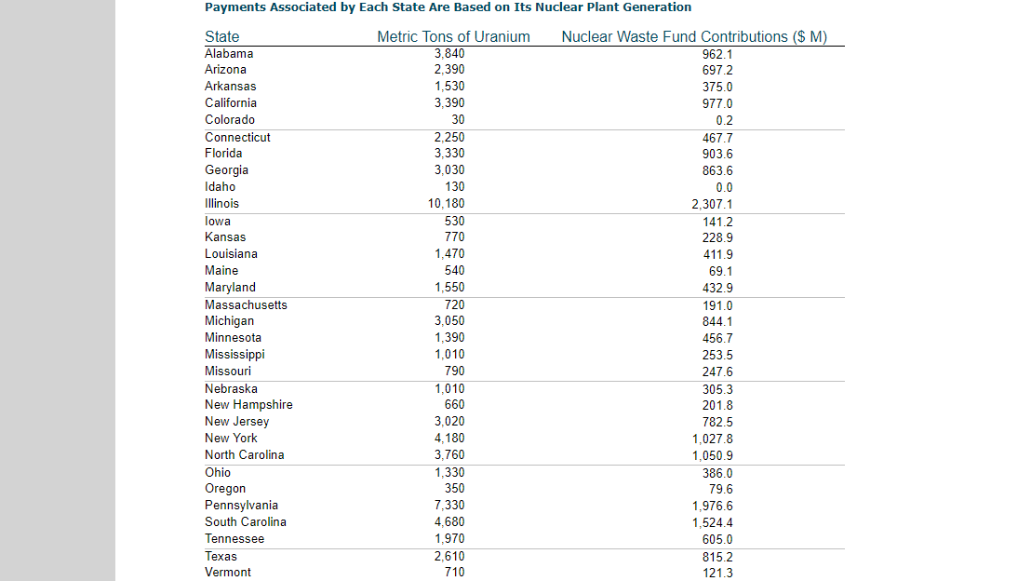(fig.1)
According to the Institute, a typical nuclear power plant generates 20 metric tons of spent fuel per year. This means the total waste production in Illinois amounts to approximately 300 tons of spent fuel every year. As years go by, the amount increases. Pretty soon Exelon will run out of space to store all of this waste. Each storage unit represents an environmental hazard, as any unit could leak its contents at any time. With their location near population centers, the risk of contaminating local communities is high, unless a more permanent and secure disposal method is found.
So far there has been only one instance of radioactive leakage in Illinois: in 1995, tritium-contaminated water leaked and infected the groundwater surrounding the Braidwood Nuclear Power Station, but the situation was discovered only days after the fact. The damage was luckily minimal, but it showcases the risk if nothing is done to secure radioactive waste with more efficient containment solutions.

Yucca Mountain

In 1982, the US government enacted the Nuclear Waste Disposal Act. Pursuant to §111(a)(4), the US government assumed an obligation to permanently dispose of civilian nuclear waste, which meant building an underground disposal site. The Department of Energy lead the search and found three potential locations by 1987: Hanford, Washington; Deaf Smith County, Texas; and the Yucca Mountain Range of Nevada. Congress, that same year, elected to build the site in Nevada and amended the 1982 Act to reflect their decision.
The Yucca Mountain Range is a volcanic ridge about 129km northwest of Las Vegas, an ideal location because the nearest habitation is at least 22km from the site itself. This meant that if a problem arose, there was no risk of anyone being harmed. The original plans foresaw a processing plant feeding into an underground network of tunnels and vaults (see fig.2). Original projections planned for a capacity up to 77,000 metric tons, but in 2008 the Department of Energy updated their plans to include another 190,000 metric tons of waste.
Due to local and state interference with the construction, the construction of the site was put indefinitely on hold with President Obama.
The latest bill to stir up the Yucca Mountain debate is H.R. 3053, currently reviewed in the Senate. If the bill passes, Congress will be able to pour funding to restart the construction of the site.

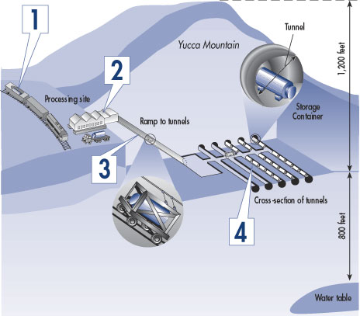(fig.2)

The Debate

The environmental disposition of the geological site is disputed between two opposing camps: Nevadans, on one side; the Department of Energy (hereinafter DOE) and the Nuclear Regulatory Commission (hereinafter NRC), on the other.
The first objection raised by the opposition is the location: the Yucca
Mountain Site, as devised, sits above the Yucca Mountain Aquifer, which supplies the Amargosa Valley (Nevada’s main farming land). The opposition contends a leak from the site would infiltrate the Aquifer and poison the farmlands, causing countless deaths and injuries. The NRC disagrees: having examined the local geology, potential climate conditions and water flows from the Aquifer, they concluded the impact of radioactive waste on soil and groundwater would be, in reality, small. Small, pursuant to the NRC, means the environmental impacts would be minor to the point of not causing any damage to the surrounding environment.
Geologically, the Yucca Mountains are a seismic and volcanically active piece of land. Opposition believe that the land, as a result, is unsuitable for storage, since earthquakes or volcanic activity could easily damage the site or the canisters within, causing radioactive waste to leak. Yet reading the DOE plans, it is clear the site would be built using state-of-the-art technology, which would contain the risk of a leak. The site’s construction would employ the defense-in-depth technique: multiple levels of protection to prevent the leakage of radioactive material into the environment. Also, the site would be under constant surveillance, increasing the reaction time if a problem arose. If any other technology had been used to build the site, then the opposition’s fears would be warranted. But given the DOE’s plans, such fearmongering is to be dismissed.
The third objection concerns transportation. The opposition has espoused the theory that transporting waste to the site would be too great a risk given the lives of millions resides along the potential transit routes. If an accident occurred during transit, i.e. from Illinois to Nevada, the area would be contaminated with radiation, putting hundreds of lives at risk. Yet according to the NRC, during the past forty years a lot of spent fuel was shipped throughout the US, without a single accident having occurred. It is optimistic to think such a success rate will continue in the future, but both the NRC and the DOE track transportation of hazardous material, and they can confidently assert that no harm will ever occur. Furthermore, the NRC periodically studies the potential risks from these shipments and it has yet to find cause for major concern in the event of a major spill during transit.
= these arguments are fair and supported with research, but somehow vague and shallow. It is the result of you trying to cover almost everything – emphasizing the role of your company and why it is necessary for it to have some repository, challenging the arguments of opponents of the repository, discussing alternatives…with limited space you are not able to go into the details.

Alternatives
The federal government has not provided an alternative to the Yucca Mountain Site. Instead, Exelon must continue to stock its waste in fuel pools and dry casks until a solution is found. However, the Exelon is running out of space and cannot secure new venues for storage.
When President Obama called for a blue-ribbons commission to resolve the dilemma, the response was as follows: it is necessary to develop a geologic disposal site; the repository must be situated in a state willing to accept the nuclear waste from the rest of the country; that the government should build a series of consolidated (temporary structures) facilities for spent fuel storage. Nevada’s current resistance to the site’s construction on their land is clear proof that no state will sacrifice itself willingly, short of the federal government taking action.
Regarding the temporary storages, civilian operators like Exelon already own their own storage units, and the DOE has one such unit in Hanford, Washington (which recently hit the news due to radioactive leaks). The storages come in two types, fuel pools or dry cask storages, and are typically located near human population centers. Each unit represents an environmental risk on its own: in fact, if a leak were to occur from any one of these storage sites, the radioactive waste would expand across the nearby countryside, maiming or killing untold numbers of civilians.
Fuel pools are deep pools of water housing spent fuel rods removed from the reactor. These pools are typically located inside the plant, but in Illinois there is an offsite fuel pool owned by the Morris Operation. Each pool is in a closed environment and kept under constant surveillance, with the aid of heat exchanges, fans and vents.
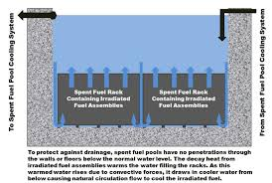The inherent risk comes from either the formation of hydrogen gas above the pools (caused by the radiolysis reaction between hot fuel rods and cold water) or the chance that the pool water might boil over. Heat exchangers are employed to keep the pool at a cold and steady temperature, while fans and vents circulate the air constantly, but none of these mechanisms are failsafe. If the water is allowed to boil over, even slightly, it will release radioactive isotopes in the air which could expand for miles, contaminating the surrounding countryside. Hydrogen gas, on the other hand, is explosive: not only could an explosion of the gas release even more radioactive elements into the air, contaminating nearby land, but it might even set off a chain reaction dwarfing Chernobyl.
Following a period of five or ten years, the allegedly cooled fuel is then collected and placed into specially made steel cylinders, called dry casks. Each cylinder is welded or bolted shut, and is covered with additional layers of material as a radiation shield.
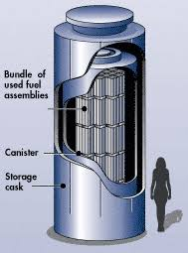
These containers are stored either onsite or near the plants, for surveillance purposes. The inherent risk here comes from shoddy workmanship or the corrosive properties of the toxic material, which might be hot enough to melt its metal prison. In either case, it would allow for radioactive isotopes to leak out and contaminate the surrounding area. In the wind is blowing, then the contamination would expand indefinitely.
Recommendation
The immediate recommendation calls for the construction of the Yucca Mountain Site, since the risks opined by Nevadans and environmentalists alike are negligible compared to the overall gravity of not having a permanent means of radioactive waste disposal.
In the interim, Exelon wishes to tender a few suggestions in the event the bill fails muster.
The first recommendation calls for a regulatory framework setting quality standards for the construction of dry cask storages. These regulations would guarantee uniform quality and assurance against potential leakage, as well as identify a category of subjects liable under product liability laws in the event of poor workmanship.
Secondly, it would be beneficial to civilian operators in general if the government reclassified the types of radioactive waste according to the radiation levels or similar mechanisms This approach would allow for Exelon et similia to prepare target-oriented approaches, guaranteeing a more efficient and effective disposal of radioactive waste compared to the current paradigm.
Third, given the difficulty in expanding the current storage facilities, it would be great if the government established standards for suitable tracts of land in lieu of public health and safety risks. This would allow the civilian operators to expand their temporary capacity further while waiting for a more permanent solution to be drafted.
Finally, it is requested that the government subsidize additional onsite storage for nuclear waste. According to the Nuclear Waste Disposal Policy Act, the government provides for storage only in the event the civilian operator lacks adequate facilities to do so, and only for a limited amount (up to 1,900 metric tons). Yet the civilian operator will need a capacity that overreaches the government’s current predisposition. Since fuel pools and dry cask storages require constant active management, subsidizing them will ease the burden of expenses until the time when the government will be able to fulfill its obligation of waste disposal.

Conclusion
Nuclear power is an essential ingredient for Illinois’ economy and its waste an unfortunate but necessary byproduct. If no solution is soon for the waste’s disposal, Exelon will soon have to shut down its plants, and the economic harm to the state, for now a hypothetical, would become a reality.
The multitude of temporary storage sites located throughout Illinois are not only a danger for the population centers located near them, but also a financial nightmare requiring constant active management. By storing the waste in a single large site, like what the Department of Energy had planned for Yucca Mountain, it is possible to significantly cut down on costs, increase surveillance and reduce the risk of radioactive waste leaking into the environment.
The Yucca Mountain project was subjected to conflicting scientific and public debate for the past fifty or so years, without much of a result. President Obama did not quash the site on scientific grounds, but as a favor to former Sen. Harry Reid of Nevada.
Many opponents are dismissing the plan because the DOE has lost all manner of credibility over the years due to poor management. Yet the NRC, the presiding US body in all nuclear matters, had released an independent report which confirms the DOE’s position. If the NRC is backing up the DOE, then by necessity any opposition to the DOE’s plans for the Yucca Mountains must be overruled.
The government cannot afford to be indecisive and the new bill being discussed must pass muster in Congress. By passing it, we can finally begin on the construction of a disposal site the nuclear industry needs for its own survival.
The site must be built.

.

= very nice paper, one of the best. 15 points, no additional comments.

References
- NEI Factsheet, Illinois and Nuclear Energy
- https://emergency.cdc.gov/radiation/arsphysicianfactsheet.asp
- https://www.npr.org/templates/story/story.php?storyId=101689489
- http://www.exeloncorp.com/locations
- http://www.nuclearpowersillinois.com/reliability
- NEI factsheet, Illinois and Nuclear Energy, p.1
- Illinois Department of Commerce, House Resolution 1146, 1/5/2015, p. 123-150
- Illinois Clean Energy Corporation (2017). Nuclear Power’s role in reducing carbon air emissions in Illinois
- NEI factsheet, Illinois and Nuclear Energy, p.2
- https://www.nei.org/Knowledge-Center/Nuclear-Statistics/On-Site-Storage-of-Nuclear-Waste/US-State-by-State-Used-Fuel-and-Payments-to-the-Nu
- https://www.nei.org/Knowledge-Center/Nuclear-Statistics/On-Site-Storage-of-Nuclear-Waste
- http://www.epa.illinois.gov/topics/community-relations/general/radiation-and-groundwater/index
- Nuclear Waste Policy 42 USC 108 §10101
- Yucca Mountain Science and Engineering Report, DOE/RW-0539-1, p.xxix-xxxv
- http://www.millennium-ark.net/News_Files/NBC/Yucca.Mountain.html
- http://stateenergyreport.com/2013/05/21/the-problem-with-yucca-mountain/
- HR 3053 RH. 115-355, Part.1
- https://www.nei.org/Master-Document-Folder/Backgrounders/Fact-Sheets/Yucca-Mountain-Myths-and-Facts-Opponents-Distort-o
- http://ag.nv.gov/Hot_Topics/Issue/Yucca/
- Yucca Mountain Science and Engineering Report, DOE/RW-0539-1
- US NRC Final Report, NUREG-2184
- US NRC Final Report, NUREG-2184, p.3-40,4-20
- US NRC Final Report, NUREG-2184, p.1-5
- https://spectrum.ieee.org/energy/nuclear/yucca-mountain-pro-con,
- DOE/RW-0539 Rev. 1, p.4-14 – 4-18,
- https://www.iaea.org/ns/tutorials/regcontrol/assess/assess3213.htm
- https://www.nrc.gov/waste/spent-fuel-transp.html
- https://www.nrc.gov/reading-rm/doc-collections/fact-sheets/transport-spenfuel-radiomats-bg.html
- Final Report, Blue Ribbons Commission on America’s Nuclear Future.
- http://www.tri-cityherald.com/news/local/hanford/article183606106.html
- https://www.nrc.gov/waste/spent-fuel-storage/pools.html
- http://allthingsnuclear.org/dlochbaum/nuclear-spent-fuel-damage-pool-accident
- https://www.nrc.gov/waste/spent-fuel-storage/faqs.html
- https://www.nrc.gov/waste/spent-fuel-storage/dry-cask-storage.html
- https://www.nrc.gov/waste/spent-fuel-storage/diagram-typical-dry-cask-system.html

NEI Factsheet, Illinois and Nuclear Energy.
https://emergency.cdc.gov/radiation/arsphysicianfactsheet.asp
https://www.npr.org/templates/story/story.php?storyId=101689489
http://www.exeloncorp.com/locations
http://www.nuclearpowersillinois.com/reliability
NEI factsheet, Illinois and Nuclear Energy p.1
Illinois Department of Commerce, House Resolution 1146, 1/5/2015, p. 123-150
Illinois Clean Energy Corporation (2017). Nuclear Power’s role in reducing carbon air emissions in Illinois
NEI factsheet, Illinois and Nuclear Energy p.2
https://www.nei.org/Knowledge-Center/Nuclear-Statistics/On-Site-Storage-of-Nuclear-Waste/US-State-by-State-Used-Fuel-and-Payments-to-the-Nu
https://www.nei.org/Knowledge-Center/Nuclear-Statistics/On-Site-Storage-of-Nuclear-Waste = Use the proper form of referencing, with the author, title of the text and source. Not only link.
http://www.epa.illinois.gov/topics/community-relations/general/radiation-and-groundwater/index
Nuclear Waste Policy Act, 42 USC §10101
DOE/RW-0539-1, p.xxix-xxxv
http://www.millennium-ark.net/News_Files/NBC/Yucca.Mountain.html
http://stateenergyreport.com/2013/05/21/the-problem-with-yucca-mountain/
HR 3053 RH. 115-355, Part.1
https://www.nei.org/Master-Document-Folder/Backgrounders/Fact-Sheets/Yucca-Mountain-Myths-and-Facts-Opponents-Distort-o
http://ag.nv.gov/Hot_Topics/Issue/Yucca/
DOE/RW-0539-1
US NRC Final Report, NUREG-2184, p.3-40,4-20
US NRC Final Report, NUREG-2184, p.1-5
https://spectrum.ieee.org/energy/nuclear/yucca-mountain-pro-con, DOE/RW-0539 Rev. 1, p.4-14 – 4-18, https://www.iaea.org/ns/tutorials/regcontrol/assess/assess3213.htm
https://www.nrc.gov/waste/spent-fuel-transp.html
https://www.nrc.gov/reading-rm/doc-collections/fact-sheets/transport-spenfuel-radiomats-bg.html
Id.
Final Report, Blue Ribbons Commission on America’s Nuclear Future.
http://www.tri-cityherald.com/news/local/hanford/article183606106.html
https://www.nrc.gov/waste/spent-fuel-storage/pools.html
http://allthingsnuclear.org/dlochbaum/nuclear-spent-fuel-damage-pool-accident
https://www.nrc.gov/waste/spent-fuel-storage/faqs.html
https://www.nrc.gov/waste/spent-fuel-storage/dry-cask-storage.html
https://www.nrc.gov/waste/spent-fuel-storage/diagram-typical-dry-cask-system.html

