Distinguished Mr. Chairman and members of the Committee!

Secretariat!
Participants of the meeting!

I am honored to be able to address to the additional session of the Meeting of the Parties to the Espoo Convention on behalf of the Ministry of Natural Resources and Environmental Protection of the Republic of Belarus. We would like to express our profound gratitude to the Committee and the Secretariat for the comprehensive consideration of the Belarusian NPP case as well as for the efforts to find the constructive solutions in connection with the notice by Lithuania, including the Law on Necessary Measures against the Threats Posed by Unsafe Nuclear Power Plants in Third Countries adopted by the Seimas of Lithuania 20 April 2017, and the declaration of Lithuanian Vice-Minister for Energy Simonas Šatūnas announced 15 July 2017. This is in fact not the first expert dialogue which took place between Belarus and Lithuania, we maintain the constructive bilateral negotiations on the issue of the Astravets Nuclear Power Plant – that is exactly what Belarus has been trying to achieve during the last 6 years.

It is important to point out that the results of the 7th session of the Meeting of the Parties to the Espoo Convention that took place in Minsk from 13 to 16 June, 2017 were adequate and encouraging for the Belarusian party to the meeting as the majority of the delegations had an opportunity to discuss many issues, including those related to the impact of the Espoo Convention on the progress towards the sustainable development goals and the implementation of the international climate change agreements, both in bilateral and multilateral formats. Belarusian first deputy natural resources and environmental protection minister Iya Malkina noted: “the Meeting of the Parties was important as it provided for sharing practices developed by 45 countries with other states, expanding the competencies of environmental impact assessment and strategic environmental assessment into various sectors of economic activity, and strengthening the role of environmental assessment with respect to planned activities for different countries”.
= I do understand your effort to make your speech as ´real´ as possible, including necessary civilities. However, you have only limited space (20 000 characters that you have exceeded by about 50% and with too many courtesies you are losing your audience.

However, the high-level segment suggested postponing the final decisions, stressed that the matter referred to the decision on all country matters, and not only on the Belarusian Nuclear Power Plant construction. During the discussion, experts agreed that the existing mechanisms of the Convention were not enough to resolve disputes and suggested the postponing as an attempt to find a compromise for all parties to the meeting.

Concerning the Belarusian-Lithuanian negotiations on the Astravets NPP – in regard to the Lithuanian side, particularly the Vice Minister: “the IAEA mission was not a full-scale: only two out of six modules were completed. They were related specifically to the resilience of the planned nuclear facilities against external risks at the Astravets Nuclear Power Plant. This means that IAEA did not complete the modules on the assessment of the site itself, environmental impact and its stress-tests”.

We hope that the provided opportunity to rest our arguments on the official documents and reports of both international and state commissions for the wide specter of specialists from such spheres as energy, environmental protection, and law to be present today will put clarity into the issues under consideration and help to find solutions on the three arguable points.

Let us begin with the claims of the Republic of Lithuania and, drawing on the experts` reports, set out a position of Belarus, reassuring the delegates of transparency of all the documents connected with the construction and operation of the Belarusian NPP and underlining our deep awareness of the responsibility for undertaking the appropriate measures, aimed at insuring the compliance of such an important object of the nuclear energy related sphere, as a nuclear power plant, with the requirements of environmental, nuclear and radiation safety.

Regarding the Site and External Event Design Mission of the IAEA (SEED mission), we would like to inform that this mission has been conducted from 16 to 20 January 2017. The mission team consisted of two experts from France and Hungary, and four IAEA staff members. The SEED mission final report was forwarded to the Belarusian side 27 April 2017. It is crucial to highlight that this mission was carried out in framework of implementation of paragraph 64 of decision VI/2 of the Meeting of the Parties that took place in Geneva from 2 to 5 June 2014, and the choice of modules was based strictly on the above mentioned recommendations. During the mission the IAEA experts` team reviewed the design parameters of the constructed nuclear power plant against external hazards specific for the Astravets site in the northern part of Belarus. The experts also reviewed the identification processes of the characteristics of these hazards (human-induced hazards – aircraft crash, off-site explosion, accidental discharge of explosives or toxic clouds and corrosive/chemical aggressive liquid into surface and ground water; natural external hazards – flood, hurricane, seismic hazard, geotechnical and etc.) and the process for screening them, as well as exchanged views with the Belarusian side on the challenges related to external events in the light of the Fukushima Daiichi accident lessons.

According to Greg Rzentkowski, Director of the IAEA`s Division of Nuclear Installation Safety, this mission demonstrated that appropriate steps have been taken by the Belarusian side to establish the design parameters of the nuclear power plant, which will ensure protection of the Belarusian NPP in the case of the worst credible external event occurs. Based on the review of the Format and Content of the Safety Analysis Report for NPP, Chapters 2 and 3 (hereafter referred to as PSAR) related to the site specific hazard characteristics and design parameters and discussions held with the Counterpart, the Review Team concluded that appropriate steps were followed to adequately address all necessary aspects of site safety and site-specific design parameters for the Belarusian NPP for relevant external hazards. Furthermore, the Review Team stated that systematic and comprehensive screening of external hazards was performed using well-documented criteria; site specific parameters are enveloped by the NPP design parameters, hazard monitoring programs are adequate and properly documented in the PSAR; and appropriate measures have been taken to address challenges related to external events in light of lessons from the Fukushima Daiichi accident. The Review Team offered also the following suggestions – the section documenting electro-magnetic interference and lightning should be improved in the Chapter 2 of the final SAR; the site-specific seismic ground motion response spectrum should be properly documented in the final SAR, taking into account soil conditions and international practice (IAEA Safety Standard Series SSG-9); and consideration should be given to future developments of safety improvements related to the challenges highlighted in the IAEA Fukushima Accident Report following completion of the stress test and PSA Level 1 and 2. The Review Team noted that the Counterpart’s practices in the following areas are in line with an international practice – commitment to conduct Level 1 and Level 2 PSA for both internal and external events before starting the commercial operation of the NPP; and comprehensive screening of site-specific external hazards.

An important point is that the Belarusian side accepts the abovementioned experts` suggestions, appreciating the necessity of transparency and “non - manipulations with international instruments and public opinion in Belarus and its neighbouring countries”, which in its order counters with the statement made by Lithuanian Vice Minister for Energy Simonas Šatūnas 15 June 2017, and reports that the following information is in public domain and published both on the official web-pages of the Belarusian NPP and IAEA, proving our will to maintain an open policy.
= nice argument with all details. I would suggest to cut off the redundant parts and unnecessary details – the message (IAEA checked our NPP, found it OK, suggested some improvements which we accepted) is being lost in details of the whole process.

Regarding the environmental impact of the Astravets Nuclear Power Plant on the surrounding areas, especially the Republic of Lithuania. We would like to remind the delegates that the Belarusian NPP is located at the north-west of the republic in the center of Astravets region in Grodno area. The distance to the border of Lithuania from the platform of the nuclear plant is about 22 km, and that all possible measures had been brought in safety precautions of our neighbouring countries. Taking into account the Lithuanian side statement, made soon after the Meeting of the Parties to the Convention on its seventh session in Minsk, 2017 on “the lack of evidence of acceptably low level risk of exposure of the population to the harmful effects of ionising radiation in the event of an accident”, we tend to rest our argument on the Final report on Environmental Impact Assessment (EIA) of the Belarusian NPP provided by the projecting scientific and research republican unitary enterprise “Belnipienergoprom”.

Subparagraphs 15.2 and 15.4 of the specification of the region of the aforecited report state that the river Viliya (Neris) is considered as the main source of technical water supply for the Belarusian NPP. The water from the river Viliya is extracted and pumped to the platform of the NPP through the pressure water pipes (9,9 km). During the period of the NPP construction for the purposes of the work execution, the extraction of water from the surface water ponds does not take place that is why considerable changing of quantitative values in the water mode of the river Viliya and other water basins will not occur. Within the indicated period, the volume of disposed sewage water into the river Viliya will not exceed 1050 m³/day. After commissioning of the NPP, the water withdrawal from the river Viliya, used for optimal operation of two energy blocks will account up to 2,54 m³/sec. In its turn, the tapping of disposed domestic sewage water into the river Viliya will amount to 910,9 m³/day with possible maximum increase up to 3600 m³/day. The forecast of the water quality in the Viliya after disposal of sewage water from the NPP during its construction and after commissioning shows that up to 10,4 km from the place of tapping (within the Belarusian territory and over 20 km from the Belarusian-Lithuanian border) will be exposed with a negligible transborder influence within the limits of maximum permissible concentration (MPC).

At the same time, the distribution of chemical pollution in the underground waters of the Belarusian NPP region is preconditioned by hydrodynamic conditions of the territory, as the polluting materials move together with the stream of underground waters. Whereas, the distance from the location of the Astravets NPP to the neighbouring territory of Lithuania is about 23 km, and the river Viliya, as the main drain of underground waters up to 30-km zone, conditions the direction of the stream to its valley, thence the polluting materials movement with the underground water stream to the territory of the Republic of Lithuania is not forecasted. The completed examination of the radiation materials migration from the platform and local source shows that the distribution of the radiation pollution in the river network within 30-km zone is practically excluded (picture 1).

Picture 1. Scheme of the hydrodynamic situation
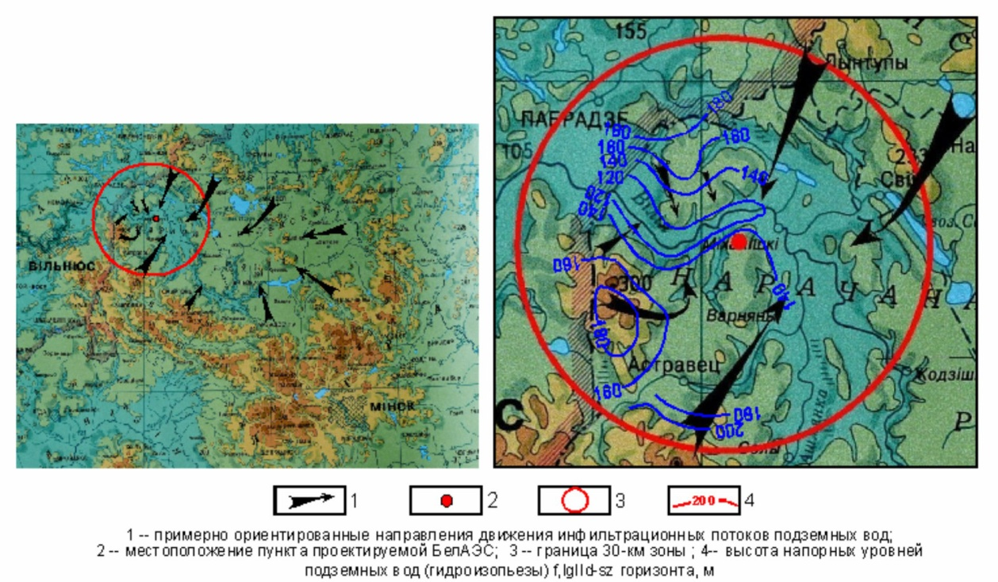
1. underground water streams directions of movement;
2. location of the Belarusian Nuclear Power Plant;
3. border of 30-km zone;
4. altitude of underground water pressure, m.

= Nice argument.

Considering the estimation of the radiation influence rendered by the Belarusian NPP on the population of the neighbouring countries, the annual population exposure of the Lithuanian boundary regions during the standard operation of the Belarusian NPP is shown in picture 2. (according to subparagraph 15.4.4). While picture 3 is connected with the input of various exposure pathways to the radiation level. At the same time, the annual population exposure of Vilnius during the standard operation of the NPP is shown in picture 4, while picture 5 is connected with the input of various exposure pathways to the radiation level in Vilnius. The annual population exposure of the Lithuanian boundary regions accounts E _{year} = 0,017 μSv (microsievert). While the annual population exposure of Vilnius E _{year} = 0,004 μSv. The value data are equal to 0,17 % and 0,04 % of the population exposure quotas from the radioactive emissions during the standard operation of the NPP (assuming perfect containment), 10 μSv /year or 0,01 mSv (millisievert).

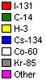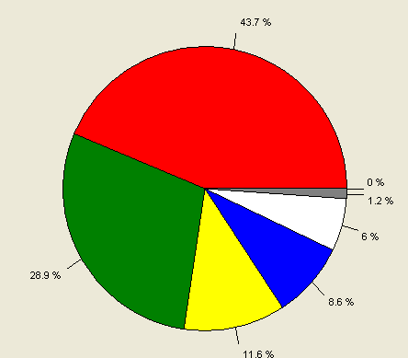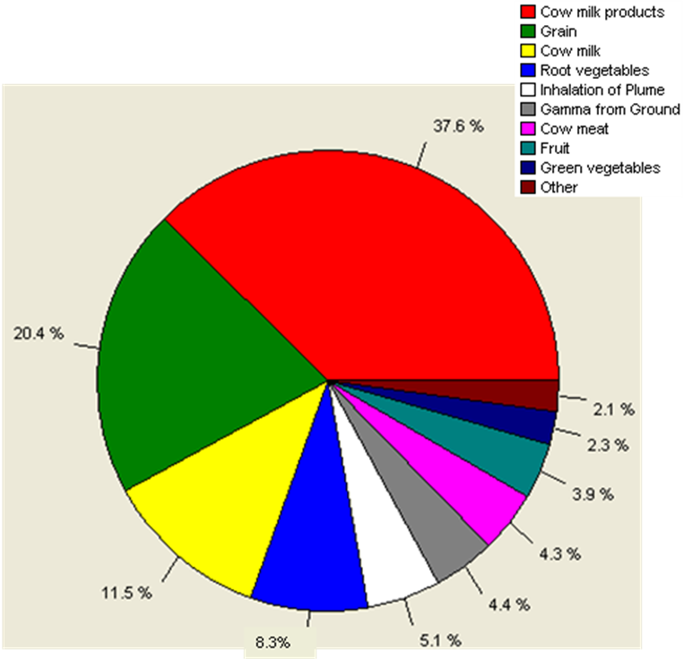
Picture 2. Dose contribution of various radionuclides (Lithuania) Picture 3. Dose contribution of various exposure pathways (Lithuania)
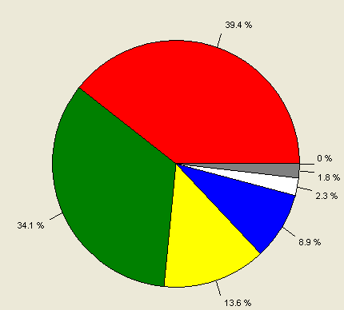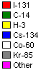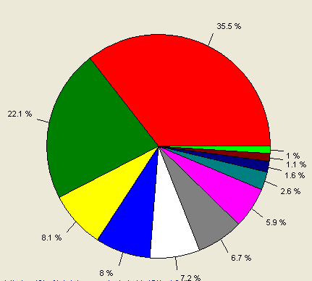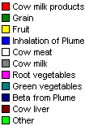
Picture 4. Dose contribution of various radionuclides (Vilnius) Picture 5. Dose contribution of various exposure pathways (Vilnius)

The forecasting population exposure in the worst course of the undesigned emergency when the radiation exposure is ultimate at various distances from the NPP is shown in table 1.

Table 1. Radiation exposure at an early stage of an accident under the undersigned emergency at various distances from the NPP
Distance, km | Dose from the cloud,  μSv | Fallouts dose  μSv | Effective inhalation dose,  μSv | Total effective dose,  μSv | Thyroid gland exposure*,  mGy
1 | 3,5 | 11,0 | 79,0 | 94,5 | 1500
2 | 2,4 | 6,3 | 47,0 | 55,7 | 910
5 | 1,1 | 2,9 | 22,0 | 26,0 | 420
25 | 0,14 | 0,18 | 1,3 | 1,62 | 25
50 | 0,11 | 0,13 | 1,00 | 1,24 | 19
___________________
*Thyroid gland exposure includes only the radioiodine dose.

It is prominent to point out that according to the World Nuclear Association, naturally-occurring background radiation is the main source of exposure for most people. Levels typically range from about 1.5 to 3.5 mSv /year or 1500 to 3500 μSv that fortifies the high safety standards and security measures taken during the construction and operation of the Astravets NPP. From the analysis of literary report it is revealed that the most crucial impact on the environment will be exerted during the construction period of the NPP and the most critical it will be for Belarusian flora. Let us highlight that the NPP design limits and its safety criteria are set in accordance with the current regulatory documentation and recommendations of the International Commission on Radiological Protection (ICRP) and IAEA.

Regarding the Belarusian NPP objective safety reassessment (stress-tests), we would like to inform the delegates that the Belarusian NPP has passed the safety tests in compliance with the European Union standards, and on November 8, 2017 the results were published in a public domain on the official webpage of the Nuclear and Radiation Safety Department of the Belarusian Emergencies Ministry (Gosatomnadzor) as well as on the website of the European Nuclear Safety Regulators Group (ENSREG). The conclusions prove that the Belarusian NPP is being built using the Russian Generation III+ design and fully meets the highest international safety standards. At the same time, the safeguards of the Belarusian NPP have been designed fully taking into account external events, that buildings, structures, and equipment of the nuclear power plant have been designed in line with the effective legislation, that safety margins have been provided.

According to the research, earthquake is one of the possible external events that have been examined by the Belarusian regulatory body. On the basis of a comprehensive probability analysis the expected maximum intensity of an earthquake that may happen in the location of the plant is 6 on the MSK-64/EMS-98 scale (should not be confused with the Richter scale which measures magnitude) which is considered the “Operating Basis Earthquake” for the nuclear power plant. However, the Belarusian NPP reactor units have been designed to rule out accidents and to safely withstand even the extremely unlikely event of an earthquake with the intensity of 8 MSK-64/EMS-98, with the intensity of 7 MSK-64/EMS-98 set as the plant's “Safe Shutdown Earthquake”.

Although floods in the area of the Belarusian NPP are virtually impossible given that water would have to rise 51.5 meters above its historical maximum levels, the plant can even withstand that degree of flooding. The analysis and simulation show that in the event of such a hypothetical flood and the consequent submersion of the nuclear power plant rooms below ground level, there would be no disruption to reactor operation.

Even the most extreme weather conditions (with the probability of occurrence less than 1 in 10,000 years), such as air temperatures of up to 50 С or wind speeds of up to 62 meters per second, or their combination would not lead to an accident as sufficient safety margins are available, even if temperatures and wind speeds were significantly above these unlikely levels.

We would like to highlight that the government of Belarus set up an interagency working group to prepare the national report. The group included representatives of the Emergencies Ministry, the Natural Resources and Environmental Protection Ministry, the Healthcare Ministry, the National Academy of Sciences of Belarus, and the company in charge of operating the Belarusian NPP. European experts provided guidance to this work as part of the European Commission’s international technical aid project.

On the basis of all the foregoing, we would like to underline that Belarus has always followed a strict fulfillment of the Espoo convention requirements and provisions, as well as its established procedural aspects. Constructing the Astravets NPP, Belarus has accomplished the environmental impact assessment procedure in strict accordance with the Convention, as well as assumed responsibility to fully implement the recommendations of the Committee and the decision VI/2 of the Meeting of the parties. At the same time, we express deep concern about the current situation in the relations with the Lithuanian side in the framework of the Belarusian NPP project. For the present moment we regret to state that Lithuania is trying to give to the current situation a political ground. It creates a very dangerous case – manipulating by the regulations of the Convention in order to slow down or ban the steps of another country which are unfavorable due to economic and political reasons. It is vital that this precedent could cause a negative impact on the advisability of the Convention for the non-EU countries. Nevertheless, it is necessary to point out that we have already gained a positive experience, based on the visit of the Latvian mass media reporters to the Belarusian NPP construction site at the end of October 2017, when it was highlighted that Belarus is open to a dialogue. Arnis Kluinis, a reporter of the Neatkariga newspaper, noted that during the tour of the nuclear power plant the reporters managed to learn everything they wanted to know. There is no evasion or understatement.

Ultimately, confidence in nuclear energy cannot be ensured without guarantees of transparency and the implication of truly independent experts in touch with the different opinions expressed by academic and civil societies. At the end of the day the choice should not be based primarily on an ideological position, but on unbiased information provided by experts on all the risks involved and the implications of the different choices. We try to show our deep interest in giving such impartial information and voice a hope that the data provided earlier are solid enough to assure the Lithuanian representatives in our diligence, and to take off successfully from the table the issues set by the Lithuanian side at the end of the 7th session of the Meeting of the Parties to the Espoo Convention on the grounds of their peaceful settlement.

As a gesture of good will, we are ready to suggest meeting in the Astravets site where we can discuss with the participation of the Committee, experts from Lithuania and the EU countries technical issues being raised by our opponents in their letters. We will also provide opportunity to get acquainted with the progress of the Belarusian NPP construction and the construction quality control system. It is important to remember – we cannot build strong relationships if we refuse to have conversations, we cannot chart more a more peaceful path if the starting point is suspicion and mistrust. We cannot build a safe world unless we work together, respect our differences and stand up for the things that matter most – national and energy security, society`s well-being. Thank you for attention!

Valiantsina Atroshkina
Ministry of Natural Resources and Environmental Protection
Republic of Belarus

= Nice paper. Since your arguments are built properly I had only a few comments in the text:
- The paper is way too long. I am aware of the pile of the resources you have used but still, you should be able to stick to the requirements of the course.
- Write either speech or scientific paper, do not try to accomplish both. Speech needs to be rather simple, since the auditorium has not enough time to process the information and calculate data. Scientific paper, on the other hand, may build on a lot of supportive materials, presenting complicated arguments and detailed explanations. Because you may read it multiple times, search for additional information etc. Your paper keep digressing from one to another form.
- Language of the paper is highly elaborated. Sometimes maybe too much, with essential information being buried under the pile of pleasantries and convoluted phrases. 14p.

Republican Unitary Enterprise “Belarusian Nuclear Power Plant” Environmental impact assessment of the NPP (2010) http://www.belaes.by/en/ecology.html
Republican Unitary Enterprise “Belarusian Nuclear Power Plant” Environmental impact assessment of the NPP (2010) http://www.belaes.by/en/ecology.html
Republican Unitary Enterprise “Belarusian Nuclear Power Plant” Environmental impact assessment of the NPP (2010) http://www.belaes.by/en/ecology.html References 1) BELTA New Agency Belarusian NPP on agenda of Espoo Convention meeting in Minsk (08.06.2017) Retrieved from: http://eng.belta.by/society/view/belarusian-npp-on-agenda-of-espoo-convention-meeting-in-minsk-102171-2017/ 2) BELTA New Agency Belarusian nuclear power plant passes EU safety tests (08.11.2017) Retrieved from: http://atom.belta.by/en/news_en/view/belarusian-nuclear-power-plant-passes-eu-safety-tests-9649/ 3) BELTA New Agency Decision on Belarusian-Lithuanian dispute delayed till next Espoo Convention meeting (19.06.2017) http://atom.belta.by/en/news_en/view/decision-on-belarusian-lithuanian-dispute-delayed-till-next-espoo-convention-meeting-9412/ 4) BELTA New Agency Latvian reporters pleased with Belarus’ openness about nuclear power plant project | ANALYTICS | NPP Belarus – Nuclear power industry – News Belarus – Technologies – BelTA (30.10.2017) Retrieved from: http://atom.belta.by/en/analytics_en/view/latvian-reporters-pleased-with-belarus-openness-about-nuclear-power-plant-project-9628/ 5) BELTA New Agency Seismic control at every stage of Belarusian nuclear power plant operation (08.11.2017) Retrieved from: http://atom.belta.by/en/news_en/view/seismic-control-at-every-stage-of-belarusian-nuclear-power-plant-operation-9657/ 6) BELTA New Agency Stress tests confirm reliability of Belarusian nuclear power plant (08.11.2017) Retrieved from: http://atom.belta.by/en/news_en/view/stress-tests-confirm-reliability-of-belarusian-nuclear-power-plant-9655/ 7) Council of the European Union Environmental concerns regarding the Belarusian NPP – Information from the Lithuanian delegation (14.02.2017) Retrieved from: http://data.consilium.europa.eu/doc/document/ST-6211-2017-INIT/en/pdf 8) Energiewende Team Lithuania’s energy transition at a crossroads (2017) Retrieved from: https://energytransition.org/2017/09/lithuanias-energy-transition-at-a-crossroads/ 9) European Nuclear Safety Regulators Group National Report of the Republic of Belarus on the Belarusian NPP objective safety reassessment (stress tests) (2017) Retrieved from: http://www.ensreg.eu/EU-Stress-Tests/Country-Specific-Reports/EU-Neighbouring-Countries/Belarus 10) European Parliament Welcome from the Chair (2017) Retrieved from: http://www.europarl.europa.eu/delegations/en/d-by/home.html 11) IAEA IAEA safety standards. Format and Content of the Safety Analysis Report for Nuclear Power Plants. Safety Guide No. GS-G-4.1 (2017) Retrieved from: http://www-pub.iaea.org/MTCD/publications/PDF/Pub1185_web.pdf 12) IAEA Report on Safety of the Belarusian NPP against Site Specific External Hazards (2017) Retrieved from: https://www-ns.iaea.org/downloads/actionplan/SEED%20Mission%20Report%20Belarus.pdf 13) Ministry of Foreign Affairs of the Republic of Lithuania Linas Linkevičius: Seimas decision shows Lithuania’s firm position concerning the Astravets NPP (22.04.2017) Retrieved from: https://www.urm.lt/default/en/news/linas-linkevicius-seimas-decision-shows-lithuanias-firm-position-concerning-the-astravets-npp 14) Ministry of Foreign Affairs of the Republic of Lithuania Lithuania’s Foreign Ministry appoints Ambassador-at-Large, who will be responsible for issues related to the Astravets NPP (05.01.2017) Retrieved from: https://www.urm.lt/default/en/news/lithuanias-foreign-ministry-appoints-ambassador-at-large-who-will-be-responsible-for-issues-related-to-the-astravets-npp- 15) Ministry of Energy of the Republic of Belarus [Министерство энергетики Республика Беларусь] President of the Republic of Belarus A. Lukashenko signed Decree No. 499 “Concerning the construction of the Belarusian Nuclear Power Plant” [Указ Президента Республики Беларусь от 2 ноября 2013 г. № 499 «О сооружении Белорусской атомной электростанции»] (2013) Retrieved from: http://minenergo.gov.by/zakonodatelstvo/ 16) Ministry of Energy of the Republic of Belarus [Министерство Энергетики РБ] Progress in implementation the project of the Belarusian NPP construction (2014) Retrieved from: https://www.iaea.org/NuclearPower/Downloadable/Meetings/2014/2014-04-07-04-11-TM-INIG/Presentations/12_Belarus_Barcoun.pdf 17) Ministry of Natural resources and environmental protection of the Republic of Belarus [Министерство природных ресурсов и защиты окружающей среды] Speech of the head of Belarusian delegation, First Deputy Minister of Natural Resources and Environmental Protection of the Republic of Belarus Mrs. Iya Malkina at the 35th session if the Implementation Committee of the Espoo Convention (2016) Retrieved from: http://www.minpriroda.gov.by/en/news-en/view/speech-of-the-head-of-belarusian-delegation-first-deputy-minister-of-natural-resources-and-environmental-1832/ 18) Nuclear and Radiation Safety Department of the Belarusian Emergencies Ministry (Gosatomnadzor) [Департамент по ядерной и радиационной безопасности МЧС Беларуси (Госатомнадзора)] The Fourth National Report of the Republic of Belarus on the implementation of the Joint Convention on the Safety of Spent Fuel Management and on the Safety of Radioactive Waste Management (2011) Retrieved from: http://www.gosatomnadzor.gov.by/phocadownload/dokladi_i_obzori/jc_national_report_of_belarus_-_2011__(english_version).pdf 19) Official Internet Portal of the President of the Republic of Belarus [Официальный интернет-портал Президента РБ] Commentary to Decree No. 499 of 2 November 2013 (2013) Retrieved from: http://president.gov.by/en/news_en/view/commentary-to-decree-no-499-of-2-november-2013-7324/ 20) Official Website of the Republic of Belarus [Официальный сайт РБ] Belarus satisfied with results of Espoo Convention meeting in Minsk (16.07.2017) Retrieved from: http://www.belarus.by/en/press-center/speeches-and-interviews/belarus-satisfied-with-results-of-espoo-convention-meeting-in-minsk_i_59150.html 21) Republican Unitary Enterprise “Belarusian Nuclear Power Plant” [Республиканское Унитарное Предприятие «Белорусская атомная электростанция»] Environmental impact assessment of the NPP (2010) Retrieved from: http://www.belaes.by/en/ecology.html 22) Republican Unitary Enterprise “Belarusian Nuclear Power Plant” [Республиканское Унитарное Предприятие «Белорусская атомная электростанция»] Preview report on EIA of the Belarusian NPP (2009) Retrieved from: http://www.belaes.by/dadvfiles/ovosen.pdf 23) Republican Unitary Enterprise “Belarusian Nuclear Power Plant” [Республиканское Унитарное Предприятие «Белорусская атомная электростанция»] Safety (2016) Retrieved from: http://www.belaes.by/en/security.html 24) Seimas of the Republic of Lithuania Astravyets Nuclear Power Plant was recognised as a threat to Lithuania’s national security by a law passed by the Seimas (15.06.2017) Retrieved from: http://www.lrs.lt/sip/portal.show?p_r=119&p_k=2&p_t=174377 25) Seimas of the Republic of Lithuania Seimas created the regulatory framework for the protection of the Lithuanian electricity market against electricity generated by unsafe nuclear power plants (20.04.2017) Retrieved from: http://www.lrs.lt/sip/portal.show?p_r=119&p_k=2&p_t=172006 26) Seimas of the Republic of Lithuania Speaker of the Seimas: "Belarus’ behaviour worries not only Lithuania" (21.04.2017) Retrieved from: http://www.lrs.lt/sip/portal.show?p_r=119&p_k=2&p_t=172018 27) UNECE Compliments to the Implementation Committee of the Convention on Environmental Impact Assessment in a Transboundary Context (The Republic of Belarus) (2017) Retrieved from: https://www.unece.org/fileadmin/DAM/env/eia/documents/ImplementationCommittee/eia.ic.s/eia.ic.s.1/IC37_2016_to_IC38_2017/2a.Letter_from_Belarus_post_IC_37_06.02.2017_eng.pdf 28) UNECE Decisions taken by the sixth session of the Meeting of the Parties to the Convention (MOP), and the second session of the Meeting of the Parties to the Convention serving as the Meeting of the Parties to the Protocol (MOP/MOP) (2014) Retrieved from: https://www.unece.org/fileadmin/DAM/env/eia/decisions/Decision_VI.2.pdf 29) WNA Nuclear Power in Belarus (2017) Retrieved from: http://www.world-nuclear.org/information-library/country-profiles/countries-a-f/belarus.aspx 30) WNA What is background radiation? (2014) Retrieved from: http://www.world-nuclear.org/uploadedFiles/org/Features/Radiation/4_Background_Radiation%281%29.pdf

