***Justice Dept. Accuses Russians of Interfering in Midterm Elections***

I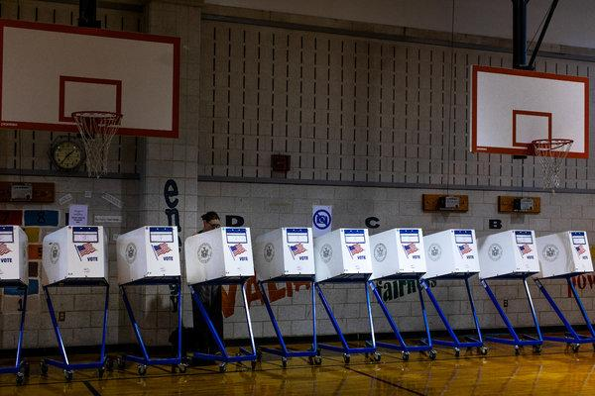

A Russian woman was charged with trying to interfere in the midterm elections, prosecutors announced on Friday. Credit: Demetrius Freeman for The New York Times

[Adam Goldman](https://www.nytimes.com/by/adam-goldman), **The New York Times** Online Edition, October 19, 2018.

WASHINGTON — Russians working for a close ally of President Vladimir V. Putin are engaging in an elaborate campaign of “information warfare” to interfere with the American midterm elections next month, federal prosecutors said on Friday in unsealing charges against a woman whom they labeled the project’s “chief accountant.”

The woman, Elena Alekseevna Khusyaynova, 44, of St. Petersburg, managed a multimillion-dollar budget for the effort to “sow division and discord” in the American political system, according to a criminal complaint. She bought internet domain names and Facebook and Instagram ads and spent money on building out Twitter accounts and paying to promote divisive posts on social media.

She worked for several entities owned by Yevgeny V. Prigozhin, a Russian oligarch sometimes known as “Putin’s chef” who was among 13 Russians [indicted in February](https://www.nytimes.com/2018/02/16/us/politics/russians-indicted-mueller-election-interference.html?module=inline) by the special counsel, Robert S. Mueller III, on charges of interfering in the election two years ago.

*[*[*Read the complaint against Elena Khusyaynova*](https://int.nyt.com/data/documenthelper/375-elena-khusyaynova-complaint/fb8206c10a6434cf2669/optimized/full.pdf#page=1)*.]*

The operation detailed in the complaint was the latest evidence that Mr. Putin had brushed off a broad Western campaign aimed at deterring Russian intrusions in Europe and the United States. In addition to [numerous Justice Department prosecutions](https://www.nytimes.com/2018/07/13/us/politics/mueller-indictment-russian-intelligence-hacking.html?module=inline) of Russians for election interference and other covert operations, the United States and its allies have imposed sanctions on prominent Russians and kicked out dozens of Russian diplomats after [the poisoning in March of a former Kremlin spy](https://www.nytimes.com/2018/09/09/world/europe/sergei-skripal-russian-spy-poisoning.html?module=inline) in Britain. Ms. Khusyaynova’s operation, prosecutors said, continued through it all.

As in 2016 — when American intelligence agencies assessed that Russia was trying to bolster the campaign of Donald J. Trump — the conspirators seized on divisions in American politics, prosecutors said in describing a yearslong effort called Project Lakhta. This year, the trolls wrote posts touching on immigration, guns, race relations, women and even the debate over the protests by National Football League players during the national anthem. Since April 2014, prosecutors said, Ms. Khusyaynova acted as the chief accountant for the project.

But this time, prosecutors said the operatives appeared beholden to no particular candidate. Russia’s trolls did not limit themselves to either a liberal or conservative position, according to the complaint. They often wrote from diverging viewpoints on the same issue.

“The conspiracy has a strategic goal, which continues to this day, to sow division and discord in the U.S. political system,” David Holt, an F.B.I. special agent, wrote in an affidavit.

Prosecutors in Virginia, not Mr. Mueller’s team, charged Ms. Khusyaynova of conspiring to defraud the United States. But those accusations appear to build on the special counsel’s earlier indictment, which also identified companies controlled by Mr. Prigozhin that were named again in the new complaint.

One of the companies, Concord Management and Consulting, has fought the special counsel’s charges in court, demanding that the government demonstrate it willfully violated the law. Friday’s criminal complaint, with its detailed descriptions of the conspiracy continuing for months after February’s indictment, appears to do just that.

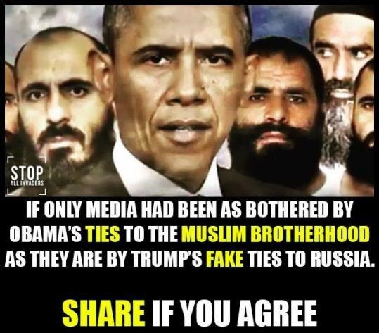

An image provided by the Justice Department shows a social media post used in the influence campaign.

Earlier Russian influence campaigns stood out for their clumsiness — Facebook posts from the Internet Research Agency, another arm of Project Lakhta that conducted Russia’s social media disruption campaign in 2016, often contained broken English and off-topic cultural references.

But the new operations appear to have been [more sophisticated](https://www.nytimes.com/2018/08/01/technology/facebook-trolls-midterm-elections.html?module=inline), with smoother messaging and a better command of American political discourse that allowed for more precisely targeted campaigns. Operatives instructed their colleagues to frame posts about former Senator John McCain, Republican of Arizona, who tangled frequently with Mr. Trump before he died in August, as an “anti-Trump geezer.” Speaker Paul D. Ryan, they said, should be described as “an absolute nobody.”

Operatives were instructed to attack Republicans who failed to sufficiently champion the construction of the border wall that Mr. Trump has sought; to stress the need for strict voter identification laws, especially in “blue states”; and to highlight “scandals that took place when Mueller headed the F.B.I.” in an attempt to discredit the special counsel’s investigation.

Acknowledging the time difference between Russia and the United States, one conspirator advised the others to post in the morning to attract liberal audiences during the American evening — “L.G.B.T. groups are often active at night,” the operative wrote — and to seek out conservatives awake in the morning by posting just before they left work for the day.

They also developed strategies for blending in to partisan American audiences. “If you write posts in a liberal group … you must not use Breitbart titles,” read one message sent to the Russian group, referring to the conservative American news site. “On the contrary, if you write posts in a conservative group, do not use Washington Post or BuzzFeed’s titles.”

The group also gave suggestions, some of them racist, for reaching specific affinity groups. One member suggested keeping posts simple when they were aimed at lesbian, gay, bisexual and transgender groups of color, writing that “colored L.G.B.T. are less sophisticated than white; therefore, complicated phrases and messages do not work.”

Framing suggestions often accompanied news stories shared by the group’s members, according to the complaint. One story, originally posted by the conservative news site World Net Daily, was titled “The 8 Dirtiest Scandals of Robert Mueller No One Is Talking About.” When instructing a group member to share the story on social media, an unnamed member of the Russian group urged colleagues to “emphasize that the work of this commission is damaging to the country and is aimed to declare impeachment of Trump,” according to the complaint.

Much of the social media content included in the complaint was fairly standard fodder for partisan Facebook pages. In 2017, a fake Facebook account called Bertha Malone was used by the Russians to post an image falsely claiming that former President Obama had ties to the Muslim Brotherhood. More than one million people saw the account, according to the complaint.

Another 2017 post, by a fake account called Rachell Edison, was used to post an image about the National Rifle Association. The text accompanying the image read “I think next 4 years will be great for all Americans, and for gun lovers especially!”

Any effect on the midterm elections is all but impossible to calculate. The disruption effort that prosecutors described went beyond the United States, targeting elections and referendums in Ukraine and the European Union.

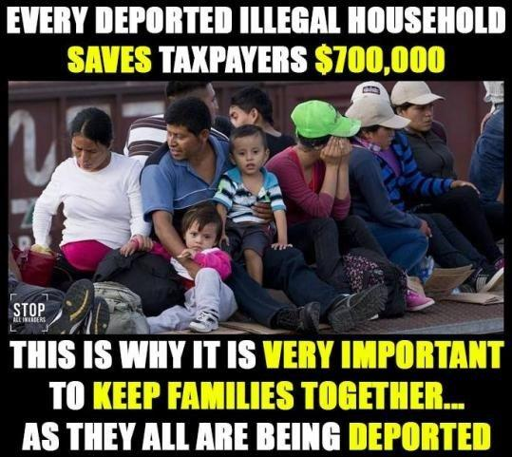

Another image provided by the Justice Department of a social media post used in the influence campaign.

Ms. Khusyaynova was fastidious, keeping detailed records of expenses for a budget that totaled more than $35 million from January 2016 to June 2018. Between January and June 2018 alone, prosecutors said, the project’s proposed operating budget totaled more than $10 million.

She routinely requested funds from Mr. Prigozhin’s companies. In one instance, she asked for 15 million rubles, or about $230,000, on Feb. 16, coincidentally the same day that Mr. Prigozhin and the other Russians were indicted.

Ms. Khusyaynova’s responsibilities also included more mundane tasks like paying salaries and renting office space.

Prosecutors said that the Russians tried to hide what they were doing, disguising payments as software support and development from entities controlled by Mr. Prigozhin. Affiliates of his companies used 14 bank accounts to finance Project Lakhta.

Friday’s announcement was the latest example of the Trump administration’s pledge to inform Americans of any foreign election meddling. The Justice Department had little reason otherwise to unseal the complaint; Ms. Khusyaynova lives in Russia, which does not have to extradite its citizens to the United States. Typically, the F.B.I. and Justice Department would keep the charges quiet and hope Ms. Khusyaynova might travel to a country where she could be detained.

“Exposing schemes to the public is an important way to neutralize them,” the deputy attorney general, Rod J. Rosenstein, said in July. “The American people have a right to know if foreign governments are targeting them with propaganda.”

Mr. Trump, who has been widely criticized for his reluctance to acknowledge and occasional outright dismissals of Moscow’s interference on his behalf, stressed on Friday that his administration had sought to protect elections, accusing the Obama administration of keeping quiet about the issue in 2016.

“It had nothing to do with my campaign,” he told reporters while traveling in Arizona.

United States intelligence agencies said separately on Friday that they believed foreign interference continued to be a threat to American democracy.

“We are concerned about ongoing campaigns by Russia, China and other foreign actors, including Iran, to undermine confidence in democratic institutions and influence public sentiment and government policies,” said a statement from the director of national intelligence, the Homeland Security Department, the F.B.I. and other agencies.

The statement echoed a warning two years ago. In October 2016, weeks ahead of the presidential vote, Obama administration officials [issued](https://www.dhs.gov/news/2016/10/07/joint-statement-department-homeland-security-and-office-director-national) a statement saying the Russian government had directed the theft of emails from American citizens and political organizations, [a reference to the hackings](https://www.nytimes.com/2016/12/13/us/politics/russia-hack-election-dnc.html?module=inline) of the Democratic National Committee and John D. Podesta, Hillary Clinton’s campaign chairman.

The statement was largely overlooked. Hours later, [the recording of Mr. Trump](https://www.nytimes.com/2016/10/08/us/politics/donald-trump-women.html?module=inline) boasting years earlier to an “Access Hollywood” host about grabbing women by their genitalia became public. And soon after that, WikiLeaks began releasing Mr. Podesta’s emails.

**Julian E. Barnes and Sharon LaFraniere contributed reporting from Washington, and Kevin Roose from New York.**

**A version of this article appears in print on Oct. 20, 2018, on Page A1 of the New York edition with the headline: U.S. Says Russians Led Online Drive To Tilt Midterms.**