WARNING! The following characterizations of academic texts in English and in Czech are generalizations only. They show typical tendencies. Of course, there are excellent academic texts written by Czech authors, and bad academic texts written by English-speaking authors!

ENGLISH Academic Texts (tendencies)

........................................................................................
- Highly structured
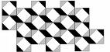
Clear division of the text (abstract, introduction, body, conclusion, bibliography)

........................................................................................
- More logical division into sections

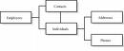
Logical division of the text into chapters, sub-chapters / sections, sub-sections etc.

........................................................................................
- Strict paragraph function

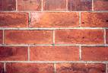
Paragraphs with clear single theme or topic, each with a ‘topic sentence’, body, and (possibly) concluding sentence – longer paragraphs

........................................................................................

- No digression from theme

Information or ideas avoided if not related to the theme

.......................................................................................

- Thesis clearly identified

Clear thesis (expressed in introduction)

.......................................................................................
- Clarity more important than style.

Repetition of expressions and use of straightforward syntactic structures to increase clarity and understandability

........................................................................................
- Author – happy to state opinions
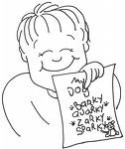
Authorial self-confidence – use of assertive statements (The results of the research show that...); clear titles (Problems associated with...)

........................................................................................

- Emphasis on understandability

Orientation towards the reader – the author is responsible for the reader’s understanding of the text.

CZECH Academic Texts (tendencies)

...........................................................................................
- Loosely structured
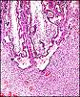
Boundaries between different parts of text less clearly identifiable

...........................................................................................
- Less logical division into topics
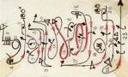
No division into sections, or less logical indication of chapters and sub-chapters etc.

...........................................................................................
- Less strict paragraph function

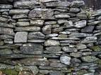
Long stretches of text devoted to one topic – made up of shorter paragraphs to provide reading pauses only

...........................................................................................

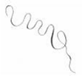
- Digression from theme allowed

Information or ideas unrelated to the theme are acceptable

...........................................................................................

- Often no explicit thesis

Explicit thesis not required. The conclusion is wherever the ‘javelin’ lands.

...........................................................................................
- Style more important than clarity
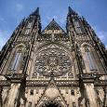
Use of synonyms and complex syntactic structures to convey message in a stylistic, ‘flowery’ way.

...........................................................................................
- Author – fear of appearing immodest

Modalization – tentative statements (From our results, it appears that...); modest titles (A small contribution to understanding problems associated with...)
...........................................................................................
- Emphasis on sounding ‘academic’
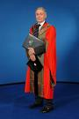
Orientation towards the subject in all its complexity – it is the reader’s responsibility (or problem?!) to make sense of it.

