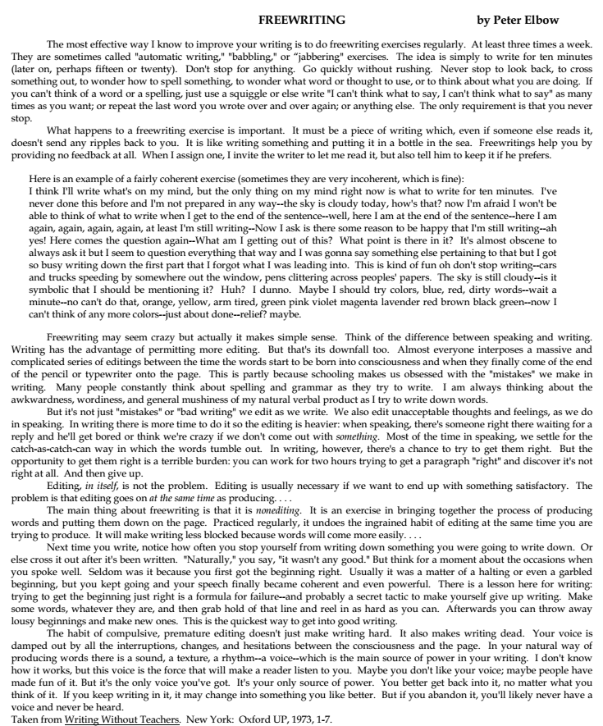

|  |  |
| --- | --- |
| **DEVELOPING YOUR PRESENTATIONAL SKILLS** | |
| **STRENGTHS** | ACTIONS I COULD TAKE TO BUILD ON THEM |
| e.g. strong voice | use strong voice (pitch, intonation) to emphasize points |
| **WEAKNESSES** | ACTIONS I COULD TAKE TO ALLOW FOR/AVOID THEM |
| e.g. quiet voice | use a microphone, rearrange the seating, use visual aids |