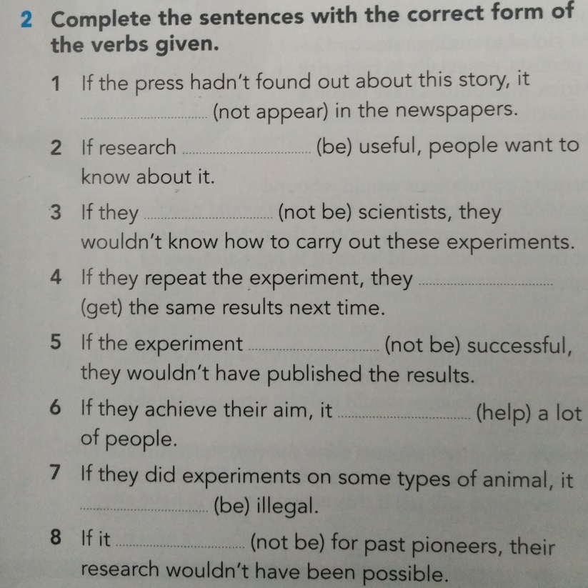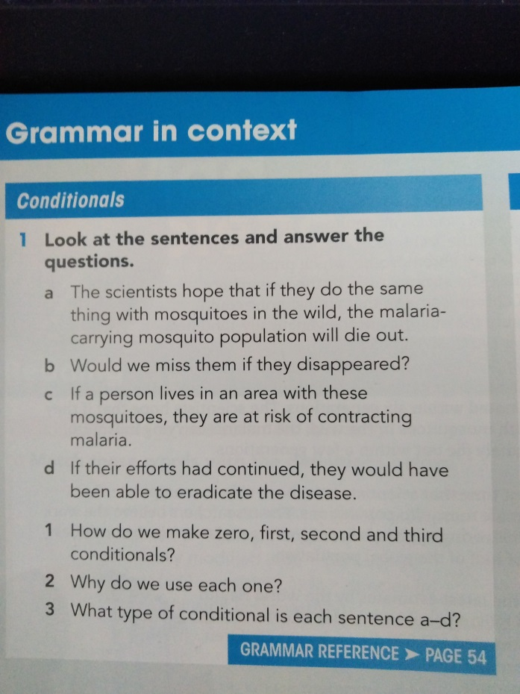

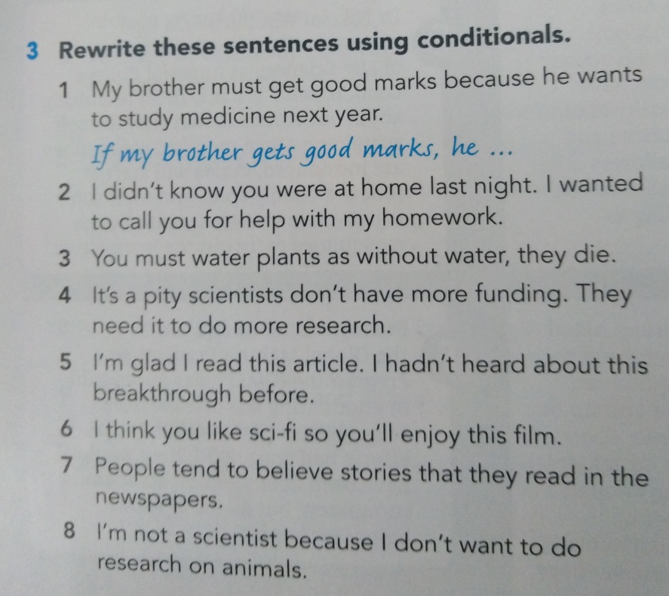

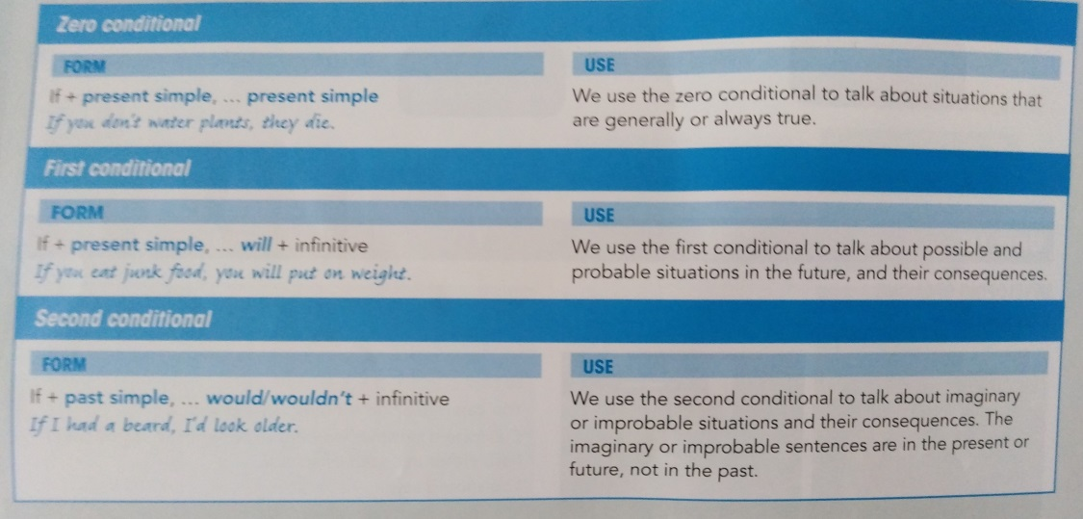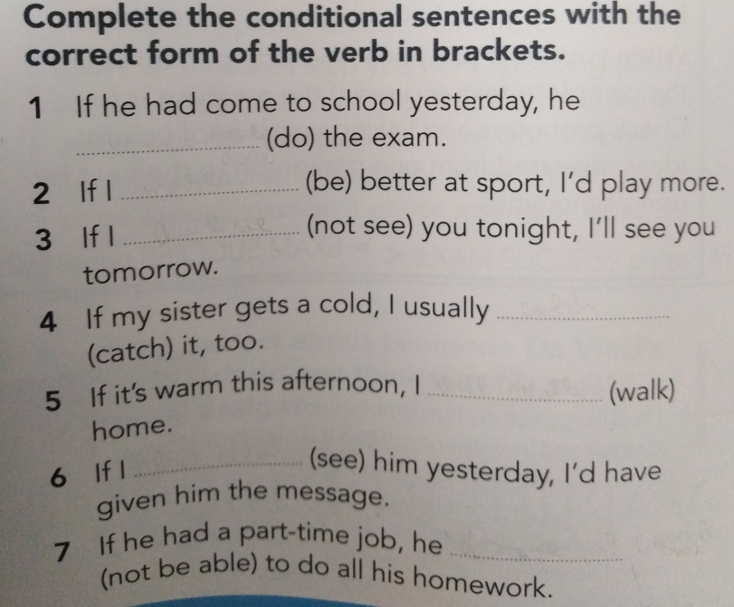

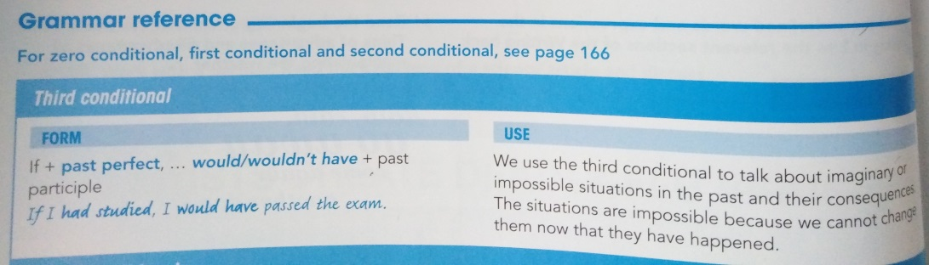

**1. Translate** **(16):**

Kdybych byl tebou, zůstal bych doma, když prší.

Když prší, je mokro.

Nepůjdeme ven, pokud bude pršet.

Kdyby bývalo nepršelo, nezůstali bychom doma.

**2. Complete the sentences with the 0, 1 or 2 conditional (14)**

If I _______ (be) you, I ________ (buy) a car.

If Peter ______________ (play), I _________ (not play) too.

I ___________ (help) if I __________ (know) myself what to do.

John _________ (be) sad if you _________ (not come) tomorrow.

If there _____ (be) problems, please ___________ (contact) the headmaster.

Sam and Paul ____________ (sing) together if they stop arguing.

I would cry during the test if the teacher _______________ (not look).

**3 Complete the conditional sentences with correct tense (20):**

If I won the lottery, I ______________ (buy) a new car.

If he had not come, it ___________________________ (be) difficult.

I will go to if you also ______________ (come).

Let’s play football if it _______________ (not rain) tomorrow.

If we _________________ (lose), we will go to the pub!

If I _________ (be) you, I ________________ (start) playing basketball.

When it _____________ (be) below 0 degrees of Celsia, the water _____________ (freeze).

We ___________________________ (won) if he had not missed the matched.

**4 Complete the sentences with the correct form of the verbs given. (20)**

1 If we’d arrived earlier, we _______________ (get) better seats.

2 I wouldn’t have made so many mistakes if I _______________ (revise) more.

3 If they _______________ (be) more careful, the disaster would never have happened.

4 If I _______________ (know) you were in town, I would have arranged to meet for a coffee.

5 He _______________ (not become) Prime Minister if his parents hadn’t encouraged him.