Lesson 3 – Public Administration – State Administration
- Separation of Powers
- Brainstorming
The state is divided into branches, each with separate and independent powers and areas of responsibility so that the powers of one branch are not in conflict with the powers associated with the other branches. What are the branches?

- Group discussion and presentation
In three groups prepare what you know about each of the branches. Present to the other groups.
Group 1 – Executive power
Group 2 – Legislative power
Group 3 – Judicial power

- Reading
Fill in the gaps with a correct word.

term elections oath citizen forces head body
is executed is divided was established is made up are elected
is entitled are appointed includes considers reverse

Power 1. _________ into legislative, executive and judicial.
Legislative power
The Parliament of the Czech Republic 2. _________ of two chambers. Every 3. ___________ who is at least 18 years old is entitled to vote for candidates to the House of Parliament (Chamber of Deputies) and the Senate.
The House of Parliament is made up of 200 members, who 4. _____________ once every four years. Every citizen who 5. __________ to vote and is at least 21 years old, can be elected to the House of Parliament.
The Senate 6. _____________ in 1996. 81 senators are elected with a six-year 7. __________ of office. The 8. _____________ take place every two years.
Executive power
The government is the supreme 9. ____________ of executive power. The president of the Republic is the 10. __________ of state and the supreme commander of the armed 11.___________. The president takes an 12. ___________ of office (___________ of allegiance) at a joint meeting of both chambers of the Parliament.
Judicial power
Judicial power 13. ____________ in the name of the republic by independent courts of law. The system of courts 14. ____________ the Supreme Court, the Supreme Administrative Court, and high, regional and district courts. The Supreme Court 15. ___________ cases on appeal and may 16. ___________ the ruling of a lower court.
The Constitutional Court is made up of 15 judges, who 17. ____________ for a term of 10 years. Decisions of the Constitutional Court are enforceable as soon as they are announced. A Constitutional Court judge can only be arrested when caught committing a crime or immediately afterward.

- Speaking
What are the powers of the President, the Parliament and the Constitutional Court? Describe the chart using the words below the chart.

Executive Branch
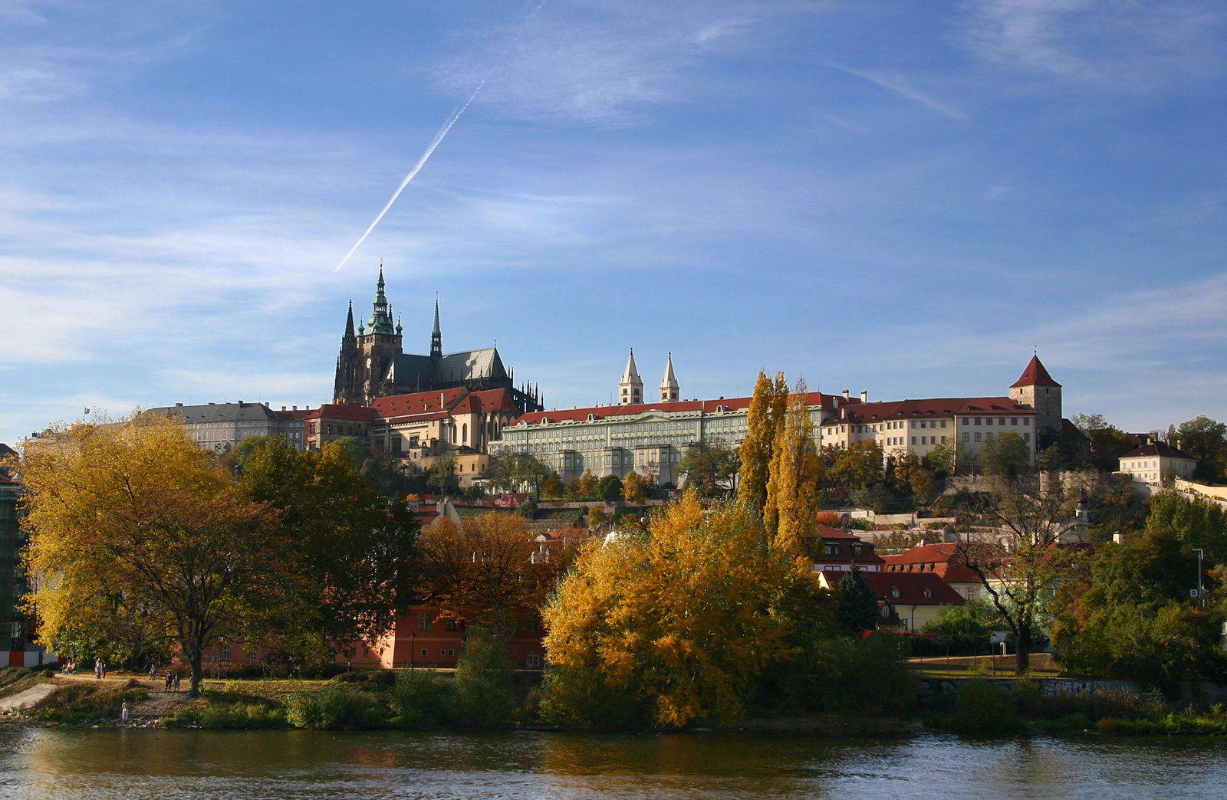

Legislative Branch Judicial Branch
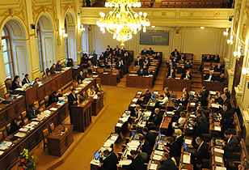

Verbs:
Decide Approve/Pass Declare Appoint Dismiss Propose Dissolve Pardon Accept Veto Sign Override

Nouns:
Laws/Acts State budget Punishments Resignation Lack of confidence Bills Members of Presidential veto

- Administrative Law
- Definition
Can you define terms administrative law, administrative proceeding, administrative agencies, and administrative rules?

- Reading and translation
Read the article and translate the underlined expressions into English or into Czech.

Administrative law is a branch of law that contains the rules and legal principles governing the administration and regulation of federal and state government agencies. It is 1.považováno za odvětví veřejného práva. Decision making in the daily activities of various federal and state agencies is governed by administrative rules.  Administrative rules are agency statements of general applicability that implement, apply, interpret, or prescribe law or policy. A violation of the rules and regulations may be considered 2.a criminal violation. An administrative rule does not 3.prescribe criminal penalties. However, if it has the force of law, it may be incorporated into a criminal law which provides that a violation of the rule is a crime.  4. Správní řízení is a non-judicial determination of fault or wrongdoing and may include, in some cases, penalties of various forms. They are typically conducted by government or military institutions.  Various other administrations of government (for example, a department regulating motor vehicles, air pollution, forestry practices, or real estate sales agents) may 5.impose fines or 6.pozastavení povolení upon persons or corporations found to be violating rules. Such rules are typically formulated by the administrative authority under general authority established and 7.omezené zákonem.  Administrative agencies are 8.granted authority to create regulations and enforce them. The legislature provides this authority to administrative agencies through the delegation of its rule making powers. Some administrative agencies are only granted authority to enforce certain regulations and not to create regulations.  Administrative agencies are bound to 9.enforce regulations as provided in the statute. Agencies cannot impose new procedures that are not provided in the statutes for enforcing rules. Agencies also cannot impose penalties that are not prescribed in the parent statutes.  People v. Samel, 115 Ill. App. 3d 905 (Ill. App. Ct. 2d Dist. 1983)  10.Obžalovaný, who was a police officer, 11.byl obžalován ze zneužití uřední moci for using the Law Enforcement Agency Data System (LEADS) for discovering the names and addresses of vehicle owners for the purpose of facilitating burglaries of their premises. The trial court 12.dismissed the charges and held that a violation of the LEADS system regulations could not form the basis for a charge of official misconduct because the regulations were not criminal in nature. However, it was partly 13.zvráceno odvolacím soudem by stating that a violation of an administrative regulation could form the basis for a charge of official misconduct 14.regardless of whether the regulation contained a penalty provision. | 1.________________  2.________________  3.________________  4.________________  5.________________  6.________________  7.________________  8.________________  9.________________  10.________________  11.________________  12.________________  13.________________  14.________________

- Language Practice – Word Formation
Complete the table

verb | elect | regulate | enforce | punish |  |  | violate | suspend
noun |  |  |  |  | resignation | decision |  |  | authority

noun | legislation | crime | constitution | president | administration | enforcement | justice
adjective

Sources:
Uslegal.com
en.wikipedia.org
http://www.czech.cz/en/Discover-CZ/Facts-about-the-Czech-Republic/Politics/Czech-Republic-Political-System

