Annex I

Members of the Constitutional Council (by appointment authority ) 1959-2004

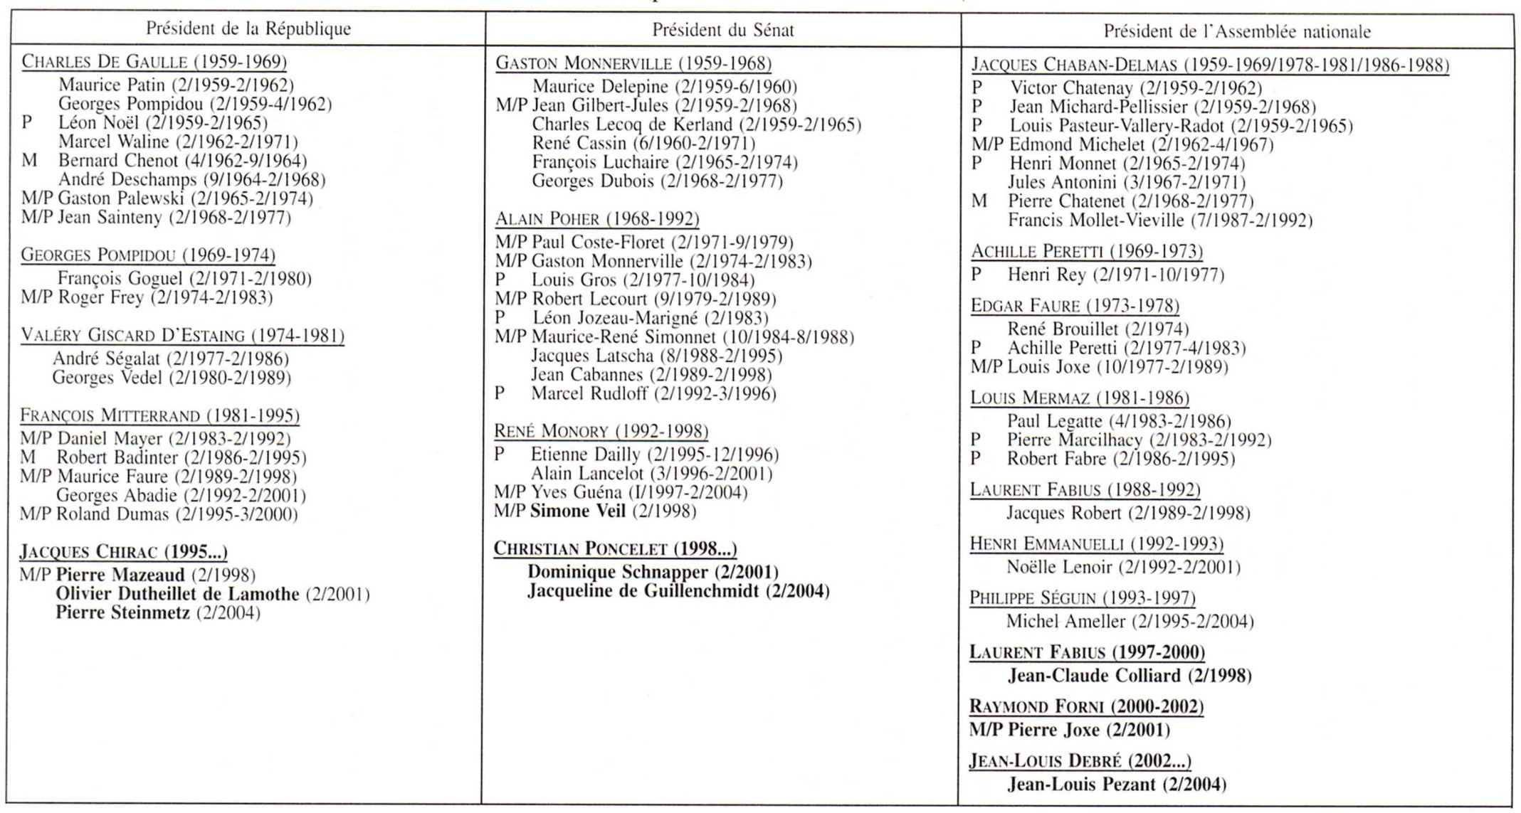
M=Minister. P=member of Parliament. Bold=present members

