THE CHANGING ROLE OF THE HIGH COURT OF AUSTRALIA

Jason L. Pierce

University of Dayton

David L. Weiden

Indiana University-Purdue University Indianapolis

Rebecca D. Wood

University of Nevada-Las Vegas

Prepared for delivery at the IPSA RC09 Interim Meeting, 2010, Bologna, Italy
In this paper, we examine several aspects of the High Court of Australia and demonstrate the changing nature of this tribunal. Specifically, in three separate sections, we examine the agenda-setting role of the Court, the decision-making process, and policy trends.

AGENDAS AND CASES AT THE HIGH COURT
The High Court has been a distinctly political branch of government from the start, even if the Court itself has been slow to acknowledge this fact (Galligan 1987). While Westminster-style governments are characterized by parliamentary sovereignty, Australia’s distinctive “Washminster” arrangement (Thompson 1980) has been characterized by constitutional sovereignty since its founding document took effect (Gleeson 2002). The architects of the Australian Constitution recognized this, and some acknowledged the crucial role the High Court would play in maintaining constitutional sovereignty (Mason 2003). The High Court has an extensive original and appellate jurisdiction. The nature of the Court’s discretionary jurisdiction tells us something important about the areas of law in which the justices engage in both state and national policymaking. The volume (McIntosh 1983) and nature (Baum et al. 1981) of the cases brought to the Court may tell us about what is important in Australian society over time. The Court’s multi-layered agenda reflects the concerns of Australia’s evolving society as well as the institutional maturation of the High Court itself.

Salient Cases in the High Court
Two important indicators of case salience in the context of the US Supreme Court are constitutional cases and amicus participation. Adopting these measures wholesale in Australia, however, might lead one to believe that the High Court does not hear very many important cases. Figure 1 shows the number of constitutional cases and cases with nonparty interveners over time. The picture is not impressive, though, until one considers the reasons why constitutional cases and cases with nonparty participation might not be the most appropriate markers of salience in the High Court.
The Australian Constitution lays out the basic relationship among the various branches and levels of Australia’s federal system of government. The distribution of power between the national and state governments has been one of the major sources of political disagreement since Australia’s federation in 1901 (Blackshield 1972). The High Court has played an important role in refereeing the constitutional distribution of power between the levels of government (Selway and Williams 2005). It is important to note that the Australian Constitution, unlike the US Constitution, does not have an analog to the Bill of Rights.
The Australian Constitution does protect some individual rights explicitly. Section 80 contains a protection of the right to a trial by jury. The right to freedom of religion is protected in Section 116. The remaining two rights are to just compensation for government takings (Paragraph 51) and a prohibition against state discrimination against residents of other states (Section 117). The bulk of Australia’s Constitution, however, is focused on the arrangement and powers of the institutions of government. As such, much of the Court’s constitutional docket is made up of public law questions, including cases about regulatory powers, and federalism.
The top portion of Table 1 presents constitutional cases by issue area in the High Court from 1976-1998. Public law cases make up about 31% of the Court’s reported cases, and they are half of the constitutional cases. Criminal cases make up about a quarter of the Court’s non-constitutional issues, but only about 16% of the constitutional docket. Slightly more than half of the Court’s rights and liberties cases are constitutional in nature, although there are not very many of them in absolute terms. These cases deal with the constitutional religious freedom protection as well as some of the implied rights cases beginning in the early 1990s.
Many of the types of cases Americans would classify as addressing the most salient questions of the day appear are non-constitutional cases in the High Court. While the main role of the modern High Court is thought to be the interpretation of Australian constitutional law, “[t]he impact of High Court decisions upon Australians is by no means limited to the Court’s adjudication on the significant constitutional issues of the day” (Williams 1995, 271). The High Court’s caseload runs the gamut of issue areas, from criminal appeals to matters of federalism to family law questions.
It may be quite clear to American onlookers why constitutional cases might elicit special treatment from the High Court, but including among the salient cases things like torts might seem quite unusual. In Australia, with its absence of a constitutional charter of rights, tort law is one of the mechanisms that has been used to further civil liberties, including free speech (Luntz 2002). One commentator has noted that, in Australia, “[t]ort law is characterized by loose sets of relatively abstract principles which allow maximum discretion to be exercised (in the main) by reference to ‘common sense’ values” (Bennett 1989, 216). The Court has recently indicated the possibility of tort law as a means to protect against privacy invasions by the media (Lindsay 2002) in the absence of constitutionally derived protections as are found in the United States (Butler 2005). In a similar way, tort law has been used in Australia as an avenue for protecting women against various types of harm, including job discrimination (Hocking and Smith 1996). The Court has also indicated that tort law may be the avenue for pursuing litigation regarding the subject of abortion (Luntz and Hambly 2006), perhaps providing remedies both for “wrongful birth” and “wrongful life” (Stretton 2005).
Australian tort law has traditionally been dependent on common law precedent, and only recently has the Australian Parliament taken the reins in reforming the law in this area (Gardiner and McGlone 1998). The dearth of legislation means that the judiciary has enjoyed the latitude to take an active role in creating a system of tort law, by which it has addressed the calls for a more efficient and fair system of balancing the interests of various groups of citizens (Cane 2003). This is not to say that all tort cases are important; there are plenty run-of-the-mill negligence cases on the Court’s docket, as well.
A common measure of case salience in the US Supreme Court is the participation of amici. While the content of their participation may not influence the Court’s final decision (Spriggs and Wahlbeck 1997), their presence serves as an indicator to the justices that the importance of the case extends beyond the present litigants (Wahlbeck et al. 1999). Indeed, this measure captures a case’s “salience to the larger social and political systems” (Hettinger et al. 2003).
Because the High Court uses tort law for such a wide range of important policymaking, it would seem obvious that nonparty participants would intervene in these cases at a high rate. The bottom portion of Table 1, however, does not bear this out. In Australia, though, the participation of nonparty interveners is more complicated than it is in the United States. Since the Judiciary Amendment Act 1976 (Cth), the attorneys-general of the federal government and the states have had the right to intervene in constitutional cases under section 78A(1). Non-governmental parties enjoy no such right. Indeed, the Court has maintained, to various degrees, a strict standard for granting leave to participate, which was laid out by Chief Justice Dixon more than fifty years ago (Williams 2000). In Australian Railways Union, Dixon requires that intervening parties demonstrate “some particular right, power or immunity in which they are concerned” before the Court will grant leave to intervene.
The process of obtaining leave to intervene is shrouded in mystery. The Court only sporadically gives reasons for denying leave to intervene. In addition, the Court does not provide notice to potential interveners about the status of their leave request until the hearing on the merits, leaving counsel for the interveners on the hook to prepare arguments that they may not be allowed to deliver (Williams 2000). All of this makes the process costly and difficult to navigate for potential interveners. Perhaps because of these costs, most of the interveners in the Court are attorneys-general intervening under section 78A(1) of the Judiciary Amendment Act. Australian courts “have not, until recently favoured the participation as amicus curiae of public interest groups” (Kenny 2004, 8). As such, the presence of nonparty interveners in a case is a likely sign that the case is salient to the various attorneys-general, but the scarcity of non-governmental interveners makes it difficult to generalize the salience of the case to interest groups and other interested parties.
The bottom portion of Table 1 presents a breakdown of nonparty participation by issue area. Given that the nonparty interveners are mostly attorneys-general, it is unsurprising that more than 40% of cases with such interveners are public law cases. The second most common issue area for intervention is in criminal cases. This, again, is not surprising. The attorneys-general are charged with managing criminal prosecutions, and this means that they have an interest in intervening in important questions of criminal law.
Indeed, one of the most important indications of case salience—in the eyes of the High Court justices, at least—may be the content of the reported decisions as compared to the noted unreported decisions and the cases denied hearing on the merits. The remaining sections investigate the content of the reported original and appellate jurisdiction cases and—to the extent possible—the unreported but noted cases.

The Court’s Merits Agenda
Like the US Supreme Court, the High Court rules on the merits of only a fraction of the case brought to it. The abolition of appeals as of right has allowed the Court discretion to choose its own cases. This has allowed the Court to hear fewer and fewer cases on the merits over time, as the red line in Figure 2 shows. In the High Court, like the US Supreme Court, the refusal of a hearing on the merits is not equivalent to the denial of an appeal. The High Court and the US Supreme Court use similar guidelines when deciding whether a case will be heard. The US Supreme Court has written its own guidelines in Rule 10 of the Supreme Court Rules. These guidelines reflect the role of the Court as a secondary appellate tribunal, which is to clarify important points of law and generally not simply to correct trial court errors. The criteria for the High Court are set out not by the Court itself, but by Parliament. The provision is Section 35A of the Judiciary Act 1903 (Cth). This section requires the Court to consider the need to promote uniformity throughout the legal system, the public importance of the question and the individual-level interests of justice and fairness.
The issue area makeup of the Court’s reported cases over time is presented in Figure 3. The vertical line represents 1984, when amendments to the Judiciary Act removed much of the Court’s nondiscretionary jurisdiction. After 1984, the drop in nondiscretionary economics cases made room for more criminal cases, which increased over time. Table 2 presents the issue area breakdown of reported decisions by chief justice. The data in this analysis pick up in 1976, a dozen years into Chief Justice Barwick’s tenure. During his tenure as chief, the Court gained greater independence from the Privy Council in the United Kingdom, it dramatically decreased its nondiscretionary docket, and it obtained administrative control over the affairs of the Australian judiciary (Mason 2002). The Barwick Court is probably best known for its extraordinarily literal interpretation of tax law under Section 90 of the Constitution. Most notably, the Barwick Court majority gutted section 260 of the Income Tax Assessment Act 1936 (Cth). Indeed, the public law issue area dominates the reported decisions in the later years of the Barwick Court. A smaller percentage of criminal cases were reported in the Barwick Court as compared with later courts.
It was during the Gibbs Court that the rest of the appeals as of right were abolished by the amendments to the Judiciary Act. Perhaps in response to this newfound docket control, the Court began to take on a more flexible approach to jurisprudence. Australian scholars point to this time as the beginning of the end of strict legalism in the High Court. Some of the most provocative cases in the Court’s history made their way to the justices (Twomey 2002). The often-divided Court began to expand the powers of the Commonwealth government at the expense of the states (Walker 2002; Zines 2000). The proposal to dam the Franklin River may not sound politically controversial, but it led to the infamous Tasmanian Dam Case. In this case, the Gibbs Court dealt a crushing blow to state sovereignty in a series of opinions “replete with policy considerations and value judgments” (Zines 2002, 14). The Gibbs Court also expanded the Commonwealth government’s conciliation and arbitration powers, as well as its external affairs power. Public law cases made up a large portion of the Gibbs Court’s reported agenda, at 29.3%. Criminal cases began their uptick during this time, as did torts.
If the Gibbs Court began to move away from strict legalism, then the Mason Court might be said to have abandoned it altogether (Doyle 1996). At the beginning of his term, the Mason Court decided one of the most important cases in the Court’s history: Cole v. Whitfield. In this unanimous decision, the Court considered the political and economic history of Australia dating back to Australia’s pre-federation experience (Selway 2002), using modern context and values to abandon the longstanding quagmire of Australia’s free trade jurisprudence (Coper 2002). A few years later, the Mason Court abandoned over 200 years of ostensibly settled law when it incorporated native title doctrine into Australian law in Mabo.
The Mason Court took great effort to increase the protection of individual rights guaranteed the Australian people. Implied rights made their way into the Australian Constitution during the Mason Court beginning with the Free Speech Cases. The Court also increasingly referenced international law in its opinions. As the Australian Constitution has no written statement of individual rights, Australia’s commitment to various international treaties provided the Mason Court with another avenue through which to secure the protection of such rights. All of these developments reflected the chief’s developing belief that the court’s primary function is to keep Australian law up to date with the changing conditions of the country (Galligan 1995). As the above discussion illustrates, the important cases do not fit squarely into a particular issue area. Criminal cases took up more of the reported case docket than in any other chief’s tenure, and the public law cases kept pace with the rate in the Gibbs Court. The Mason Court spent less time on economics cases, following a pattern that would continue into the Brennan Court. Tort cases began to increase in prevalence, echoing the Court’s interest in engaging in policymaking.
Despite the rapidly changing membership of the Brennan Court, it managed to accomplish a lot more than many onlookers had expected (Haultain 1997). Under Brennan’s leadership, the Court began to consolidate many of the sweeping legal changes coming from the Mason Court, and in this it was quite successful (Baker and Gageler 2002). For example, while distancing itself somewhat from the perceived activism of its predecessor, the Brennan Court maintained the substance of much of the implied rights and native title jurisprudence of the Mason Court (Stone 2000). The Brennan Court also clarified the Gibbs Court’s cases centralizing power to the Commonwealth government. The balance of cases in the Gibbs Court did not shift much from that of its predecessor, although the docket share of rights and liberties cases continued to grow.

The High Court’s Unreported Cases
The preceding discussion deals with the Court’s reported decisions, but these make up only part of the Court’s workload. The High Courts Judicial Database (Haynie et al. 2007) used in the sections above includes data derived only from cases reported in the Commonwealth Law Reports (CLR), which are chosen by the justices for publication. The volumes of the CLR also include lists of “unreported but noted” cases. But even these lists exclude the matters that did not elicit written opinions from the Court, or matters that were not deemed particularly notable.
All of this means that the Court’s workload is considerably higher than it would at first appear. Like their counterparts on the US Supreme Court, High Court justices have registered complaints about excessive workload burdens (Baum 1997; Craske and Gibbs 2002). Justice Michael McHugh has noted that “the workload of the High Court Justices borders on oppressive” (McHugh 2005, 5).
The unreported but noted cases are made up of many different types of matters. Figure 4 illustrates the makeup of this portion of the Court’s workload. In the early years, the bulk of these cases are appeals as of right. As Parliament prepared for the 1984 amendments to the Judiciary Act, the Court’s unreported but noted docket shifts dramatically. The criminal special leave cases make up a small amount of the difference, but the majority of the change shifts from appeals as of right to non-criminal special leave applications. The volume of unreported but noted cases is presented in Figure 5. After the 1984 abolition of the Court’s nondiscretionary jurisdiction, the number of unreported but noted cases climbs dramatically. As Figure 6 shows, however, this change is tame when compared to the jump in total matters filed. While the High Court deals with a smaller number of agenda-setting decisions than the does US Supreme Court, jurisdictional restrictions put in place by the Australian Parliament force judicial review cases to bypass the Federal Court, “thereby imposing an oppressive and inappropriate burden on the High Court” (Mason 2003, 7). In addition, the High Court justices handle the agenda-setting decisions on their own, without the help of court clerks (or, as they are known in Australia, associates) (Horton 2002). This is in stark contrast to the great degree of discretionary power delegated by US Supreme Court justices to their clerks (Duxbury 2001).
As such, hearing and disposing of the increasing number of special leave petitions is among the most significant drain on the High Court’s time (Gleeson 2004). These petitions account for much of the disparity between unreported but noted cases and the total number of matters filed in the Court in Figure 6. The addition of the video link system in 1987 allowed the justices to begin hearing nationwide petitions without having to travel, and this made the logistics of the special leave process a little less harrowing (Jackson 1996). Even still, the Court’s tradition of hearing oral arguments in virtually all of these special leave petitions means that, video link or not, the process is incredibly time consuming.
The consideration and disposition of applications for special leave to appeal is a duty that the justices do not take lightly (McHugh 2005). Special leave hearings allow the judges to deal directly with the litigants, “without the go-between of the associate, without the risk of documents not reaching the judge, of being summarized in some erroneous way, or of crucial information simply being buried in the briefs or missing altogether” (Horton 2002, 120). In addition to this, members of the bench often decide to give written reasons for these decisions.

Discussion
At first glance, much of the Court’s work might seem relatively routine. The Court reports an average of 57 cases per year. This is little more than half the number of cases handed down by the US Supreme Court. Among these, there are few civil rights and civil liberties cases—the bread and butter of the modern US Supreme Court. Constitutional cases are few and far between, and the ones decided by the High Court tend to involve government regulation and not the pressing questions of individual liberties. Nonparty interventions are quite rare, and are typically government actors.
The real story is a bit more complicated than that. As this section demonstrates, the interesting cases do not jump out in the tables and figures. Because of the nature of the Australian Constitution and the High Court’s institutional design, the foundationally important cases are tucked in amongst cases dealing with government regulation, non-constitutional criminal cases and even torts. The common measures of salience do not work well in Australia. In addition, the High Court is much busier than its reported decisions would indicate. The Court issues a substantial number of not-quite-so-important decisions, which it lists in the back of the authorized law reports. Even this list sells the justices short, though; the volume of special leave petitions has become so oppressive in recent years that the Court was forced to abandon some of its cherished tradition of oral arguments at the agenda setting stage.

CHANGES IN THE DECISION-MAKING PROCESS AT THE COURT
The preceding pages identified several factors that shape the High Court’s agenda, including formal rule structures like the Commonwealth Constitution, the Judiciary Act 1903, the High Court Rules, as well as informal factors such as amici participation. They described the processes by which the Court constructs its agenda and disaggregated that agenda by issue area and chief justice. They reveal a politically significant and occasionally controversial Court that has modified its agenda setting processes in response to an ever-growing demand for its services.
This section of the paper provides a descriptive analysis of how the Court handles cases once accepted for review and how the processes for handling cases has evolved over time. Drawing from scholarship on the US Supreme Court, it then illustrates how these processes reflect elements of both the private and public litigation models for appellate advocacy. It also demonstrates how the Court transitioned over the twentieth century from the private to the public model in not inconsequential ways, yet in important ways maintains a stronger fidelity to the private model.
A brief description of these two models is first in order. The private litigation model understands litigation first and foremost as resolving disputes between specific parties. Those parties directly involved bring their conflict before courts, where judges function as passive umpires, reaching decisions specifically tailored to the disputes (Fuller 1978). In the public model, litigation still resolves specific disputes, but it has additional effects, including social control, lawmaking (in the sense that some legal rules are judge-created) (Shapiro 1981), promulgation and enforcement of public norms (Chayes 1976; Fiss 1979; 1982), and providing a venue for interest groups to pursue policy goals (Lawrence 1990; Olson 1990).

Dividing the Workload
The Commonwealth Constitution, the Judiciary Act 1903, the High Court Rules, and the Court’s Practice Directions structure how the Court ultimately handles its caseload. Parliament retains authority over the former, while the justices determine the substance of the latter two. The number of justices hearing a case depends upon the jurisdictional route the case followed to the High Court (original or appellate), and secondly, the legal issues it raises.
Section 73 of the Constitution defines the Court’s appellate jurisdiction, where it grants authority over “all judgments, decrees, orders, and sentences,” including decisions of state and territory courts. When an appeal comes from a single judge on a state supreme court, a very rare event, the appeal is heard by three High Court justices. Most appeals come from the Full Federal Court, a state Supreme Court, or a state Court of Appeal. Typically five justices hear these appeals, as long as the only issue is the construction of a statute, a minor extension or modification of an existing principle, the correction of the application of a principle by the court below, a question of procedural irregularity, or the correction of a finding of fact. All seven justices usually participate on appeals regarding the Constitution, the correctness of a precedent, a reconsideration of an important principle of law, a conflict between two supreme courts, or a question of public importance (Brennan 2007).
Section 75 provides that original jurisdiction extends to the Court in matters, inter alia, where the Commonwealth is being sued, disputes between the states or individuals from different states, or disputes involving a state and an individual from another state. Section 76 grants Parliament authority to vest certain original jurisdiction matters with the Court, including disputes over the Constitution’s interpretation and laws made by Parliament. Factors similar to those that shape panels for cases on appeal are also at play with original jurisdiction matters, although there are a handful of matters where three judge panels form, such as the return of an order nisi for judicial review of non-judicial decisions.
As the following table and chart indicate, the annual docket has contained fewer cases in recent years involving single justices or smaller panels of justices, say less than four. The vast majority of cases are handled by five- and seven-judge panels.
Table 5.

Data Source: High Courts Judicial Database, 2007.

Once cases are accepted on appeal or original jurisdiction, the Chief Justice nominates justices to hear each case. Any justice who does not appear on the proposed list may join the case, if he or she wishes, which is a right rarely exercised. Chief Justices make assignments so the workload is distributed with rough parity and to account for sittings when justices may be otherwise unavailable. Original jurisdiction matters are similarly assigned.

Organizing Arguments
The High Court historically followed the British practice of relying exclusively on oral arguments and any research that the justices and their associates conducted. Attorneys could submit written summaries of their arguments as early as the 1950s, although the extent to which the justices relied upon such submissions and therefore the extent to which advocates relied on written submissions to advance their cases varied by chief justice and the institutional practices they encouraged. Chief Justices Barwick (1964-1981) and Gibbs (1981-87) both preferred oral submissions for the ability that mechanism afforded to get to central questions and issues (Kirby 2006). Chief Justice Mason (1987-95) required written submissions that canvassed all major arguments, a practice that continues under his successors, Chief Justices Brennan (1995-98), Gleeson (1998-2008), and French (2008-current).
Under the Court’s current Practice Directions, written submissions are envisaged to help the parties and justices better understand the contentions of the parties, to enhance the utility of oral arguments, and to avoid uncertainties and misunderstandings. The appellant and respondent briefs may be no more than twenty pages in length, must identify the issues the appeal presents and indicate whether under s78B of the Judiciary Act 1903 the state attorneys general should be notified in case they wish to intervene. This section grants state attorneys general a right to intervene in matters regarding constitutional interpretation. Both appellant and respondent are able a few days before oral arguments to file reply briefs of no more than five pages (High Court Practice Direction No. 1 2000; see also Jackson 1997).
The Court does not formally restrict the length of oral arguments, as the U.S. Supreme Court does, so it is not uncommon for hearings to last several days. That said, contemporary hearings are usually shorter in duration than was historically the case. The infamous Bank Nationalization Case (1948) occupied 39 hearing days, while the Communist Party Case (1951) was heard over 24 days. Major constitutional cases involving multiple parties today only take a handful of days, a much abbreviated process but still infinitely longer than oral arguments in the U.S. Supreme Court. In May 2006, for example, a total of 39 advocates were heard in the Work Choices case—the largest number in any single case—which only occupied six days of hearings.
The chart that follows shows the average number of days that elapsed between the start and conclusion of oral arguments for reported cases by year. The data for each category are reported by percentage of all cases reported in a given year. Just to be clear, the chart’s data capture the number of days that elapsed between the start and conclusion of oral arguments. Because it is not uncommon for the Court to hold hearings in a case on several different days, with days of inactivity in between, these data do not reflect the number of days the oral argument necessarily took. With those provisos, what can be gleaned? First, it should be underscored that the Court completes the vast majority of hearings over two or fewer days. On average in any given year 85 percent of hearings occurred over two or fewer days. In only one year (1970) did the Court settle less than 70 percent of cases in two or fewer days and in only two years (1998 and 2000) were any less than 80 percent of cases handled in two or fewer days. Having said that, there is clearly a longitudinal trend for increasing percentages of cases being resolved in two or fewer days. Further analysis is necessary to determine how much of this trend may be attributed to the Court’s increasing reliance on written submissions during the second half of the twentieth century. Second, it appears that if the Court could not complete a hearing in two or fewer days, it was just as likely the hearing transpired over many months as it was likely to wrap up within a month. Hearings occurred over three to twenty days in an average of 8.5 percent of cases each year. An average of 7 percent of hearings in any given year occurred over more than 20 elapsed days. The point to be made is that complex, time-consuming litigation always has occurred notwithstanding the efficiency achieved through greater reliance on written submissions.
Figure 7.
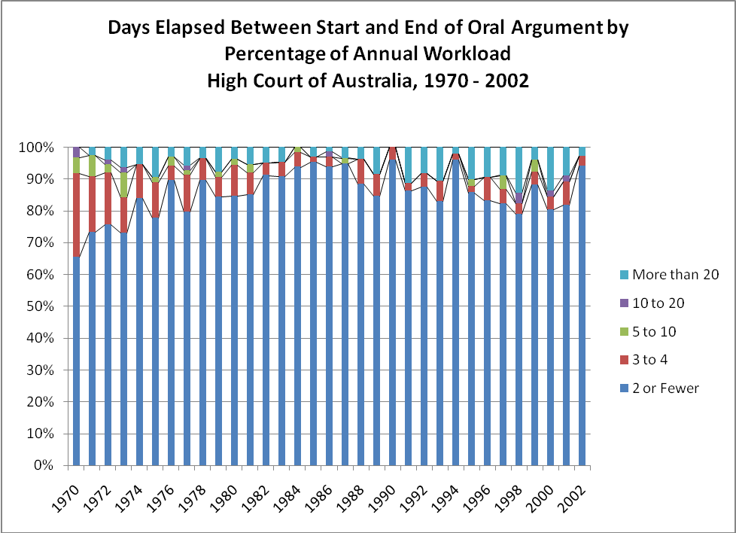

Source: High Courts Judicial Database, 2007.

The Judiciary Act 1903 empowers the justices to set the calendar for the Court’s sittings. The Court currently sits for two consecutive weeks of each month, except January and July when it recesses. During each monthly sitting, a day is set aside for hearing motions, such as motions for leave to appeal, special leave to appeal, and removal of causes, the latter being a procedure under s40 of the Act whereby the Court may determine constitutional questions that emerge during the course of litigation in lower courts. The Court hears these motions in Canberra, Sydney, or Melbourne. Although two-thirds of its sitting days are in Canberra, it still hears full cases in the regional capitals of Adelaide, Perth, Hobart, and Brisbane as warranted by workload. This peripatetic schedule has been hotly debated over the years, with some justifying it for the cost savings it brings to litigants and the positive public relations that come from having the Court on the road. Critics of the practice lament the cost and hassle of conducting the Court’s business in multiple and far-flung locales.

Judgment Writing Procedures & Practices
The processes that unfold between the conclusion of a hearing and the announcement of a decision have varied based on a number of factors. Unlike the U.S. Supreme Court, the High Court has not institutionalized a regular conference after oral arguments where the justices discuss the cases and explore who may form a majority and who may dissent. Whether and to what extent the justices confer with each other, exchange draft opinions, and explore opportunities for joint judgments or concurrences depends on the justices’ personalities, their rapport with and physical proximity to each other, and the Chief Justice’s interest in and capacity for encouraging an exchange of ideas and consensus building.
In its earliest years, consultations occurred because the justices all lived in Sydney and had similar judicial orientations. As justices with different judicial temperaments and those domiciled outside Sydney were appointed, consultation decreased. It was not uncommon in the 1910s and 1920s for justices to learn of their colleagues’ decisions and reasoning when they were announced in court. Ad hoc conferences and circulation of draft judgments became more common from the 1930s to the 1980s, but none of it was routinized. Seeing the utility of the U.S. Supreme Court’s conference system, Chief Justice Barwick, for instance, attempted to put similar practices in place but found scant support for it among his colleagues.
Chief Justice Mason came the closest to institutionalizing a conference system. Monthly meetings were held to discuss cases and explore opportunities for collaboration. Additional meetings were called if it was thought important for the Court to speak unanimously, if it could, if fact, in particular cases. This process continued during the Brennan Court. The Gleason Court’s practice was to hold informal discussions following oral arguments and when not sitting (Clark 2003). Under the current Chief Justice, Robert French, conferences are held the week after each sitting to discuss cases that have been heard. It falls to the Chief Justice during these conferences to negotiate which justice or justices should write opinions in a case and see that it is resolved in a timely manner.
Having said that, the Australian judicial culture is heavily influenced by the British seriatim tradition where each judge is encouraged, though not required, to write individual judgments (Gleeson 2007). A long list of scholars, judges, and legal practitioners have criticised the Court for its consistently fragmented decisions (see Beaumont, 1999; Campbell, 2003; Gleeson, 2003) and debated the merits and demerits of seriatim and collective judgments (see Orr, 1988; Kirby, 2004). Attorneys lament that seriatim judgment writing makes it more difficult to advise clients on points of law. Lower court judges claim that it is harder to discern core rationales and reasoning across multiple judgments, therefore complicating the application of precedent. Furthermore, some express concern that the seriatim tradition undermines public confidence in law because it appears open to multiple interpretations. Critics of the seriatim tradition call for more joint or single judgments, which purportedly clarify the law and imbue decisions with greater authority (Schmidhauser, 1979).
Others are critical of joint judgments. Concessions and compromises are sometimes required to secure consensus. This can produce bland, disjointed judgments – judgments written by committee – that lack clarity and persuasion. Collective judgment writing also can foster laziness, when judges rely on their colleagues’ work, or enable ambitious judges to exercise disproportionate influence. Finally, some think that joint or single judgments gloss over complexities to legal questions, the variety of potential answers to those questions, and the divisions likely present within society on the answers (Stone1942; Moorehead 1952).
Given this seriatim tradition, it falls to individual justices’ inclinations and the Chief Justice’s capacity to encourage “opinions of the Court” or majority judgments. The extent to which the Court achieves this institutional cohesion certainly varies longitudinally and by chief justice, as evidenced in the two charts below (see Pierce 2008). The first measure is a unanimity statistic, which records for each case whether the Court’s decision was unanimous. The second measure, the judgment production statistic, records the number of judgments written in each case. A third measure, a cohesion score, is sensitive to the variations in panel size and the size of the en banc Court over its history. This measure is calculated for each case by dividing the total number of judgments issued in the case by the total number of judges participating in the case, then subtracting that result from one.
These charts show that cohesion on the Court has varied longitudinally and by chief justices, but has generally increased from 1940 to 2002. Cohesion was at its nadir during the Latham and Barwick Courts and strongest during the Dixon and Mason Courts. All three cohesion measures were regressed against dummy variables for each chief justice. Statistically significant coefficients would indicate that the variance is statistically significant. Variation in the unanimity scores was statistically significant for Chief Justices Mason, Barwick, and Dixon. Significant variation was found with the judgment production and cohesion statistics for Chief Justices Latham, Dixon, Barwick, and Gibbs. These results collectively confirm that the variation by chief justice was not just by chance. Indeed, Pierce (2008) concluded that a number of variables shape the Court’s cohesion, including the composition of the bench, its workload, the chief justice’s leadership qualities, the abolition of appeals from Australian courts to the Privy Council sitting in London.

POLICY TRENDS AT THE HIGH COURT

In this section, we examine decisional trends at the High Court to examine the issue of the political impact of the Court over time. Rather than focus upon the votes of the individual justices, this section examines the High Court as an institution and utilizes the case as the unit of analysis in the period from 1970 to 2002.

In the time period from 1970 to 2002, there were two important changes that influenced the High Court. As discussed above in the first section of this paper, the Court obtained almost complete control of its agenda in 1984 through the amendments to the Judiciary Act. Before that time, the High Court did not have the exclusive authority to decide which cases would appear on its docket (Patapan 2000). However, the abolition of appeals as of right dramatically changed the ability of the High Court to determine its own jurisprudential course.

Also noted above is the jurisprudential shift by the Court during the tenure of Chief Justice Mason. In a series of important cases during the Mason Court, the High Court abandoned the pure legalism model and adopted a more expansive jurisprudential philosophy (see generally Pierce 2006), as individual and implied rights were embraced by the Court. Thus, it appears that a more activist approach by the members of the Mason Court resulted in a greater tendency towards judicial policymaking. Both of these changes are naturally relevant to the analysis of the policymaking and decisional trends at the High Court.

To examine and explain the changes in policymaking at the High Court, two descriptive analyses are conducted: the examination of outcomes at the Court and also the analysis of ideological decision-making.

Appellant Success at the High Court

We start with the fundamental question of who wins on appeal at the Court. Stated another way, this inquiry seeks to determine how often the High Court ruled in favor of the appellant and thus reversed the decision of a lower court. In the overall period from 1970 to 2002, the High Court ruled in favor of the appellant and reversed the lower court (or vacated or remanded the lower court decision) at an aggregated rate of 44.6 percent. Figure 7 graphically displays the percentage of rulings in favor of the appellant by year. Although there is some fluctuation, there is a generally stable pattern of rulings in favor of the appellant in the period from 1970 to 1986. However, starting in 1987, there is a clear trend (with the exception of 1991) in favor of a greater percentage of rulings for the appellant. This would seem to provide some support for the proposition that complete discretion in the control of the docket allowed the Court to reverse a greater percentage of lower court decisions. Stated another way, the fact that the High Court no longer had to accept appeals as of right—a substantial number of which were likely without merit—appears to have resulted in a greater number of cases wherein the appellant was able to prevail.

Table 6 shows the appellant winning percentage, broken down by the issue area of the case and also divided by chief justice era; Figure 8 displays the same information graphically. The data in Figure 8 show that, in every issue area except for civil rights and liberties, there has been a definite upward trend for the percentage of appellant victories, starting during the Gibbs Court. The increase is most pronounced for public law and criminal cases. The anomaly is those cases dealing with civil rights and liberties, where an increase in appellate victories is observed during the Gibbs era only. This anomaly may be explained by the relatively low number of civil rights and liberties cases, which never exceeds 19, during any Court era.

There are several surprises in Table 6. One is the relatively high likelihood of appellants in family law cases to prevail. The data show that petitioners in family law cases succeeded nearly half of the time during the Gibbs and Mason Courts, and substantially higher than that during the Barwick, Brennan, and Gleeson eras. This is surprising because family law cases are often motivated by non-economic reasons, which may portend a weak case. To be sure, the success rates for family law cases must be approached with caution, given the low number of cases in this category in the Brennan and Gleeson eras.

Also surprising is the success rate for petitioners in criminal cases. Even more so than family law cases, appeals in criminal matters are likely to be motivated by non-economic calculations. That is, a convicted criminal facing a long prison sentence is more likely to bring an appeal even if the probability of success is low (Songer 2008). Thus, the high rate of appellant success, especially during the Mason, Brennan, and Gleeson years, may indicate that many criminal cases, which were previously brought as of right, were without merit. The increase over time may also indicate that the Court, after 1984, was granting some criminal matters in order to pursue an expansion of civil liberties. The data regarding the directionality of the Court’s decisions over time, discussed below, may be relevant to this question.

Overall, the longitudinal data regarding the likelihood of the High Court to rule in favor of the appellant do provide support for the proposition that the abolition of appeals as of right significantly changed the role of the Court. The increasing tendency for the justices to reverse lower court judges may demonstrate a shift towards a more rights-based jurisprudence, as suggested by Galligan (1986).

Changes in Ideology at the High Court

Next, we turn to trends in the directionality of the Court’s decisions over time. In other words, the ideological position of the High Court over time will be examined, in terms of how often the Court ruled in a “liberal” direction. Here, a liberal decision will be defined as a ruling in favor of a criminal defendant, in favor of the party seeking to expand or protect civil rights and liberties, for the economic underdog in tort and business cases, and for the government in public law cases.

Although it is an oversimplification, the High Court of Australia has often been described as a fairly conservative court, especially in the earlier years of the institution. However, numerous commentators have argued that the Court became significantly more liberal, activist, and political during the Mason Court era (see, e.g., Galligan 1986; Patapan 2000; Pierce 2006). However, there have been few empirical analyses of this proposition. This section of the paper will provide an exploratory examination of the hypothesis that the High Court has become—and remained—a much more liberal institution in terms of policy outcomes.

The aggregated rate of liberal decisions in the time period 1970 to 2002 is 41.4%. Stated another way, the High Court issued liberal outcomes less than half of the time for the last third of the 20th century. However, the overall rate of liberal outcomes provides only a blunt look at the overall political tendency of the High Court. It is the rate of change over time that is of interest.

Figure 9 displays the percentage of liberal outcomes by year. The data show that the year with the lowest rate was 1974, where the Court ruled in a liberal direction in just 25% of all cases. The year with the highest percentage of liberal outcomes was 1998, with a 54.8% rate. Overall, the line graph in Figure 9 indicates a modest but steady increase in liberal outcomes over time. Intriguingly, the major fluctuation occurred in 1991—the heart of the Mason Court era—when the Court ruled in a liberal direction in just 29.5% of all cases. However, despite some fluctuations over time, the data do indicate a relatively stable, though modest, increase in liberal outcomes after the procedural changes in 1984 and the jurisprudential changes of the Mason Court.

The data in Figure 9 do not support the proposition that the Brennan Court represented a return to a more conservative jurisprudential approach, after the Mason Court revolution. The data show that, with the exception of 1995 (36.7%), liberal outcomes at the Court remained above the overall average for the period 1970-2002. Furthermore, the rate of liberal decisions remained above the average during the early years of the Gleeson Court, with the exception of 1999 (37.3%). Further analysis of the years 2003 to 2009 will allow for additional confirmation of the proposition that the High Court has undergone a significant and enduring change in terms of policy outcomes.

Table 7 examines outcomes in different issue areas, and Figure 10 displays that information graphically. The most conservative decisions have been in the area of economic issues, and this tendency has remained fairly stable over time. Indeed, the percentage of liberal outcomes in economic cases never exceeds the overall average, and is in fact considerably lower than that average for every Court era. This remarkable stability appears to indicate that the High Court deems its role to be quite laissez-faire when deciding cases involving private economic matters.

However, this tendency towards economic conservatism clearly does not apply to tort cases, where the rate of liberal outcomes is the highest in three of five Court eras. Indeed, liberal outcomes in tort matters substantially exceed the overall average in every chief justice era. It is difficult to reconcile the extreme conservatism in economic cases with the extreme liberalism in tort matters.

Between these two extremes are the issue areas of criminal law, public law, and civil rights and liberties. The percentage of liberal outcomes in criminal law cases has risen moderately but steadily over time. During the Barwick Court, the rate of liberal outcomes was 37.63%. During the most recent years available for the early years of the Gleeson Court, the rate was 53.73%. Again, this change may result from the High Court’s acquisition of discretionary docket control, and could also be due to the Court’s jurisprudential shift.

In public law cases (which involve governmental action, such as taxation and regulation), the rate of liberal outcomes has fluctuated, reaching a high of 61.9% in the Gleeson Court, and a low of 42.11% in the Brennan Court era.

Finally, the issue area of civil rights and liberties present some of the strongest data to support the proposition that the High Court possibly retreated from the activism of the Mason Court subsequent to the retirement of Chief Justice Mason. Indeed, liberal outcomes in civil rights and liberties cases reached their zenith during the Mason Court era, with a rate of 64.71%. However, that rate declined to just 36.36% during the Brennan Court. This data may indicate that the justices during the Brennan Court indeed sought to step back from the jurisprudential shifts enacted during those years, albeit only in civil rights cases. However, the results for civil rights and liberties cases should once again be approached with caution, due to the relatively low number of observations in this issue area.

Overall, the trends for policy making and liberal outcomes do seem to indicate that a moderate, though clearly evident, shift occurred in the years from the Barwick Court to the Gleeson Court. While the High Court of Australia is clearly not as activist in its orientation as other apex courts around the world, the data do suggest that the Court has undergone several significant changes. Further research will confirm the extent of these transformations.

Figure 1 -- Constitutional Cases and Nonparty Participation, 1976-1998
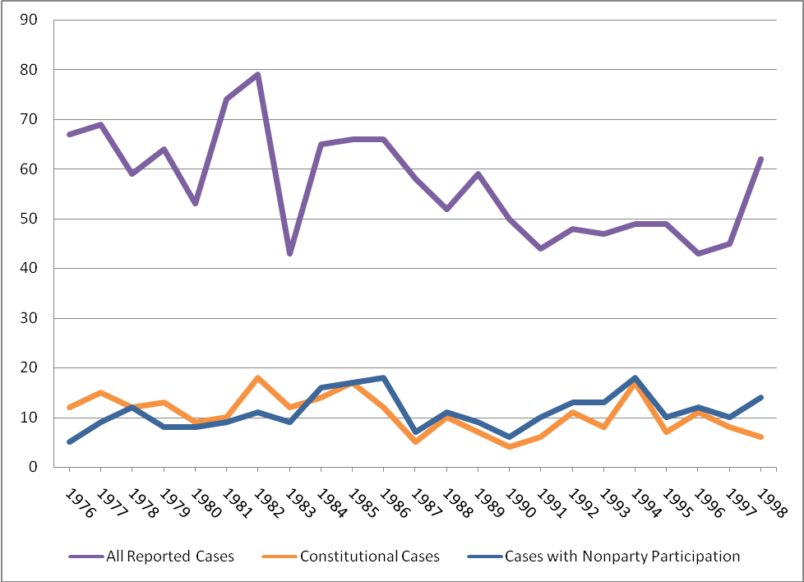

Table 1 -- Issue Area and Nonparty Participation in Constitutional Cases, 1976-1998
Issue Area | Constitutional Issue |  | Nonconstitutional Issue
 | n | % of Const. | n | % of Nonconst.
Criminal | 38 | 15.6% | 271 | 25.4%
Rights/Liberties | 28 | 11.5% | 24 | 2.2%
Public Law | 123 | 50.4% | 278 | 26.1%
Economics | 20 | 8.2% | 266 | 24.9%
Torts | 15 | 6.1% | 177 | 16.6%
Family Law | 18 | 7.4% | 40 | 3.7%
Other Issue | 2 | 0.8% | 11 | 1.0%
Total | 244 | 100% | 1067 | 100%
Nonparty Participant | 171 | 70.1% | 84 | 7.9%
 | Nonparty Participation |  | No Nonparty Participation
 | n | % of Nonparty | n | % of No Nonparty
Criminal | 41 | 16.1% | 267 | 25.4%
Rights/Liberties | 26 | 2.5% | 26 | 10.2%
Public Law | 105 | 41.2% | 295 | 28.1%
Economics | 33 | 12.9% | 251 | 23.9%
Torts | 20 | 7.8% | 171 | 16.3%
Family Law | 26 | 10.2% | 32 | 3.0%
Total | 255 | 100% | 1051 | 100%

Figure 2 -- Original Jurisdiction Cases on the High Court, 1976-1998
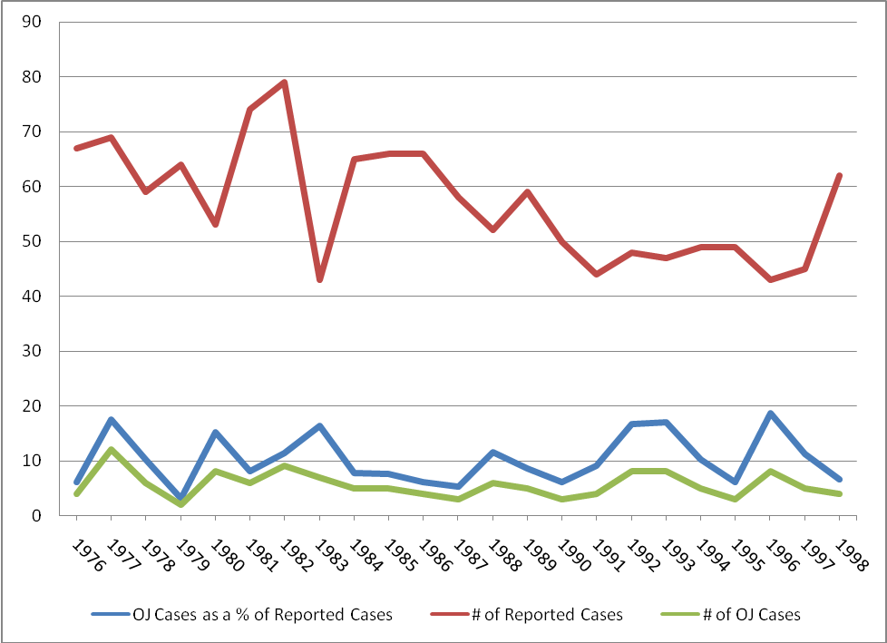

Figure 3 -- Reported Decisions by Issue Area, 1976-1998
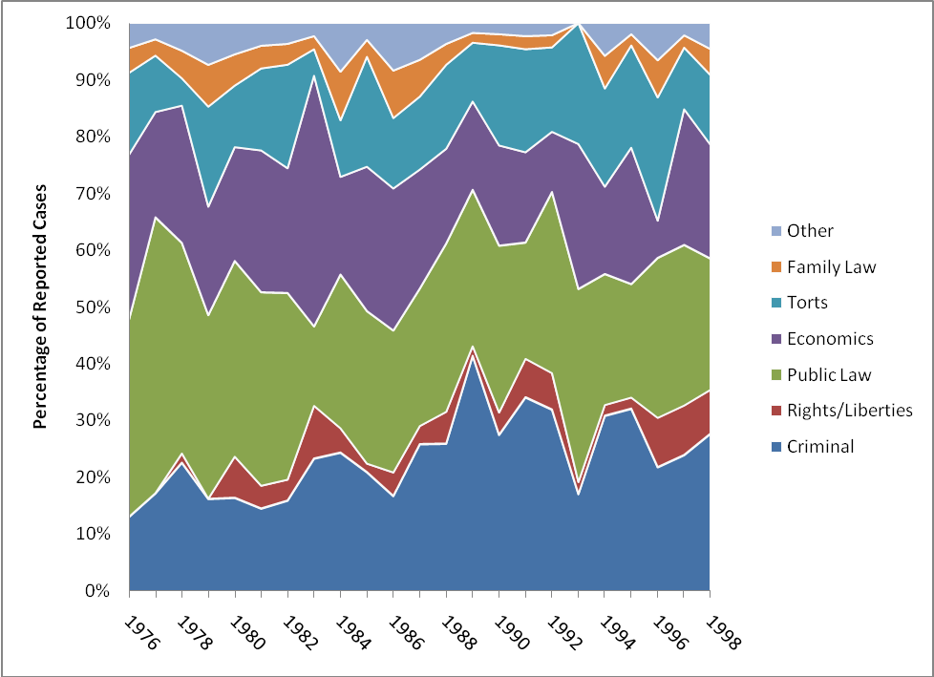

Table 2 -- Issue Area of Cases by Chief Justice, 1976-1998
Issue Area | Barwick  (1976-1981) | Gibbs  (1981-1987) | Mason  (1987-1995) | Brennan  (1995-1998) | Gleeson  (1998)
Criminal Cases | 55 (17.1%) | 78 (20.2%) | 124 (29.4%) | 38 (25.7%) | 14 (41.2%)
Rights & Liberties | 6 (1.9%) | 16 (4.1%) | 17 (4.0%) | 11 (7.4%) | 2 (5.9%)
Public Law | 124 (38.6%) | 113 (29.3%) | 119 (28.2%) | 37 (25.0%) | 8 (23.5%)
Economics | 76 (23.7%) | 99 (25.6%) | 76 (18.0%) | 32 (21.6%) | 3 (8.8%)
Torts | 38 (11.8%) | 57 (14.8%) | 68 (16.1%) | 36 (16.9%) | 4 (11.8%)
Family Law | 18 (5.6%) | 19 (4.9%) | 13 (3.1%) | 5 (3.4%) | 3 (8.8%)
Other | 4 (1.2%) | 4 (1.0%) | 5 (1.2%) | 0 (0.0%) | 0 (0.0%)
Total | 321 (100%) | 386 (100%) | 422 (100%) | 148 (100%) | 34 (100%)

Figure 4 -- Unreported Cases by Type Noted in the CLR, 1976-1998
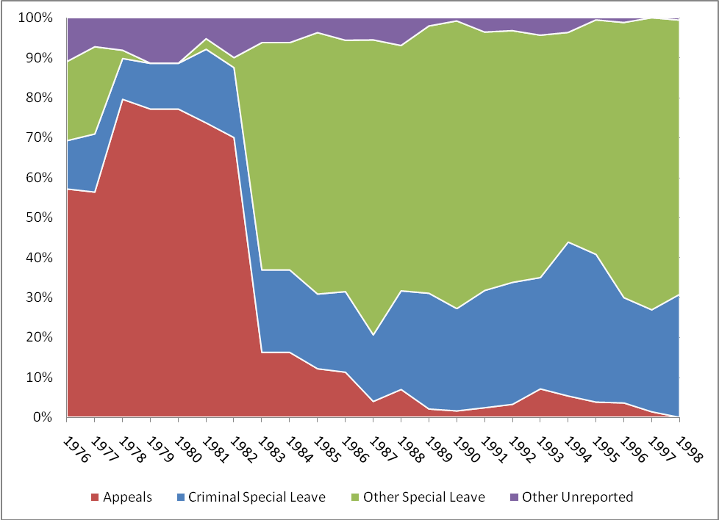

Figure 5 -- Reported and Noted Unreported Cases, 1976-1998
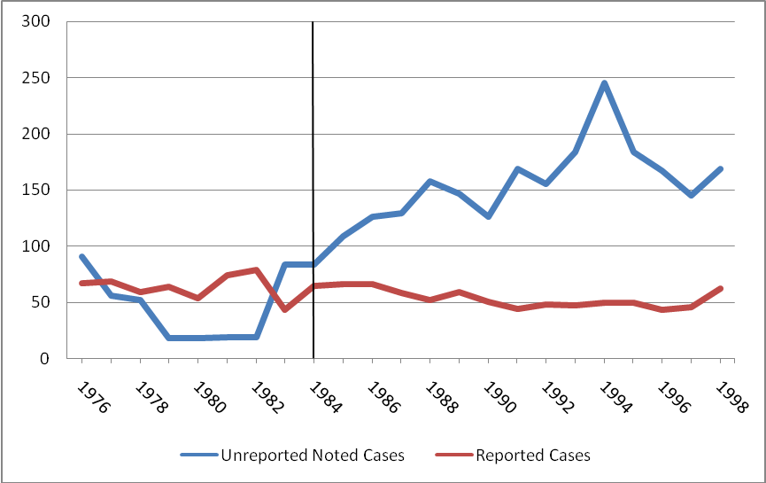

Figure 6 -- Reported and Noted Unreported Cases with Total Matters Filed, 1976-2006
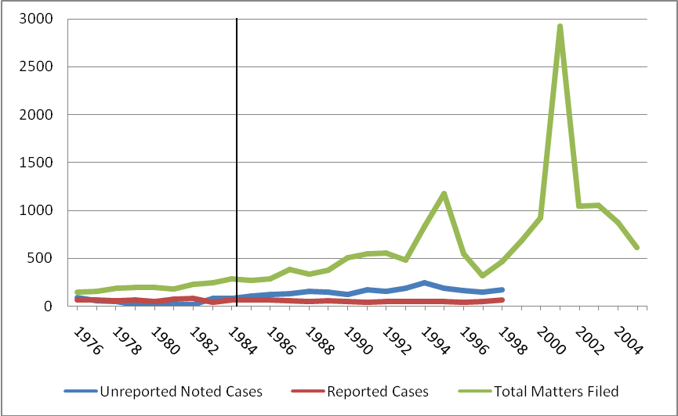

Table 6 --Appellant Winning Percentage by Issue Area of Cases and Chief Justice, 1970-2002
Chief Justice era Issue Area Appellant Wins N
Barwick (1970-81) Criminal 36.56% 93
Civil rights & liberties 21.11% 19
Public law 39.37% 287
Economics 35.84% 173
Torts 44.79% 96
Family law 55.88% 34
Gibbs (1981-87) Criminal 40.26% 77
Civil rights & liberties 56.25% 16
Public law 30.09% 113
Economics 33.33% 99
Torts 42.11% 57
Family law 42.11% 19
Mason (1987-95) Criminal 56.00% 125
Civil rights & liberties 41.18% 17
Public law 51.67% 120
Economics 44.74% 76
Torts 57.35% 68
Family law 46.15% 14
Brennan (1995-98) Criminal 52.63% 38
Civil rights & liberties 27.27% 11
Public law 50.00% 38
Economics 53.13% 32
Torts 48.00% 25
Family law 80.00% 5

Gleeson (1998-02) Criminal 61.19% 67
Civil rights & liberties 20.00% 10
Public law 60.32% 63
Economics 48.78% 41
Torts 52.94% 34
Family law 63.63% 11
Cases coded as Other omitted due to small number of observations.

Table 7 – Liberal Decisions by Issue Area of Cases and Chief Justice, 1970-2002
Chief Justice era Issue Area Liberal ruling N
Barwick (1970-81) Criminal 37.63% 93
Civil rights & liberties 42.11% 19
Public law 44.95% 287
Economics 21.39% 173
Torts 47.92% 96
Gibbs (1981-87) Criminal 48.05% 77
Civil rights & liberties 43.75% 16
Public law 53.98% 113
Economics 21.21% 99
Torts 56.14% 57
Mason (1987-95) Criminal 52.00% 125
Civil rights & liberties 64.71% 17
Public law 52.50% 120
Economics 18.42% 76
Torts 60.29% 68
Brennan (1995-98) Criminal 52.63% 38
Civil rights & liberties 36.36% 11
Public law 42.11% 38
Economics 31.25% 32
Torts 64.00% 25
Gleeson (1998-02) Criminal 53.73% 67
Civil rights & liberties 60.00% 10
Public law 61.90% 63
Economics 21.96% 41
Torts 52.94% 34

Family law cases omitted, because directionality is not coded for this issue area. Cases coded as Other omitted due to small number of observations.

Figure 7 – Appellant Victories by Year, 1970-2002

Figure 8 – Percentage of Appellant Victories by Issue Area and Chief Justice, 1970-2002

Figure 9 – Liberal Decisions by Year, 1970-2002

Figure 10 – Percentage of Liberal Decisions by Issue Area and Chief Justice, 1970-2002

Works Cited

The data used in this analysis come from several different sources, which reflect the different layers of the Court’s agenda. Information about the reported cases between 1976 and 1998 come from the High Courts Judicial Database project (Haynie et al. 2007). These data were compiled from the decisions hand-picked by the Justices for publication in the official Court records, the Commonwealth Law Reports (CLR). Here, we find information about cases deemed particularly important by the justices. The CLR also provides a list of unreported cases “of which a note may be valuable to the profession.” This is the second layer of the Court’s agenda: the unreported but noted cases. The third level of the agenda is made up of the cases that are summarily dismissed or denied special leave to appeal, along with other matters of which the Court must dispose. Data on the overall volume of Court business was compiled from the High Court’s Annual Reports from 1983 through the 1994-95 term, and then from the 1996-97 term through the 2006-07 term. Unfortunately, the early Annual Reports are hard to come by. The 1983 report contains a summary of workload data going back to 1977. The last yearly annual report is the 1993 edition. Beginning in 1994, the new registrar began issuing data by term instead of by year. So, the 1993 data are for the calendar year 1993, and the 1994 data are for the 1993-94 term. This term-by-term pattern has been followed in all subsequent Annual Reports. At this time, we have been unable to locate the 1995-1995 Annual Report; as such the total number of matters filed for 1996 have been extrapolated from the remaining data.
For example, Australian Capital Television v. Commonwealth (1992) 177 CLR 106 (finding an implied right to freedom of political communication).
Australian Railways Union v. Victorian Railways Commissioners (1930) 44 CLR 319 at 331.
This section was meant to be an anti-tax avoidance provision. In cases like FCT v. Commonwealth Aluminium (1980) 143 CLR 646, and Slutzkin v. FCT (1977) 140 CLR 314, the Barwick Court set the groundwork for the creation of numerous tax avoidance schemes by reading Section 260 very narrowly (Kobetsky and Krever 2002). This process added complexity to the tax code and purposefully failed to consider the legislative intent of the statute.
Commonwealth v. Tasmania (1983) 158 CLR 1.
R. v. Coldham; Ex Parte Australian Social Welfare Union (1984) 159 CLR 297.
Koowarta v. Bjelke-Petersen (1982) 153 CLR 168.
(1988) 165 CLR 360.
Mabo v. Queensland [No. 2] (1992) 171 CLR 1 (overturning the longstanding doctrine holding that Australia was terra nullius on the arrival of the European settlers).
Nationwide News v. Wills (1992) 177 CLR 1; Australian Capital Television v. Commonwealth (1992) 177 CLR 106 (holding that a fundamental freedom of speech could be implied from the principle of representative government laid out in the Constitution).
For example, Minister for Immigration and Ethnic Affairs v. Teoh (1995) 183 CLR 273 (holding that the ratification of the UN Convention on the Rights of the child, though not yet incorporated into Australian statutory law, had generated a legitimate expectation that the treaty would be honored).
See Lange v. Australian Broadcast Corporation (1997) 189 CLR 520; Levy v. Victoria (1997) 189 CLR 579.
Wik Peoples v. Queensland (1996) 187 CLR 1 (holding that, to the extent that pastoral leases were in conflict with native title, the leases would prevail).
See Residential Tenancies Tribunal (NSW), RE; Ex parte Defence Housing Authority [Henderson’s Case] (1997) 190 CLR 410 (reducing the extent to which the Commonwealth is exempted from state-levied taxes); Ha v. New South Wales (1997) 189 CLR 465 (classifying state-instituted tobacco taxes as excises, giving the Commonwealth government the sole authority to levy these taxes).
Bank of NSW v. Commonwealth (1948) 76 CLR 1.
Australian Communist Party v. Commonwealth (1951) 83 CLR 1.
New South Wales v. Commonwealth (2006) 231 ALR 1.
The year 2002 was chosen as the endpoint for this analysis for the practical reason that the High Courts database (Haynie et al. 2008) only extends to this year.
Cole v. Whitfield; Mabo v. Queensland [No. 2].
In this section, all analyses are conducted using the High Courts Judicial Database (Haynie et al. 2007). The High Courts Database contains only reported cases, therefore the results should be viewed with appropriate caution.
For further detail on the coding of directionality in cases and votes, see Haynie et al. 2008b.

