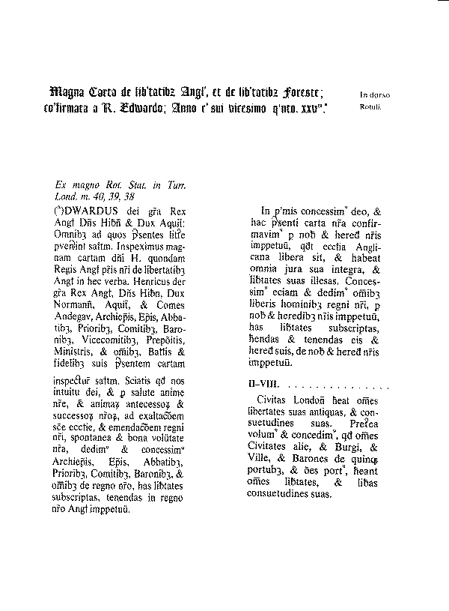

Magna Carta (1215)

I. FIRST, We have granted to God, and by this our present Charter have confirmed, for Us and our Heirs for ever, that the Church of England shall be free, and shall have all her whole Rights and Liberties inviolable. We have granted also, and given to all the Freemen of our Realm, for Us and our Heirs for ever, these Liberties under-written, to have and to hold to them and their Heirs, of Us and our Heirs for ever.

IX. THE City of London shall have all the old Liberties and Customs which it hath been used to have. Moreover We will and grant, that all other Cities, Boroughs, Towns, and the Barons of the Five Ports, and all other Ports, shall have all their Liberties and free Customs.

XXIX. NO Freeman shall be taken or imprisoned, or be disseised of his Freehold, or Liberties, or free Customs, or be outlawed, or exiled, or any other wise destroyed; nor will We not pass upon him, nor condemn him, but by lawful judgment of his Peers, or by the Law of the Land. We will sell to no man, we will not deny or defer to any man either Justice or Right.

Bill of Rights 1689 :

Englishmen, as embodied by Parliament, possessed certain immutable civil and political rights. These included:

freedom from royal interference with the law (the Sovereign was forbidden to establish his own courts or to act as a judge himself)

freedom from taxation by royal prerogative, without agreement by Parliament

freedom to petition the Monarch

freedom from a peace-time standing army, without agreement by Parliament

freedom [for Protestants] to have arms for defence, as allowed by law

freedom to elect members of Parliament without interference from the Sovereign

the freedom of speech in Parliament, in that proceedings in Parliament were not to be questioned in the courts or in any body outside Parliament itself (the basis of modern parliamentary privilege)

freedom from cruel and unusual punishments, and excessive bail

freedom from fines and forfeitures without trial

Certain acts of James II were specifically named and declared illegal on this basis.

The flight of James from England in the wake of the Glorious Revolution amounted to abdication of the throne.

Roman Catholics could not be king or queen of England since "it hath been found by experience that it is inconsistent with the safety and welfare of this protestant kingdom to be governed by a papist prince". The Sovereign was required to swear a coronation oath to maintain the Protestant religion.

William and Mary were the successors of James.

Succession should pass to the heirs of Mary, then to Mary's sister Princess Anne of Denmark and her heirs, then to any heirs of William by a later marriage.

The Sovereign was required to summon Parliament frequently, later reinforced by the Triennial Act 1694. (http://www.yale.edu/lawweb/avalon/england.htm)

Virginia Declaration of Rights

„I That all men are by nature equally free and independent, and have certain inherent rights, of which, when they enter into a state of society, they cannot, by any compact, deprive or divest their posterity; namely, the enjoyment of life and liberty, with the means of acquiring and possessing property, and pursuing and obtaining happiness and safety.

II That all power is vested in, and consequently derived from, the people; that magistrates are their trustees and servants, and at all times amenable to them.
.......................
V That the legislative and executive powers of the state should be separate and distinct from the judicative; and, that the members of the two first may be restrained from oppression by feeling and participating the burthens of the people, they should, at fixed periods, be reduced to a private station, return into that body from which they were originally taken, and the vacancies be supplied by frequent, certain, and regular elections in which all, or any part of the former members, to be again eligible, or ineligible, as the laws shall direct.

VI That elections of members to serve as representatives of the people in assembly ought to be free; and that all men, having sufficient evidence of permanent common interest with, and attachment to, the community have the right of suffrage and cannot be taxed or deprived of their property for public uses without their own consent or that of their representatives so elected, nor bound by any law to which they have not, in like manner, assented, for the public good.
.............................
XII That the freedom of the press is one of the greatest bulwarks of liberty and can never be restrained but by despotic governments.
..............................
XV That no free government, or the blessings of liberty, can be preserved to any people but by a firm adherence to justice, moderation, temperance, frugality, and virtue and by frequent recurrence to fundamental principles.

XVI That religion, or the duty which we owe to our Creator and the manner of discharging it, can be directed by reason and conviction, not by force or violence; and therefore, all men are equally entitled to the free exercise of religion, according to the dictates of conscience; and that it is the mutual duty of all to practice Christian forbearance, love, and charity towards each other.

Adopted unanimously June 12, 1776 Virginia Convention of Delegates drafted by Mr. George Mason“

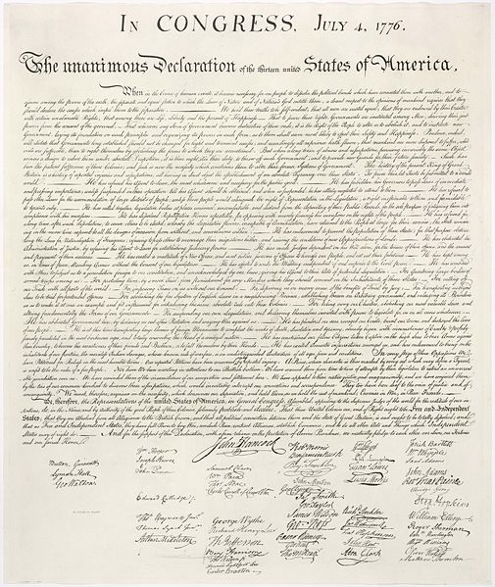

In CONGRESS, July 4, 1776.
The unanimous Declaration of the thirteen united States of America,
When in the Course of human events, it becomes necessary for one people to dissolve the political bands which have connected them with another, and to assume among the powers of the earth, the separate and equal station to which the Laws of Nature and of Nature's God entitle them, a decent respect to the opinions of mankind requires that they should declare the causes which impel them to the separation.
We hold these truths to be self-evident, that all men are created equal, that they are endowed by their Creator with certain unalienable Rights, that among these are Life, Liberty and the pursuit of Happiness. (Note: the original hand-written text ended on the phrase "the pursuit of property" rather than "the pursuit of Happiness" but the phrase was changed in subsequent copies in part because it was broader. The latter phrase is used today).
That to secure these rights, Governments are instituted among Men, deriving their just powers from the consent of the governed, That whenever any Form of Government becomes destructive of these ends, it is the Right of the People to alter or to abolish it, and to institute new Government, laying its foundation on such principles and organizing its powers in such form, as to them shall seem most likely to effect their Safety and Happiness. Prudence, indeed, will dictate that Governments long established should not be changed for light and transient causes; and accordingly all experience hath shewn, that mankind are more disposed to suffer, while evils are sufferable, than to right themselves by abolishing the forms to which they are accustomed. But when a long train of abuses and usurpations, pursuing invariably the same Object evinces a design to reduce them under absolute Despotism, it is their right, it is their duty, to throw off such Government, and to provide new Guards for their future security.
Such has been the patient sufferance of these Colonies; and such is now the necessity which constrains them to alter their former Systems of Government. The history of the present King of Great Britain is a history of repeated injuries and usurpations, all having in direct object the establishment of an absolute Tyranny over these States. To prove this, let Facts be submitted to a candid world.
He has refused his Assent to Laws, the most wholesome and necessary for the public good.
He has forbidden his Governors to pass Laws of immediate and pressing importance, unless suspended in their operation till his Assent should be obtained; and when so suspended, he has utterly neglected to attend to them.
He has refused to pass other Laws for the accommodation of large districts of people, unless those people would relinquish the right of Representation in the Legislature, a right inestimable to them and formidable to tyrants only.
He has called together legislative bodies at places unusual, uncomfortable, and distant from the depository of their Public Records, for the sole purpose of fatiguing them into compliance with his measures.
He has dissolved Representative Houses repeatedly, for opposing with manly firmness of his invasions on the rights of the people.
He has refused for a long time, after such dissolutions, to cause others to be elected, whereby the Legislative Powers, incapable of Annihilation, have returned to the People at large for their exercise; the State remaining in the mean time exposed to all the dangers of invasion from without, and convulsions within.
He has endeavoured to prevent the population of these States; for that purpose obstructing the Laws for Naturalization of Foreigners; refusing to pass others to encourage their migrations hither, and raising the conditions of new Appropriations of Lands.
He has obstructed the Administration of Justice by refusing his Assent to Laws for establishing Judiciary Powers.
He has made Judges dependent on his Will alone for the tenure of their offices, and the amount and payment of their salaries.
He has erected a multitude of New Offices, and sent hither swarms of Officers to harass our people and eat out their substance.
He has kept among us, in times of peace, Standing Armies without the Consent of our legislatures.
He has affected to render the Military independent of and superior to the Civil Power.
He has combined with others to subject us to a jurisdiction foreign to our constitution, and unacknowledged by our laws; giving his Assent to their Acts of pretended Legislation:
For quartering large bodies of armed troops among us:
For protecting them, by a mock Trial from punishment for any Murders which they should commit on the Inhabitants of these States:
For cutting off our Trade with all parts of the world:
For imposing Taxes on us without our Consent:
For depriving us in many cases, of the benefit of Trial by Jury:
For transporting us beyond Seas to be tried for pretended offences:
For abolishing the free System of English Laws in a neighbouring Province, establishing therein an Arbitrary government, and enlarging its Boundaries so as to render it at once an example and fit instrument for introducing the same absolute rule into these Colonies
For taking away our Charters, abolishing our most valuable Laws and altering fundamentally the Forms of our Governments:
For suspending our own Legislatures, and declaring themselves invested with power to legislate for us in all cases whatsoever.
He has abdicated Government here, by declaring us out of his Protection and waging War against us.
He has plundered our seas, ravaged our coasts, burnt our towns, and destroyed the lives of our people.
He is at this time transporting large Armies of foreign Mercenaries to compleat the works of death, desolation, and tyranny, already begun with circumstances of Cruelty & Perfidy scarcely paralleled in the most barbarous ages, and totally unworthy the Head of a civilized nation.
He has constrained our fellow Citizens taken Captive on the high Seas to bear Arms against their Country, to become the executioners of their friends and Brethren, or to fall themselves by their Hands.
He has excited domestic insurrections amongst us, and has endeavoured to bring on the inhabitants of our frontiers, the merciless Indian Savages whose known rule of warfare, is an undistinguished destruction of all ages, sexes and conditions.
In every stage of these Oppressions We have Petitioned for Redress in the most humble terms: Our repeated Petitions have been answered only by repeated injury. A Prince, whose character is thus marked by every act which may define a Tyrant, is unfit to be the ruler of a free people.
Nor have We been wanting in attentions to our British brethren. We have warned them from time to time of attempts by their legislature to extend an unwarrantable jurisdiction over us. We have reminded them of the circumstances of our emigration and settlement here. We have appealed to their native justice and magnanimity, and we have conjured them by the ties of our common kindred to disavow these usurpations, which, would inevitably interrupt our connections and correspondence. They too have been deaf to the voice of justice and of consanguinity. We must, therefore, acquiesce in the necessity, which denounces our Separation, and hold them, as we hold the rest of mankind, Enemies in War, in Peace Friends.
We, therefore, the Representatives of the united States of America, in General Congress, Assembled, appealing to the Supreme Judge of the world for the rectitude of our intentions, do, in the Name, and by Authority of the good People of these Colonies, solemnly publish and declare, That these united Colonies are, and of Right ought to be Free and Independent States; that they are Absolved from all Allegiance to the British Crown, and that all political connection between them and the State of Great Britain, is and ought to be totally dissolved; and that as Free and Independent States, they have full Power to levy War, conclude Peace, contract Alliances, establish Commerce, and to do all other Acts and Things which Independent States may of right do. And for the support of this Declaration, with a firm reliance on the protection of divine Providence, we mutually pledge to each other our Lives, our Fortunes and our sacred Honor.

Text of the Bill of Rights
The Preamble to the Bill of Rights:
Congress of the United States begun and held at the City of New-York, on Wednesday the fourth of March, one thousand seven hundred and eighty nine.
THE Conventions of a number of the States, having at the time of their adopting the Constitution, expressed a desire, in order to prevent misconstruction or abuse of its powers, that further declaratory and restrictive clauses should be added: And as extending the ground of public confidence in the Government, will best ensure the beneficent ends of its institution.
RESOLVED by the Senate and House of Representatives of the United States of America, in Congress assembled, two thirds of both Houses concurring, that the following Articles be proposed to the Legislatures of the several States, as amendments to the Constitution of the United States, all, or any of which Articles, when ratified by three fourths of the said Legislatures, to be valid to all intents and purposes, as part of the said Constitution; viz.
ARTICLES in addition to, and Amendment of the Constitution of the United States of America, proposed by Congress, and ratified by the Legislatures of the several States, pursuant to the fifth Article of the original Constitution.

First Amendment – Freedom of religion, speech, press, and peaceable assembly as well as the right to petition the government.
Congress shall make no law respecting an establishment of religion, or prohibiting the free exercise thereof; or abridging the freedom of speech, or of the press; or the right of the people peaceably to assemble, and to petition the Government for a redress of grievances.

Second Amendment – Right to keep and bear arms.
A well regulated Militia being necessary to the security of a free State, the right of the people to keep and bear Arms, shall not be infringed.

Third Amendment – Protection from quartering of troops.
No Soldier shall, in time of peace be quartered in any house, without the consent of the Owner, nor in time of war, but in a manner to be prescribed by law.

Fourth Amendment – Protection from unreasonable search and seizure.
The right of the people to be secure in their persons, houses, papers, and effects, against unreasonable searches and seizures, shall not be violated, and no Warrants shall issue, but upon probable cause, supported by Oath or affirmation, and particularly describing the place to be searched, and the persons or things to be seized.

Fifth Amendment – Due process, double jeopardy, self-incrimination, private property.
No person shall be held to answer for any capital, or otherwise infamous crime, unless on a presentment or indictment of a Grand Jury, except in cases arising in the land or naval forces, or in the Militia, when in actual service in time of War or public danger; nor shall any person be subject for the same offence to be twice put in jeopardy of life or limb; nor shall be compelled in any criminal case to be a witness against himself, nor be deprived of life, liberty, or property, without due process of law; nor shall private property be taken for public use, without just compensation.

Sixth Amendment – Trial by jury and other rights of the accused.
In all criminal prosecutions, the accused shall enjoy the right to a speedy and public trial, by an impartial jury of the State and district where in the crime shall have been committed, which district shall have been previously ascertained by law, and to be informed of the nature and cause of the accusation; to be confronted with the witnesses against him; to have compulsory process for obtaining witnesses in his favor, and to have the Assistance of Counsel for his defense.

Seventh Amendment – Civil trial by jury.
In suits at common law, where the value in controversy shall exceed twenty dollars, the right of trial by jury shall be preserved, and no fact tried by a jury, shall be otherwise reexamined in any court of the United States, than according to the rules of the common law.

Eighth Amendment – Prohibition of excessive bail, as well as cruel and unusual punishment.
Excessive bail shall not be required, nor excessive fines imposed, nor cruel and unusual punishments inflicted.

Ninth Amendment – Protection of rights not specifically enumerated in the Bill of Rights.
The enumeration in the Constitution, of certain rights, shall not be construed to deny or disparage others retained by the people.

Tenth Amendment – Powers of states and people.
The powers not delegated to the United States by the Constitution, nor prohibited by it to the states, are reserved to the states respectively, or to the people.

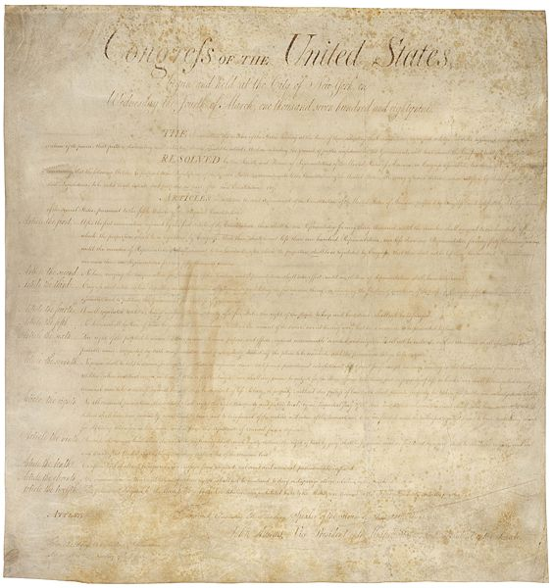

Prohlášení práv člověka a občana (1789)
Představitelé francouzského lidu, ustanoveni v Národním shromáždění, domnívajíce se, že nevědomost, zapomenutí nebo pohrdání lidskými právy jsou jedinými příčinami veřejných neštěstí a zkorumpování vlád, rozhodli se vyložit v slavnostní Deklaraci přirozená, nezcizitelná a posvátná práva člověka za tím účelem, aby tato Deklarace, neustále jsouc před očima všem členům lidské společnosti, uváděla jim stále na paměť jejich práva a jejich povinnosti; aby činy zákonodárné moci a činy výkonné moci mohly být v každé chvíli porovnávány s účelem každé politické instituce a byly v důsledku toho chovány ještě více v úctě; aby požadavky občanů, když se budou napříště zakládat na jednoduchých a nepopíratelných zásadách, směřovaly vždy k zachování ústavy a ku blahu všech.
V důsledku toho Národní shromáždění uznává a vyhlašuje, za přítomnosti a pod záštitou Nejvyšší Bytosti, tato práva člověka a občana:
- Lidé se rodí a zůstávají svobodnými a rovnými ve svých právech. Společenské rozdíly se mohou zakládat pouze na prospěšnosti pro celek.
- Účelem každého politického společenství je zachování přirozených a nezadatelných práv člověka. Tato práva jsou: svoboda, vlastnictví, bezpečnost a právo na odpor proti útlaku.
- Princip veškeré svrchovanosti spočívá v podstatě v národě. Žádný sbor, žádný jednotlivec nemůže vykonávat moc, která by z něj nebyla výslovně odvozena.
- Svoboda spočívá v tom, že každý může činit vše, co neškodí druhému. Proto výkon přirozených práv každého člověka nemá jiných mezí než ty, které zajišťují ostatním členům společnosti užívání týchž práv. Tyto meze mohou být ustanoveny pouze zákonem.
- Zákon má právo zakazovat pouze činy škodlivé společnosti. Nikomu nemůže být bráněno v tom, co není zakázáno zákonem, a nikdo nemůže být nucen činit něco, co zákon nenařizuje.
- Zákon je vyjádřením všeobecné vůle. Všichni občané mají právo účastnit se osobně nebo prostřednictvím svých zástupců při jeho vytváření. Zákon má být stejný pro všechny, ať už poskytuje ochranu či trestá. Všichni občané, jsouce si před zákonem rovni, mají stejný přístup ke všem hodnostem, veřejným úřadům a zaměstnáním, podle svých schopností a jen na základě rozlišení, která vyplývají z jejich ctností a z jejich nadání.
- Každý člověk může být obžalován, zatčen nebo uvězněn pouze v případech stanovených zákonem a pouze způsoby, které zákon předepisuje. Ti, kteří vyžadují, vyhotovují, vykonávají nebo dávají vykonávat svévolné příkazy, mají být potrestáni; ale každý občan předvolaný nebo vzatý do vazby na základě zákona musí okamžitě poslechnout, jinak se stává vinným pro odpor.
- Zákon má stanovit pouze tresty, které jsou nezbytně a zřejmě nutné; každý může být potrestán pouze na základě zákona, schváleného a vyhlášeného před spáchaným činem a zákonně prováděného.
- Každý člověk je pokládán za nevinného až do té doby, kdy je prokázána jeho vina; jestliže se pokládá za nezbytné zatknout jej, každá přísnost, která by nebyla nutná k zajištění jeho osoby, má být přísně potlačena.
- Nikomu se nesmí dít újma pro jeho názory, i náboženské, ledaže by jejich projev rušil pořádek stanovený zákonem.
- Svobodné sdělování myšlenek a názorů je jedním z nejdrahocennějších práv člověka, každý občan může tedy svobodně mluvit, psát, tisknout, jest se mu však zodpovídat za zneužívání této svobody v případech zákonem stanovených.
- Záruka práv člověka a občana vyžaduje existenci veřejné moci; tato moc je tedy zřízena ve prospěch všech a ne tedy k osobnímu užitku těch, kterým je svěřena.
- K vydržování veřejné moci a k úhradě správních výdajů je zapotřebí společných daní; mají být rovnoměrně rozvrženy na všechny občany podle jejich majetkové schopnosti.
- Všichni občané mají právo určit sami nebo prostřednictvím svých zástupců potřebnost veřejných daní, svobodně k nim dát souhlas, kontrolovat jejich používání, určit jejich kvótu, základ, způsob jejich vybírání a dobu jejich trvání.
- Společnost má právo žádat na každém veřejném úředníkovi počet z jeho činnosti.
- Společnost, ve které záruka práv není zajištěna a ve které rozdělení moci není zavedeno, nemůže o sobě říkat, že má ústavu.
- Protože vlastnictví je nedotknutelným a posvátným právem, nikdo ho nemůže být zbaven kromě případu, kdy by to vyžadovala zákonně zajištěná veřejná nezbytnost, a pod podmínkou spravedlivého a předchozího odškodnění.
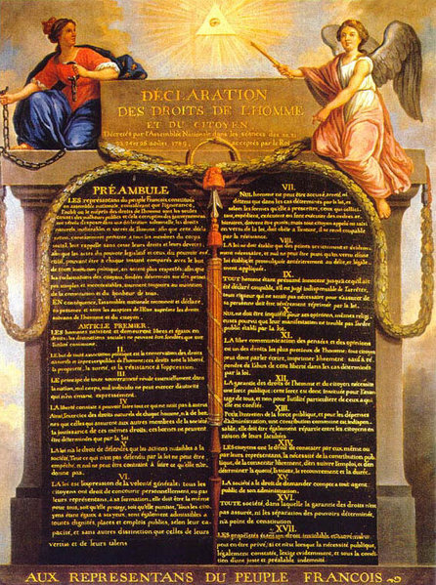

142

Základní zákon státní

daný dne 21. prosince 1867

o obecných právech občanů státních v královstvích a zemích v radě říšské zastoupených

Má platnost v Čechách, Dalmatsku, Haliči a Vladimiřsku s Krakovskem, v Rakousích pod Enží, Salcbursku, Štyrsku, Korutansku, Krajinsku, v Bukovině, Moravě, Slézsku, Tyrolsku, Vorarlbersku, Istriansku a Gradišťku, též v městě a okršlku Trstském

(Obsaž. v částce LXI. zákonníka říšského, č. 142, str. 394, vyd. a rozesl. dne 22. prosince 1867).

S přivolením obojí sněmovny rady říšské vidí se Mi vydati nížepoložený základní zákon o obecných právích občanů státních, a naříditi takto:

Článek 1

Všichni obyvatelé náležející ku královstvím a zemím v radě říšské zastoupeným, mají obecné rakouské státní právo občanské.

Zákon ustanovuje, pod kterými výminkami kdo rakouského státního práva občanského může nabyti, jeho užívati a kdy a jak ho pozbude.

Článek 2

Před zákonem jsou všichni státní občané rovni.

Článek 3

Všichni občané státní mohou rovnou měrou veřejných úřadův dojíti. Aby cizozemci veřejných úřadův dojíti mohli, potřebí, aby prvé nabyli rakouského státního práva občanského.

Článek 4

Volné stěhování se osob a jmění v mezech státu ničím není obmezeno.

Každému občanu státnímu, který v některé obci bydí a platí v ní daň ze svého majetku nemovitého, ze svého výdělku nebo příjmu, přísluší právo, voliti a volenu býti do zastupitelstva obecního, pod týmiž výminkami, jako příslušníkům obce.

Svoboda, vystěhovati se ze země, obmezena jest z příčiny státu toliko brannou povinností.

Obchodně vybírati se může jediné tehda, když se užije reciprocity.

Článek 5

Jmění jest neporušitedlné. Mimo vůli může se někomu odejmouti něco, což jeho jest, jen v těch případnostech, a tím spůsobem, jak ustanovuje zákon.
Článek 6

Každý občan státní může na každém místě v státě se zdržovati a bydleti, jakýchkoli věcí nemovitých nabývati a jimi volně vládnouti, též pod výminkami zákonem vyměřenými jakou koli živnost provozovati.

Spůsobem zákona a z příčin obecného dobrého dopouští se, by se obmezilo právo, mrtvé ruce statků nemovitých nabývati a k té ruce jimi vládnouti.

Článek 7

Všeliký svazek poddanství a člověčenství navždy jest zrušen. Všeliká povinnost nebo vybývání, z důvodů rozděleného práva vlastnického na nějakém statku nemovitém záležející, může se vykoupiti, aniž jest dovoleno, příště statků nemovitých podobnými povinnostmi nevykupitedlnými zavazovati.

Článek 8

Svoboda osobní jest pojištěna.

Zákon, daný dne 27. října 1862 (č. 87 zákonníka říšského) pro ochranu svobody osobní, prohlašuje se tímto za čásť tohoto základního zákona státního.

Byl-li by kdo proti zákonu zatčen aneb zatčení jeho prodlouženo, vzejde z toho státu povinnost, nahraditi mu za takové ublížení škodu.

Článek 9

Právo domácí jest neporušitedlné.

Článek 10

Tajnost psaní nebudiž porušována, a psaní zabavována buďte dle zákonů o tom vydaných toliko v případech války aneb z rozkazu soudcovského, leč že by byl někdo dle zákona zatčen nebo by bylo v domě hledáno.

Článek 11

Každému přísluší právo petiční.

Petice pod společným jménem podávati se mohou jenom od korporací neb spolků zákonem uznaných.

Článek 12

Rakouští občané státní mají právo se shromažďovati a spolky činiti. Jak se těchto práv má užívati, ustanovuje se zvláštními zákony.

Článek 13

Každý má právo, mínění své v mezech zákon slovem, písmem, tiskem nebo vyobrazením volně pronášeti.

Tisku není dovoleno ani pod censuru dávati, ani propůjčováním koncesí obmezovati. Administrativní zápovědi poštovské k zdejším věcem tištěným se nevztahují.

Článek 14

Úplná svoboda víry a svědomí každému jest pojištěna.

Požívání práv občanských a politických nezávisí na vyznání víry; však povinnostem občanským nemůže býti vyznání náboženské na újmu.

Nikdo nemůže přidržován býti k nějakému výkonu církevnímu aneb k účastenství v nějaké slavnosti církevní, není-li postaven pod mocí někoho jiného, který dle zákona k tomu má právo.

Článek 15

Každá církev a společnost náboženská zákonem uznaná má právo, náboženství společně a veřejně provozovati, své záležitosti vnitřní a své moci pořádati a spravovati, ústavy, fundace a fondy ku potřebám náboženství, vyučování a dobročinnosti ustanovení držeti a jich užívati; jest však, jako každá společnost, poddána obecným zákonům státním.

Článek 16

Přívržencům vyznání náboženského, které není zákonem uznáno, dovoleno jest, v domě náboženství provozovati, pokud takové provozování není ani proti zákonu, ani proti mravopočestnosti.

Článek 17

Věda a učení vědecké jest svobodné.

Každý občan státní má právo, ústavy vyučovací a vychovací zřizovati a na nich vyučovati, když dle zákona prokáže, že jest k tomu spůsobilý.

Vyučování domácí není tímto spůsobem obmezeno.

O vyučování náboženství ve školách přísluší péči míti církvi neb společnosti náboženské, jíž se dotýče.

Státu náleží v příčině veškerého vyučování vychovatelství právo nejvyššího řízení a dozorství.

Článek 18

Každý má toho vůli, vyvoliti si své povolání a vzdělati se k němu, jak a kde mu libo.
Článek 19

Všichni národové v státě mají rovné právo, a každý národ má neporušitedlné právo, chovati a vzdělávati národnost a řeč svou.

Rovné právo všech v zemích obvyklých řečí ve škole, úřadě a v životě veřejném od státu se uznává.

V zemích, v kterýchž bydlí několik národů, zřízena buďte veřejná učiliště tím spůsobem, by se každému národu dostalo náležitých prostředků, vzdělati se ve své řeči, aniž by byl kdo nucen, učiti se druhému jazyku zemskému.

Článek 20

Pokud vláda odpovědná může práva, přivedená v článcích 8., 9., 10., 12. a 13., na čas a v některém místě zastaviti, vyměřeno bude zvláštním zákonem.

Ve Vídni, dne 21. prosince 1867.

František Josef m. p.
Svod. pán Beust m. p.
Svod. pán Becke m. p.
Svod. pán John m. p., p. podm.
Rytíř Hye m. p.
Bernard rytíř Meyer v. r.

