 | People in Land Law | Name of document
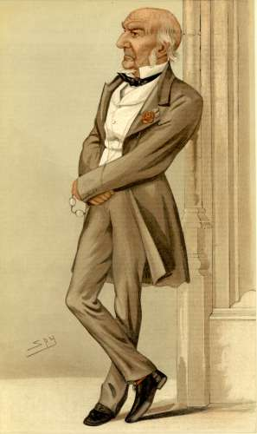 | FREEHOLDER  can be  LANDLORD | TITLE DEED | - owns the land  - can repossess the land  - charges rent
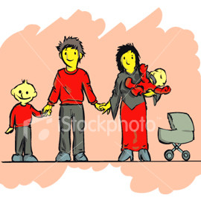 | LEASEHOLDER  or LESSEE  (is a TENANT)  can be  LANDLORD | LEASE | - doesn´t own the land  - pays rent to a landlord  - usually buys as long a lease as possible (e.g. 99 years)  - can charge rent as a landlord
 | LICENSEE  (is a TENANT) | LICENSE | - shorter and less secure terms than a leaseholder  - pays rent to a landlord (usually every week or month)  - if he fails to pay the rent, the landlord may be able to repossess the property more easily than from a leaseholder

