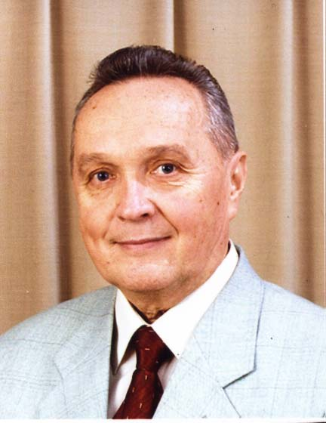
The address of the President of the Russian Association of the philosophy of law (St. Petersburg), a doctor of law, a professor, a distinguished scientist of Russian Federation Edward V. Kuznetsov to the representatives of government, business, science, culture and religion.

In March of 2005 the St. Petersburg Association of the Philosophy of Law was created. The philosophy of law has been compared with phoenix since ancient times, which revived from the aches every time its enemies were celebrating the so-called victory over it. The time is coming when phoenix will straighten its powerful wings and the word "Law" will gain its natural meaning which is justice. Usually people tend not only to the law, but to the fair right with the moral capacity. The experience of totalitarian legal reality shows that legal positivism has shown a remarkable disrespect for the law, and crossed it as a high spiritual phenomenon.
The end of the XX-th century was known as the period of the collapse of many rationalistic myths about humans, a society in general, law and a state. Having lost the connection with existence, human consciousness acknowledged itself with self-assurance as the only true reality (cogito ergo sum). Now the purpose of life has to be made up, but not looked for, it has to be created by humans. Religion seemed to be an illusion while law was gradually becoming an accumulation of positivist ideas, according to which the state regulations were called to substitute the natural essence of law which is inseparably linked with morals. Spiritual growth was declared as something that has no value and it was quickly put on the last place. The destruction of the very basics of the human existence started in the social sphere just like the disintegration of an atom. It took a monstrous historical and metaphysical experiment of totalitarianism that led to the deaths of millions of people and destroyed almost all spheres of society’s life to remove (but, unfortunately, not completely) the rationalistic illusion that has firmly rooted in the minds of many people of the XX century. In reality it became clear that social life has its own laws, and the most important of them are connected with the recognition of the line, beyond which any invasion is not permitted. This line if we use the language of the philosophy of law is called personal freedom of a human being and his natural rights. The philosophy of law is a spirit of law, and its letter must correspond to that spirit. Almost a hundred years ago it was noticed in "Vekhi" that the Russian intelligentsia's mistake was that they understood the law not like a legal belief but like a forced rule. It is necessary to understand it is not possible to demand civil virtues from a human being who was put into the state of a slave or hireling, but without those virtues any civilized state is impossible and no regulations can function.
XXI century marks the beginning of the transition to a new socio-cultural paradigm. Today crisis affects all the spheres of human activities and culture. Collective and individual social upheavals, that affect us, require a global scientific answer. This answer can be given if only all the structures of our society unite. Russian Association of the Philosophy of Law (St. Petersburg) makes a first step in this direction with awareness of its difficulty. We hope that our weak voices will be heard and supported by the representatives of government, business, culture and religions and scientists. For them the words mercy, justice, kindness and tolerance determine their way of life.
The most important goals of the Association of the Philosophy of Law are:
- revival and development of philosophy of law in contemporary Russia, the evolution of ideas related to knowledge and protection of natural and inalienable human rights that allocated in the legislation
- further integration of modern legal science with the world community
- revival and development of progressive ideas of outstanding philosophers of law in Russia
- development and organization of programs and research projects
- organization of national and international forums and the realization of international programs and activities in the field of international cooperation in law
- scientific seminars on the philosophical problems of law
- advice and assistance in training and retraining of staff (Russian and foreign)
Association is opened for any new scientific direction in law. It is a structural element of the World Association of the Philosophy of Law and Social Philosophy (IVR). 25 May 2005 decision of the Executive Committee of the World Association of the Philosophy adopted St. Petersburg Association of the Philosophy of Law as a new section. Members of Association took part in the 21 International IVR Congress in Sweden in 2003, the 22 Congress in Spain in 2005 and the 23 International IVR Congress in Poland in 2007. There were no any similar forums in Russia, although Russia used to have a lot of big achievements in such types of questions. In addition in 1860 B. Chicherin and later P. Novgorodtsev raised the issue of the revival of the natural right in Russia, but only in 1910 French scientist Sharmon raised the same question in Europe.
Everyone knows economic forums in Davos where the representatives of government, business and scientific community usually rush. But the World Law Congress is no less important and meaningful event not only for St. Petersburg, but for Russia.
World Forums on the philosophy of law are held from 1909, since the foundation of IVR. They deal with current problems of legal theory and jurisprudence. So at the 21 Congress that was held in 2003 in Sweden contemporary philosophers and legal scholars lectured: A. Pechenik (Sweden), R. Aleksi (Germany), R. Pozner (USA), E. Pottaro (Italy). Lectures on the subject of “Law and economy”, “Law, morals and politics”, “Justice, authorities and the law”, “New technologies in law and politics”, “Politics of Human Rights”, “Nation States and the universal values” were in the center of attention. Hundreds of delegates from all over the world take part in congress’s work. Typically these events are held under the patronage of senior State governors. This way the 17 World IVR Congress was held in Italy under the protection of the president of the Italian republic Oscar Scalfaro, European Parliament, Chairman of the Cabinet of Ministers of Italy, Minister of Foreign Affairs of Italy, Minister of Justice, Minister of Education in Italy and the leaders of the city administration (Bologna). We need to approach such setting of issue.
Today in the World IVR Congresses Russia (as France) is represented by two associations Moscow and St. Petersburg. In 2009 the 24 World IVR Congress will be in China. It is a hundredth anniversary of IVR. We would like to express a hope that one of the congresses will be held in Russia. Russian legal science deserves it. It is also recognized abroad. For example, Eugeniy Trubetskoi is known to have been called a genius in law at the international conference devoted to the1000-th anniversary of the baptizm of Russia in 1988, in the report of an Italian scientist and catholic priest Chesar Scribano . History knows the fact that at the end of the nineteenth century the most prominent scientists from England, Germany and France came to Russia to listen to 27 year-old law professor N.M. Korkunov! The study books on the theory of law written by him were considered to be the best in Europe.
We have a lot of ideas, and their realization requires support. So join us, support and help us! The world does not revolve around the new noise, but around new ideas it revolves silently.

e-mail: kuznetsov_femida@mail.ru
тел.: 8(812) – 343-21-71
8(812) – 373-09-45

