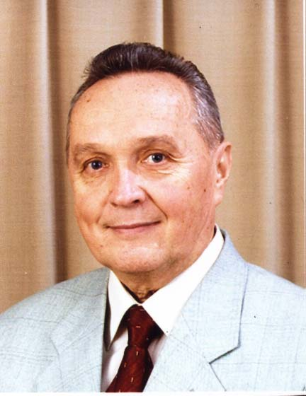
Eduard Kuznetsov
Eduard Kuznetsov is doctor of law, professor, hornored scientist of Russia. He graduated from the Lenengrad’s State University, faculty of law, and the special post – graduate program for teaching in French speaking countries. Нe has worked as a People’s Judge for a few years. He defended a thesis of “Category of reason and consequences in law making” (1970), and a thesis for a Doctor’s degree on them “Philosophy of law in Russia” (1990). His main scientific direction is the theory and philosophy of law. He trained 25 candidates and Doctors of science. He was elected to be a member of the International Academy of Acmeological sciences. He read lectures of the theory and philosophy of law several times in universities of Sweden and Spain. He took part in World Congresses of philosophy of law (Sweden – 2003; Spain – 2005). He published more than 150 scientific works. Introduction in law (1987). Philosophy of law in Russia (1989); Science about law and State (1999),Challenge to the law of XXI century (1998), Bases of the Russian law, Part I (1997); Legal tantology (SPb. 2002); Ontolgy of law in the Russian scientific tradition (L. Petragitsky). SPb., 2002 ( jointly with I. Rakitskaya), Biomedical technologies and law in the third millennium (Spb., 2003), are among them. He has State awards.

