ESTIMATION OF VISUAL ACUITY

Estimate your visus and visus of a person with refraction error (estimate his/her visus with and without spectacles).

 | person without refraction error | person with refraction error
 |  | without spectacles | with spectacles
Visus OD
Visus OS

Conclusion:…………………………………………………………………………………………………………………………………………………………………………………………………………………………………………………………………………………………….

ACCOMMODATION
Protocol:
punctum proximum: , punctum remotum:

Conclusion:…………………………………………………………………………………………………………………………………………………………………………………………
VISUAL FIELD AND BLIND SPOT

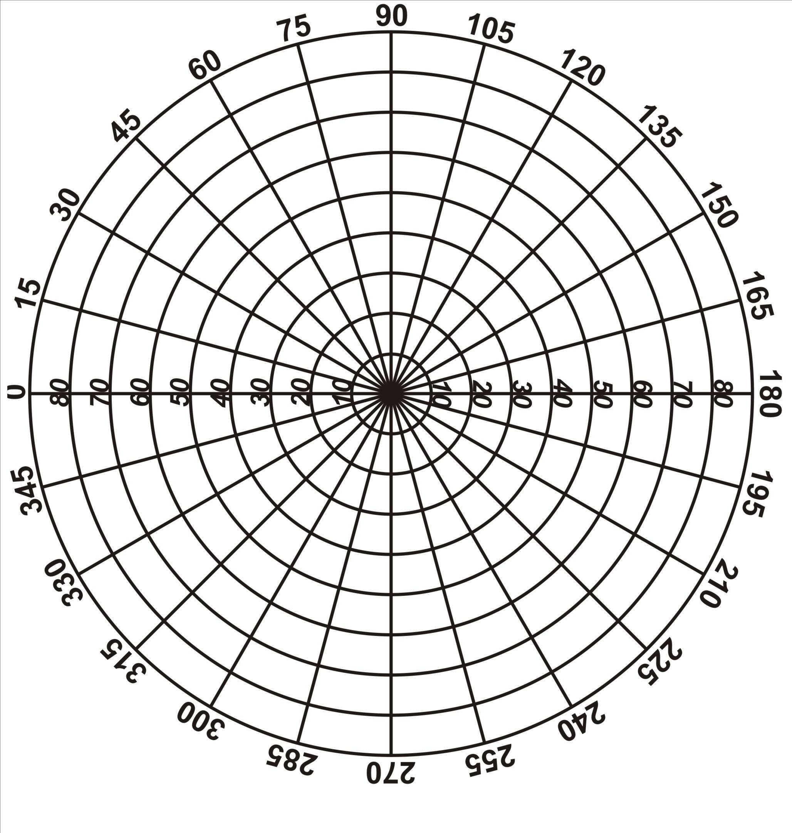
Protocol:

a)

b) Estimation of blind spot

……………………..

Conclusion:…………………………………………………………………………………………………………………………………………………………………………………………………………………………………………………………………………………………………………………………

ASTIGMATISM

Protocol: describe the observed manifestations of astigmatism; estimate its angular plane

Conclusion:…………………………………………………………………………………………………………………………………………………………………………………………………………………………………………………………………………………………………………………………

EXAMINATION OF COLOR BLINDNESS

Protocol:
Record the results for each table in several examined person:
…………………………………………………………………………………………………………………………………………………………………………………………………………………………………………………………………………………………………………………………………………………………………………………………………………………………………………………………………………………………………………………………………………………………………………………………………………………………………………………………………………………………………………………………………………………………………………………………… Conclusion:……………………………………………………………………………………………………………………………………………………………………………………………………………

SUBJECTIVE HEARING TESTS

Weber test

Results
Time of hearing of the right ear t1:
Time of hearing of the left ear t2:
Ratio of t1/t2

Rinne test
Results
Right ear
Time of hearing the tuning fork through bone conduction t1:
Time of hearing the tuning fork through air conduction
after bone conduction t2:
Total time of hearing of tuning fork t:
The ratio of the time interval t2/t1:
Left ear
Time of hearing the tuning fork through bone conduction t1:
Time of hearing the tuning fork through air conduction
after bone conduction t2:
Total time of hearing of tuning fork t:
The ratio of the time interval t2/t1:

Conclusion:…………………………………………………………………………………………………………………………………………………………………………………………...
…………………………………………………………………………………………………..

