CZECH FOR FOREIGNERS II

[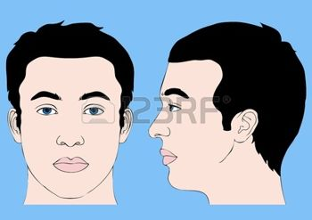](http://www.google.cz/url?sa=i&rct=j&q=&esrc=s&source=images&cd=&cad=rja&uact=8&ved=0ahUKEwiS7ZiN7orMAhVDVRoKHXtzB90QjRwIBw&url=http%3A%2F%2Fcz.123rf.com%2Fprofile_eveleen&bvm=bv.119408272,d.d2s&psig=AFQjCNH1KzNyIjYx3sLvBKv-bzoiBOn21A&ust=1460610953448626)

|  |
| --- |
| cranium |
| hair |
| face |
| face |
| forehead |
| nose |
| nostril |
| adenoid |
| eye |
| eyes |
| eyelid |
| eyebrow |
| eyelash |
| ear, ears |
| ears |
| cheek |
| chin |
| mouth |
| lip, lips |
| tongue |
| tooth |
| dentition |
| gum |
| palate |
| jaw |
| upper, lower jaw |
| vertex |
| occiput, the back part of the skull |
| scruff (of the neck) |