Flow cytometry

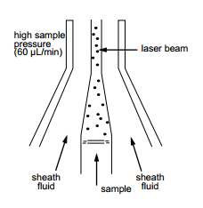
Flow cytometry is a technology that measures and then analyses multiple physical characteristics of single p_ _ _ _ _ _ _ _s, usually cells, as they flow in a f_ _ _d stream through a b_ _m of light. The properties measured include a particles’ relative size, relative g_ _ _ _ _ _ _ _ _y or internal c_ _ _ _ _ _ _ _y, and relative f_ _ _ _ _ _ _ _ _ _e intensity. These characteristics are determined using an optical-to-electronic coupling system. This system records how the cell or particle s_ _ _ _ _ _s laser light and e_ _ _s fluorescence.
A flow cytometer is made up of three main systems: fluidics, optics and electronics.
The fluidics system transports particles in a stream to the laser beam for interrogation.
The optics system consists of lasers to i_ _ _ _ _ _ _ _e the particles in the sample stream and optical filters to direct the resulting light signals to the a_ _ _ _ _ _ _ _ _e detectors.
The electronics system c_ _ _ _ _ _s the detected light signals into electronic signals. These signals can then be p_ _ _ _ _ _ _d by the computer.
In the flow cytometer, particles are carried to the laser intercept in a fluid stream. Any suspended particle or cell from 0.2-150 micrometers in size is suitable for analysis. The portion of the fluid stream where particles are located is called the sample core. When particles pass through the laser intercept, they scatter laser light. Any fluorescent molecules present on the particle fluoresce. The scattered and fluorescent light is collected by appropriately positioned l_ _ _ _s. A combination of beam splitters and filters brings the scattered and fluorescent light to the appropriate detectors. The detectors produce electronic signals. These signals correspond with the optical signals striking the detectors.

Questions:
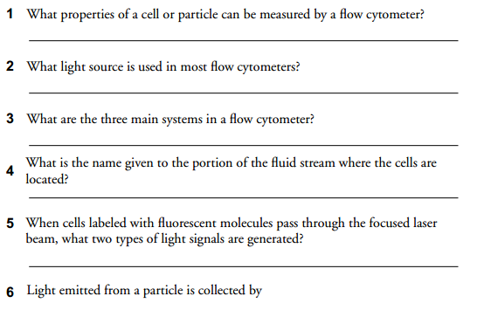
Source: http://www.d.umn.edu/~biomed/flowcytometry/introflowcytometry.pdf

Vocabulary warm-up
1 Particles příslušný
2 Fluid vydávat, vyzařovat
3 Beam čočky
4 Granularity optická lavice/soustava
5 Complexity zpracovat
6 Fluorescence granularita
7 Emit částice
8 Scatter paprsek
9 Illuminate složení (buňky)
10 Appropriate kapalina
11 Convert fluorescence
12 Process laločnatost
13 Lenses rozptýlit
14 Lobularity osvítit, ozářit
15 Optical bench přeměnit
Source: Dastych M., English for Laboratory Technicians, Brno – MU, 2008.

Grammar point
Past perfect (předminulý čas). Source: Murphy, R., English Grammar in Use, Cambridge University Press, 2012.

