Unit 3 Labour
Task 1 Management of labour
- Study the phrases below. What do they mean? In what context are they used?

Semi - recumbent position
Birth is imminent
The head is descending down the pelvis
To push involuntarily
The head is about to crown
You must pant now
This might sting
Constant reassurance
A gush of blood

- Watch the series of educational films for midwives. Take notes. Do you find anything surprising?
- How to deliver a baby
https://www.youtube.com/watch?v=VGRdy1cMXoo

- How to deliver a baby II
https://www.youtube.com/watch?v=tf3P_DGEUic

- Physiological delivery of placenta
https://www.youtube.com/watch?v=_jRQaLeazCM

- Placenta delivery by controlled cord traction
https://www.youtube.com/watch?v=S2TWmI4RiSA

Task 2 Pain relief and comfort in labour
Labour is one of the major life-events a woman will experience. Its memory will remain with her; negative impressions will give rise to psychological problems with implications for the whole family. That is why midwives should use their skills to achieve for each woman and her partner an experience which they regard as positive.

- Decide which of the verbs below are synonyms. You should end up with two groups of words. Can you think of one word with which they all combine?
to ease to handle to reduce to cope with to relieve to lessen

- Perception of pain
The way in which an individual perceives and reacts to pain is affected by many factors, what do you think they are?
- Positions in labour. Discuss their advantages and disadvantages from the perspective of a midwife.
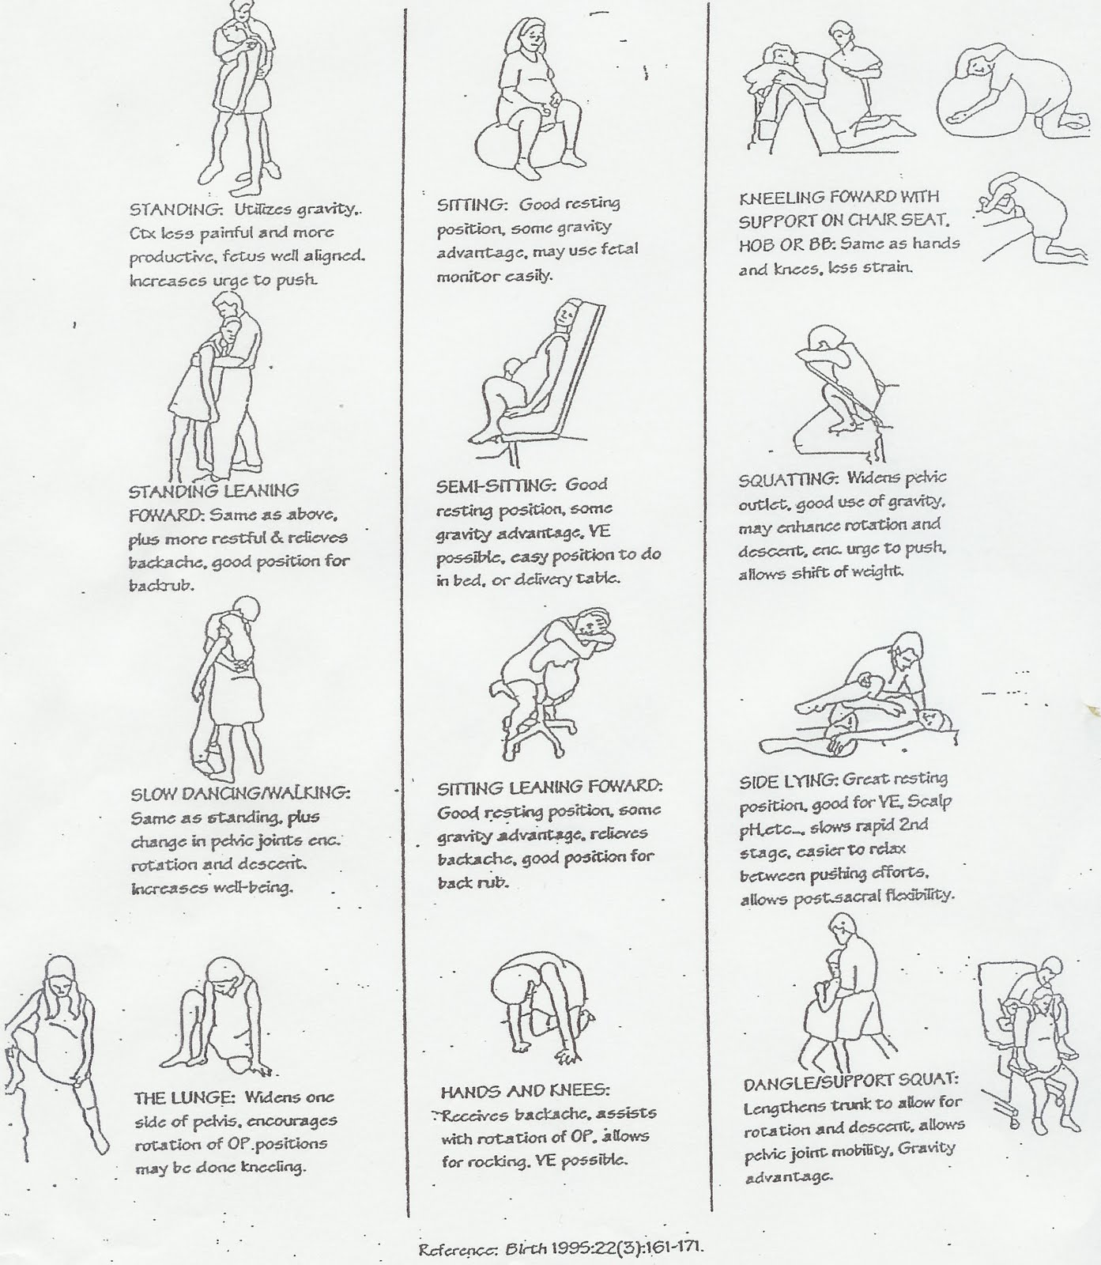
(Source: http://karacarrero.com/stages-of-labor/)
- Pain relief options
The following extracts are from an article on pain relief methods during labour. What are they?
- …………… is a regional anaesthetic, given as a single painkilling injection into a person´s back to numb the body from the waist down. It works faster than an epidural and is commonly used for C-sections, forceps, ventouse, and stitching up after an episiotomy or tear.
- ……………. is a mixture of oxygen and nitrous oxide which is inhaled through a mask or a mouthpiece. It can help to cope with pain during contractions. It is safe, as it does not stay in the body or hinder the progress of labour.
- ……………. applied to the lower back eases the pain and gives distraction from contractions. Applied to the shoulders it makes the woman feel more relaxed and stimulates her body to release endorphins, which act as natural painkillers.
- ……………..
To give birth in ………….. the woman has to be full term, with no prior complications, no infection or excessive bleeding. Buoyancy makes the woman feel lighter and warmth of the ………….. eases the pain of the contractions.
- ……………..
Women who have companions with them need less analgesia. The ………. can help in many ways: keeping company, massaging the woman´s back, holding her hand, comforting her in difficult moments, etc.
- ………………. is a fine plastic tube, which is inserted by an anaesthetist into a person´s back in order to block the sensation of pain from the waist down, so the abdomen is numb. When the ……………. begins to wear off, it is possible to top up (add another dose) so it can still be used for the delivery of the placenta or a C-section, if necessary. However, ……………….. may prolong the second stage of labour.

- Role play
- Student A): It´s your first pregnancy and you want to have a natural birth with as little pain relief as possible.
Student B): You are a midwife. Inform the patient about natural pain relief methods.

- Student A): It´s your second pregnancy. The first childbirth was a nightmare because it took 18 hours and you didn´t have any pain relief at all. You want to give birth with a very effective pain relief.
Student B): You are a midwife. Inform the patient about pain relief choices.

Useful phrases:
You can/ may… It´s possible to… It´s a good idea to…
Task 3 Passive voice
- Complete the sentences with suitable forms of the verbs in brackets, either in active or passive voice:
- A midwife will ………… (assign) to a particular woman and remain with her through her entire labour.
- Midwives must also …………. (provide) support by giving information about the progress of labour.
- It is essential that the woman …………. (encourage) to feel at ease.
- Strong feeling of security and satisfaction …………….. (associate) with a reduction in the length of labour and fewer perinatal complications.
- If the woman ………………. (teach) relaxation techniques she should …………. (remind) of them and ……………. (support) as she puts them to practice.
- The presence of strangers ……………. (increase) stress for the woman.
- The woman has a right to remain alone with her partner if she wishes so and the midwife …………. (consider) it safe for both mother and foetus.
- The companion of the woman must ………… (fully inform) when a sudden emergency develops.
- Ideally the companion of the woman ………….. (involve) in pre-labour preparation and decision making.
Choose at least two of the above sentences and discuss them in pairs.

- Now, complete the sentences in passive voice in the respective tenses:
The midwife encourages the woman. – The woman ………………………… by the midwife.
The midwife encourages the woman. – The woman ………………………… by the midwife.
The midwife has encouraged the woman. – The woman …………………….. by the midwife.
The midwife is encouraging the woman. – The woman ……………………… by the midwife.
The midwife should encourage the woman. – The woman …………………… by the midwife.

Task 4 Water birth
Read the essay on water birth, then write the number of the paragraph where the writer makes each point below. Put a cross if the point is not included.
- Nurses have a greater risk of infection with water births.
- Water births are becoming more widely available.
- The mother´s anxiety is reduced in water.
- Water births cause delays if emergency treatment is needed.
- Women who have given birth in water often choose to again.
- There is a risk of baby breathing water into its lungs.
- Bleeding is difficult to monitor.
- The mother can change position more easily in water.

1 Water birth is becoming increasingly popular and more and more hospitals are making this option available to women. However, it is important for women to be aware that there are potential problems as well as benefits before opting for a water birth.
2 The main benefit of a water birth is that it makes labour more comfortable. It is easier for the woman to move around, which gives her a feeling of control and therefore makes her feel more relaxed and less anxious. The reduced pain of water birth also lowers anxiety. For this reason, being in water lowers the blood pressure, which avoids a range of complications.
3 On the negative side, it is difficult to monitor the woman accurately during a water birth, so it is not suitable for high-risk pregnancies. Also, it is easier for waterborne pathogens to be transferred from mother to baby – or to medical staff. In addition to this, although being in water reduces the mother´s pain, it can also weaken the contractions. Another drawback is the risk of hypothermia unless water temperature is carefully monitored. Finally, the risk of heavy blood loss is increased in water, as bleeding is difficult to measure underwater.
4 Despite these disadvantages, both patients and medical staff are very positive about water birth and many women opt to do it again for subsequent children. With more training and facilities, the limitations of water birth could be reduced.

After you read:
There are a number of connectors used in the essay. Highlight them and divide into these categories:
Connectors used: a) to add an idea b) to contrast ideas c) to give reasons

