Class IV cavity

Localisation: proximal surfaces of incisors and canines with loss of a part or whole incisal edge.
Material: Composite
Gaining access: easy, the defect is accessible.
Determining the edges. We only round the sharp edges. We perform bevelling and prepare the retentive border.
For this purpose, we use diamond burs either a ball, flame or pointed one with fine grit (red code). The retentive border is ca 1 mm wide and 0.5 mm deep.
We work with a matrix (a polyester band) sealed by wedges similarly as in Class III cavities. We follow the steps for making the composite filling as was described in Class III cavities.
Fig. 1: Retentive border 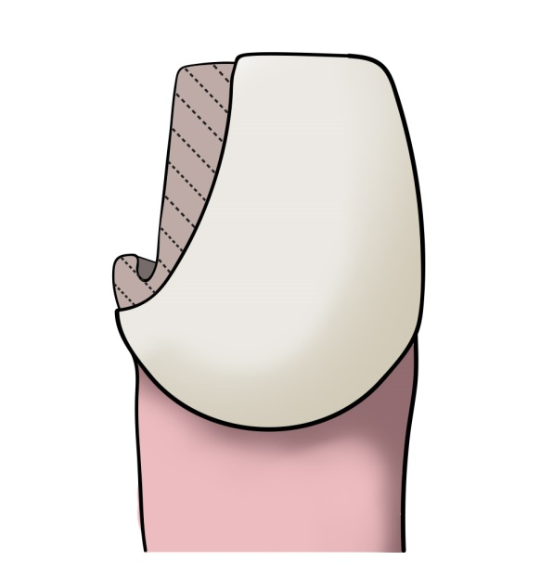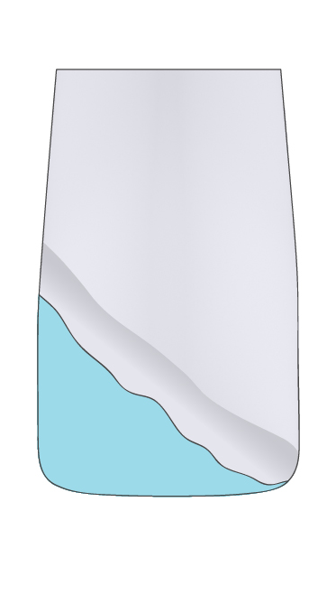
Fig. 2: Application of primer and bond with a special brush (microbrush)
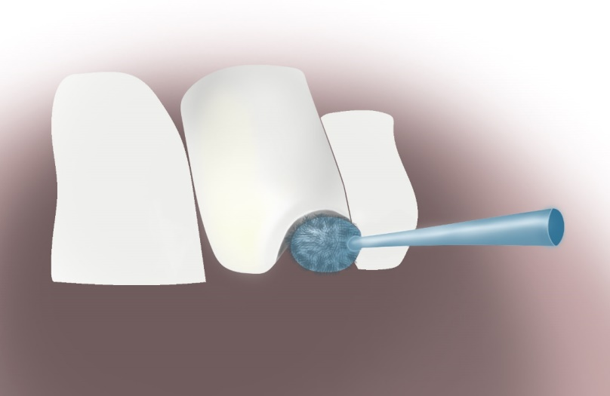

We start depositing layers of composite from the oral side, in this phase we can press the matrix to the oral side with our finger. We create layers of different shades of the composite.
Fig. 3: Scheme of layering – we place dentin shades on the enamel shade and then cover it again with the enamel shade
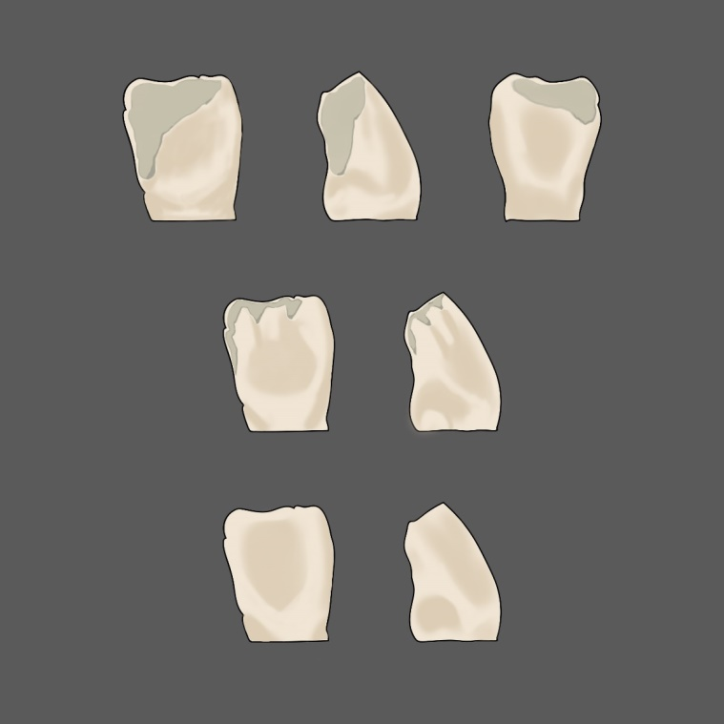

The completed filling is polished as previously described.

