Class V cavity

Location:
Cervical area
Class V cavities include caries or defects of non-carious origin (erosions, abrasions, and wedge defects).
All hard dental tissues meet in the cervical area, a continuous flow of liquid from gingival sulcus makes it difficult to keep a dry working field. Dental tissue layers are very thin here and there is a considerable risk of opening the pulp chamber.
Fig. 1: A scheme of possible layout of dental tissues in the cervical area and localisation of the cavity
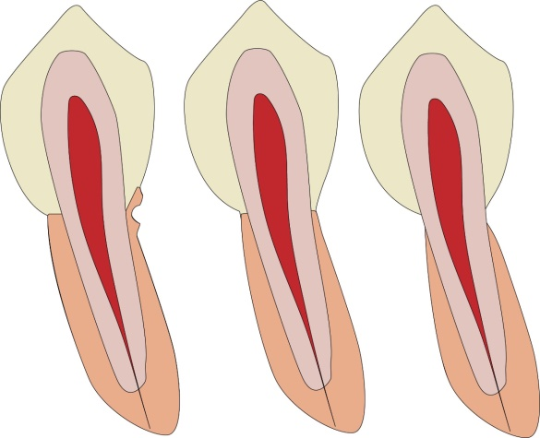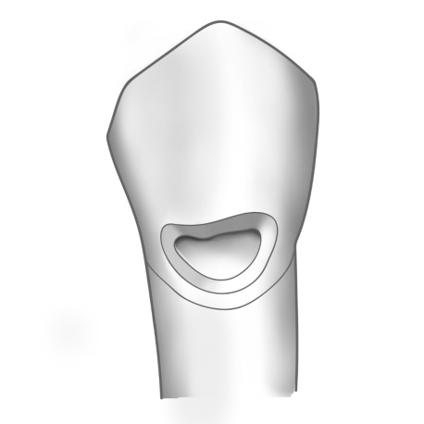

Materials:
Amalgam (in the side part of teeth)
Composite (for cavities primarily in the enamel, especially in the frontal part of teeth, excellent hygiene, a dry working field is easily kept).
Glass ionomer cement (for cavities located mainly elsewhere than in enamel, difficulties to keep the working field dry, average oral hygiene).
Combination of glass ionomer cement and composite (sandwich filling).
Gaining access to the defect – the defect is directly accessible.

Determining the outline of the cavity
PREPARATION FOR AMALGAM
The cavity is extended by ca 0.5 mm under the free edge of gingiva, it reaches mesially and distally up to the ridge which is located on the edge of vestibular (oral) surface and proximal surface. Occlusal surface lies below maximal convexity.
We prepare undercuts.
The depth of the cavity is 0.75 mm gingivally and 1.2 mm occlusally.
The pulp wall follows the convexity of the tooth.
We start the preparation with a diamond pear-shaped bur with standard grit (blue code). We smoothen the walls with a fine bur of the same shape (red code).
Fig. 2: A cavity for amalgam

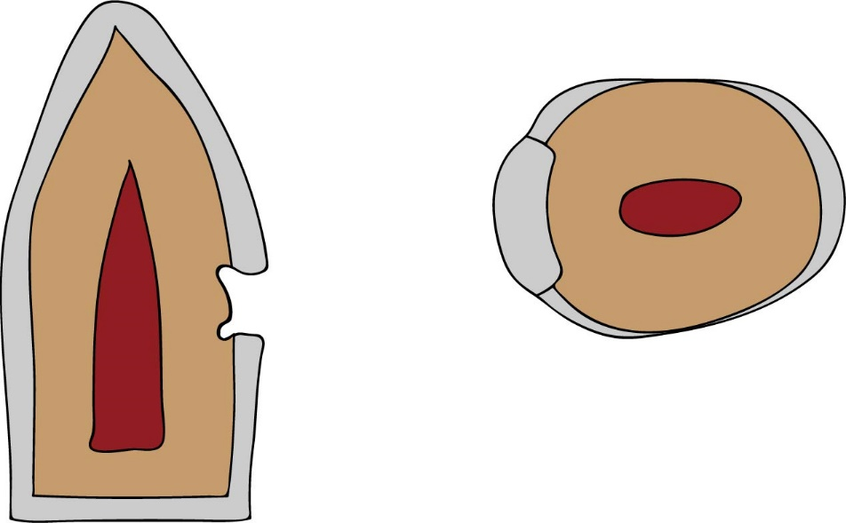
PREPARATION FOR COMPOSITE
The cavity is located supragingivally, it is limited to the carious lesion and has a box shape with rounded walls. Pulp wall again follows the convexity of the tooth. We bevel the enamel edges. If the cavity exceeds the enamel, then we do not bevel walls in that part of cavity.

We start the preparation with a diamond pear-shaped bur with standard grit (blue code). We bevel the walls of the cavity in enamel by a fine diamond cylindrical pointed bur (red code), we only smoothen the walls outside the enamel with the same type of bur.

Fig. 3: A cavity for composite localised in enamel, the enamel is bevelled
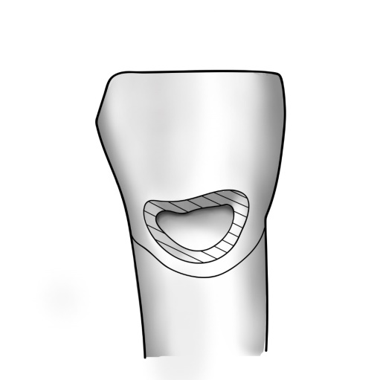

Fig. 4: A cavity for composite localised only partly in the enamel. The enamel is bevelled, and the edge of the cavity outside of the enamel is only smoothen. A suitable material is composite or glass ionomer cement in combination with composite (sandwich filling). The glass ionomer cement replaces the lost dentin while composite the enamel.
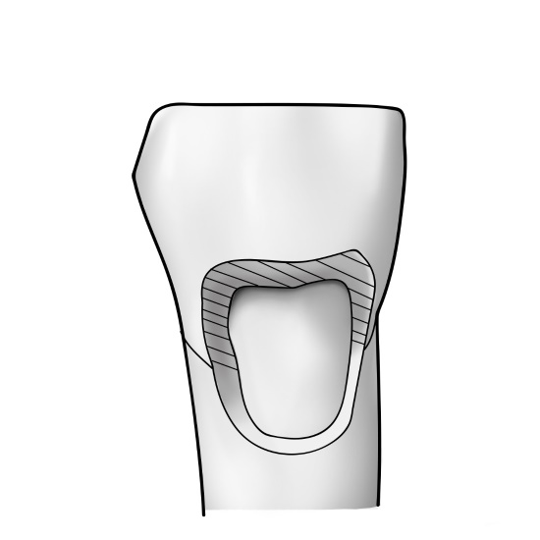

We prepare the cavity for glass ionomer cement in the extent of the carious lesion, we smoothen the walls.
Fig. 5: A cavity for glass ionomer cement located outside of the enamel. The walls are only smoothened.
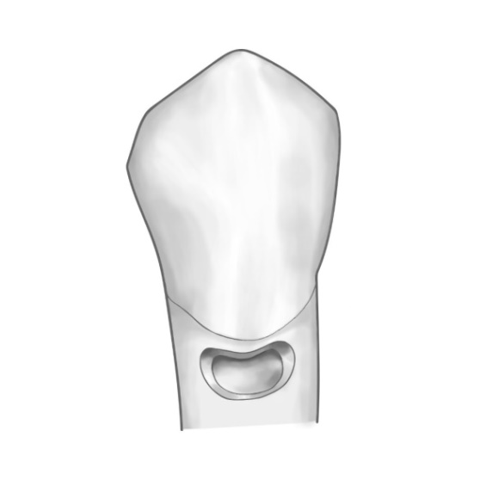

MAKING OF THE FILLING

Dry working field and a matrix
It is difficult to keep the working field dry in the cervical area. Sometimes it is difficult to apply cofferdam even if the retraction clamp is used. It is recommended to place the retraction thread into the gingival sulcus.
Transparent cervical matrices of various sizes can be used for composite. The same matrices may also be used for glass ionomer cement, although there are special matrices for glass ionomer cement made of soft metal with a special surface treatment.
For securing a dry working field, we can use Belvedere matrix it is placed around the tooth, into the gingival sulcus and sealed with wedges. It is suitable for composite filling.
Amalgam
We condense the filling material in layers, and in the end we smoothen it with a burnisher so that the transition between the filling and the tooth is smooth. We polish the filling during the next appointment.
Composite
We make the filling according to the rules for working with composite (etching, rinsing, application of primer and bond, polymerisation, depositing in layers, thorough polymerisation, shaping and polishing).
Glass ionomer cement
We treat the cavity by a conditioner, rinse it, apply cement in excess, and after its solidification we cover it with a protective varnish. We shape it as little as possible, we leave that preferably to the next appointment.

