**9 Pupil**

# 9.1 Basic Knowledge

**Function.** The pupil refers to the central opening in the iris. It acts as an aperture to improve the quality of the resulting image by controlling the amount of light that enters the eye.

**Pupillary light reflex.** This reflex arc consists of an afferent path that detects and transmits the light stimulus and an efferent path that supplies the muscles of the iris (Fig. 9.**1**).

**Afferent path.** This path begins at the light receptors of the retina (Fig. 9.**1**, A), continues along the optic nerve (B), the optic chiasma (C) where some of the fibers cross to the opposite side. The path continues along the optical tracts (D) until shortly before the lateral geniculate body (E). There the *afferent reflex path* separates from the visual pathway and continues to the pretectal nuclei (F) and from there to *both* Edinger–Westphal nuclei (G). Each of the two pretectal nuclei conducts impulses to *both Edinger–Westphal nuclei.* This bilateral connection has several consequences:

Both pupils will normally be the same size *(isocoria)* even when one eye is blind. Deviations of up to 1 mm are normal.

Both pupils will narrow even when only one eye is illuminated *(consensual light reflex).*

**Efferent parasympathetic path.** This path begins in the *Edinger–Westphal nucleus* (G). Its nerve fibers form the parasympathetic part of the oculomotor nerve (H) and travel to the ciliary ganglion (I) in the orbit. Postganglionic nerve fibers pass through the short ciliary nerves to the effector organ, the *sphincter pupillae muscle* (J).

Perlia’s nucleus and the Edinger–Westphal nuclei are also responsible for the **near reflex**, which consists of accommodation, convergence, and miosis.

**Efferent sympathetic nerve supply to the pupil.** Three neurons connected by synapses supply the pupil (Fig. 9.**2**):

The *central first neuron* begins in the posterior hypothalamus (A), passes the brain stem and the medulla oblongata to the ciliospinal center (Budge’s center; B) in the cervical spinal cord (C8 –T2).

The *preganglionic second neuron* extends from the ciliospinal center through the white rami communicantes and sympathetic trunk (C) to the superior cervical ganglion (D). It is vulnerable to certain lesions such as Pancoast tumors because it is immediately adjacent to the tip of the lung.

The *postganglionic third neuron* extends from the superior cervical ganglion as a neural plexus along the internal carotid artery, ophthalmic artery, and long ciliary nerves to the effector organ, the *dilator pupillae muscle* (E).

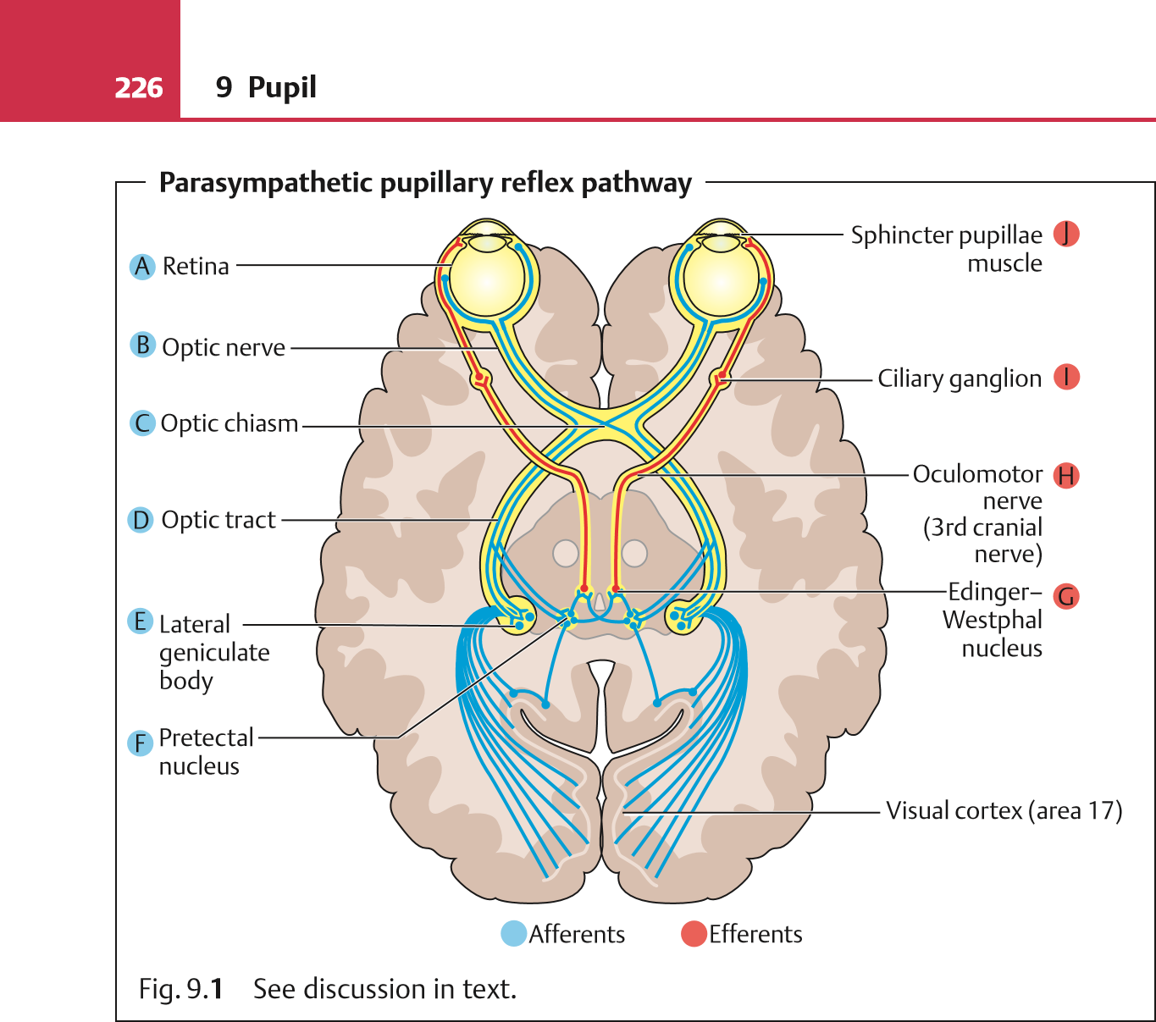**Normal pupil size.** Pupil size ranges from approximately 1 mm (**miosis**) to approximately 8 mm (**mydriasis**).

Pupils tend to be wider in teenagers and in darkness. They are also wider with joy, fear, or surprise due to increased sympathetic tone, and when the person inhales deeply.

Pupils tend to be narrower in the newborn due to parasympathetic tone, in the elderly due to decreased mesencephalic inhibition and sympathetic diencephalic activity, in light, during sleep, and when the person is fatigued (due to decreased sympathetic activity).

Lang, Ophthalmology: A Pocket Textbook Atlas, 2nd Ed. (ISBN 978-1-58890-555-0), copyright © 2007 Thieme Medical Publishers. All rights reserved. Usage subject to terms and conditions of license.

9.2 Examination Methods

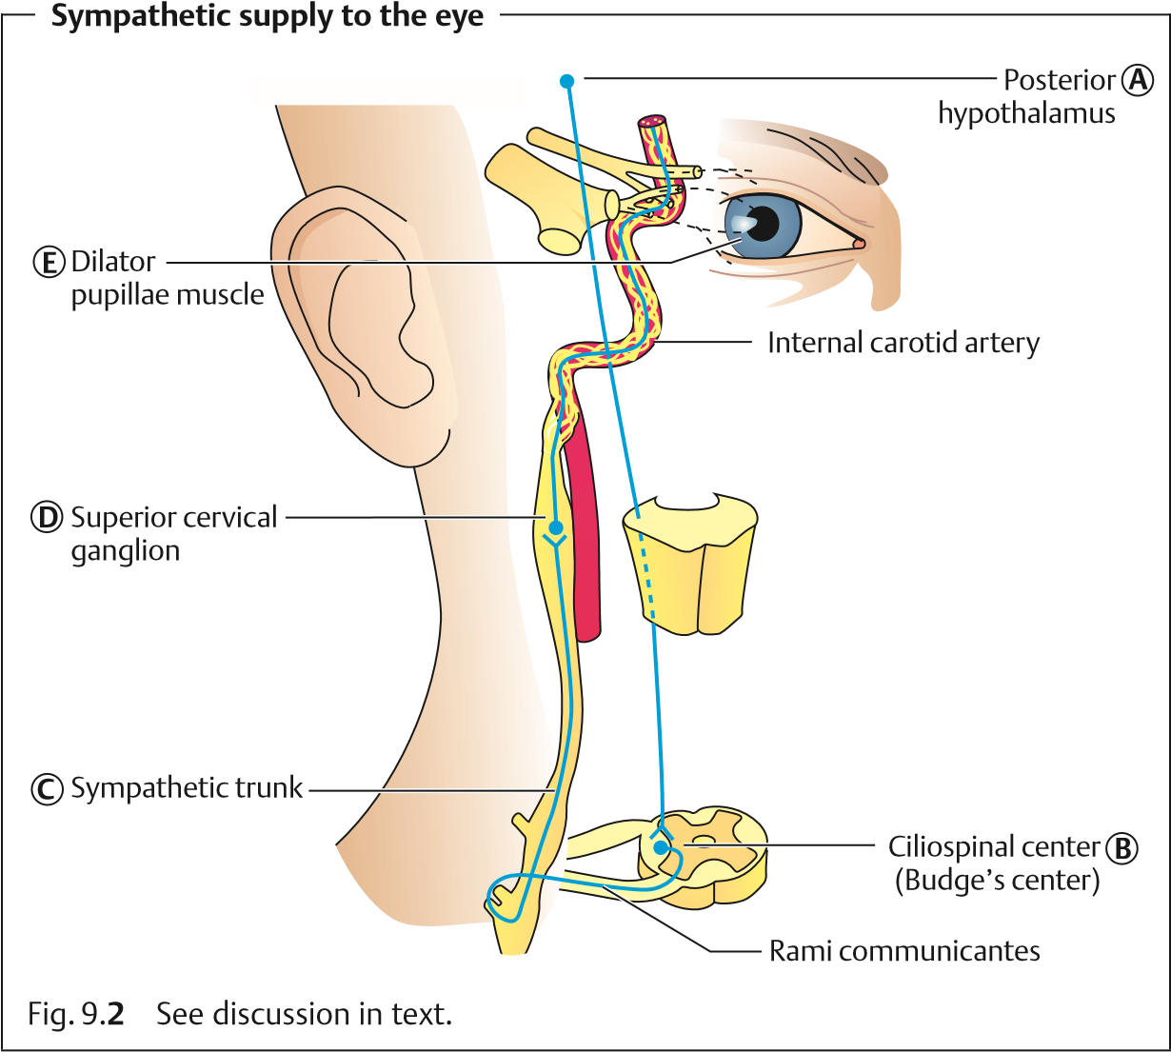

# 9.2 Examination Methods

Complete examination of the pupil includes testing direct and indirect light reflexes, the swinging flashlight test, testing the near reflex, and morphologic evaluation of the iris. A synopsis of all findings is required to determine whether a disorder is due to ocular or cerebral causes (see section 9.4).

# Testing the Light Reflex (Table 9.1)

The light reflex is tested in subdued daylight where the pupil is slightly dilated. The patient gazes into the distance to neutralize near-field miosis.

**Direct light reflex.** The examiner first covers both of the patient’s eyes, then uncovers one eye. Normally the pupil will constrict after a latency period of about 0.2 seconds. The other eye is tested in the same manner.

Lang, Ophthalmology: A Pocket Textbook Atlas, 2nd Ed. (ISBN 978-1-58890-555-0), copyright © 2007 Thieme Medical Publishers. All rights reserved. Usage subject to terms and conditions of license.

**228**

Tab. 9.

**1**

Characteristic pupil findings in unilateral lesions of the pupillary reflex pathway

**Localization of the lesion**

**unilateral**

**)**

**(**

**Direct light**

**reflex**

**Swinging-**

**Indirect light reflex**

**flashlight test**

**Findings**

**Contralateral**

**Ipsilateral**

Afferent pupil-

lary pathway

optic nerve,

(

retina)

Slight lesion

Severe lesion

+

–

++

++

+

–

Slight con-

strictions

faster dilation

Dilation

Isocoria

Efferent

pupillary

pathway

Oculomotor

lesion

Ciliary gan-

glion lesion

–

+

–

+

++

++

No response

Delayed con-

striction,

delayed dila-

tion

Anisocoria

– = response absent, + = weak response, ++ = strong response

**Pupil**

**9**

9.2 Examination Methods

**Indirect or consensual light reflex.** The examiner separates the patient’s eyes by placing his or her hand on the bridge of the patient’s nose. This prevents incident light from *directly striking* the eye being examined, which would elicit a *direct light reflex.* The examiner then illuminates the other eye while observing the reaction of the covered, unilluminated eye. *Normally both pupils will constrict,* even in the unilluminated eye.

**Swinging flashlight test.** This test is used to diagnose a *discrete unilateral or unilaterally more pronounced sensory deficit* in the eye (optic nerve and/or retina). Often damage to the optic nerve or retina is only partial, such as in partial atrophy of the optic nerve, maculopathy, or peripheral retinal detachment. In these cases, the remaining healthy portions of the afferent pathway are sufficient to trigger constriction of the pupil during testing of the direct light reflex. This constriction will be less than in the healthy eye but may be difficult to diagnose from discrete pupillary reflex findings alone. Therefore, the *reflexive behavior of both eyes should be evaluated in a direct comparison* to detect differences in the rapidity of constriction and subsequent dilation. This is done by moving a light source alternately from one eye to the other in what is known as a swinging flashlight test.

Reproducible results can only obtained if the examiner strictly adheres to this **test protocol**:

The patient focuses on a remote object in a room with subdued light. This neutralizes convergence miosis, and the pupils are slightly dilated, making the pupillary reflex more easily discernible.

The examiner alternately illuminates both eyes with a relatively bright light, taking care to maintain a *constant distance, duration of illumination, and light intensity* so that both eyes must adapt to the same conditions.

The examiner evaluates the *initial constriction* upon illumination and the *subsequent dilation* of the pupil.

Where the pupil constricts more slowly and dilates more rapidly than in the fellow eye, one refers to a *relative afferent pupillary defect.* The defect is “relative” because the difference in pupillary reflex only occurs when there is a difference in the sensory defect to the left and right eye.

# Evaluating the Near Reflex

The **near reflex triad** consists of:

1. Convergence of the visual axes.
2. Accommodation.
3. Constriction of the pupils (miosis).

The near reflex is tested by having the patient focus on a distant object and then on an object in the near field. Usually this is the patient’s finger, which is brought to within 10 cm of the eyes. *The near reflex is intact* if both eyes continuously converge with accommodation and miosis appropriate for the patient’s age as the object is moved to within 10 cm of the eyes. The examiner should take care to avoid illuminating the pupil, which will produce a light reflex with miosis.

## 9.3 Influence of Pharmacologic Agents on the Pupil

(Table 9.**2**)

Tab. 9.**2** Influence of pharmacologic agents on the pupil

|  |  |  |
| --- | --- | --- |
| **Substance group and individual active agents** | **Mechanism and duration of action** | **Indication and special considerations** |
| ***Miotics***  **Parasympathomimetics**  Direct parasympathomimetics | – Act on acetylcholine receptors of the sphincter pupillae muscle (miosis) and the ciliary muscle (increased accommodation) |  |
| – Acetylcholine | – Extremely short duration of action (several minutes) | Intraocular application only, e.g., keratoplasty; ineffective as eyedrops (rapid breakdown) |
| – Pilocarpine | – Effective for 5–7 h | Used therapeutically for acute angle closure glaucoma |
| – Carbachol | * Effective for 7–9 h * *Stronger* miotic effect than pilocarpine | Today only very rarely used |
| ***Mydriatics***  **Parasympatholytics** | – Act by blocking acetylcholine receptors of the sphincter pupillae muscle (mydriasis) and the ciliary  muscle (accommodation  paralysis) |  |
| – Tropicamide | – Effective for approximately 4–6 h (shortest-  acting mydriatic) | Used for diagnostic purposes |
| – Cyclopentolate | * Effective for approxi-mately 12–24 h * More cycloplegic thanmydriatic | Used **diagnostically** for objective measurement of refraction; used **therapeutically** to relax the ciliary body (in iritis) |

9.3 Influence of Pharmacologic Agents on the Pupil

Tab. 9.**2** Continued

|  |  |  |
| --- | --- | --- |
| **Substance group and individual active agents** | **Mechanism and duration of action** | **Indication and special considerations** |
| – Homatropine | – Effective for approximately 1–2 days | Used therapeutically  (in iritis) |
| – Scopolamine | – Effective for approximately 1 week | Used therapeutically for protracted mydriasis, for example following surgical repair of retinal  detachment or in iridocyclitis |
| – Atropine | – Effective for more than 1 week (longest acting mydriatic) | For all therapy requiring protracted mydriasis, for example following surgical repair of retinal  detachment and in  iridocyclitis |
| **Sympathomimetics**  Direct sympathomimetics | – Act on the epinephrine receptors of the dilator pupillae muscle | Primarily for diagnostic purposes |
| – Epinephrine | – Only slightly effective; rapidly broken down by  amino oxidases | Used in the diagnosis of Horner syndrome and in intraocular application  for better mydriasis during surgery |
| – Phenylephrine | * Effective for approxi-mately 6 h (onset and   duration of action similar to tropicamide; see para-  sympatholytics)   * Advantage: does notcause accommodation   paralysis | Used for diagnostic purposes due to its short  duration of action |
| Indirect sympathomimetics | – Inhibit reabsorption of norepinephrine | For diagnostic purposes |
| – Cocaine 4% | – Effective for approximately 6 h | Today used as eyedrops only for diagnostic pur-  poses and in Horner syn-  drome (see p. 235) |

Drug-induced mydriasis is contraindicated in patients with a shallow anterior chamber, due to the risk of acute angle closure glaucoma.

## 9.4 Pupillary Motor Dysfunction

Pupillary motor dysfunction must be distinguished from a number of differential diagnoses that include not only ocular disorders but neurologic and internal disorders. Diagnosis is difficult, because *isocoria or anisocoria are nonspecific clinical symptoms.* Therefore, functional tests are indicated to confirm the diagnosis. The following section uses diagrams of the initially presenting clinical symptoms to illustrate the various types of pupillary dysfunction. The text presents the differential diagnoses with the functional studies used to confirm the respective diagnosis.

Isocoria with constricted or dilated pupils is primarily of interest to the neurologist and less so to the ophthalmologist. These disorders are therefore discussed at the end of the section.

# Isocoria with Normal Pupil Size



## Relative Afferent Pupillary Defect

**Causes.** Unilateral sensory disorder such as retinal detachment, neuritis of the optic nerve, atrophy of the optic nerve, or retinal vascular occlusion.

**Diagnostic considerations.**

Direct light reflex is decreased or absent (relative afferent pupillary defect) in the affected eye.

The consensual light reflex in the affected eye is weak or absent but normal in the unaffected eye.

The swinging flashlight test reveals dilation in the affected eye when illuminated (*Marcus Gunn pupil*) or reduced constriction and earlier dilation in the presence of lesser lesions (afferent pupillary defect).

Near reflex is normal.

Unilaterally reduced visual acuity and/or field of vision.

Unilateral blindness (afferent defect) does not produce anisocoria.

## Bilateral Afferent Pupillary Defect

**Causes.** Bilateral sensory disorder such as maculopathy or atrophy of the optic nerve.

**Diagnostic considerations.**

Delayed direct and consensual light reflexes.

The swinging flashlight test produces identical results in both eyes (where disorder affects both sides equally).

Near reflex is normal.

Bilaterally reduced visual acuity and/or field of vision. **Anisocoria with Dilated Pupil in the Affected Eye**



## Complete Oculomotor Palsy

**Causes.**

Processes in the base of the skull such as tumors, aneurysms, inflammation, or bleeding.

Processes in the area of the superior orbital fissure or apex of the orbit.

**Diagnostic considerations.**

Direct and consensual light reflexes without constriction in the affected eye (fixed pupil).

Near reflex miosis is absent.

Impaired motility and double vision.

Sudden complete oculomotor palsy (loss of motor and parasympathetic function) is a sign of a potentially life-threatening disorder. In unconscious patients,

unilateral mydriasis is often the only clinical sign of this.

## Tonic Pupil

**Causes.** Postganglionic damage to the parasympathetic pathway, presumably in the ciliary ganglion, that frequently occurs with diabetes mellitus, alcoholism, viral infection, and trauma.

**Diagnostic considerations.**

Direct and consensual light reflexes show absent or delayed reaction, possibly with worm-like segmental muscular contractions.

Dilation is also significantly delayed.

Near reflex is slow but clearly present; accommodation with delayed relaxation is present.

Motility is unimpaired.

Pharmacologic testing with 0.1% pilocarpine.

* Significant miosis in the affected eye (denervation hypersensitivity).
* No change in the pupil of the unaffected eye (too weak).

Adie’s tonic pupil syndrome: the tonic pupil is accompanied by absence of the Achilles and patellar tendon reflexes.

Tonic pupil is a relatively frequent and completely harmless cause of unilateral mydriasis.

## Iris Defects

**Causes.**

Trauma (aniridia or sphincter tears)

Secondary to acute angle closure glaucoma

Synechiae (post-iritis or postoperative)

**Diagnostic considerations.** Patient history and slit lamp examination.

## Following Eyedrop Application

Unilateral Administration of a Mydriatic Simple Anisocoria

**Causes.** Presumably due to asymmetrical supranuclear inhibition of the Edinger–Westphal nucleus.

**Diagnostic considerations.**

Direct and consensual light reflexes and swinging flashlight test show constant difference in pupil size.

Near reflex is normal.

Pharmacologic testing: cocaine test (4% cocaine eyedrops are applied to both eyes and pupil size is measured after 1 hour): bilateral pupil dilation indicates an intact neuron chain.

# Anisocoria with a Constricted Pupil in the Affected Eye



## Horner Syndrome

**Causes.** Damage to the sympathetic pathway.

Central (first neuron):

* Tumors
* Encephalitis
* Diffuse encephalitis

Peripheral (second neuron)

* Syringomyelia
* Diffuse encephalitis
* Trauma
* Rhinopharyngeal tumors
* Goiter
* Aneurysm
* Processes in the tip of the lung

Peripheral in the strict sense (third neuron)

* Vascular processes
* Internal carotid aneurysm

**Clinical picture.**

Miosis (approximately 1–2 mm difference) due to failure of the dilator pupillae muscle.

Ptosis (approximately 1–2 mm difference) due to failure of the muscle of Müller.

Enophthalmos due to failure of the rudimentary lower eyelid retractors. This makes the lower eyelid project so that the eye appears smaller. This condition only represents a type of pseudoenophthalmos.

Decreased sweat gland secretion (only present in preganglionic disorders as the sweat glands receive their neural supply via the eternal carotid).

**Diagnostic considerations.**

Direct and consensual light reflexes are intact, which distinguishes this disorder from a parasympathetic lesion); the pupil dilates more slowly

(dilation deficit).

Near reflex is intact.

Pharmacologic testing with cocaine eyedrops

* **PeripheralHornersyndrome.** *On the affected side,* there is slight mydriasis (decrease in norepinephrine due to nerve lesion). *On the unaffected side,* there is significant mydriasis.
* **Central Horner syndrome.** *On the affected side,* the pupil is dilated. *On the unaffected side,* the pupil is also dilated (the norepinephrine in the synapses is not inhibited).

**Following Eyedrop Application**

Unilateral Administration of a Miotic as in Glaucoma Therapy

# Isocoria with Constricted Pupils



## Argyll Robertson Pupil

**Causes.** The precise location of the lesion is not known; presumably the disorder is due to a lesion is in the pretectal region and the Edinger–Westphal nucleus such as tabes dorsalis (Argyll Robertson phenomenon), encephalitis, diffuse encephalitis, syringomyelia, trauma, bleeding, tumors, and alcoholism.

**Diagnostic considerations.**

Direct and consensual light reflexes are absent.

Near reflex is intact or there is overcompensation (the Edinger–Westphal nucleus is being controlled via the convergence center).

The pupil is not round, and constriction is not always symmetrical. There is no reaction to darkness or pharmacologic stimuli.

## Bilateral Pupillary Constriction due to Pharmacologic Agents

**Causes.**

Morphine

Deep general anesthesia

Pilocarpine eyedrops

**Toxic Bilateral Pupillary Constriction Causes.** E.g., mushroom poisoning.

## Inflammatory Bilateral Pupillary Constriction

**Causes.**

Encephalitis

Meningitis

# Isocoria with Dilated Pupils



## Parinaud Oculoglandular Syndrome

**Causes.** Tumors such as pineal gland tumors that selectively damage fibers between the pretectal nuclei and the Edinger–Westphal nucleus.

**Diagnostic considerations.**

Fixed dilated pupils that do not respond to light.

Normal near reflex.

Limited upward gaze (due to damage to the vertical gaze center) and retraction nystagmus.

## Intoxication

**Causes.** Atropine, spasmolytic agents, anti-Parkinson agents, antidepressants, botulism (very rare but important), carbon monoxide, cocaine.

## Disorders

Migraine

Schizophrenia

Hyperthyreosis

Hysteria

Epileptic seizure

Increased sympathetic tone (Bumke’s anxiety pupils)

Coma

Agony

Lang, Ophthalmology: A Pocket Textbook Atlas, 2nd Ed. (ISBN 978-1-58890-555-0), copyright © 2007 Thieme Medical Publishers. All rights reserved. Usage subject to terms and conditions of license.