**Zrakový nerv**

Oskar Gareis and Gerhard K. Lang

# 13.1 Basic Knowledge

The optic nerve extends from the posterior pole of the eye to the *optic chiasm*

(Fig. 13.**1**). After this characteristic crossing, the fibers of the optic nerve travel as the *optic tract* to the *lateral geniculate body.* Depending on the shape of the skull, the optic nerve has a total length of 35–55 mm. The nerve consists of:

An intraocular portion.

An intraorbital portion.

An intracranial portion.

**Path of the optic nerve**

Globe

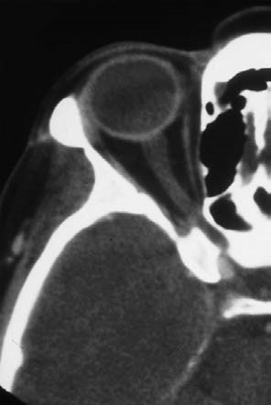

Optic nerve

Optic canal

Optic chiasm

Fig. 13.

**1**

CT

image showing

the intraorbital

and intracranial

portions of the

optic nerve.

# Intraocular Portion of the Optic Nerve

The intraocular portion of the optic nerve is visible on ophthalmoscopy as the **optic disc**. All the retinal nerve fibers merge into the optic nerve here, and the central retinal vessels enter and leave the eye here. The complete absence of photoreceptors at this site creates a gap in the visual field known as the *blind spot*.

**Shapeandsize.** The optic disc (Fig. 13.**2**) is normally *slightly vertically oval* with an average area of approximately 2.7 mm2 and a horizontal diameter of approximately 1.8 mm. There is a *wide range of physiologic variability in the size of the optic disc*; its area may vary by a factor of seven, and its horizontal

diameter by a factor of two and one-half.

**Color.** The normal physiologic color is *yellowish-orange*. The temporal half of the optic disc is usually slightly paler.

**Margin.** The margin of the optic disc is *sharply defined* and readily distinguished from the surrounding retinal tissue. On the nasal side, the greater density of the nerve fibers makes the margin slightly less distinct than on the temporal side. A common clinical observation is a crescent of pigment or irregular pigmentation close to the optic disc on the temporal side; sometimes the sclera will be visible through this crescent.

**Prominence of the optic disc.** The normal optic disc is not prominent. The nerve fibers are practically flush with the retina.

**Normal optic disc**

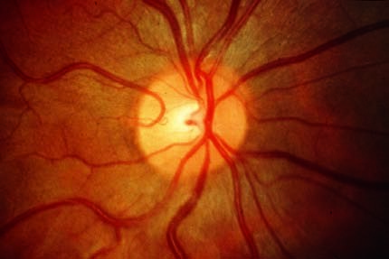

Cilioretinal

vessel

Vein

Artery

Optic cup

Neuroretinal

rim

Fig. 13.

**2**

Typical signs of a normal pupil include a yellowish-orange neuroretinal

rim sharply set off from the retina.

13.1 Basic Knowledge

**Neuroretinal rim** (Fig. 13.**2**). This consists of the bundles of all the optic nerve fibers as they exit through the scleral canal. The rim has a *characteristic configuration*: the narrowest portion is in the temporal horizontal region followed by the nasal horizontal area; the widest areas are the vertical inferior and superior areas.

**Optic cup.** This is the *slightly eccentric cavitation* of the optic nerve that has a slightly flattened oval shape corresponding to that of the neuroretinal rim. It is the brightest part of the optic disc. No nerve fibers exit from it (Fig. 13.**2**). The **size of the optic cup** correlates with the size of the optic disc; the larger the optic disc, the larger the optic cup. Because enlargement of the optic cup means a loss of nerve fibers in the rim, *it is particularly important to document the size of the optic cup*. This is specified as the horizontal and vertical *ratios of cup to disc diameter* (cup – disc ratio). Due to the wide range of variability in optic disc size, it is not possible to specify absolute cup–disc ratios that indicate the presence of abnormal processes.

**Central retinal artery and vein.** These structures usually enter the eye slightly nasal to the center of the optic disc. Visible pulsation in the vein is normal. However, *arterial pulsation* is *always abnormal* and occurs with disorders such as increased intraocular pressure and aortic stenosis.

**Cilioretinal vessels** are aberrant vessels originating directly from the choroid

(short posterior ciliary arteries). Resembling a cane, they usually pass along the temporal margin of the optic disc and supply the inner layers of the retina (Fig. 13.**2**).

**Blood supply to the optic disc** (Fig. 13.**3**): The optic disc receives its blood supply from the ring of Zinn, an anastomotic ring of small branches of the short posterior ciliary arteries and the central retinal artery. Both groups of vessels originate from the ophthalmic artery, which branches off of the internal carotid artery and enters the eye through the optic canal. The central retinal artery and vein branch into the optic nerve approximately 8 mm before the point at which the optic nerve exits the globe. Approximately 10 short posterior ciliary arteries penetrate the sclera around the optic nerve.

# Intraorbital and Intracranial Portion of the Optic Nerve

The **intraorbital portion** begins after the nerve passes through a sieve-like plate of scleral connective tissue, the lamina cribrosa. Inside the orbit, the optic nerve describes an S-shaped course that allows extreme eye movements.

After the optic nerve passes through the optic canal, the short **intracranial portion** begins and extends as far as the optic chiasm. Like the brain, the intraorbital and intracranial portions of the optic nerve are surrounded by sheaths of dura mater, pia mater, and arachnoid (see Fig. 13.**3**). The nerve receives its blood supply through the vascular pia mater sheath.

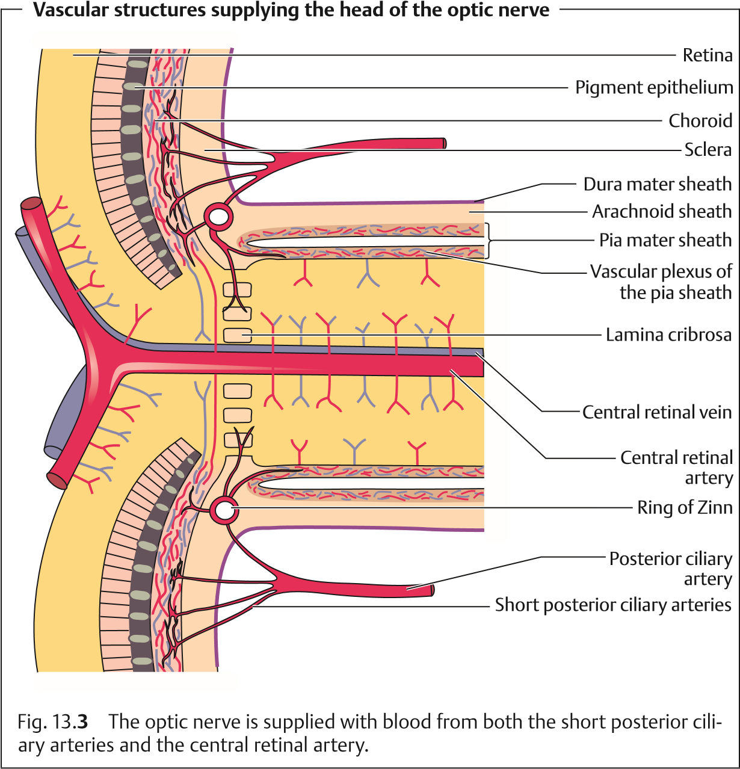

## 13.2 Examination Methods

These include:

Ophthalmoscopy (see Chapter 1).

Visual acuity testing (see Chapter 1). Perimetry test (see Chapter 14).

Pupillary light reflex (see Chapter 9).

Testing color vision (for example with the panel D 15 test).

Optic disc tomography (HRT) (see Chapter 10). Visual evoked potential (VEP).

**Panel D 15 test of color vision.** This is a color marker sorting test. The patient is presented with 15 small color markers that he or she must select and sort

according to a fixed blue color marker. Patients with color vision defects will typically confuse certain markers within the color series. The specific color vision defect can be diagnosed from these mistakes.

**Visual evoked potential** (VEP). The VEP can be regarded as an *isolated occipital*

*EEG*. The electrical responses in the brain to optical stimuli are transmitted by electrodes placed over the occipital lobe. Measurements include the *speed of conduction* (i.e., latency; normal values range between 90 and 110 ms) and the *voltage differential* between the occipital lobe and skin electrodes (i.e., amplitude; normal values depend on the laboratory setting). The *most important indication* for VEP testing is retrobulbar optic neuritis to demonstrate an extended latency period in demyelinization, such as in diffuse encephalitis.

**13.3 Disorders that Obscure the Margin of the Optic Disc**

# Congenital Disorders that Obscure the Margin of the Optic Disc

There are *normal* variants of the optic disc in which the margin appears fully or partially blurred. Care should be taken to distinguish them from abnormal findings.

## Oblique Entry of the Optic Nerve

Where the **optic nerve exits the eye in an oblique and nasal direction**

(Fig. 13.**4**), the nerve fibers on the nasal circumference will be elevated. The *tightly compressed nasal nerve fibers* will obscure the margin of the optic disc. Accordingly, *temporal nerve fibers are stretched,* and the neuroretinal rim can-

**Oblique entry of the optic nerve**

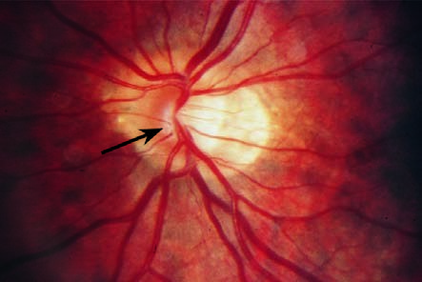

Fig. 13.

**4**

Tightly

compressed nasal

nerve fibers

cause slight

elevation of the

optic disc, and

the margin of the

disc is obscured.

not be clearly distinguished. Often an adjacent crescentic, whitish area, known as a temporal crescent, will be observed on the temporal side. This crescent is frequently seen in myopia and is referred to as a myopic crescent. It can also be circular.

## Tilted Disc

An **optic nerve that exits the eye superiorly** (Fig. 13.**5**) is referred to as a tilted disc. The *superior circumference of the margin of the optic disc will be obscured* in a manner similar to oblique entry of the optic nerve. A number of other changes may also be observed, including an inferior crescent, situs inversus of the retinal vessels, ectasia of the fundus, myopia, and visual field defects. These findings may occur in various combinations and are referred to collectively as **tilted-disc syndrome**. This is *clinically highly significant* as nasal inferior ectasia of the fundus can produce temporal superior visual field defects. Where these findings are bilateral, care should be taken to distinguish them from pituitary tumors. This clinical picture is regarded as a form of *rudimentary coloboma*.

## Pseudopapilledema

Pseudopapilledema (Fig. 13.**6**) is due to a *narrow scleral canal*. Because of the constriction, the nerve fibers are tightly compressed. The optic disc is **elevated and the full circle of the margin obscured**. The optic cup is absent, and the retinal vessels appear tortuous. There are no abnormal morphologic changes such as bleeding, nerve fiber edema, and hyperemia; visual acuity and visual field are normal. Pseudopapilledema *can* occur with hyperopia,

**Tilted disc**

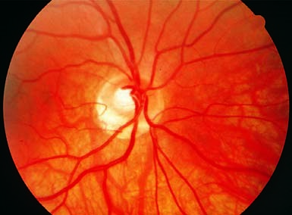

Fig. 13.

**5**

Oblique entry

of the optic nerve superi-

orly, with an inferior cres-

cent and inferior seg-

mental ectasia of the fun-

dus.

**Pseudopapilledema**

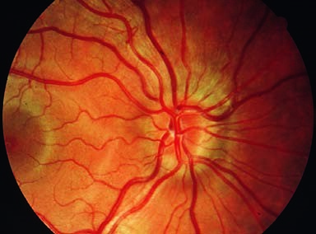

Fig. 13.

**6**

Circular blur-

ring of the margin of the

optic disc, with absence

of the optic cup.

although it is encountered equally frequently in emmetropic or slightly myopic eyes.

*Differential diagnosis:* optic disc edema, optic disc drusen (Table 13.**1**).

Tab. 13.**1** Differential diagnosis of pseudopapilledema, optic disc drusen, and papilledema

|  |  |  |  |
| --- | --- | --- | --- |
| **Differential criterion** | **Pseudopapilledema** | **Optic disc drusen** | **Papilledema** |
| Size of optic disc | Small | Small | Unaffected |
| Optic cup | Absent | Absent | Initially present |
| Spontaneous venous pulse | Possibly present | Possibly present | Absent |
| Veins and papillary capillaries | Normal | Normal | Obstructed |
| Color of optic disc | Normal | Pale | Hyperemic |
| Peripapillary bleeding | Absent | Absent | Present |
| Peripapillary nerve fibers | Normal | Normal | Edematous |
| Angiography | Normal | Intrinsic fluorescence | Early leakage |
| Ultrasound | Atypical | Highly reflective deposits | Atypical |

## Myelinated Nerve Fibers

Normally, retinal nerve fibers are not myelinated. However, **myelinated areas** occasionally occur in the retina (Fig. 13.**7**). They occur most frequently **at the margin of the optic disc**. Whitish and striated, they simulate segmental or circular blurring of the margin. Myelinated nerve fibers can *also occur on the periphery of the retina*. Because of their location in the innermost layer of the retina, they tend to obscure the retinal vessels. Myelinated nerve fibers normally cause no loss of function. Only extensive findings can lead to small scotomas.

## Bergmeister Papilla

The fetal hyaloid artery emerges from the optic disc to supply the vitreous body and lens. Glial and fibrous tissue may persist if the structure is not fully absorbed. This vestigial tissue, usually on the nasal side of the optic disc, is known as **Bergmeister papilla.** When this tissue takes the form of a veil-like membrane overlying the surface of the optic disc, it is also referred to as an **epipapillary membrane** (Fig. 13.**8**). Usually this condition is *asymptomatic*.

## Optic Disc Drusen

Drusen are **yellowishlobularbodiesinthetissueoftheopticdiscthatareusually bilateral (in 70% of cases)**. Ophthalmoscopy can reveal superficial drusen but not drusen located deep in the scleral canal. In the presence of optic disc drusen, the disc appears *slightly elevated with blurred margins and without an optic cup* (Fig. 13.**9**). Abnormal morphologic signs such as hyperemia and

**Myelinated nerve fibers**

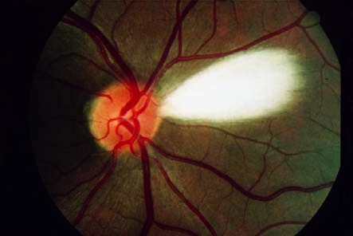

Fig. 13.

**7**

As

they are myeli-

nated, the nerve

fibers appear

whitish and

striated and can

simulate seg-

mental blurring

of the margin.

**Bergmeister’s papilla**

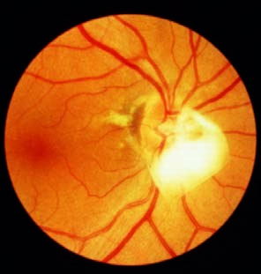

Fig. 13.

**8**

Remnants of the hyaloid

artery, forming a veil-like epipapillary

membrane overlying the surface of

the optic disc, are seen on the nasal

side.

**Optic disc drusen**

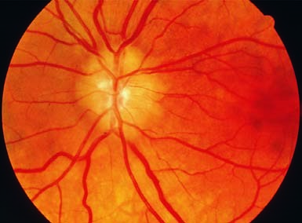

Fig. 13.

**9**

The yellowish

lobular deposits (drusen)

make the optic disc ap-

pear elevated with

blurred margins and

without an optic cup.

nerve fiber edema will not be present. However, bleeding in lines along the disc margin or subretinal peripapillary bleeding may occur in rare cases.

A small lamina cribrosa appears to be a factor in the *etiology* of the disorder. This impedes axonal plasma flow, which predisposes the patient to axonal degeneration. This in turn produces calcifications exterior to the axons (drusen). Retinal drusen are hyaline deposits in the Bruch membrane and are a completely unrelated process.

Drusen usually **do not cause any loss of function**. Deep drusen can cause compressive atrophy of nerve fibers with resulting subsequent visual field defects.

Optic disc drusen can be diagnosed on the basis of characteristic ultrasound findings of highly reflective papillary deposits. Fluorescein angiography findings of autofluorescence prior to dye injection are also characteristic.

See Table 13.**1** for *differential diagnosis*.

# Acquired Disorders that Obscure the Margin of the Optic Disc

The normal variants and congenital changes discussed in the previous section must be distinguished from *abnormal changes to the optic disc due to nerve fiber edema*. The term optic disc edema is used in a generic sense to describe any such change. However, this term should be further specified whenever possible:

**Optic disc edema without primary axonal damage.**

* Papilledema.
* Hypotension papilledema.

**Optic disc edema with direct axonal damage.**

* Inflammation: papillitis or retrobulbar optic neuritis.
* Infarction with ischemic optic neuropathy (arteriosclerotic or arteritic).

**Optic disc edema due to infiltration.**

* For example, due to an underlying hematologic disorder.

## Papilledema

***Definition:*** Bilateral optic disc edema secondary to increased intracranial pressure.

**Epidemiology.** Epidemiologic data from the 1950s describe papilledema in as many as 60% of patients with brain tumors. Since then, advances in neuroradiology have significantly reduced the incidence of papilledema. The diagnostic importance of the disorder has decreased accordingly.

**Etiology.** An adequate theory to fully explain the pathogenesis of papilledema is lacking. Current thinking centers around a mechanical model in which increased intracranial pressure and impeded axonal plasma flow through the narrowed lamina cribrosa cause nerve fiber edema. However, there is no definite correlation between intracranial pressure and prominence of the papilledema. Nor is there a definite correlation between the times at which the two processes occur. However, severe papilledema can occur within a few hours of increased intracranial pressure, such as in acute intracranial hemorrhage. Therefore, papilledema is a *conditional, unspecific sign of increased intracranial pressure* that does not provide conclusive evidence of the cause or location of a process.

In approximately 60% of cases, the increased intracranial pressure with papilledema is caused by an *intracranial tumor*; 40% of cases are due to other causes, such as hydrocephalus, meningitis, brain abscess, encephalitis, malignant hypertension, or intracranial hemorrhages. The patient should be referred to a neurologist, neurosurgeon, or internist for diagnosis of the underlying causes.

Every incidence of papilledema requires immediate diagnosis of the underlying causes as increased intracranial pressure is a life-threatening situation.

The incidence of papilledema in the presence of a brain tumor decreases with increasing age; in the first decade of life it is 80%, whereas in the seventh decade it is only 40%. Papilledema cannot occur where there is atrophy of the optic nerve, as papilledema requires intact nerve fibers to develop.

**Special forms.**

*Foster Kennedy syndrome*. This refers to isolated atrophy of the optic nerve due to direct tumor pressure on one side and papilledema due to increased intracranial pressure on the other side. Possible causes may include a meningioma of the wing of the sphenoid or frontal lobe tumor.

*Hypotension papilledema*. This refers to a nerve fiber edema due to ocular hypotension. Possible causes may include penetrating trauma or fistula secondary to intraocular surgery.

**Symptomsand diagnostic considerations.** Visual function remains unimpaired for long time. This significant discrepancy between morphologic and functional findings is an *important characteristic in differential diagnosis*. **Early functionalimpairmentscanincludereversibleobscurations.** *Perimetry testing* may reveal an increase in the size of the blind spot (Fig. 13.**10c**). Central visual field defects and concentric narrowing of the visual field are **late functional impairments** that occur with existing complex atrophy of the optic nerve.

Papilledema is characterized by significant morphologic findings and only slight visual impairment.

The following **phases** can be distinguished by *ophthalmoscopy*:

**Early phase** (Fig. 13.**10a**). First the nasal margin and then the superior and inferior margins of the optic disc are obscured because of the difference in the relative densities of the nerve fibers. The optic cup *is initially preserved*. This is important in a differential diagnosis to exclude pseudopapilledema and optic disc drusen. The optic disc is hyperemic due to dilation of the capillaries, and there is no pulsation in the central retinal vein. Edema can produce concentric peripapillary retinal folds known as Paton’s folds.

**Acute phase** (Fig. 13.**10b**). This is characterized by increasing elevation of the optic disc, radial hemorrhages around the margin of the optic disc and grayish-white exudates. *The optic cup is often no longer discernible*. The color of the optic disc will be red to grayish-red.

**Chronic phase.** Significant optic disc edema is present. *The optic cup is obliterated*, and the hyperemia will be seen to subside.

**Papilledema**

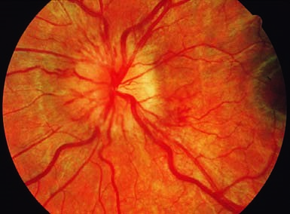

Fig. 13.

**10**

**a**

Early phase of papil-

ledema. The nasal margin

of the optic disc is par-

tially obscured. The optic

disc is hyperemic due to

dilatation of the capillar-

ies, and the optic cup is

still visible.

**b**

Acute stage. The optic

disc is increasingly ele-

vated and has a gray to

grayish-red color. Radial

hemorrhages around the

margin of the optic disc

and grayish-white exu-

dates are observed. The

optic disc can no longer

be clearly distinguished.

Continue

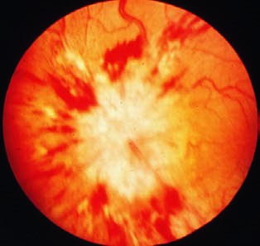

**Atrophic phase.** Proliferation of astrocytes results in complex or secondary atrophy of the optic nerve.

**Differential diagnosis.** This includes pseudopapilledema, optic disc drusen (Table 13.**1**), abnormalities of the optic disc without functional impairment, optic disc edema with hypertension, and optic neuritis.

**Treatment.** Intracranial pressure should be reduced by treating the underlying disorder (see Etiology). Once intracranial pressure has been normalized, the papilledema will resolve within a few weeks. Usually complex atrophy of the optic nerve will remain. The severity will vary according to the duration of the papilledema.

**385**

**Papilledema(continued)**

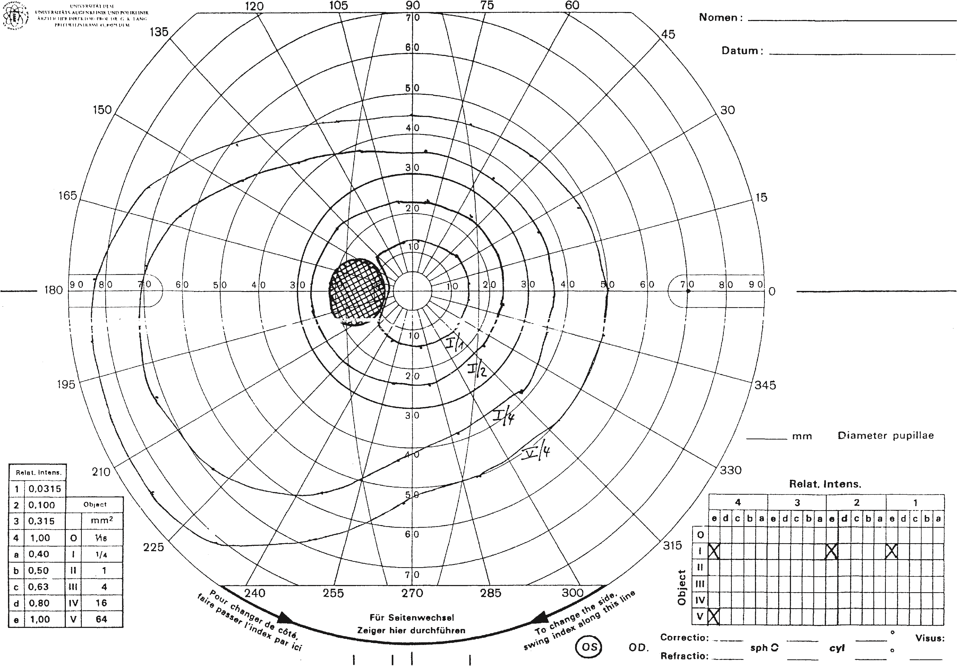

Fig. 13.

**10**

**c**

Functional findings. The enlarged blind spot (indicated by hatching) is an early functional correlate to the ophthalmo-

scopic findings. The markers used in the test are light markers of varying size (indicated by roman numerals) and varying light in-

tensity (indicated by arabic numerals and letters). The larger the number, the larger the size and greater the light intensity of the

respective marker. The table at the lower right shows which markers were used in the test. The table at the lower left shows the

values corresponding to the numerals and letters.

13.3

DisordersthatObscuretheMarginoftheOpticDisc

Lang,

Ophthalmology:

A

Pocket

Textbook

Atlas,

2

nd

Ed.

(

ISBN

978-1-58890-555-0)

,

copyright

©

2007

Thieme

Medical

Publishers.

All

rights

reserved.

Usage

subject

to

terms

and

conditions

of

license.

## Optic Neuritis

***Definition:*** Optic neuritis is an inflammation of the optic nerve that may occur within the globe (**papillitis**) or posterior to it (**retrobulbar optic neuritis**).

**Epidemiology.** Optic neuritis occurs most frequently in adults between the ages of 20 and 45. Women are more frequently affected than men. Some 20–40% of patients with optic neuritis develop diffuse encephalitis (multiple sclerosis).

**Etiology.** *Papillitis.*

*Inflammatory processes.* These include infectious diseases such as Lyme disease, malaria, and syphilis, and manifestations in the optic nerve of inflammation of the orbit, paranasal sinuses, or base of the skull.

*Autoimmune disorders.* These include lupus erythematosus, polychondritis, regional enteritis (Crohn disease), ulcerative colitis, nodular panarteritis, and Wegener’s granulomatosis.

*Toxic damage* due to agents such as methanol, lead, Myambutol (ethambutol hydrochloride), and chloramphenicol. In 70% of these cases, the *cause is not determined*.

**Retrobulbar optic neuritis.** The primary causes of this disorder are *demyelinating diseases of the central nervous system* such as diffuse encephalitis. In 20% of cases, retrobulbar optic neuritis is an isolated early symptom of diffuse encephalitis. However, a differential diagnosis should always also consider the *other causes of papillitis mentioned above*.

**Symptoms.** The **cardinal symptom** is *sudden loss of vision*, which may occasionally be accompanied by fever (*Uhthoff symptom*). The field of vision is typically impaired by a central scotoma (Fig. 13.**11b**), paracentral scotomas, a

**Papillitis**

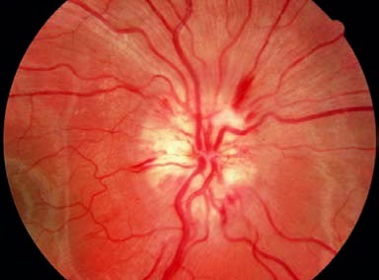

Fig. 13.

**11**

**a, b**

**a**

Papillitis in Lyme dis-

ease. The margin of the

optic disc is slightly ob-

scured by edema and hy-

peremia of the head of

the optic nerve. The optic

cup is obscured.

Continue

**387**

**Papillitis(continued)**

Fig. 13.

**11**

**b**

Central scotoma in papillitis. A central scotoma is a typical functional finding in retrobulbar optic neuritis but one

that may also be observed in papillitis. In this case, a relative scotoma is present (indicated by single hatching)—i.e., the patient is

only unable to discern markers I/1 and weaker in central ar

ea whereas larger markers are visible (see also Fig. 13.

**10**

)

. The blind spot

is also located next to this area.

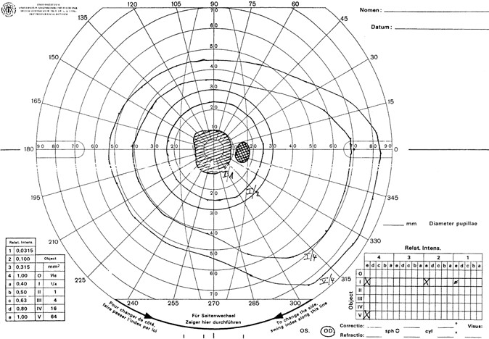

13.3

DisordersthatObscuretheMarginoftheOpticDisc

Lang,

Ophthalmology:

A

Pocket

Textbook

Atlas,

2

nd

Ed.

(

ISBN

978-1-58890-555-0)

,

copyright

©

2007

Thieme

Medical

Publishers.

All

rights

reserved.

Usage

subject

to

terms

and

conditions

of

license.

centrocecal scotoma involving the macula and blind spot, and wedge-shaped visual field defects up to and including complete blindness.

**Other symptoms** include pain that increases in extreme positions of gaze and when pressure is applied to the globe, and reduced perception of color intensity.

**Diagnostic considerations.** Ophthalmoscopic findings in **papillitis** (Fig. 13.**11a**) include edema and hyperemia of the head of the optic nerve. This flattens the optic cup and obscures the margin of the optic disc. Bleeding at the margin of the optic disc may or may not be present. The elevation of the optic disc is considerably less than in papilledema.

The optic disc will appear normal in **retrobulbar optic neuritis**.

In retrobulbar optic neuritis, the patient sees nothing (due to a central scotoma), and the physician sees nothing (the fundus appears normal).

**Other findings upon examination** include an afferent pupillary defect (this is regularly encountered; see Chapter 9), red – green color vision defect, and delayed latency in the visual evoked potential.

**Differential diagnosis. Papilledema.** Initially there is no loss of function.

**Ischemicopticneuropathy.** The central scotoma is lacking, and patients are usually over the age of 60.

**Treatment.** This depends on the underlying disorder. Retrobulbar optic neuritis with severe loss of vision (less than 0.1) can be treated with high doses of steroids—i.e., 1000 mg of oral prednisolone daily for 3 days and 1 mg of oral prednisolone per kilogram of body weight on days 4–14. However, this treatment only leads to more rapid restoration of vision. Final visual acuity after 1 year is identical with or without high-dose steroid therapy.

**Prognosis.** This depends on the underlying disorder. Severe permanent losses of visual acuity are possible, as are significant spontaneous improvements. **Retrobulbaropticneuritisindiffuseencephalitis** usually exhibits a strong tendency toward spontaneous improvement within 4 weeks without any treatment. However, *discrete functional defects* such as reduced visual contrast and reduced perception of color intensity will *always* remain. Morphologic findings *always* include a *pale optic* disc as a result of complex atrophy of the optic nerve following papillitis or partial isolated atrophy of the optic nerve following retrobulbar optic neuritis.

## Anterior Ischemic Optic Neuropathy (AION)

The following forms of anterior ischemic optic neuropathy (AION) are distinguished according to the cause of the disorder:

**Arteriosclerotic** anterior ischemic optic neuropathy.

**Arteritic** anterior ischemic optic neuropathy.

### Arteriosclerotic Anterior Ischemic Optic Neuropathy

***Definition:*** An acute disruption of the blood supply to the optic disc—i.e., optic disc infarction, resulting from vascular changes in arteriosclerosis.

**Epidemiology.** Arteriosclerotic AION is a common cause of sudden loss of visual acuity. The greatest incidence of this disorder is between the ages of 60 and 70. In contrast to arteritic AION, it can also occur in adults below the age of 60.

**Etiology.** The causes of the disorder lie in acute disruption of the blood flow through the lateral branches of the short posterior ciliary arteries and the ring of Zinn in the setting of severe arteriosclerosis. A narrow scleral canal—i.e., a small optic disc, is a predisposing factor. The disorder known as *diabetic papillopathy* also belongs to this group of disorders, although it has a better prognosis in terms of vision.

**Symptoms.** Patients report a *sudden unilateral loss of visual acuity*. This is due to segmental or complete infarction of the anterior portion of the optic nerve. Severity is variable. The patient may present with wedge-shaped visual field defects (Fig. 13.**12b**) or horizontal visual field defects that correlate with segmental nerve fiber edemas. However, severe concentric defects progressing to total blindness can also occur. Vision may or not be impaired. An afferent pupillary defect is always present.

**Diagnostic considerations.** The patient will frequently have a history of hypertension, diabetes mellitus, or hyperlipidemia.

**389**

13.3

Disorders that Obscure the Margin of the Optic Disc

**Ophthalmoscopy** will reveal edema of the optic disc, whose margin will be accordingly obscured. The margin is often obscured in a segmental pattern, which is an important criterion in differential diagnosis (Fig. 13.**12a**). The head of the optic nerve is also hyperemic with marginal bleeding.

Obscured segments of the margin of the optic disc that correlate with visual field defects are a sign of AION.

**Treatment.** Anterior ischemic optic neuropathy is nearly impossible to treat.

Attempted methods include hemodilution (pentoxifylline infusions, acetylsalicylic acid, and bloodletting depending on hematocrit levels) and systemic administration of steroids to control the edema. Diagnosis of the underlying cause is important; examination by an internist and Doppler ultrasound studies of the carotid artery may be helpful. Underlying disorders such as diabetes mellitus or arterial hypertension should be treated.

**Prognosis.** The prognosis is usually poor even where therapy is initiated early. Isolated atrophy of the optic nerve will appear within 3 weeks; complex atrophy of the optic nerve is less frequent but may also be observed.

Lang, Ophthalmology: A Pocket Textbook Atlas, 2nd Ed. (ISBN 978-1-58890-555-0), copyright © 2007 Thieme Medical Publishers. All rights reserved. Usage subject to terms and conditions of license.

### Arteritic Anterior Ischemic Optic Neuropathy

***Definition:*** An acute disruption of the blood supply to the optic disc due to inflammation of medium-sized and small arterial branches.

**Epidemiology.** The annual incidence is approximately three cases per 100 000.

The disorder occurs almost exclusively after the age of 60. Women are affected slightly more often than men, accounting for 55% of cases. Fifty percent of patients suffer from ocular involvement within a few days up to approximately 3 months after the onset of the disorder.

**Etiology.** Giant cell arteritis is a frequently bilateral granulomatous vasculitis that primarily affects the medium-sized and small arteries. Common sites include the temporal arteries, ophthalmic artery, short posterior ciliary arteries, central retinal artery, and the proximal portion of the vertebral arteries, which may be affected in varying combinations.

**Symptoms.** Patients report *sudden unilateral blindness or severe visual impairment*. Other symptoms include headaches, painful scalp in the region of the temporal arteries, tenderness to palpation in the region of the temporal arteries, pain while chewing (a characteristic sign), weight loss, reduced general health and exercise tolerance. Patients may have a history of amaurosis fugax or polymyalgia rheumatica.

**Diagnostic considerations.** The **ophthalmoscopic findings** are the same as in arteriosclerotic AION (see Fig. 13.**12a**). **Other findings** include a significantly increased erythrocyte sedimentation rate (precipitous sedimentation is the most important hematologic finding), an increased level of C-reactive protein, leukocytosis, and iron-deficiency anemia.

**Anterior ischemic optic neuropathy (AION)**

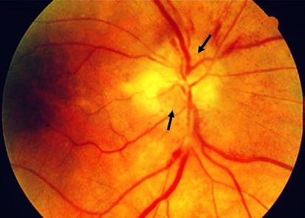

Fig. 13.

**12**

**a**

The su-

perior and inferior

segments of the mar-

gin of the optic disc

are obscured (arrows)

due to edema. This is

a typical morphologic

sign of AION.

Continue

**391**

**Anteriorischemicopticneuropathy(continued)**

Fig. 13.

**12**

**b**

The superior and inferior wedge-shaped visual field defects correlate with obscured segments of the margin of the

optic disc. As these are absolute scotomas, they are indicated by cross-hatching.

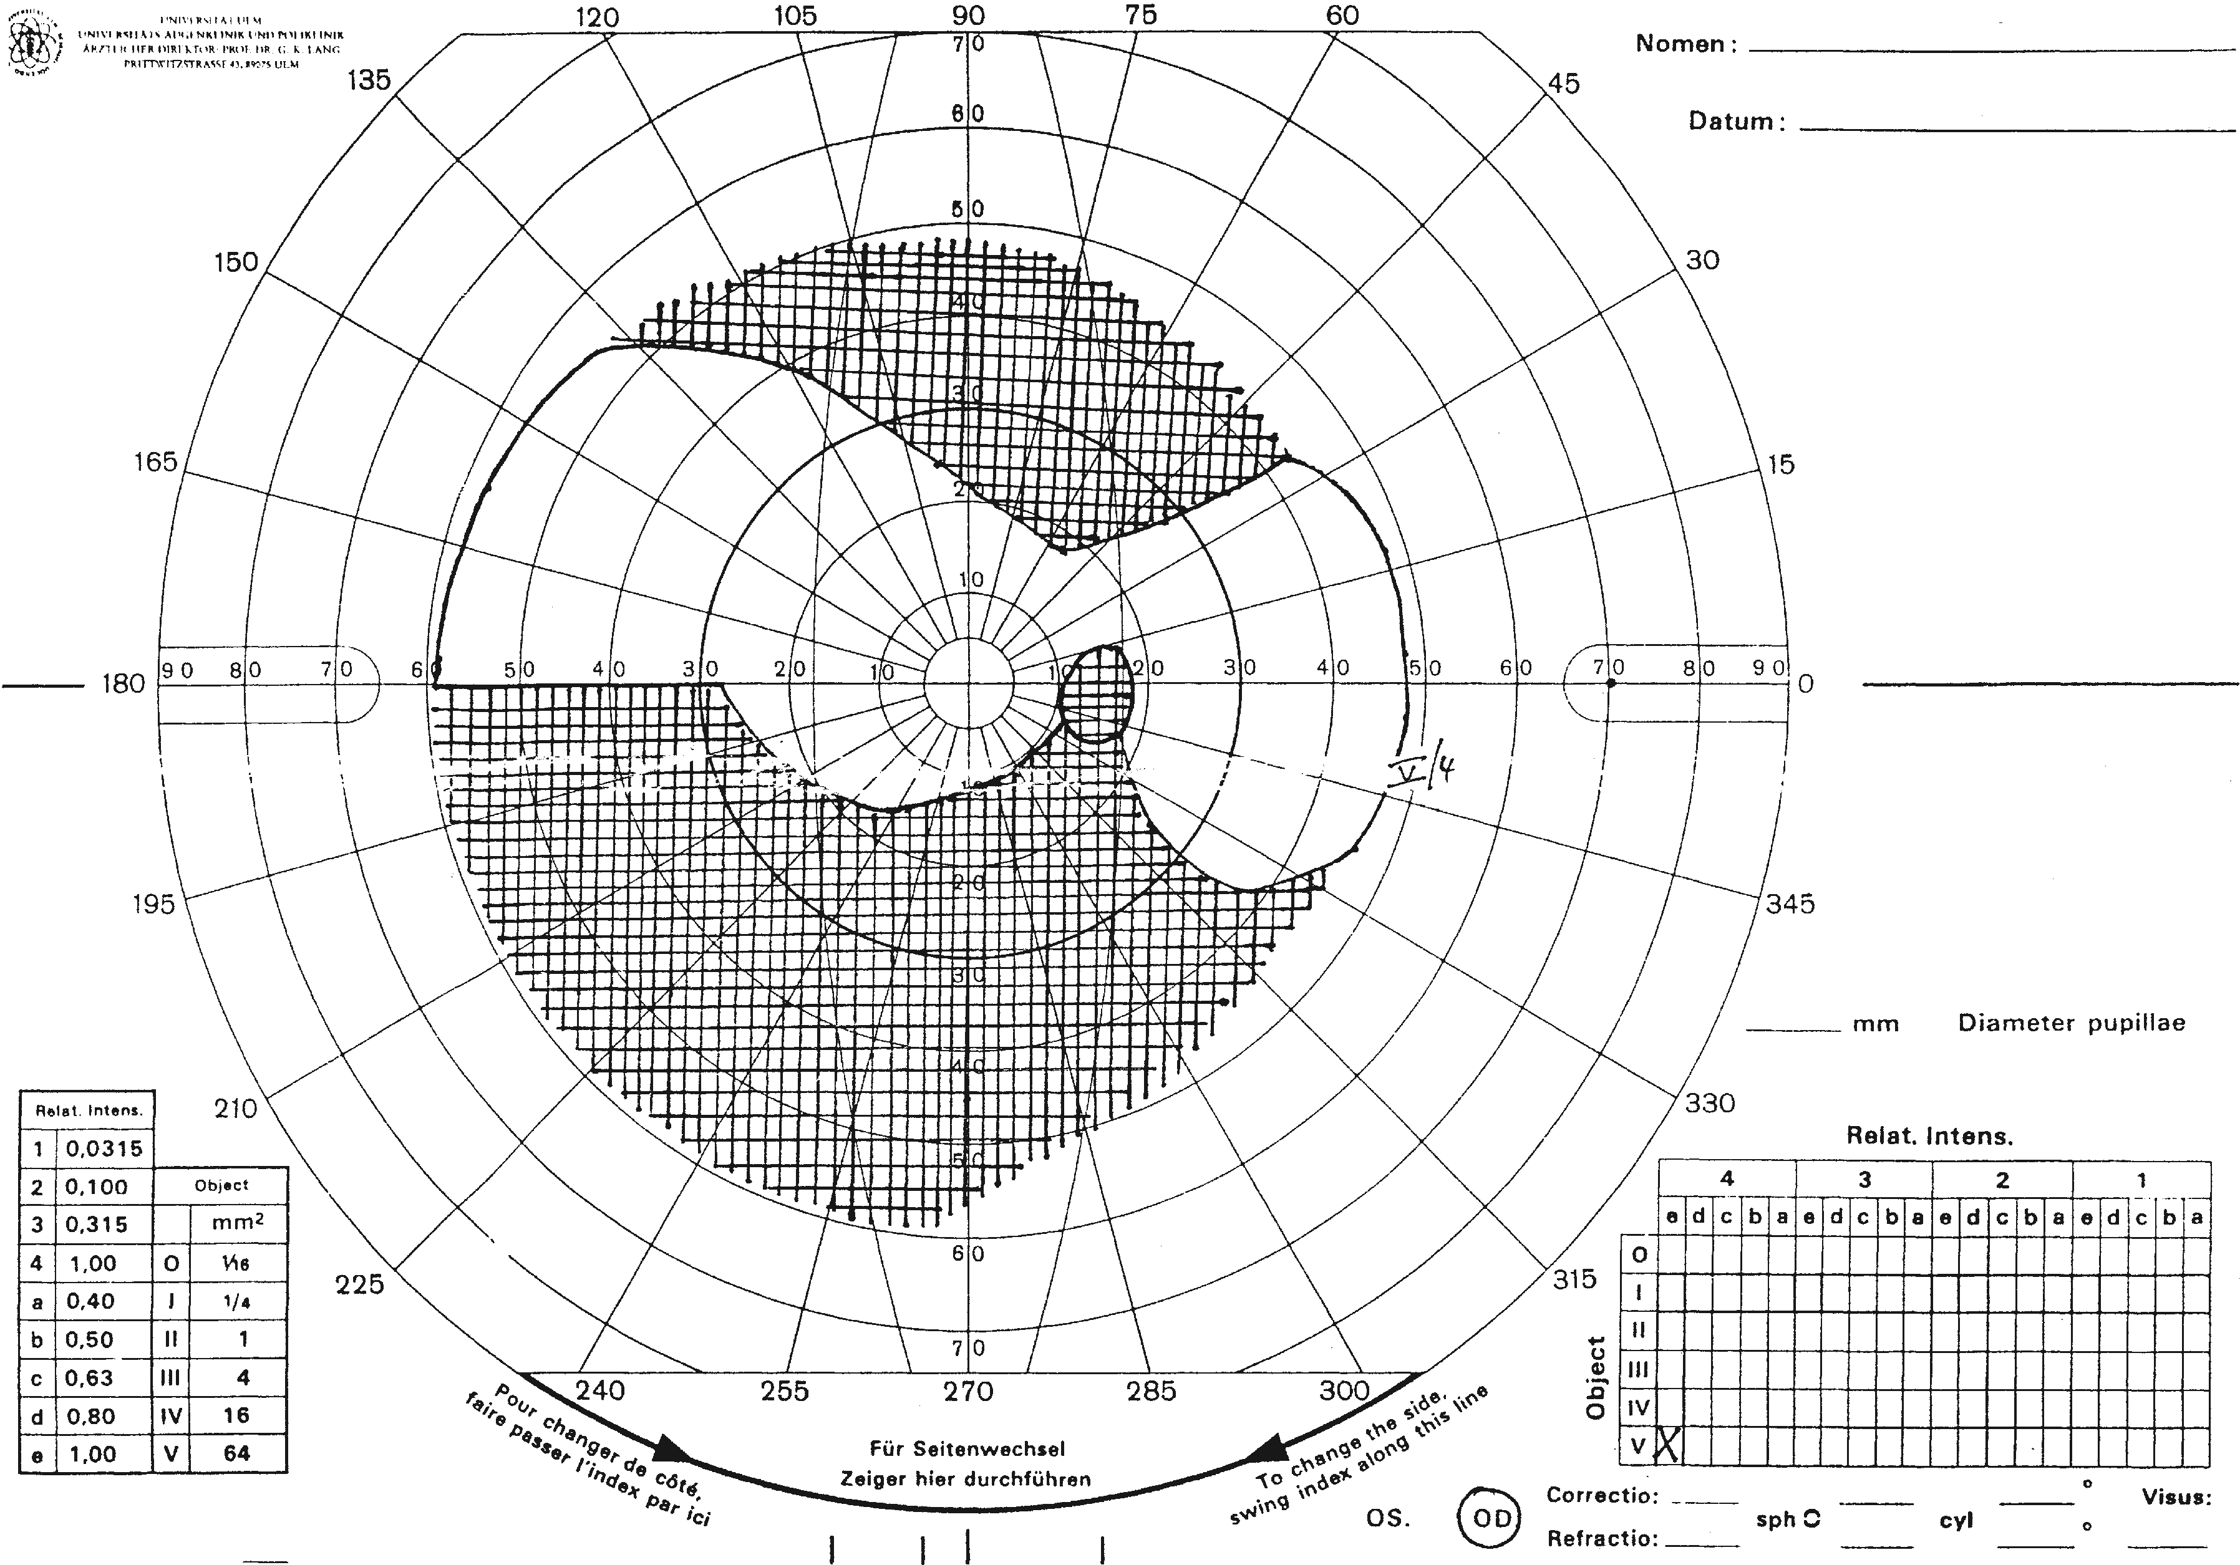

13.3

DisordersthatObscuretheMarginoftheOpticDisc

Lang,

Ophthalmology:

A

Pocket

Textbook

Atlas,

2

nd

Ed.

ISBN

(

978-1-58890-555-0)

,

copyright

©

2007

Thieme

Medical

Publishers.

All

rights

reserved.

Usage

subject

to

terms

and

conditions

of

license.

enting with anterior ischemic optic neuropathy.

Erythrocyte sedimentation rate should be measured in every patient pres-

**Prominent temporal arteries in temporal arteritis**

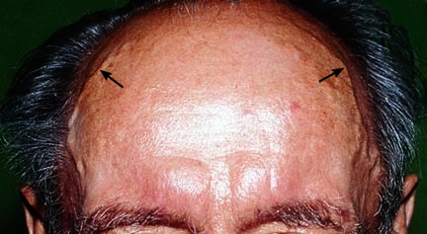

Fig. 13.

**13**

The

prominent tem-

poral arteries are

painful on palpa-

tion and have no

pulse.

The temporal arteries are prominent (Fig. 13.**13**), painful to palpation, and have no pulse. The diagnosis is confirmed by a biopsy of the temporal artery. Because of the segmental pattern of vascular involvement, negative histologic findings cannot exclude giant cell arteritis.

Giant cell arteritis should be considered in every patient presenting with anterior ischemic optic neuropathy.

**Differential diagnosis.** Arteriosclerotic AION should be considered.

**Treatment.** *Immediate* high-dosage systemic steroid therapy (initial doses up to 1000 mg of intravenous prednisone) is indicated. Steroids are reduced as the erythrocyte sedimentation rate decreases, C-reactive protein levels drop, and clinical symptoms abate. However, a maintenance dose will be required for several months. Vascular treatment such as pentoxifylline infusions may be attempted.

High-dosage systemic steroid therapy (for example 250 mg of intravenous prednisone) is indicated to protect the fellow eye even if a giant cell arteritis is only suspected.

**Prognosis.** The prognosis for the affected eye is *poor* even where therapy is initiated early. Immediate steroid therapy is absolutely indicated because in approximately 75% of cases the fellow eye is affected within a few hours and cerebral arteries may also be at risk.

## Infiltrative Optic Disc Edema

Infiltration of the optic disc occurs in about one in three cases of leukosis or other blood dyscrasias. This infiltration results in optic disc edema that is usually associated with infiltration of the meninges. The optic disc edema can therefore occur from both direct leukemic infiltration and secondary to increased pressure in the meninges of the optic nerve. The prognosis for both

vision and survival is poor.

**13.4 Disorders in which the Margin of the Optic Disc is Well Defined**

# Atrophy of the Optic Nerve

***Definition:*** Irreversible loss of axons in the region of the third neuron (from the retinal layer of ganglion cells to the lateral geniculate body).

**Morphology and pathologic classification.** Atrophy of the optic nerve is classified according to its morphology and pathogenesis. The following forms are distinguished **on the basis of ophthalmoscopic findings:**

Primary atrophy of the optic nerve

Secondary atrophy of the optic nerve

Glaucomatous atrophy of the optic nerve

Forms of primary atrophy of the optic nerve can be further classified according to their pathogenesis:

*Ascending* atrophy in which the lesion is located anterior to the lamina cribrosa in the ocular portion of the optic nerve or retina.

*Descending* atrophy in which the lesion is located posterior to the lamina cribrosa in a retrobulbar or cranial location.

**Etiology. Etiology of primary atrophy of the optic nerve.** The most important causes are as follows:

*Ascending atrophy (after 2–4 weeks)*.

* Usually vascular, such as central retinal artery occlusion or anterior ischemic optic neuropathy.

*Descending atrophy (after 4–6 weeks)*.

* Compressive, such as from an orbital or intracranial mass or hydrocephalus.
* Traumatic, such as avulsion, compression of the optic nerve in a fracture, or hematoma in the optic nerve sheath.
* Inflammatory, such as retrobulbar optic neuritis, arachnoiditis of the optic chiasm, or syphilis.

*Toxic*.

* Chronic abuse of low-grade tobacco and alcohol in tobacco and alcohol amblyopia.
* Lead, arsenic, or thallium.
* Methyl alcohol.
* Medications, such as ethambutol, chloramphenicol, gentamicin, isoniazid, vincristine, penicillamine, etc.

*Congenital or hereditary*.

* Infantile hereditary optic atrophy (an autosomal-dominant disorder with slow progressive loss of visual acuity, color vision defects, and visual field defects.
* Juvenile hereditary optic atrophy (similar to the infantile form, only the onset is usually later, in the second decade of life).
* Leber’s optic atrophy.
* Behr infantile recessive optic atrophy.

*Systemic disorders*.

* Hemorrhagic anemia or pernicious anemia. – Leukosis.

**Etiology of secondary atrophy of the optic nerve.** The most important causes are:

Papilledema.

Anterior ischemic optic neuropathy. Papillitis.

The etiology of any atrophy of the optic nerve should be determined to exclude possible life-threatening intracerebral causes such as a tumor.

**Symptoms.** The spectrum of functional defects in optic atrophy is broad. These range from small peripheral visual field defects in partial optic atrophy to severe concentric visual field defects or blindness in total optic atrophy.

**Diagnostic considerations.** The most important examinations are a detailed history, ophthalmoscopy, and perimetry testing. Color vision testing and visual evoked potential may be useful as follow-up examinations in begin-

ning optic atrophy.

**Primary atrophy of the optic nerve.** Ophthalmoscopy will reveal a well defined, pale optic disc (Fig. 13.**14**). The pallor can cover the entire optic disc (it will appear chalk-white in total optic atrophy), or it may be partial or segmental. The neuroretinal rim is atrophied, which causes the optic disc to flatten out. The diameter of the retinal vessels will be decreased.

**Secondary atrophy of the optic nerve.** Ophthalmoscopy will reveal a pale optic disc. The disc is slightly elevated due to proliferation of astrocytes, and the margin is blurred (Fig. 13.**15**). The optic cup will be partially or completely obscured. The retinal vessels will be constricted.

**Treatment.** The disorder involves *irreversible* damage to the nerve fibers. As a result, no effective treatment is available.

**Primary atrophy of the optic nerve**

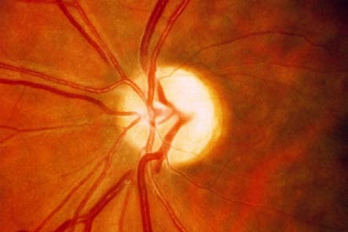

Fig. 13.

**14**

The

optic disc is well

defined and pale.

The neuroretinal

rim is atrophied,

resulting in a flat-

tened optic disc.

**Secondary atrophy of the optic nerve**

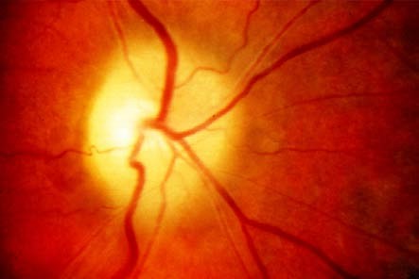

Fig. 13.

**15**

The

optic disc is ele-

vated and pale

due to prolifera-

tion of astro-

cytes.

**Prognosis.** Early identification and timely management of a treatable cause such as a tumor or pernicious anemia can arrest the progression of the disorder. Where this is not the case, the prognosis for vision is poor.

## Special Forms of Atrophy of the Optic Nerve

**Leber’s atrophy.** Here there is involvement of both optic nerves *without additional neurologic symptoms*. In 85% of cases, men between the ages of 20 and 30 are affected. The disorder is due to mutations in the mitochondrial DNA.

**Waxy pallor optic atrophy**

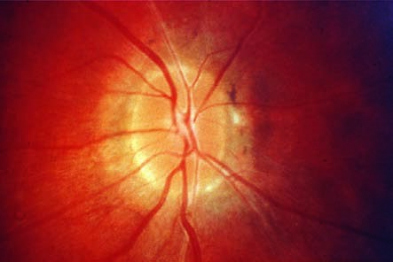

Fig. 13.

**16**

Waxy

pallor optic atro-

phy is associated

with tapetoreti-

nal degeneration.

*Ophthalmoscopy* will reveal optic disc edema as in papillitis followed by primary optic nerve atrophy. Initial retrobulbar optic neuritis is also possible.

*Functional symptoms* include a large central scotoma with a peripherally limited visual field. This will lead to significant loss of vision within a few months, although the remaining vision will not decrease any further. There is no *treatment*.

**Behrdisease(infantilerecessiveopticatrophy).** This is also a disorder involving both optic nerves. However, in contrast to Leber’s atrophy there are *additional neurologic symptoms*. These may include ataxia and mental retardation. The disease is an inherited autosomal-recessive disorder and manifests itself in early childhood.

*Ophthalmoscopy* will reveal progressive optic atrophy with severe loss of visual acuity but without complete blindness. There is no *treatment*.

**Waxy pallor optic atrophy.** This disorder (Fig. 13.**16**) is associated with tapetoretinal degeneration, such as retinitis pigmentosa.

*Ophthalmoscopy* will reveal an *optic disc with a wax-like pallor* that is shallow with a well defined margin. There will be severe thinning of the central retinal vessels. The *cause of the wax-like yellow color is not known*.

There is no *treatment*.

# Optic Nerve Pits

An optic nerve pit (Fig. 13.**17**) is characterized by a **round or oval grayish depressioninthepapillarytissuethatdoesnotcompromisethemarginofthe optic disc**. These pits are usually found in an inferior temporal location, although they do occur elsewhere. In 85% of cases, one eye is affected. Several pits in one optic disc have been described. Serous retinal detachment occurs in 25% of cases, depending on the location of the pit. Where the detachment affects the macula, a significant loss of visual acuity will result that will prove

**Optic nerve pits**

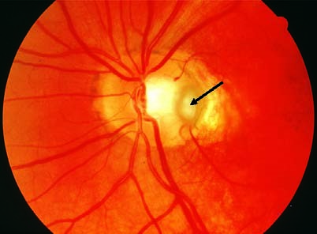

Fig. 13.

**17**

These are

oval, grayish temporal

depressions in the

papillary tissue (arrow).

**Optic disc coloboma**

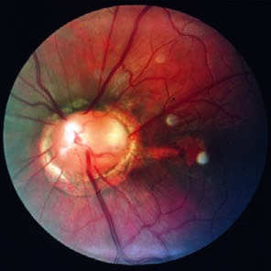

Fig. 13.

**18**

The optic disc is enlarged,

with a funnel-shaped depression with

whitish tissue and a peripapillary pig-

ment ring. The retinal vessels do not

branch from a central venous or arte-

rial trunk.

very difficult to manage with laser surgery. Otherwise optic nerve pits are an *incidental finding without any functional deficit*. They are considered to be rudimentary colobomas.

# Optic Disc Coloboma (Morning Glory Disc)

An optic disc coloboma (Fig. 13.**18**) is the result of incomplete closure of the embryonic optic cup. The optic disc is enlarged with a funnel-shaped depression with whitish tissue and a peripapillary pigment ring. The retinal vessels extend outward across the margin of the disc in a radial pattern without a central trunk vessel. Patients with optic disc coloboma often have *decreased visual acuity and visual field defects*.

**Melanocytoma**

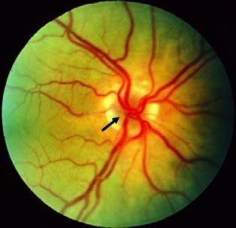

Fig. 13.

**19**

A benign tumor of the

optic disc, which represents a

special form of nevus (arrow).

## 13.5 Tumors

Optic nerve tumors are classified as **intraocular** or **retrobulbar tumors**. Intraocular tumors are rare.

# Intraocular Optic Nerve Tumors

**Melanocytoma** (Fig. 13.**19**): These are benign pigmented tumors that primarily occur in blacks. The color of the tumor varies from gray to pitch black. It is often eccentric and extends beyond the margin of the optic disc. In 50% of cases, one will also observe a peripapillary choroidal nevus. Visual acuity is usually normal, although discrete changes in the visual field may be present.

13.5 Tumors

**Astrocytoma** (Fig. 13.**20**): Astrocytomas appear as white reflecting “mulberry” masses that can calcify. Their size can range up to several disc diameters. The tumor is highly vascularized. Visual field defects can result where the tumor is sufficiently large to compress the optic nerve. Astrocytomas occur in tuberous sclerosis (Bourneville disease) and neurofibromatosis (Recklinghausen disease).

**Hemangioma** (Fig. 13.**21**): Capillary hemangiomas are eccentric, round orange-colored vascular deformities on the optic disc (von Hippel disease).

**Astrocytoma in tuberous sclerosis (Bourneville disease)**

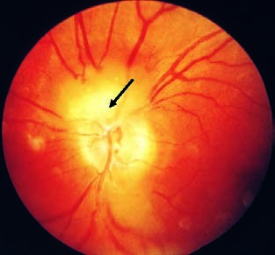

Fig. 13.

**20**

A whitish, “mulberry”

tumor on the superior margin of

the optic disc (arrow).

**Capillary hemangioma in von Hippel disease**

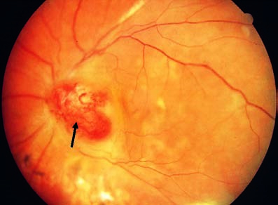

Fig. 13.

**21**

Eccentric capillary vascular deformity on the optic disc (arrow).

They may occur in association with other angiomas, for example in the cerebellum (in von Hippel–Lindau disease).

# Retrobulbar Optic Nerve Tumors

The most common retrobulbar optic nerve tumors are **gliomas** and **meningiomas.** *Symptoms* include a usually slow loss of visual acuity with exophthalmos. *Ophthalmoscopy* will reveal descending primary atrophy of the optic nerve. *Meningioma of the sheath of the optic nerve* is typically accompanied by the formation of opticociliary shunt vessels with compression of the central retinal vessels.