TEST A – PHYSIOTHERAPY ……………………….…………………………………………
NAME

ONLY ONE FROM a,b,c IS CORRECT

- Which of the following organelles is involved in protein synthesis: a) peroxisome b) Golgi apparatus c) lysosome
- Which of structures does not belong to cytoskeleton: a) actin microfilaments b) collagen fibers c) neurofilaments
- Which intercellular junctions has communicating function: a) zonula adherens b) nexus (gap junction) c) zonula occludens
- Stratified squamous keratinized epithelium coveres: a) skin (as epidermis) b) lines intestines c) lines blood vessels
- Which structure is not typical for epithelial tissue: a) basement membrane b) blood vessels c) desmosome
- Fixed cell of connective tissue proper is: a) lymphocyte b) fibrocyte c) reticulocyte
- Free or mobile or wandering cell of connective tissue proper is: a) pigment cell b) macrophage c) adipose cell
- Function of plasma cell in connective tissue is production of: a) specific antigens b) collagen fibers c) histamine, heparin
- Reticular connective tissue occurs in: a) lymph organs b) ligaments c) fibrous capsule
- Isogenous groups of chondrocytes are typical for: a) fibrocartilage b) elastic cartilage c) hyaline cartilage
- Hyaluronic acid in ground substance of connective tissue is main of: a) glycosaminoglycans b) proteoglycans c) glycoproteins
- One of 3 types of cartilage is not covered with perichondrium : a) hyaline cartilage b) elastic cartilage c) fibrocartlage
- Elastic cartilage occurs in: a) joints b) auricle c) trachea
- True statement about periosteum is: a) coveres outer surface of bone b) lines marrow cavity c) coveres articular cartilage
- True statement about osteoclast: a) derives from lymphocyte b) secretes osteoid c) resorb bone matrix
- Which type of bone is immature, without lamellae: a) compact bone b) spongy bone c) woven bone
- Ossification of flattened bones of skull is: a) membranous b) en(do)chondral c) intracartilaginous
- Ossification of long bone definitely ends with closure of: a) line of errosion b) epiphyseal plate c) zone of cartilage hypertrophy
- Synchondrosis is when bones are linked by: a) dense connective tissue b) bone tissue c) cartilage
- Bones in skull are linked by: a) dense connective tissue b) bone tissue c) cartilage
- Nissl’s substance in perikarion of neuron is represented by: a) pigment b) glycogen c) endoplasmic reticulum
- Which of following substance is not neurotransmitter: a) acetylcholine b) dopamine c) heparin
- Whih of following cells does not belong to central neuroglia: a) satellite cell b) oligodendrocyte c) microglia
- Which of following neuroglia cells is phagocyting cells: a) microglia b) astrocyte c) ependymocyte

DIAGRAM: numbers from picture write into the list of structures
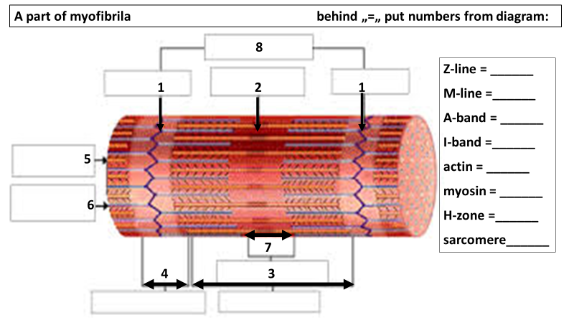

Results and evaluation of the test: 32 points is maximum

24 multiple choice questions / à 1 correct answer point gain max. 24
Diagram / à correct identification point gain max 8

 | mark | points
 | A 1 | 32 - 30
 | B 1- | 29 - 27
 | C 2 | 26 - 23
 | D 2- | 22 - 18
 | E 3 | 17 - 12
 | F 4 | 11 - 0
HISTOLOGY

