**Task 4: Composite - composition, properties, indications, contraindications, classification, making filling.**

Dental composite resins (better referred to as "resin-based composites" or simply "filled resins") are types of synthetic resins that are used in dentistry as restorative permanent material or adhesives.

A composite filling (Fig. 1) is used to repair a tooth that is affected by decay, cracks, fractures, etc. The decayed or affected portion of the tooth will be removed and then filled with a composite filling.

Fig. 1: Dental composites

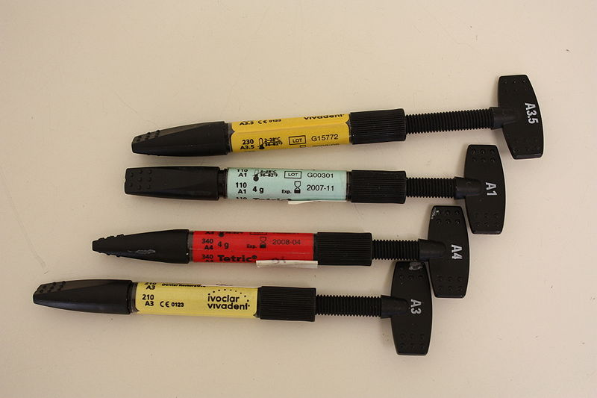

Resin composite fillings are made of a ceramic and plastic compound. Please perform composition of these materials better:

They consist of:

Organic matrix

Inorganic filler

Coupling agent

Initiating system

Pigments and stabilizators.

Specify the chemical composition and the importance of each component.

Composite resins are most commonly composed of Bis-GMA and other dimethacrylate monomers (TEGMA, UDMA, HDDMA), a filler material such as silica and in most current applications, a photoinitiator. The principle of curing composite material is polymerization.

What i happening during the polymerization – describe

There are many types of filling materials available, each with their own advantages and disadvantages.

Please perform the classification of composite materials

* acc to mode of polymerization
* acc to size of filler particles

Characteristic of materials:

Composite fillings, along with silver amalgam fillings, are the most widely used today. Because composite fillings are tooth colored, they can be closely matched to the color of existing teeth, and are more aesthetically suited for use in front teeth or the more visible areas of the teeth.

As with most dental restorations, composite fillings are not permanent and may someday have to be replaced. Composite materials are premanent filling materials. However they must be sometimes replaced. They are very durable, and will last many years, giving you a long lasting, beautiful smile.

|  |  |
| --- | --- |
| **Advantages** | **Drawbacks** |
| Invisible. The same color as your teeth, these fillings blend in. | Takes longer. The process of placing a resin filling is more involved, so it takes more of your time and the dentist’s |
| Easy adhesion. Resin composite bonds to the surface of your tooth. | More frequent replacement. Resin composite fillings last five to seven years, which is half the lifetime of an amalgam filling.Source of this information. |
| Preserves maximum amount of tooth. The flexibility of resin composite means less drilling is required.This is not due to the flexibility but due to their binding to hard dental tissue. |  |

Composite fillings are usually placed in one appointment. While the tooth is numb, your dentist will remove decay as necessary. The space will then be thoroughly cleaned and carefully prepared before the new filling is placed. If the decay was near the nerve of the tooth, a special medication will be applied for added protection.What?

Please perform sequence of operation step by step from preparation to final step.It is not necessary to describe classes. Making filling generally.

The composite filling will then be precisely placed, shaped, and polished, restoring your tooth to its original shape and function.

Composite fillings are most suitable material for the class 3 cavity, class 5 cavity which sits in enamel.

**Securing retention**

Retention depends on the type of material used (undercuts, fissures and grooves for amalgam, dental tissue etching for composite, treatment with conditioner for glass ionomer cement).

**Class 5 cavities**

Class V cavities include caries or defects of non-carious origin (erosions, abrasions, and wedge defects).

All hard dental tissues meet in the cervical area, a continuous flow of liquid from gingival sulcus makes it difficult to keep a dry working field. Dental tissue layers are very thin here and there is a considerable risk of opening the pulp chamber.

Materials

Composite (for cavities primarily in the enamel, especially in the frontal part of teeth, excellent hygiene, a dry working field is easily kept).

Preparation for Composite

The cavity is located supragingivally, it is limited to the carious lesion and has a box shape with rounded walls. Pulp wall again follows the convexity of the tooth. We bevel the enamel in order to remove the aprismatic enamel and achieve good retentive pattern. If the cavity exceeds the enamel, then we do not bevel walls in that part of cavity.

We start the preparation with a diamond pear-shaped bur with standard grit (blue code). We bevel the walls of the cavity in enamel by a fine diamond cylindrical pointed bur (red code), we only smoothen the walls outside the enamel with the same type of bur.The cavity does not have any indercuts.

Fig. 2: A cavity for composite localised in enamel, the enamel is bevelled



Fig. 3: A cavity for composite localised only partly in the enamel. The enamel is bevelled, and the edge of the cavity outside of the enamel is only smoothen. A suitable material is composite or glass ionomer cement in combination with composite (sandwich filling). The glass ionomer cement replaces the lost dentin while composite the enamel.



A box is rounded (no sharp edges), no undercuts are prepared. A fissure of diamond bur (cylinder bur) with standard grit (blue) is used. For finishing of the preparation: Diamond cylinder bur with fine grit (red code). We do not bevel the enamel.

MAKING OF THE FILLING

Dry working field and a matrix

It is difficult to keep the working field dry in the cervical area. Sometimes it is difficult to apply cofferdam even if the retraction clamp is used. It is recommended to place the retraction thread into the gingival sulcus.

Transparent cervical matrices of various sizes can be used for composite. The same matrices may also be used for glass ionomer cement, although there are special matrices for glass ionomer cement made of soft metal with a special surface treatment.

For securing a dry working field, we can use Belvedere matrix it is placed around the tooth, into the gingival sulcus and sealed with wedges. It is suitable for composite filling.

For composite make the filling according to the rules for working with composite (etching, rinsing, application of primer and bond, polymerisation, depositing in layers, thorough polymerisation, shaping and polishing).

**Class I cavity**

Class I cavities include caries or defects of fissures and pits (palatal surfaces of upper incisors – mainly the lateral incisors, buccal surface of lower molars and palatal surfaces of upper molars).

**Materials:**

Composite (small to medium cavities, good oral hygiene and the possibility of securing a completely dry working field required).

The cavity does not have any indercuts. A box is rounded (no sharp edges), no undercuts are prepared. A fissure of diamond bur (cylinder bur) with standard grit (blue) is used. For finishing of the preparation: Diamond cylinder bur with fine grit (red code). We do not bevel the enamel.

**The principle of preventive extension:**

If the caries is small, cavity is limited to the carious lesion. We open the fissures leading to the carious lesion and include them into preparation. We seal the carries of small extent. The extension for class 5 cavity for composite is 1mm limit only to carious region.

**The principle of retention:**

The thickness of filling is minimally 2 mm, enamel is supported by dentin everywhere, all transitions are rounded with no sharp edges.

Acid etching using phosphoric acid is performed, washing, application of the primer bond and light curing follow. The filling material is placed in portions (appr. 1 mm) and each portion is cured.

**The principle of resistance:**

The thickness of filling is minimally 2 mm, enamel is supported by dentin everywhere, all transitions are rounded with no sharp edges.

Inlay from metal alloy (we use dental precious metal).

Composite or ceramic inlay

Unlike during the preparation for a metal inlay, we do not bevel the enamel.

Otherwise, the preparation is identical with the preparation for a metal inlay.

We use composite cement and adhesive technology for cementing (similarly as when making the composite filling). This procedure will be taught in the clinical part of the studies.