Glass Ionomers and Inlays

Glass ionomers: -
Glass-ionomer cements belong to the class of materials known as acid-base cements. They are based on the product of reaction of weak polymeric acids with powdered glasses of basic character. The setting occurs in concentrated solutions in water and the final structure contains a substantial amount of unreacted glass which acts as filler to reinforce the set cement.
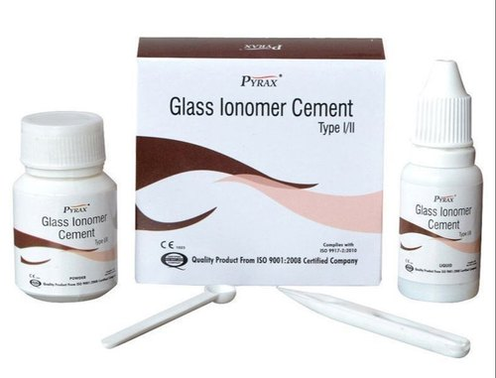
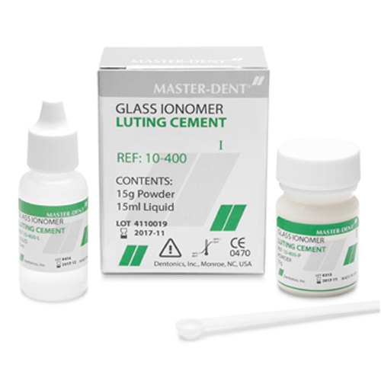
The term “glass-ionomer” was applied to them in the earliest publication, but is not strictly correct. The proper name for them, according to the International Organization for Standardization, the ISO for short, is “glass polyalkenoate cement, but “glass-ionomer” is recognized as an acceptable trivial name and is widely used within the dental profession. Glass ionomer cements are high strength bases used primarily for permanent cement, as a base, and as a Class V filling material. They are supplied as a powder and a liquid, or as a powder that is mixed with water. The liquid is typically a polyacrylic acid. Pure glass ionomers require no etching. The tooth simply needs to be cleaned with a mild acid.

Composition: -
There are three essential ingredients to a glass-ionomer cement, namely polymeric water-soluble acid, basic (ion-leachable) glass, and water. These are commonly presented as an aqueous solution of polymeric acid and a finely divided glass powder, which are mixed by an appropriate method to form a viscous paste that sets rapidly.

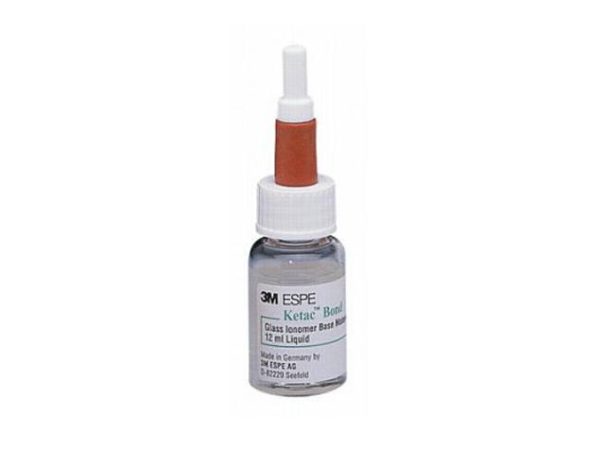
Liquid Part:
- Tartaric Acid
- Poly Acid (Polyacrylic, Polymaleic)
- Water
Powder Part:
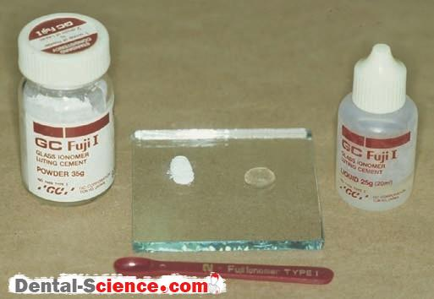
- Aluminum Silicate Glass
  - SiO2 (Silicon Dioxide)
  - Al2O5 (Aluminum Pentoxide)
  - CaO (Calcium Oxide)
  - N2O (Dinitrogen Oxide)
  - P2O5 (Phosphorus Pentoxide)
  - F (Fluorine)

Principle of Setting: -
- Acid-Base Reaction (chemically)
- Dual cured glass-ionomers (resin modified) – acid – base reaction andpolymerization

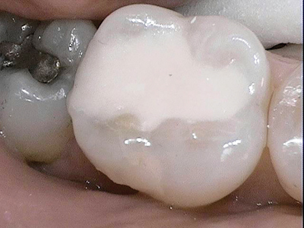
Properties: -
- Chemical bonding with hard dental tissues
- Thermal expansion similar to dentin
- Releases Fluoride ions
Advantages: -
- Aesthetically acceptable
Disadvantages: -
- Mechanically not so strong
Indications: -
- Classes I, II, III, V (Temporary for classes I and II. Permanent for Class V)
- Sealants
- Protection of Tooth
- Cementation in prosthetic¨
- Sealers
Contraindications: -
- CANNOT EVER use on class IV or Permanent classes I and II
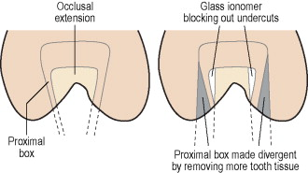
Cavity-like shape: -
- Dish-like cavity
Procedure: -
- Preparation
- Limited on caries region (less extension)
- Conditioning
- Washing
- Filling in one block (not portion)
- Varnish after setting
- Polishing next appointment

Please add classification of glassionomers – acc to their composition, acc.to indication.

Inlays: -
An inlay is a pre-molded/modeled rigid filling fitted into the grooves of a tooth and do not extend over the cusps of tooth. The patient is numbed using a local anesthetic and the dentist drills the tooth to remove and clean out the decay in the tooth. This is one of the restorative methods used to repair a tooth after it sustains harm from injury or decay that does not affect the cusps of the tooth. The dentist takes an impression and sends it to a laboratory where the inlay is made. Inlays are manufactured from porcelain or composite resin material matching the color of the tooth, and provide almost invisible dental restoration while repairing the chewing surface. Dental inlays are generally more durable than regular fillings made from composite or amalgam, and gold inlays are the most durable and the most expensive of the materials available, according to the American Dental Association.
If you sustain damage in spite of good oral hygiene, a dental inlay might be the way to go. Also, your dentist is likely to recommend an inlay instead of a regular fitting if the damage to the biting surface matches these criteria:
- Broken, fractured or decayed teeth where it does not affect the cusp of the tooth.
- It is extensive enough to require a large dental filling that may weaken the remaining structure.
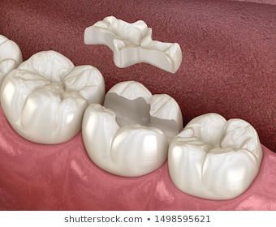
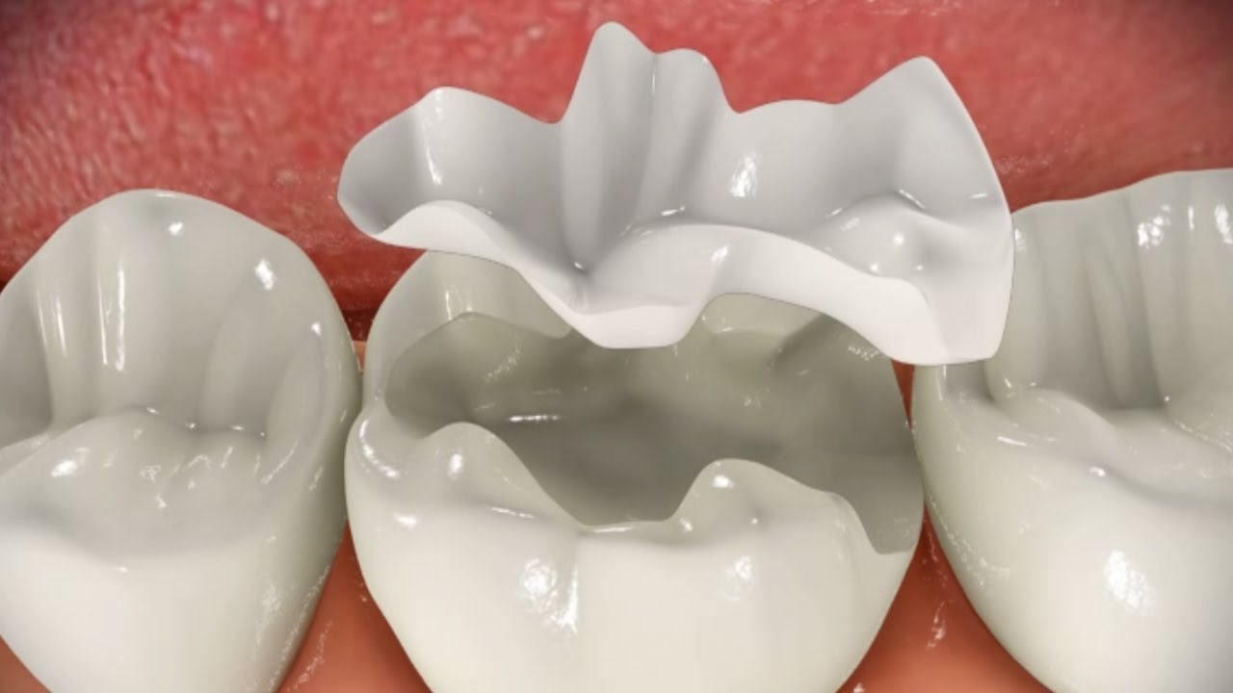
- The level of injury does not allow for removal of enough tooth material to support mounting a crown.Source of these pictures.

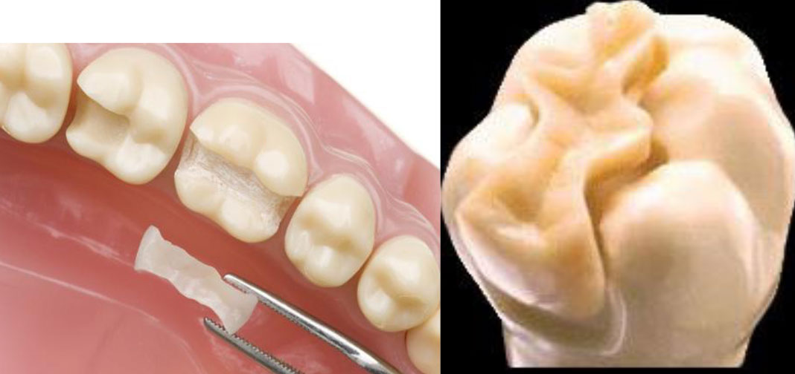
Composition: -
- Metal Alloy
- Composite
- Ceramics
Advantages: -
- Strong, durable, and have an exceptional longevity
- More biocompatible with better tissue response
- Control of contour and contact
- Much more wear resistant than direct composite restoration
Disadvantages: -
- Number of appointment and more chair time
- More expensive than direct restorations
- More technique sensitive
- Repair is difficult
Indications: -
- High esthetic demand
- Replace moderate to large existing restoration
- Fractured tooth/restoration
- Moderate to large primary caries
- Diastema closure and occlusal surface corrections this is not a good indication for inlay. In frontal area we definitely prefere fillings (made of plastic material), or in some cases aesthetic veneers.
Contraindications: -
- Unable to adequately isolate the field
- Parafunctional habits – bruxing, clenching, excessive wear - this is for composite or ceramics inlays, metal inlays can be usede
- Small restorations
- Short tooth life expectancy
- Young patients til the age of 18, better later.
Cavity-like shape: -
- Divergent
- Enamel is beveled in outer half for metal inlays, for composite and ceramic inlays we do not bevel enamel, with exception axial walls and outer edge of the gingival wall.
Some Information: -
- Inlay is a rigid filling
- It is fabricated out of the oral cavity in the dental lab
- It is luted into the cavity using a luting material – cement
- The Preparation is different (walls are divergent)
Direct Method of Inlay Preparation: -
- 1. Preparation
- 2. Isolation
- 3. Modeling of wax
- 4. Sprue pin with reservoir
- 5. Placement on the wax cone
- 6. Transport to dental lab
- 7. Making of the inlay- lost wax method
- 8. Cementation

Indirect Method of Inlay Preparation: -
- 1. Preparation
- 2. Taking impressions
- 3. Transport to dental lab
- 4. Making of the inlay- model, isolation, modeling, lost wax method
- 5. Cementation
Ceramic and composite inlays are made in various ways according to the material used. For cementation composite cements are used and the procedure requires acid etching, priming, bonding and cementation. Inner part of the inlay is treated by sandblasting (composite, zirconia), etching with hydrofluoric acid (lithiumdisilicate ceramic) and silanization. Absolutely dry operating field is strongly recommended.

