Amalgam - Table of Contents

Amalgam - Table of Contents 1
Composition and properties of Amalgam 2
What is Amalgam? 2
Composition of Amalgam 2
Properties of Amalgam 3
Indications and contraindications of Amalgam 4
Indications 4
Indications and contraindications for premolar and molar teeth restaurations 4
Depending on the occlusal defect extension 4
Depending on the cervical/approximal defect extension 5
Further contraindications 5
Advantages of (silver) Amalgam 5
Disadvantages 5
Making the preparation and filling 6
References 7

Composition and properties of Amalgam

What is Amalgam?

Amalgam is a permanent filling material (liquid mercury and metal alloys) which is used for classes I, II, and V. This is, because amalgam is not aesthetically pleasing but has a good retention, if the cavity is prepared right.

Composition of Amalgam

There are different types of amalgam, depending on the percentage of metal components and the purpose of the particular amalgam, such as high copper amalgam, which is used mostly for restorative dentistry. This is because of the strength and the resulting increase in durability of the amalgam.

Constituent | % of Total | Function
Ag | 67 - 74 | Ag is responsible for good corrosion resistance, hardness Sn is responsible for plasticity, it does not have goog corrosion resistance.
Sn | 25 - 28
Cu | 0 - 6 (12 - 30) | Strength and hardness
Zn | 0 - 2 | No purpose, residual  It is important for fabrication of alloy – it is deoxidant. Residual.
Hg | 0 - 3 | Pre-amalgamation

- traditional amalgams = < 6% Cu (150 years) => measurable amount of γ₂
  - not all particles are dissolved
  - γ₂ – responsible for a lack of strength and excessive creep (amalgam melting point ~ 80 °C) and corrosion
- high-Cu-content amalgams = 12 – 30% of Cu (1960s) => almost no γ₂
  - a higher compressive strength
  - more rapid set to full strength
  - a reduction in creep
  - a reduced susceptibility to corrosion

Explain flow and creep. Explain principle of external electrochemic corrosion and internal electrochemic corrosion.

Properties of Amalgam

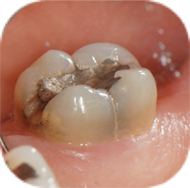
It is a macromolecularno macromolecular, you probably ment material with micromechanical retention. filling which has a high retention. Amalgam is made from metal components, so although it is a durable and strong material, it does undergo minor variations when exposed to temperature changes. The expansion and contraction of amalgam is inevitable. This may lead to micro leakages and secondary caries, if the amalgam is not properly filled.or properpy mixed Another property is, that amalgams cannot absorb as much pressure when applied to one area. It can easily be cracked and therefore lead to secondary carries, if not modulated properly.I do not agree – amalgam is brittle and therefore is necessary to have proper thickness of the filling. (2 mm on occlusal sirface and 4 mm when cusp replacement).

Indications and contraindications of Amalgam

Indications

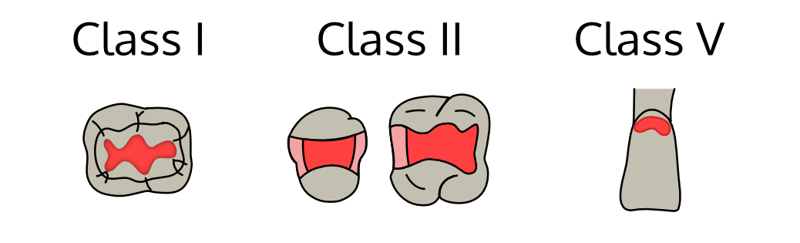

Moderate to large cavities in posterior area (class I., II., V.).

Class I: central cavities in the areas of pits and fissures of premolars and molars.

Class II: approximal cavities of premolars and molars, in which there is
- Heavy occlusion
- Extension on the root surface
- Problem of isolation
- It is indicated in heavy occlusion because amalgam has greater wear resistance than composites. Minor contamination with what ? during the amalgam placement has less adverse effects as compared to composite restorations.

Class V: cervical area cavities, only use if aesthetics are of no concern

Indications and contraindications for premolar and molar teeth restaurations

Depending on the occlusal defect extension

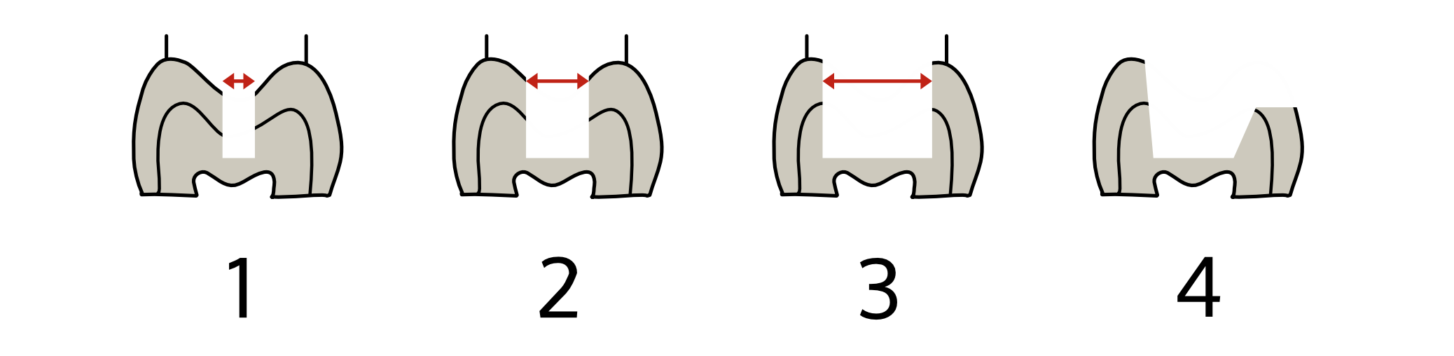
Amalgam is indicated for medium -large cavities in posterior area – I.a II. Class and V. classif this cavity is out of aesthetic zone.
1: small | 2: moderate | 3: large | 4: crown replacement
- + | + | - | - (+)

- unsuitable // + suitable // () limited suitability

Source of pictures please add.

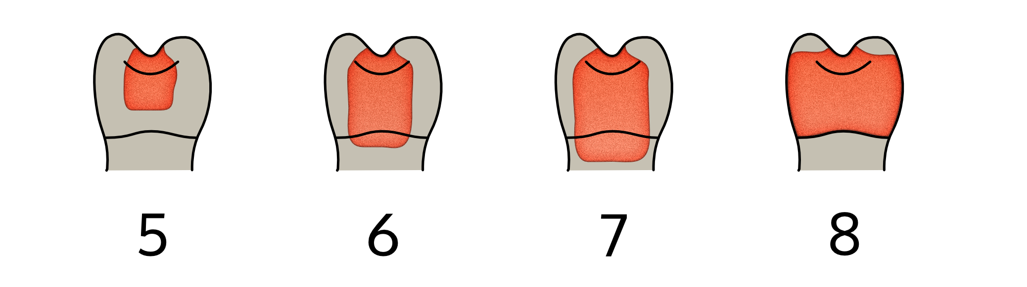
Depending on the cervical/approximal defect extension

5: cervical enamel | 6: cervical dentin | 7: wide apical | 8: wide buccolingual
+ | + | (+) - | -

- unsuitable // + suitable // () limited suitability

Further contraindications
- fillings in frontal area
- pregnancy
- children till the age of 15
- allergy

Advantages of (silver) Amalgam
- Ease of manipulation
- Satisfactory marginal adaptation
- Wider range of application
- Physical characteristics of amalgam are comparable to enamel and dentin
- Less technique sensitive
- Self-sealing
- Biocompatible
- Good wear resistance
- Low cost
- Can be completed in one dental visit
- Bonded amalgam restorations can also bond to tooth structure.

Disadvantages
- Poor aesthetics
- Amalgam fillings can corrode or tarnish over time, causing discoloration
- Extensive preparation to hold an amalgam filling
- Lack of strength and toughness, amalgam is not strong enough to reinforce the weakened tooth structure
- Poor tensile strength making it a brittle material
- Lack of adhesion, does not bond to tooth
- Being metallic restoration it is non-insulating
- Results in galvanic current in association with gold restoration or even in same restoration with nonuniform condensation
- Marginal degradation is seen in low copper alloys
- Mercury toxicity.

Making the preparation and filling

Tools needed are dentals burs – fissure/round bur and inverted cone bur, amalgam carrier, condenser, 3 times bend spatula, ball burnisher, frahm carver and maybe an excavator. For larger cavities you may also need a matrix band as well.

- Prepare the outline for the cavity using the fissure bur, making sure that the bur is always at 90 degrees to the occlusal surface. Be careful not to destroy the cusps or the marginal ridges and do not have any sharp edges. Use an excavator to remove the caries if needed.
- Next using the inverted cone bur prepare the undercut to allow for the retention of the amalgam.
- Mix the amalgam using the Amalgamator, then use the amalgam carrier to take a piece of the amalgam to the cavity.
- Use the condenser to firmly press the amalgam into the cavity making sure not to leave any spaces.
- Keep adding more amalgam and condensing it into the cavity until the cavity is filled.
- Using the Frahm carver remove the excess amalgam and recreate the pits and fissures.
- Use the 3 times bend spatula to rebuild the amalgam towards the cusps.
- Use the ball burnisher to smoothen the filling.
- You may now ask the patient to close the teeth together and see if it is comfortable. Use coloured paper between the teeth to find any areas where the filling may be too high or if the tooth above needs to be trimmed down a little.
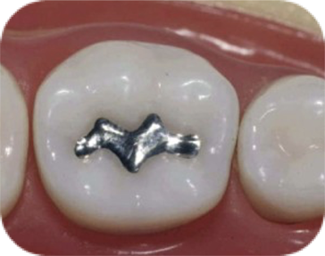
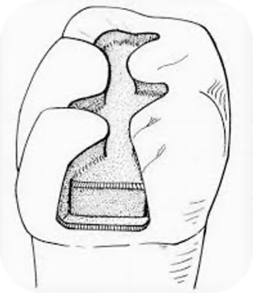

References
- https://en.wikipedia.org/wiki/Amalgam_(dentistry)
- https://image.slidesharecdn.com/dentalamalgam-120203090746-phpapp01/95/dental-amalgam-22-728.jpg?cb=1328260529
- https://www.google.com/url?sa=i&url=https%3A%2F%2Fwww.cerarootclinic.com%2Fmercury-amalgam-problems-and-the-cracked-tooth%2F&psig=AOvVaw1efY0VdcazemdwPxQWW3Bo&ust=1584917446833000&source=images&cd=vfe&ved=0CAIQjRxqFwoTCOjis97TrOgCFQAAAAAdAAAAABAD
- https://pocketdentistry.com/tooth-preparation-for-amalgam-restoration/
- https://is.muni.cz/auth/el/med/podzim2019/aZLLC011p/um/5_Dental_materials_18_OP.pdf?fakulta=1411;obdobi=7483;studium=823130
- https://is.muni.cz/auth/el/med/podzim2019/aZLPR0131p/ClassI._and_amalgampptx.pdf?fakulta=1411;obdobi=7483;studium=823130
- Memorix Zahnmedizin, Thomas Weber, 3. vollständig überarbeitete und erweiterte Auflage, Thieme Verlag, 2010

